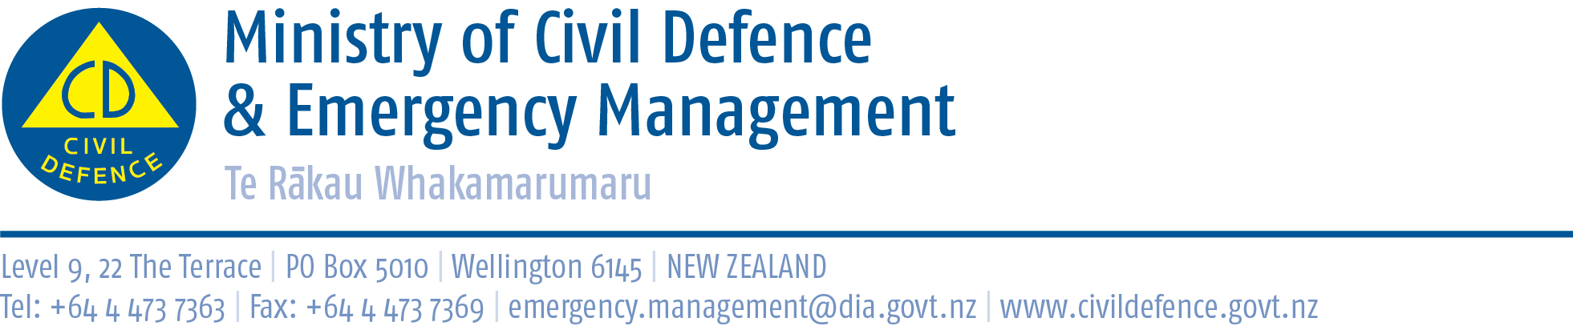

Media release 22 August 2013

Civil defence public education campaign is working
Research released today shows the Get Ready Get Thru emergency preparedness campaign is proving highly successful.
The Director of Civil Defence Emergency Management, John Hamilton, said highlights of the 2013 survey carried out by research company Colmar Brunton include:
- 71 per cent of people who have seen Get Ready Get Thru advertising said they have taken action to prepare because of the advertising
- 29 per cent of people took part in our country’s first ever national earthquake drill, New Zealand ShakeOut, by doing the Drop, Cover and Hold drill
- 62 percent of people feel more prepared for an earthquake because of New Zealand ShakeOut.
Mr Hamilton said the Colmar Brunton survey of emergency preparedness has been carried out since 2006. It is believed to be the longest running, consistent research on a public education programme in New Zealand, and possibly in the world.
The trend is positive – a steady increase – and it is most encouraging to see the campaign is working. However, we are building on a very low benchmark and the percentages of people actually prepared are still low. We have no room for complacency.
In 2006 only 7 percent of people were fully prepared for an emergency at home and elsewhere. While in just seven years that has increased almost two-and-a-half times, it is still only 17 per cent of the country who are fully prepared.
Likewise in 2006, 21 per cent of people were prepared at home. That has increased by 52 per cent to 32 per cent of the country.
We will continue our campaign with the Ministry running national advertising, and with regional civil defence emergency management groups and councils organising events and promotions in their areas.
We will encourage, advise and provide information about how to prepare but people must take responsibility for themselves and their loved ones to:
- have emergency supplies, including food and water for at least three days
- have a plan for what they would do in an emergency at home, work, school, or elsewhere
- update their emergency supplies.
Copies of all the Colmar Brunton surveys since 2006 are available at on the Ministry’s website at http://www.civildefence.govt.nz/memwebsite.nsf/wpg_URL/For-the-CDEM-Sector-Public-Education-Get-Ready-Get-Thru-Campaign?OpenDocument

Please also see Mr Hamilton’s media release (20 August 2013) “Do NOT get outside quickly after an earthquake: Guide for workplace earthquake plan” at www.civildefence.govt . The messages in Get Ready Get Thru, New Zealand ShakeOut, and the media release support each other.
• Get Ready Get Thru encourages personal and household preparedness. That is, what I and my
family will do if we are at home or elsewhere.
• New Zealand ShakeOut was a national earthquake drill. During an earthquake, wherever you are,
Drop, Cover and Hold.
• “Do NOT get outside quickly after an earthquake” is about the need for workplaces to have an
earthquake plan for what to do after Drop, Cover and Hold.

Media contact

Ministry of Civil Defence & Emergency Management
Public Information Duty Officer,
Telephone: 04 494 6951
E-mail: pim@ncmc.govt.nz

Follow the Ministry on Twitter or subscribe to our RSS feed

 If a disaster happened now, would you be ready? www.getthru.govt.nz

