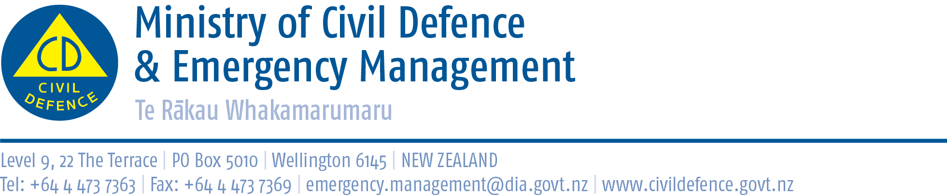

Media release 20 August 2013

Do NOT get outside quickly after an earthquake:
Guide for workplace earthquake plan
It is frightening to stay in a building immediately after an earthquake but it is much safer than immediately going outside.
The Director of Civil Defence Emergency Management, John Hamilton, said it is not like a fire. You do not have to evacuate a building straight away unless it is showing obvious signs of distress.
When you eventually evacuate, do take your wallet, coat, bag, etc. You are more vulnerable if you leave those things behind. If you have a getaway kit or “go bag”, take it.
Have a plan before you need it. Tell others what you plan to do. An evacuation assembly area in case of fire might not be appropriate after an earthquake. Large open areas with no tall buildings, power lines or other hazards immediately adjacent are best. It is often better to remain in your building until a safest route has been found.
“Seeing thousands of people gathered outside Wellington high rise buildings on Friday afternoon was extremely worrying,” the Director of Civil Defence Emergency Management, John Hamilton said.
“Glass and masonry falling into streets cause terrible casualties. A major after-shock could have been tragic for those standing in the street.
“What we saw was that many people knew to Drop, Cover and Hold during the earthquake but most did not know what to do afterwards.”
The Ministry suggests workplaces develop a plan for what to do immediately after a major earthquake, assuming serious damage. In the case of smaller, more common, earthquakes such a plan can be scaled back.
The plan needs to focus on what staff should do and include all of:
- Do it together – Discuss arrangements with staff from other organisations in the building. Arrange to check on and support each other during and after an earthquake.
- Drop, Cover and Hold – This is what to do during an earthquake. (Staff who are away from their workplace and outside when an earthquake strikes should move no more than a few steps then Drop, Cover and Hold.)
- On your floor – After the shaking stops, staff gather together, care for injuries, select a leader.
- In your building – Establish what has happened to all your staff. After stairs are checked, if possible, gather in one place.
- Gather information – about your building (e.g. are the stairs to the ground level useable) and what is happening around your area and elsewhere in town.
- Staff priorities – Family, children, medical needs, essential work etc.
- If necessary evacuate – Use previously identified routes to move away from the building. Take bags, phones, wallets and any emergency supplies you have (“go bag”).
- If practicable keep a register of staff present, log when they leave and their intentions (e.g. fetch children from day-care, walk home etc.). Arrange to travel in groups.
- Disperse – staff can head home or to an alternate workplace but maybe not all at once else all transport and roads will be overloaded.
- Practise – people need to know what the plan is and practise it.

Business continuity planning, which protects the business ability to keep trading or to recover, is also important but should be kept separate from the immediate response plan to avoid confusion.
“Friday’s response indicates growing resilience in Wellington to earthquakes of this magnitude. Civil defence emergency management had little to do; buildings performed well and people knew and used Drop, Cover and Hold.
“However, we can do more to guide people on what they should do after the shaking stops.”

Media contact

Ministry of Civil Defence & Emergency Management
Public Information Duty Officer,
Telephone: 04 494 6951
E-mail: pim@ncmc.govt.nz

Follow the Ministry on Twitter or subscribe to our RSS feed

 If a disaster happened now, would you be ready? www.getthru.govt.nz

