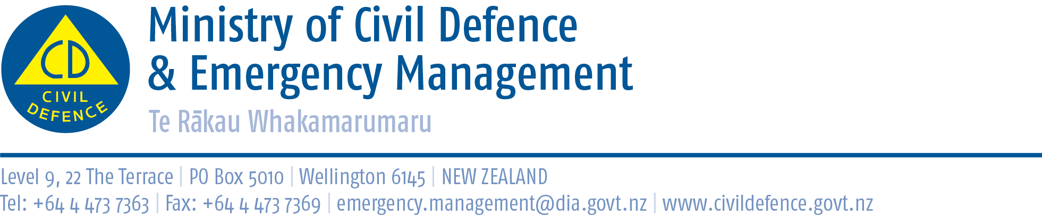

Media release 6 August 2013

Ministry funding for 17 local civil defence projects
The Ministry of Civil Defence & Emergency Management has approved funding for 17 local government projects that will improve local and regional civil defence emergency management.
Projects to receive funding are:
- Northland in partnership with Southland, business continuity planning for small and medium-sized businesses
- Northland, review of community response plans
- Northland, community resilience for vulnerable people
- Northland, Kaipara District Council resilience programme
- Auckland, further development of smartphone app for web, other mobile and social media
- Auckland, enhancing Smartphone alerting to allow other regions to join
- Taranaki, emergency management information system (EMIS) trainer
- Taranaki, whanau resilience project
- Taranaki, marae emergency welfare response plan
- Hawkes Bay, resource for early childhood education
- Wellington, emergency management information system (EMIS) trainer
- Nelson-Tasman, Marlborough and West Coast, emergency management information system (EMIS) trainer
- West Coast, tsunami evacuation zones
- Canterbury, VHF radios for Kaikoura
- Canterbury, digital content for public education
- Canterbury, emergency management information system (EMIS) trainer
- Otago, identify lifelines vulnerabilities and interdependencies

More information about the projects is available from the Ministry’s website at http://www.civildefence.govt.nz/memwebsite.nsf/wpg_URL/For-the-CDEM-Sector-CDEM-Groups-CDEM-Resilience-Fund?OpenDocument
The Director of Civil Defence Emergency Management (CDEM), John Hamilton, said the CDEM Resilience Fund provides up to $889,000 a year for local government projects.
Funding is provided to local authorities and regional CDEM Groups for specific projects that will enhance local and regional resilience to emergencies. It is additional to councils’ and Groups’ day-to-day civil defence work, which is funded by local authorities.

Media contacts

The Ministry can provide regional contacts for specific projects.

Ministry of Civil Defence & Emergency Management
Public Information Duty Officer,
Telephone: 04 494 6951
E-mail: pim@ncmc.govt.nz

Follow the Ministry on Twitter or subscribe to our RSS feed

 If a disaster happened now, would you be ready? www.getthru.govt.nz

