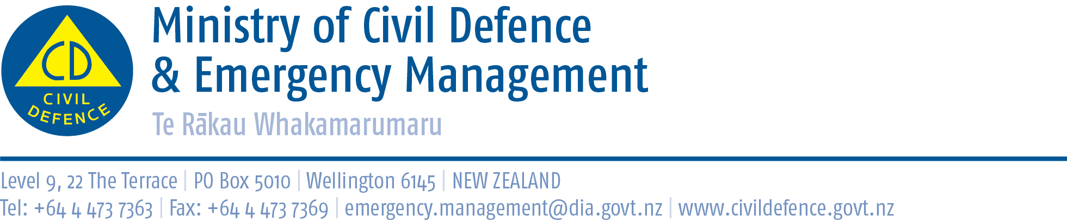

Media release 28 June 2013

Trial of compost toilets: When you have to go, you have to go!
An initial trial has shown that emergency composting toilets might be an alternative to port-a-loos and chemical toilets if sewerage lines are damaged or broken.
The Wellington Regional Emergency Management Office (WREMO) ran the four-week trial involving 11 Wellington households and workplaces. It is described in the June issue of the Ministry of Civil Defence & Emergency Management’s quarterly magazine, Impact.
The trail showed how emergency composting toilets can be used safely and successfully, and also identified areas where they may not be suitable.
Following the trial, WREMO is working with various agencies in the region to include compost toilets as an option in planning for sewerage disruption.
The “Report on a trial of emergency compost toilets” has been published by WREMO at http://www.gw.govt.nz/publications-2/
Other articles in Impact include:
- Manawatu-Wanganui Regional Council’s “State of environment” report
- Rotorua’s Youth in Emergency Services project
- WREMO introducing community-driven emergency management
- Thames Valley’s tsunami exercise
- Northland celebrating 10 years of civil defence emergency management
- Hawkes Bay tsunami evacuation drill at Clive
- Hawkes Bay trialling emergency warning signs that can display different messages
- South Island-wide earthquake exercise
- and many more.

Impact is available from the Ministry’s website at http://www.civildefence.govt.nz/memwebsite.nsf/wpg_URL/For-the-CDEM-Sector-Publications-Impact?OpenDocument

Media contact:

Ministry of Civil Defence & Emergency Management
Public Information Duty Officer,
Telephone: 04 494 6951
E-mail: pim@ncmc.govt.nz

Follow the Ministry on Twitter or subscribe to our RSS feed

 If a disaster happened now, would you be ready? www.getthru.govt.nz

