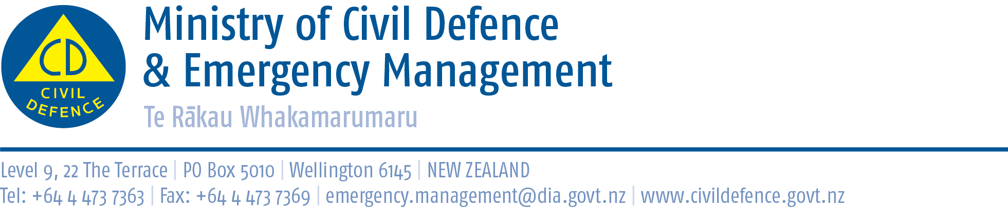

Media advisory 7 February 2013

To: Chief Reporter
News Editor
Chief of Staff
Bureau Chief, etc.

Thank you for your support after
Santa Cruz earthquake and Solomon Islands tsunami

I would like to thank media organisations for your support yesterday in advising New Zealand of the potential risk we faced after the Santa Cruz earthquake and the tsunami that hit the Solomon Islands.

Media play a key role in providing public information during potential and actual emergencies. Timely, professional reporting means more people get the necessary messages, faster. Yesterday, that is exactly what happened with the initial national advisory, then the more detailed, scaled-down, regional advisory, and finally with the cancellation.

Similar patterns will occur in most emergencies. The emergency will develop and change, and as we get more information we will change our view of the situation. We aim to quickly get information and updates to the public about what has happened, the response, and what the public should or should not do. Thank you for your engagement in that process.

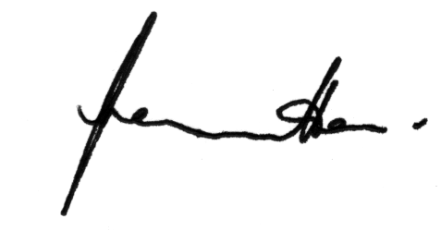
John Hamilton
Director of civil Defence Emergency Management

Media contact:
Public Information Duty Officer,
Telephone: 04 494 6951
E-mail: pim@ncmc.govt.nz

