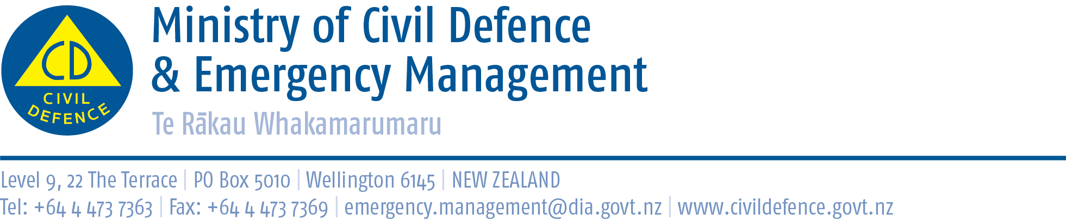

Media Release 20 December 2012

New Zealander returns from UN deployment in Philippines

Northland Civil Defence Emergency Management (CDEM) Group manager, Graeme MacDonald, returned last night from a two-week United Nations deployment in the typhoon ravaged Philippines.
The damage from Super Typhoon Pablo has been devastating, affecting almost 1 million people and hundreds of thousands of properties.
Mr MacDonald was deployed in Mindanao as part of a seven-strong United Nations Disaster Assessment Coordination (UNDAC) team. The team was part of the international response to the typhoon.
The UNDAC team carried out initial rapid needs assessments in the worst affected areas to gather information on the impact of the typhoon and needs of the affected population. The second phase of the mission focused on establishing three humanitarian hubs in Davao, Trento and Nubuturan to facilitate deliver of aid to those affected communities.
As of December 18, more than 1,040 people have died and 844 people are still missing. About 26,000 people remain in 63 evacuation centres. A further 960,000 people are outside of the centres staying in the ruins of their homes, open areas, or with host communities.
Power and telecommunications are still down in the worst hit municipalities of Cateel, Baganga and Boston in Davao Oriental province, and New Bataan and Maragusan in Compostela Valley.
An estimated 131,999 to 207,718 houses have been destroyed, 83 health facilities were destroyed and 253 damaged, and 592 schools have been damaged.
UNDAC teams are only deployed when requested by a government. Their role is to work with that country’s emergency management agencies and government to plan and manage international support.
Such teams are highly trained, able to deploy within 24 hours, and must be self-sufficient so they do not burden the country affected by the disaster. They provide their own telecommunications, shelter, food and other resources as needed.
The UNDAC team to the Philippines was made up of Mr MacDonald, two UN staff, and emergency management personnel from Denmark, Canada, Singapore and Thailand, and was supported by three specialist communications experts from Singapore.
Maintaining strong international links is one of the Ministry of Civil Defence & Emergency Management’s priorities. Few, and probably no, countries in the world can respond on their own to a major national disaster. The objectives of New Zealand’s international programme for CDEM are to:
- be a good global citizen by supporting countries facing major disaster, particularly our neighbours in the Pacific and Asia
- ensuring that should New Zealand ever need it, we would be able to receive international support quickly
- increase our own ability to respond in New Zealand by learning lessons from other countries and international exercises.

Mr MacDonald will be available for media interviews from 9.00am today.

Media contact:

Northland Civil Defence Emergency Management Group Manager
Graeme MacDonald
Mobile 0274 767978

Ministry of Civil Defence & Emergency Management
Public Information Duty Officer,
Telephone: 04 494 6951
E-mail: pim@ncmc.govt.nz

Follow the Ministry on Twitter or subscribe to our RSS feed

 If a disaster happened now, would you be ready? www.getthru.govt.nz

