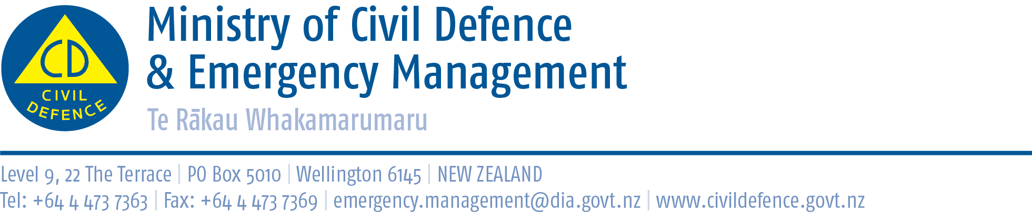

Media Release 2 October 2012

Huge response to New Zealand ShakeOut evaluation,
more staff needed to input information

So many New Zealand ShakeOut evaluation forms are being returned that GNS Science is hiring a group of students to input all the data.

The Director of Civil Defence Emergency Management, John Hamilton, said more than 1.3 million people were involved in New Zealand’s first ever nation-wide earthquake drill last Wednesday. After the drill people were asked to send observer forms to GNS Science, which is evaluating the campaign.

Already an estimated 5,000 forms have arrived, and they keep coming, most of them in the post!

“We decided to give people the option to reply by email, online, by fax or by post. It has surprised us that most of the replies are coming back by post,” Mr Hamilton said.

“Maybe there is a lesson here for others asking for public feedback. Give people as many options as possible and let them decide what is easiest to use.

“We are getting observer forms from small, medium and large businesses, embassies, schools, families – the whole range of people who took part. It’s a great response.”

GNS’s Social Science team is gearing up for long hours of data entry and number crunching.

“We are chuffed to bits with the response from the public and while it does mean a substantial and unexpected increase in work load, this is a very happy problem to have. More feedback means more robust and rich data analysis, which is very exciting,” Sara McBride, the New Zealand ShakeOut Evaluation Team Leader at GNS, said.

“This evaluation will tell us how people understood the ShakeOut message of ‘Drop, Cover, and Hold’. It can also tell us by sector, region, and business size how people performed and where the gaps are for future campaigns. We are the first ShakeOut to do observer research like this in the world and that makes it ground-breaking research.”

As far as we know, this is the biggest ‘observational research’ done in New Zealand. It is unusual to have so many people voluntarily observing an event, recording it and sending in their observations.

“I think it is a comment about how engaged so many people and organisations were in New Zealand ShakeOut,” Mr Hamilton said.

GNS Science expects to have completed a preliminary evaluation report by December.

Observation forms

Observation forms can still be sent in until October 26. Please send them to:
- https://www.surveymonkey.com/s/nzshakeout
- Email nzshakeoutobserv@gmail.com
- Fax 04 570 4600
- Post Attention: ShakeOut Evaluation, PO Box 30368, Lower Hutt.

Media contacts:

Ministry of Civil Defence & Emergency Management
Public Information Duty Officer,
Telephone: 04 494 6951
E-mail: pim@ncmc.govt.nz

GNS Science
Sara McBride
New Zealand ShakeOut Evaluation Team Leader
Telephone: 021 269 0312
E-mail: S.McBride@gns.cri.nz

Find out more about New Zealand ShakeOut at www.shakeout.govt.nz

Follow the Ministry on Twitter or subscribe to our RSS feed

 If a disaster happened now, would you be ready? www.getthru.govt.nz

