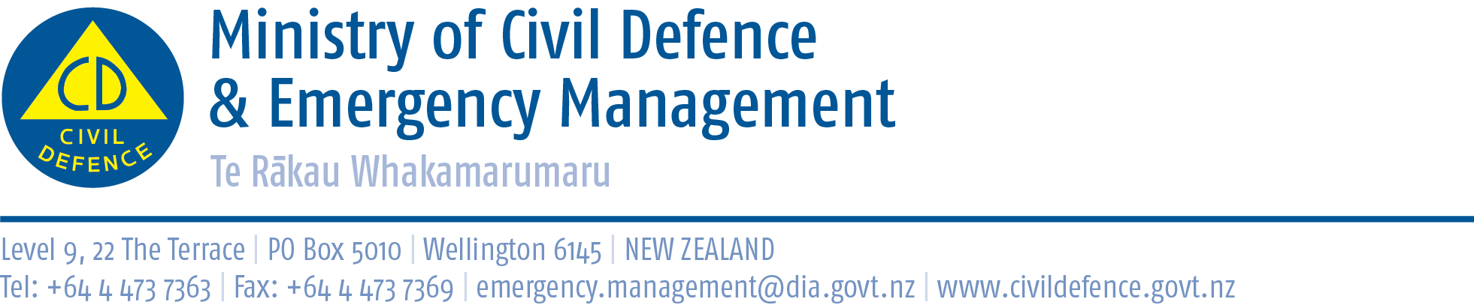

Media Release 26 September 2012
New Zealand ShakeOut, more than 1.3 million involved:
tremendous response continues

The Ministry of Civil Defence & Emergency Management is delighted with New Zealand’s tremendous response to our first ever national earthquake drill, New Zealand ShakeOut, and that response from schools, businesses, councils, people at home and media is continuing.

The Director of Civil Defence Emergency Management, John Hamilton, said within minutes of the drill people began sending observation forms, photos, emails and other feedback to the Ministry and GNS Science, which is evaluating the campaign.

“We have received more than 1,000 comments already,” Mr Hamilton said, “almost all, are positive.”

The most common question or criticism is there was no siren or alarm played publicly from town halls, fire stations and the like.

Mr Hamilton said this was a deliberate decision because of experience in California during the first Great California ShakeOut. There, public sirens caused confusion and many people thought they were real fire, tsunami or other alarms. From the beginning, organisations have been encouraged to look at what ways they could start the drill

Some of what happened around the country
- The drill was triggered in different ways that suited different organizations: voice commands, whistles, PA systems, playing the civil defence “sting”, even an air horn.
- One business explained the Drop, Cover and Hold drill to its staff in an email and told them: ‘Now I know what you're thinking, "Pft! they aren't actually going to make us do this are they?" WRONG! at 9:26am we're going to all take part in the drill and perform the steps listed above. The wardens for each area will be there to instruct you. It's five minutes of your time that could save your life in the event of a real earthquake. Anyone who takes the [word deleted] will be forced to remain in the hold position for an excruciating amount of time............I'm talking survivor style, limbs shaking, sweat beading, severe look of discomfort on your face........not fun. If you would like more information about the drill feel free to come and ask me or click on the link below.’
More of what happened around the country
- Fast food chains and some retailers did the Drop, Cover and Hold drill with staff and customers.
- A childcare centre near the coast tested is tsunami evacuation procedures for babies and toddlers.
- Thousands of schools did Drop, Cover and Hold earthquake drills, and some tested evacuations.
- Wellington Airport hosted a public drill involving a large crowd of airport, shop, café and other staff, local politicians and many members of the public.
- Several businesses had short staff meetings after the drill to discuss what happened and what was learned.
- At least one organisation timed a morning tea bake-off for after the drill.
- The Minister of Civil Defence, Chris Tremain, took part in the drill with a group of children from Reignier School in Napier who were visiting Parliament.
- Starting at 9:26am this morning, Te Aroha Community Hospital’s shut off its power, water and generator or 24 hours. It is testing, as realistically as possible, its emergency procedures, while continuing to care for patients and aged care residents. Food will be cooked on the hospital’s barbecues, water will come from the tanks on top of the boiler house, portaloos and chemical toilets will be used, and the night shift will work using LED lamps.

Your videos, pictures, stories etc

We would love to see your stories and pictures. They will be shared with others who took part and will be used for part of the evaluation of the campaign. Photos, You Tube videos and stories can be uploaded to www.shakeout.govt.nz/share. After they have been reviewed, they will be available for everyone to see.

Observation forms

GNS Science is evaluating the campaign. Please send your “observers’ result form” to: nzshakeourobserv@gmail.com; https://www.surveymonkey.com/s/nzshakeout; fax 04 570 4600; or post to Attention: ShakeOut Evaluation, PO Box 30368, Lower Hutt.

And you can still register

We know some organisations could not do the drill today and are taking part over the next few days. They can still register and do the drill for another two weeks until October 10. Go to http://www.shakeout.govt.nz/register/index.php

Media contact
Public Information Duty Officer
Telephone: 04 494 6951
E-mail: pim@ncmc.govt.nz

