

Media Release 24 September 2012
New Zealand ShakeOut only two days to go!
More broadcasters to play the sting at 9:26am Wednesday www.shakeout.govt.nz/broadcasters/

It is only two days to go until the start of our country’s national earthquake drill, New Zealand ShakeOut, and thousands of schools and workplaces, including shopping centres and national retail chains, and more than 1.2 million people are already involved.

The most common question they have been asking the National Coordinators is, “how will I start the drill?” While people are coming up with all sorts of ways to do that (including announcements on public address systems, messages pushed out onto everyone’s computers, bells, whistles and voice commands) the answer for many is, “listen to your radio or watch TVNZ”.

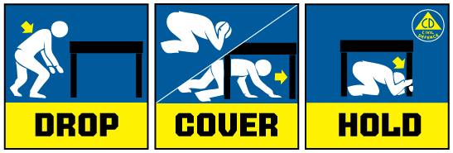
At 9:26am on Wednesday many radio stations throughout the country will broadcast a brief announcement that the drill is starting, they will then play the civil defence “sting”, and the announcers will talk people through the Drop, Cover and Hold drill for about 10 seconds. TVNZ will broadcast an earthquake drill live from Mt Eden Normal Primary School.

The New Zealand ShakeOut website has a growing list of broadcasters who will be playing the “sting”, with more are being added every day. See the list at www.shakeout.govt.nz/broadcasters/

Radio and television broadcasters, including those not playing the sting on Wednesday, are giving New Zealand ShakeOut great support. They are making programmes about emergency preparedness, playing interviews, reporting what is happening, having DJs remind people about the campaign, and playing advertising.

“Print and online media are getting behind the campaign too,” The Director of Civil Defence Emergency Management, John Hamilton said. “We are very grateful to the media. We would not have such a number of people involved without the great support we are getting.”

The civil defence ‘sting’

The civil defence ‘sting’ is an electronic sound that has been given to broadcasters to use before making an official civil defence emergency announcement.

Using it to trigger the start of New Zealand ShakeOut is a useful reminder to broadcasters, a message to the public about the significance of the sound, and a reminder that radio will be a key way of getting information after a major emergency.

International research, most recently after tragic bush fires in Australia, revealed that people often did not respond to evacuation and other official announcements because they “heard” them as if they were advertising.

However, where an alert was broadcast immediately before an official announcement people were much more likely to listen to it and act on it.

If you use the ‘sting’ for ShakeOut, you must follow these rules:
- The sting should only be used to signal that an official civil defence message will follow immediately.
- The sting must not be used for any purpose other than a civil defence warning or a civil defence drill. If it is used for other purposes, there is the risk that it will lose its value as an alert and people will ignore it in future.
- The sting must not be used as a siren or an alarm on its own. Without an announcement people will not know what they should do. It would not help but would, instead, cause confusion.
- When the sting is used for a drill, a statement must be broadcast immediately before the sting is sounded explaining that it is a drill and what kind of drill it is. For example, in the case of the New Zealand ShakeOut earthquake drill, the statement would explain that an earthquake drill was about to start and the sting would then sound for a few seconds. After the drill a statement should be broadcast that the drill has ended.

Media contact
Public Information Duty Officer
Telephone: 04 494 6951
E-mail: pim@ncmc.govt.nz

