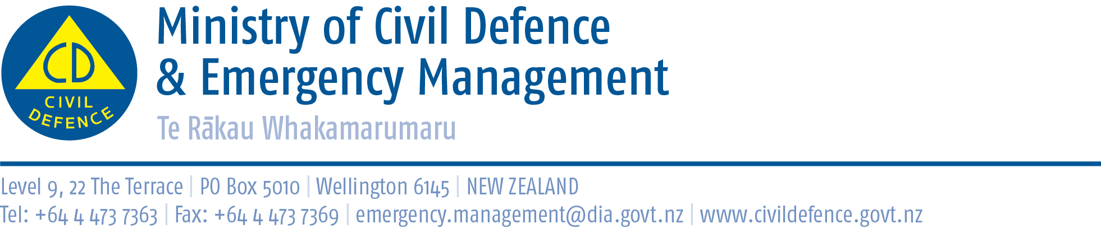

Media Release 19 September 2012

New Zealand ShakeOut, one week to go!
- More than 1.1 million people!
- Te Aroha Community Hospital’s awesome exercise
- What is happening in your region?

With one week to go until our first ever nationwide earthquake drill, New Zealand ShakeOut, Waikato’s Te Aroha Community Hospital might just be the most involved organisation in the country.

Starting at 9:26am next Wednesday, the hospital’s power and water will be shut off and its generator disconnected for 24 hours. It will test, as realistically as possible, its emergency procedures, while continuing to care for patients and aged care residents.

Te Aroha Community Hospital can take up to nine medical patients and 37 people in its adjacent aged care facility. It has a staff of around 60.

Food will be cooked on the hospital’s barbecues, water will come from the tanks on top of the boiler house, portaloos and chemical toilets will be used, and the night shift will work using LED lamps.

Nationally, more than 1.1 million people have already signed up and there is still time for more to join in. Read about what they are doing in the September issue of the quarterly civil defence magazine, Impact.

Copies of Impact can be downloaded from http://www.civildefence.govt.nz/memwebsite.nsf/wpg_URL/For-the-CDEM-Sector-Publications-Impact?OpenDocument

Other events and activities include:
- The New Zealand Breakers basketball team and the Auckland Council hosting an event at an inner city business.
- In Stratford, Taranaki, Adam and Allan Young are using their stockcar to promote the civil defence message.
- Marlborough supermarkets, Bunnings and Mitre 10 are hosting the regional civil defence group’s communications truck and holding competitions.
- In Greymouth the New World is supporting Grey District’s civil defence emergency management office.
- Clutha District civil defence emergency management staff are working with local schools and pre-schools, businesses and individuals.
- Waitaki District Council has been involving its local media and schools.
- The Wellington regions mayors and regional council chair have been strongly supporting New Zealand ShakeOut.
- The free booklet, Shut Happens, and the website www.resilientbusiness.co.nz have been developed to help small and medium sized businesses prepare for and recover from emergencies.
- The Minister of Civil Defence has given his backing and many central government agencies are involved.

Further information about New Zealand ShakeOut events in your region is available from the 16 regional coordinators.

Media contact
Public Information Duty Officer,
Telephone: 04 494 6951
E-mail: pim@ncmc.govt.nz\

