

Media Release 3 September 2012
New Zealand ShakeOut Update - We now have 1 million participants!

We are sooooooo excited!

This morning, on the second anniversary of the first Canterbury earthquake, we reached our goal of 1 million people for the Drop, Cover and Hold national earthquake drill.

Berhampore School in Wellington edged us over the mark :-)

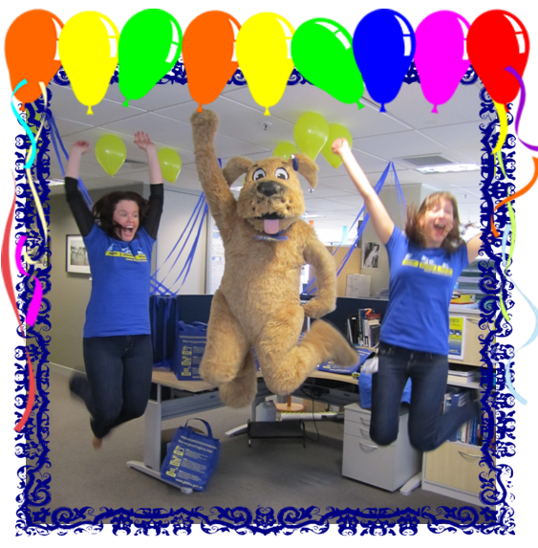
New Zealand ShakeOut National Coordinators Jo Guard and Anita Komen, and Stan the Dog, celebrate 1 million!

Our thanks go to all of you who are promoting the ShakeOut and encouraging people to sign up for New Zealand ShakeOut - you are doing an amazing job! Keep it up as we still have 3 weeks to go.

New Zealand ShakeOut is the world's first, nationwide ShakeOut campaign.

Our aim is to have 1 million people do the “Drop, Cover and Hold” earthquake drill at 9:26-26:9 (9:26am on 26 September 2012)!

The 9:26-26:9 earthquake drill is the focal point of New Zealand ShakeOut because it is a clear, simple action that people can take to help prepare themselves for an earthquake. It is also a first step, and it encourages people to look at their preparedness in more detail.

The drill is supported by a dedicated New Zealand ShakeOut website. The website is where individuals, families, community groups and organisations can sign up to participate and get information. It also includes a whole range of resources that you can use to help promote the campaign. You get to it from www.getthru.govt.nz

There is also a Facebook page http://www.facebook.com/NzGetThru ,Twitter account http://twitter.com/nzgetthru , paid radio, TV and on-line advertising, and promotional activity.

Crucial to the success of New Zealand ShakeOut is organisations and people joining and encouraging others to be involved. To help that happen, the campaign is working with businesses, local government, schools, central government agencies and other organisations.

It’s easy as 1, 2, 3!
- Sign up now – go to www.getthru.govt.nz (it takes only two minutes).
- Spread the word (share with friends, family and workmates via word of mouth, Facebook, Twitter, email and other methods).
- Do the drill Drop, Cover and Hold drill on 9:26-26:9.

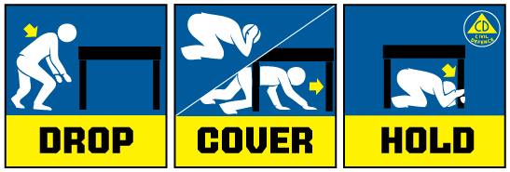

Media contact
Public Information Duty Officer,
Telephone: 04 494 6951
E-mail: pim@ncmc.govt.nz

