

Media Release 29 August 2012

Shut Happens!, the “sting”, new earthquake video, road signs and more than 920,000 people signed up for Zealand ShakeOut!

New Zealand’s first ever national earthquake drill, New Zealand ShakeOut, is exactly four weeks away, at 9:26am on September 26 (9:26-26:9).

As of today, more than 920,000 people have signed up - the target is to have 1 million people involved.

The Director of Civil Defence Emergency Management, John Hamilton, said the 9:26-26:9 earthquake drill is the focal point of New Zealand ShakeOut because it is a clear, simple action that people can take to help prepare themselves for an earthquake. It is also a first step, and it encourages people to look at their preparedness in more detail.

“It is fantastic to see the number of people signing up and the interest from right across New Zealand,” Mr Hamilton said.

Some of the initiatives that have come from New Zealand ShakeOut include:
- Shut Happens! Resilient Organisations has published a free resource for small and medium sized enterprises to help them plan to “get thru” an emergency.
- Many broadcasters are getting involved and will be broadcasting announcements to trigger the drill at 9:26-26:9. The “sting” is the civil defence alert played before an official civil defence announcement. You can listen to it at http://www.getthru.govt.nz/web/GetThru.nsf/web/BOWN-7GYTRQ?opendocument#Sting
- GNS Science has produced a new, three minute online video, New Zealand: Where two tectonic plates collide, explaining why earthquakes happen in New Zealand. http://www.youtube.com/watch?v=aQTfFCMYEI4
- New Zealand Transport Agency will use its electronic Variable Message Signs on urban, rural and regional roads to remind people about New Zealand ShakeOut.

All this and more, in the latest issue of the New Zealand ShakeOut newsletter http://www.civildefence.govt.nz/memwebsite.nsf/Files/Shakeout/$file/Shakeout-newsletter-August2.pdf

What is New Zealand ShakeOut?

New Zealand ShakeOut is the world's first, nationwide ShakeOut campaign.

Our aim is to have 1 million people do the “Drop, Cover and Hold” earthquake drill at 9:26-26:9 (9:26am on 26 September 2012)!

The drill is supported by a dedicated New Zealand ShakeOut website. The website is where individuals, families, community groups and organisations can sign up to participate and get information. It also includes a whole range of resources that you can use to help promote the campaign. You get to it from www.getthru.govt.nz

There is also a Facebook page http://www.facebook.com/NzGetThru ,Twitter account http://twitter.com/nzgetthru , paid radio, TV and on-line advertising, and promotional activity.

Crucial to the success of New Zealand ShakeOut is organisations and people joining and encouraging others to be involved. To help that happen, the campaign is working with businesses, local government, schools, central government agencies and other organisations.

It’s easy as 1, 2, 3!

- Sign up now – go to www.getthru.govt.nz (it takes only two minutes).
- Spread the word (share with friends, family and workmates via word of mouth, Facebook, Twitter, email and other methods).
- Do the drill Drop, Cover and Hold drill on 9:26-26:9.

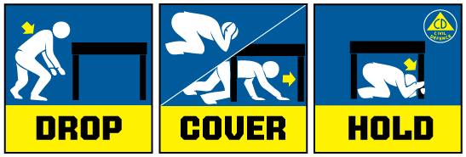

Media contact
Public Information Duty Officer,
Telephone: 04 494 6951
E-mail: pim@ncmc.govt.nz

