

Media Release 16 August 2012

750,000 participating national earthquake drill!

As of today, more than 750,000 people are participating in New Zealand’s biggest ever earthquake drill, New Zealand ShakeOut.

The Director of Civil Defence Emergency Management, John Hamilton said the aim is to have 1 million people do the “Drop, Cover and Hold” earthquake drill at 9:26-26:9 (9:26am on 26 September 2012)!

“With six weeks to the drill we are well on the way to our target but there is still a way to 1 million,” Mr Hamilton said.

Taking New Zealand’s population as 4.4 million, the target of 1 million is 23 percent of the population. Currently, 17 percent of the country has registered for New Zealand ShakeOut.

Crucial to the success of New Zealand ShakeOut is organisations and people joining and encouraging others to be involved. To help that happen, the campaign is working with businesses, local government, schools, central government agencies and other organisations.

The biggest category of registrations to date is schools, which is as expected. The second biggest is businesses.

“It is great to see businesses getting involved, with many of them looking at this as more than solely a drill. We have businesses looking at the earthquake safety of their buildings, planning and testing how they would operate after an emergency, and considering the safety of customers and visitors to their sites.”

The 9:26-26:9 earthquake drill is the focal point of New Zealand ShakeOut because it is a clear, simple action that people can take to help prepare themselves for an earthquake. It is also a first step, and it encourages people to look at their preparedness in more detail.

The drill is supported by:

• a dedicated website (get to it from www.getthru.govt.nz)
• Facebook page ( http://www.facebook.com/NzGetThru )
• Twitter account ( https://twitter.com/#!/nzgetthru)
• paid advertising and promotional activity
- a wide range of free resources that people can download and use themselves.

It’s easy as 1, 2, 3!

- Sign up now – go to www.getthru.govt.nz (it takes only two minutes).
- Spread the word (share with friends, family and workmates via word of mouth, Facebook, Twitter, email and other methods).
- Do the drill Drop, Cover and Hold drill on 9:26-26:9.

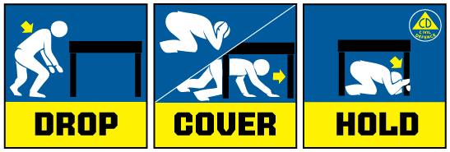

Media contact

Public Information Duty Officer,
Telephone: 04 494 6951
E-mail: pim@ncmc.govt.nz

