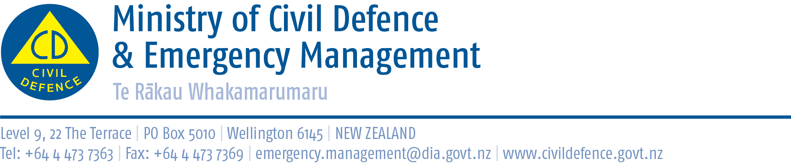

Media Release 29 July 2012

New multi-lingual radio ads start: “Drop, Cover, and Hold”

From tomorrow (Monday), people will hear new Drop, Cover and Hold earthquake preparedness ads on the radio - in six different languages.

The Director of Civil Defence Emergency Management, John Hamilton, said the advertising is part of New Zealand ShakeOut, a campaign to have 1 million people involved in an earthquake drill at 9:26-26:9 (9:26am 26 September).

As well as in English, the new ads will be broadcast in Samoan, Hindi, Cantonese, Mandarin and Korean. These are the languages with the largest groups of people for whom English is not their first language.

“We want as many people as possible to hear about New Zealand ShakeOut, to spread the word and to know that in an earthquake they should Drop, Cover and Hold,” Mr Hamilton said.

“Already, more than 560,000 have registered for New Zealand ShakeOut.

“Radio and TV advertising will build up closer to the day. We are also using social media, on-line advertising will start next week, and we are working directly with businesses, local government, schools, central government agencies and others to get them involved.

“We are well on the way but 1 million is a challenging target. Find out about New Zealand ShakeOut and get involved!”

Link to the resources page on the New Zealand ShakeOut website, please scroll down the page for MP3 versions of the new radio ads http://www.shakeout.govt.nz/resources/

New Zealand ShakeOut

New Zealand ShakeOut is a national campaign aimed at having 1 million people involved in an earthquake drill at 9:26-26:9 (9:26am 26 September). The drill is supported by:
• a dedicated website (get to it from www.getthru.govt.nz)
• Facebook page ( http://www.facebook.com/NzGetThru )
• Twitter account ( https://twitter.com/#!/nzgetthru)
• paid advertising and promotional activity.

It’s easy as 1, 2, 3!
- Sign up now – go to www.getthru.govt.nz (it takes only two minutes).
- Spread the word (share with friends, family and workmates via word of mouth, Facebook, Twitter, email and other methods).
- Do the drill Drop, Cover and Hold drill on 9:26-26:9.

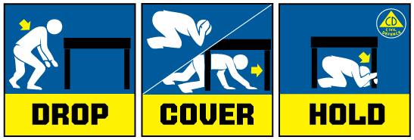

Media contact:
Public Information Duty Officer,
Telephone: 04 494 6951
E-mail: pim@ncmc.govt.nz

