

Media Release 24 July 2012

Not all bleaches are safe to use in stored drinking water

The Ministry of Civil Defence & Emergency Management has reviewed its advice about storing water for emergencies and has issued new, additional information.

The Director of Civil Defence Emergency management, John Hamilton, said the Ministry’s advice has been to add household bleach to stored water. That should still be done. However, with new products coming onto the market not all bleaches are safe to use in drinking water.

It is not safe to use bleaches that contain added scent or perfume, surfactants or other additives - they can make people sick. Surfactants will make the water foam or bubble when it is shaken or mixed. If the product's label is not clear about what has been added to the bleach, do not use the product for the safe storage of water.

Instructions for safely storing water
- Wash bottles thoroughly in hot water.
- Fill each bottle with tap water until it overflows.
- Add five drops of plain, household bleach per litre of water (or half a teaspoon for 10 litres) and put in storage. Do not drink for at least 30 minutes after disinfecting.
- Do not use bleaches that contain added scent or perfume, surfactants or other additives - they can make people sick.
- Label each bottle with dates showing when the bottles were filled and when they need to be refilled.
- Check the bottles every 12 months. If the water is not clear, throw it out and refill clean bottles with clean water and bleach.
- Store bottles away from direct sunlight in a cool dark place. Keep them in two separate places and where there is not likely to be flooding.

Mr Hamilton said the new advice came about after a member of the public asked the Ministry if bleach that included a surfactant could be used in stored, drinking water.

“We contacted a manufacturer of bleach and the Ministry of Health, both of whom willingly provided the information we needed to write new advice for the public.”
New Zealand ShakeOut – 1 million people involved in an earthquake drill!

At 9:26am on 26 September (9:26-26:9) New Zealand ShakeOut aims to have 1 million people in New Zealand do a “Drop, Cover and Hold” earthquake drill.
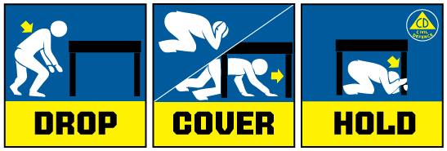
It will be the first ShakeOut earthquake drill held nationwide in the world and will be the biggest earthquake public education campaign ever staged in New Zealand.

The 9:26-26:9 earthquake drill is the focal point of New Zealand ShakeOut because it is a clear, simple action that people can take to help prepare themselves for an earthquake. It is also a first step, and it encourages people to look at their preparedness in more detail.

The drill is supported by:
• a dedicated website (get to it from www.getthru.govt.nz)
• Facebook page ( http://www.facebook.com/NzGetThru )
• Twitter account ( https://twitter.com/#!/nzgetthru)
• paid advertising and promotional activity.

It’s easy as 1, 2, 3!
- Sign up now – go to www.getthru.govt.nz (it takes only two minutes).
- Spread the word (share with friends, family and workmates via word of mouth, Facebook, Twitter, email and other methods).
- Do the drill Drop, Cover and Hold drill on 9:26-26:9.

Media contact

Public Information Management Duty Officer
Telephone: 04 494 6951
E-mail: pim@ncmc.govt.nz

