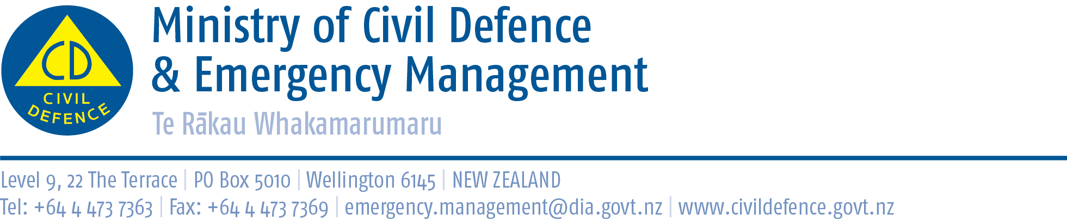

Media Release 16 July 2012

Mt Roskill Primary School a champion of preparedness

The latest issue of the Education Gazette features Mt Roskill Primary School as a champion of emergency preparedness. www.edgazette.govt.nz

The Director of Civil Defence Emergency Management, John Hamilton, said it is a credit to the school to see the Education Gazette highlighting its efforts to educate its children and their families about emergency preparedness and to be involved in the national earthquake drill, New Zealand ShakeOut, in September.

Each term the school has an emergency procedures practice and makes sure children have information to take home. Many of the school’s families are new to the country and English is their second language. The information their children bring home is an important part of the family’s and community’s learning about the hazards in the area and how to prepare for emergencies.

As well as practising emergency drills, awareness of natural disasters is highlighted through different curriculum activities. Children have studied the Auckland volcanic field, the Christchurch earthquake and the earthquake and tsunami that hit Japan.

Learning about natural disasters will continue and there will be a special focus on the topic in the lead up to New Zealand ShakeOut.

Students from the school, and also from Mt Eden Primary School, appear in the Ministry of Civil Defence & Emergency Management’s new earthquake preparedness television commercials.

The Education Gazette article has been distributed with this media release as a PDF file.

New Zealand ShakeOut

New Zealand ShakeOut is a national campaign aimed at having 1 million people involved in an earthquake drill at 9:26-26:9 (9:26am 26 September). The drill is supported by:
• a dedicated website (get to it from www.getthru.govt.nz)
• Facebook page ( http://www.facebook.com/NzGetThru )
• Twitter account ( https://twitter.com/#!/nzgetthru)
• paid advertising and promotional activity.

It’s easy as 1, 2, 3!
- Sign up now – go to www.getthru.govt.nz (it takes only two minutes).
- Spread the word (share with friends, family and workmates via word of mouth, Facebook, Twitter, email and other methods).
- Do the drill Drop, Cover and Hold drill on 9:26-26:9.

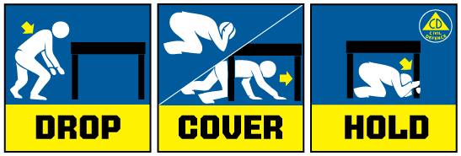

Media contact:
Public Information Duty Officer,
Telephone: 04 494 6951
E-mail: pim@ncmc.govt.nz

