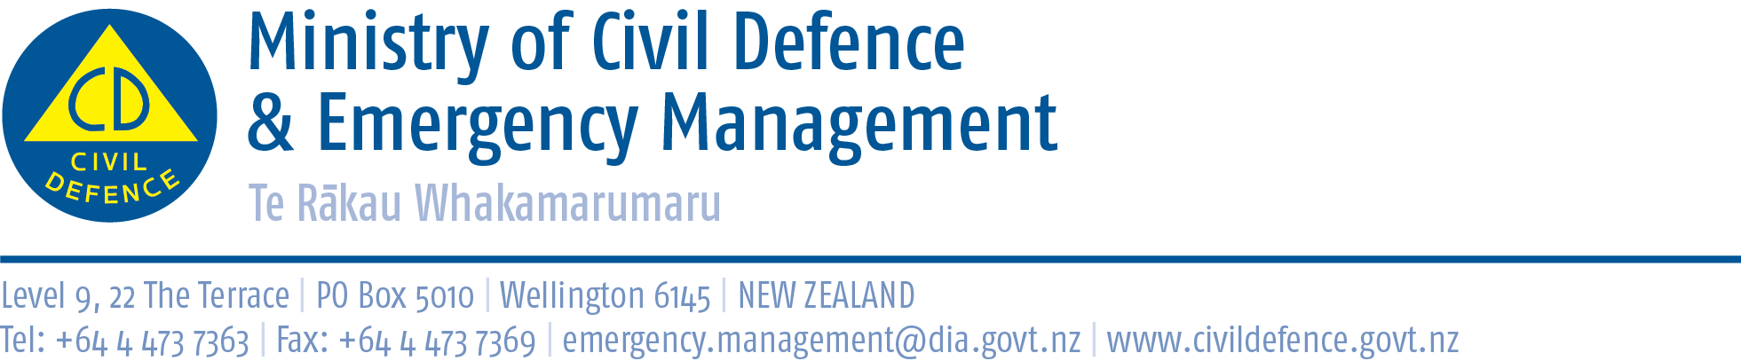

Media Release 4 July 2012

New website provides all regions’ earthquake hazard information

Last night’s earthquake off the coast of Taranaki showed all of New Zealand is prone to earthquakes.

For the first time one website now provides a way to easily access information about regional earthquake hazards across New Zealand. Go to http://www.shakeout.govt.nz/whyparticipate/ and select a region under “New Zealand earthquake hazards”.

The initiative is part of New Zealand ShakeOut, a campaign to have 1 million people involved in an earthquake drill at 9:26am 26 September (9:26-26:9).

The Director of Civil Defence Emergency Management, John Hamilton, said New Zealand earthquake hazards draws together information from the Ministry of Civil Defence & Emergency Management, GNS Science, the 16 regional Civil Defence Emergency Management Groups, and the local authorities that make up the Groups.

“We often receive questions from families, students and businesses asking about earthquake hazards in their area,” Mr Hamilton said. “New Zealand earthquake hazards will make it easier for them to find that information.

“Better understanding of a hazard is a step towards preparedness.”

As well as providing regional earthquake hazard information, each region’s page also links to the Get Thru website, which gives information that can be used throughout the country to prepare for emergencies, including earthquakes.
A word of caution – not all regions are equal, and people move

Mr Hamilton urged caution to people visiting New Zealand earthquake hazards and seeing their region faced lower earthquake hazards than others.

While earthquake hazard varies from region to region, all of New Zealand is prone to earthquakes. Also, New Zealanders are mobile. You could be anywhere when an earthquake strikes - at home, at work, at school or on holiday. Know what to do, Drop, Cover and Hold.

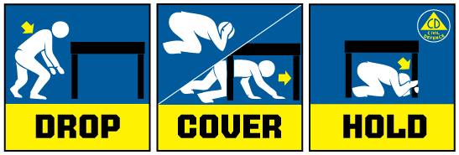
This advice has been reviewed by New Zealand and international researchers in light of the Canterbury earthquakes of 2010 and 2011 and is still: If you are inside a building, move no more than a few steps, then:
- DROP to the ground (before the earthquake drops you!),
- Take COVER by getting under a sturdy desk or table, and
- HOLD on to it until the shaking stops.

Stay indoors until the shaking stops and you are sure it is safe to exit. In most buildings in New Zealand you are safer if you stay where you are until the shaking stops.

New Zealand ShakeOut

New Zealand ShakeOut is a national campaign aimed at having 1 million people involved in an earthquake drill at 9:26-26:9 (9:26am 26 September). The drill is supported by:
• a dedicated website (get to it from www.getthru.govt.nz)
• Facebook page ( http://www.facebook.com/NzGetThru )
• Twitter account ( https://twitter.com/#!/nzgetthru)
• paid advertising and promotional activity.

Media contact:
Public Information Duty Officer,
Telephone: 04 494 6951
E-mail: pim@ncmc.govt.nz

