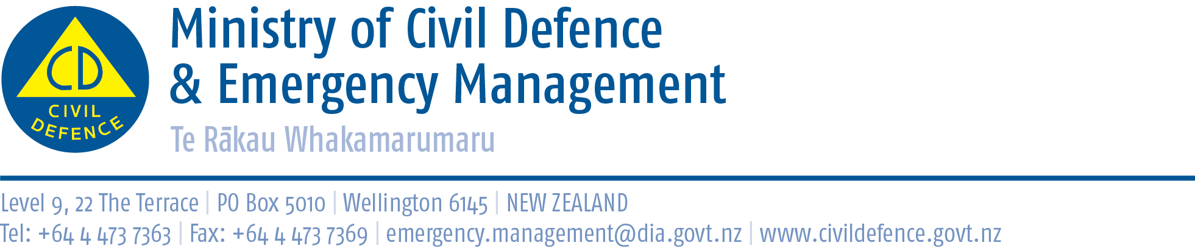

Media advisory 27 June 2012

Drop, Cover and Hold – the right thing to do in an earthquake Launch of new TV advertising and online videos

Media are invited to preview new television advertising and online videos that will begin screening on Thursday June 28.

Photo and interview opportunities
- The children featured in the advertising, from Roskill and Mt Eden Primary Schools.
- Peter Elliott, who fronts the national Get Ready campaign.
- Minister of Civil Defence, Chris Tremain.
- Four hundred children demonstrating the Drop, Cover and Hold earthquake drill.
- The new advertisements.

Venue and programme
Mt Roskill, Primary School, Frost Road, Mt Roskill, Auckland
Thursday 28 June 2012
1:45pm, junior school choir performs
2:00pm, Minister of Civil Defence, Chris Tremain, arrives
2.05 pm, speech from the Minister
2.10 pm, screening of the new TV advertisements and online video clips
2.20 pm, what the children say and earthquake drill - the children with Peter Elliott
2.30 pm, media interviews with the children featured in the advertisements
3.00 pm, finish

A DVD of the commercials and the extras reel will be available at the launch and also online.

The Drop, Cover and Hold campaign and New Zealand ShakeOut

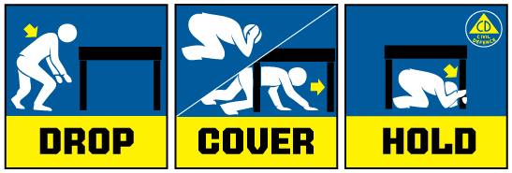

The campaign has two purposes, to address any confusion about the right actions to take in an earthquake and to help promote New Zealand ShakeOut.

Following the Canterbury and Christchurch earthquakes there was confusion around the right actions to take and images of people running outside as well as reports, incorrectly, suggesting you should not take cover under a table. The campaign reinforces the advice of the Ministry of Civil Defence & Emergency Management, GNS Science, EQC and the New Zealand Society for Earthquake Engineering. That is, Drop, Cover and Hold during an earthquake.

New Zealand ShakeOut is a national campaign aimed at having 1 million people involved in an earthquake drill at 9:26-26:9 (9:26am 26 September). The drill is supported by a dedicated website (get to it from www.getthru.govt.nz), Facebook page (http://www.facebook.com/NzGetThru), Twitter account (https://twitter.com/#!/nzgetthru), paid advertising and promotional activity.

The advertising features primary school children from Mt Roskill and Mt Eden Primary Schools in Auckland talking about what an earthquake is and what to do when an earthquake happens. They were filmed at Mt Roskill Primary School and the Ministry acknowledges the support provided by the school to enable the production. The spontaneous responses from the children are compelling and powerful and will, we believe, make the advertisements relevant and interesting to both young and adult audiences. The new ads also feature Peter Elliott who fronts our Get Ready campaign to ensure continuity.

Media contact:
Public Information Duty Officer,
Telephone: 04 494 6951
E-mail: pim@ncmc.govt.nz

