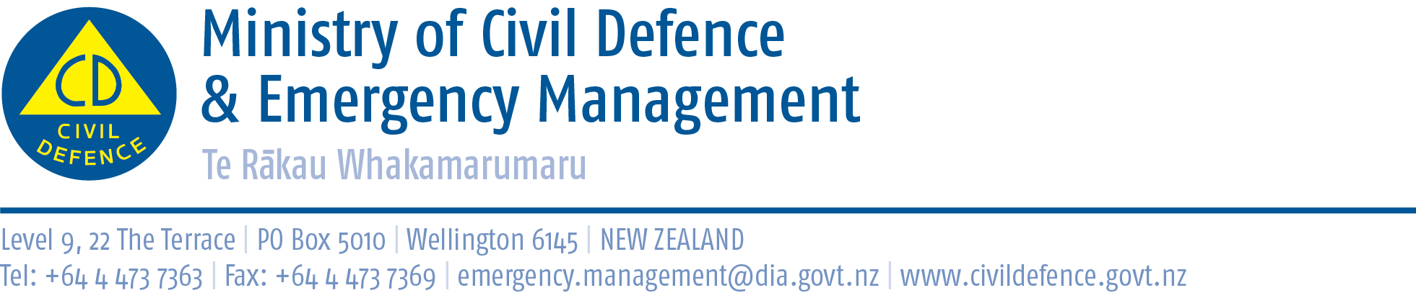

Media Release 29 March 2012

1 million people doing an earthquake drill at 9:26-26:9?

You can too!

At 9:26am on 26 September (9:26-26:9) New Zealand ShakeOut aims to have 1 million people in New Zealand do a “Drop, Cover and Hold” earthquake drill.

It will be the first ShakeOut earthquake drill held nationwide in the world and will be the biggest earthquake public education campaign ever staged in New Zealand.

The six month campaign started today at Owhiro Bay School in Wellington, where the Minister of Civil Defence, the Hon. Chris Tremain, launched the New Zealand ShakeOut website – get to it through www.getthru.govt.nz . This is where people, businesses and other organisations can receive a range of information on earthquakes, preparedness and the Drop, Cover and Hold drill, and register for New Zealand ShakeOut.

New Zealand ShakeOut will gain momentum over time. The website was launched today, a Facebook page and Twitter account will be launched soon and there will be advertising on radio and TV. Many promotional activities are being organised around the country – all leading up to the nationwide earthquake drill.

The Director of Civil Defence Emergency Management, John Hamilton said, “if there is one key message for people to take from today’s launch it is that New Zealand ShakeOut is for everyone in New Zealand. We need to know what to do in an earthquake, and practice it as our nationwide earthquake drill. Drop, Cover and Hold is the right action to take in an earthquake.

“It is very appropriate to hold the launch at a school. We know that children take home to their families the emergency preparedness lessons they learn at school. The Ministry of Education is supporting that by encouraging all schools in the country to participate in New Zealand ShakeOut by doing a Drop, Cover and Hold drill at 9:26-26:9.

“It is important for businesses and workplaces to be involved too – earthquakes can happen at any time. That is why the drill is timed for a weekday morning when people will be going about their normal day to day business.

“Councils and mayors are crucial players. They are our communities’ leaders and are connections into businesses, community groups and families.

“I am delighted that Kapiti Coast Mayor Jenny Rowan was at the launch today representing all the Wellington region’s mayors. Ms Rowan, and other mayors and councils around the country, will be encouraging all the organisations they work with, and their own councils, to Drop, Cover and Hold at 9:26-26:9.

“Central government has a role too, doing the drill at work, encouraging staff to prepare at home, and ‘sharing the ShakeOut’ with the organisations and people they work with.

“New Zealand ShakeOut is for everybody, at home, school, work, on holiday, wherever we might be at 9:26-26:9.”

More information about New Zealand ShakeOut

Samples of some of the information available from the New Zealand ShakeOut website were included in the media pack at the launch today. They are available from the media archive on the Ministry’s website http://www.civildefence.govt.nz/memwebsite.nsf/wpg_URL/Media-Media-release-archive-Index?OpenDocument

Media contact:
Vince Cholewa
Public Information Manager
Telephone: 04 494 6951
E-mail: pim@ncmc.govt.nz

Follow the Ministry on Twitter or subscribe to our RSS feed

 If a disaster happened now, would you be ready? www.getthru.govt.nz

