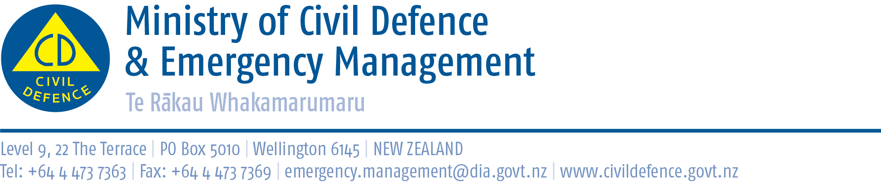

Media Release 7 March 2011

Japan – New Zealand disaster management collaboration

Top Japanese scientists and senior government officials arrive in New Zealand tomorrow (Thursday) to share Japanese and New Zealand disaster management expertise.

The Director of Civil Defence Emergency management, John Hamilton, said they will take part in a three-day workshop in Wellington and Christchurch which aims to identify projects of practical use to the recovery in Tohoku prefecture in Japan and Christchurch.

The workshop finishes with an inspection of the Christchurch CBD on Saturday – on the eve of the one-year anniversary of the devastating earthquake and tsunami in Tohoku. The workshop is a joint initiative of the Japanese and New Zealand Ministries of Foreign Affairs and New Zealand’s Ministry of Civil Defence and Ministry of Science and Innovation.

Mr Hamilton said the event also has a wider aim of encouraging collaboration between Japanese and New Zealand, universities, research institutes and other science agencies.

“Both our countries suffered major natural disasters last year,” Mr Hamilton said. “We have a lot to offer and to learn from each other.

“Our common aim is to make our own countries safer and more resilient, and also to share the hard lessons we have learned to help others.”

The scientists will work in three groups, with the flexibility to look at other topics if the opportunity arises. The planned working groups will look at soil behaviour in earthquakes, the interaction of soil and structures in earthquakes, and recovery and reconstruction.

This year is the 60th anniversary of diplomatic relations between the two countries, and the seminar is one of a range of bilateral engagements planned.

Japanese Attendees

Participants:
- Associate Professor Norio Maki (Disaster Prevention Research Institute, Kyoto University)
- Professor Masato Motosaka (Earthquake Disaster Research Laboratory, Tohoku University)
- Professor Ikuo Towhata (University of Tokyo).

Observers:
Japanese Embassy and Foreign Ministry staff.

New Zealand Attendees

Participants:
Representatives from the University of Auckland, University of Canterbury and Massey University.

Observers:
Staff from the Ministry of Civil Defence & Emergency Management, Canterbury Earthquake Recovery Authority, Department of Building and Housing, GNS Science, Scion Research, NIWA, the Ministry of Science and Innovation and the Ministry of Foreign Affairs and Trade.

Media opportunity

Friday March 10, 12:30pm to 1pm, Ministry of Science and Innovation, level 3, 33 Bowen Street, Wellington.

Media contact:
Vince Cholewa
Public Information Manager
Telephone: 04 494 6951
E-mail: pim@ncmc.govt.nz

Follow the Ministry on Twitter or subscribe to our RSS feed

 If a disaster happened now, would you be ready? www.getthru.govt.nz

