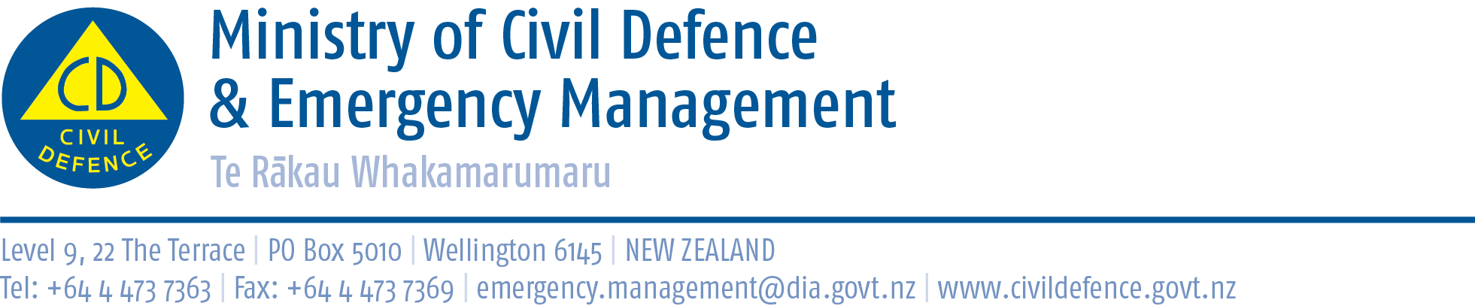

Media Release 23 August 2011

Lessons for United States and New Zealand from Kiwi schools teaching about disasters

There are lessons for both the United Sates and New Zealand from the way Kiwi primary and intermediate school children are taught how to prepare for disasters.

Ian Axford (New Zealand) Fellow, Victoria Johnson, has spent seven months studying New Zealand schools’ disaster preparedness programme What’s the Plan Stan? Ms Johnson worked in New York City’s Office of Emergency Management during the 9/11 response and recovery and was Policy Director of the United States National Commission on Children and Disasters, which presented its final report to President Obama in October last year.

Ms Johnson was hosted in New Zealand by the Ministry of Civil Defence & Emergency Management and supported by the Massey University Joint Centre for Disaster Research.

“The key finding for New Zealand is we have a good teaching resource that too many schools do not use,” the Director of Civil Defence Emergency Management, John Hamilton said.

“Teachers who know about it like it and describe the teaching materials as ‘child-friendly, flexible, informative, well organised and beneficial’. Some said that as well as helping children, the programme had helped teachers, parents and their greater community.”

“Now that we have this research we will work with the Ministry of Education and civil defence staff at city and district councils to help us plan how to better encourage schools and support teachers to use What’s the Plan Stan?

“With the feedback we have received, it would be a great shame for a good programme to not be used more widely in our schools,” Mr Hamilton said.

In the United States the Federal Emergency Management Agency and Department of Education are currently considering strategies to reach children and youth through disaster preparedness in schools and extracurricular activity.
For them, What’s the Plan Stan? shows the merit of a nationally consistent programme developed by working closely with teachers, and education and emergency management authorities. It also shows that even a well developed programme needs further, continuing support so that teachers are encouraged and helped to use it in their already busy timetables.

Copies of Ms Johnson’s research
Ms Johnson’s report, Disaster Preparedness Education in Schools: Recommendations for New Zealand and the United States, has been published by Fulbright New Zealand and is available from http://www.fulbright.org.nz/voices/axford/2011_johnson.html
What’s the Plan Stan? website www.whatstheplanstan.govt.nz

Ian Axford (New Zealand) Fellowships
Established by the New Zealand Government in 1995 to reinforce links between New Zealand and the United States, Ian Axford (New Zealand) Fellowships in Public Policy provide opportunity for outstanding mid-career professional from the United States to gain firsthand knowledge of public policy in New Zealand, including economic, social and political reforms and management of the government sector.

The Fellowships were named in honour of Sir Ian Axford, an eminent New Zealand astrophysicist and space scientist who was patron of the fellowship programme unit his death in March 2010.

Lessons saved lives
Wellington school girl, Abby Wutzler, 10, was holidaying with her family at Litia Sini Beach Resort at Lalomanu when the quake and tsunami struck on 30 September 2009. She ran the length of the beach yelling that the sea was going out and a tsunami was coming, alerting her family and other holidaymakers to head for higher ground. One of the first things the family did when they got home was to contact Kay Mudge, the Makara Model School teacher who had taught Abby about tsunami, to thank her. "I feel so incredibly proud of her. I feel that all that work I do was worth it because of this," Mrs Mudge said.

Media contact
Ministry of Civil Defence & Emergency Management
Public Information Duty Officer,
Telephone: 04 494 6951
E-mail: pim@ncmc.govt.nz

Follow the Ministry on Twitter or subscribe to our RSS feed

 If a disaster happened now, would you be ready? www.getthru.govt.nz

