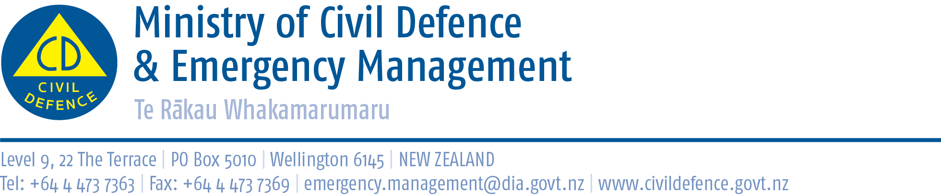

Media Release 20 January 2011

Civil defence response team returns from Queensland floods

New Zealand’s civil defence response team returned today from the Queensland floods.

“This was the first time a New Zealand civil defence response team has been deployed overseas, and they have performed exceptionally well,” the Director of Civil Defence Emergency Management, John Hamilton said today.

“They have been thanked and praised by the people and families they helped, the emergency services they worked with, and Australian local, state and federal governments.

“They are a credit to themselves, their team and to New Zealand.”

Mr Hamilton said that the families and friends of the team also deserve praise.

“Team members have told us that support from home has been invaluable and greatly appreciated. It lifted their spirits and helped them keep going through long days of physically and emotionally draining work.

“They have been working amongst loss and devastation. At times they were giving support and hope to people who had been overwhelmed and were on the brink of giving up.

“Team members have said that it was a most humbling and rewarding experience to help those people start recovery and to see them smile again.”

Summary of activities

The team deployed to Brisbane on January 8 from where it was assigned to the Condamine area. There they were divided in to smaller teams tasked with supporting families returning to their home after being evacuated for several days.

The team was later moved to Miles and Dalby, and then on to Brisbane from where they performed similar tasks in the urban suburbs of Lowood (Ipswich) and Newmarket (Brisbane) as well as assisting with setting up civil defence headquarters in the affected areas, task management and establishing communications.

The range of skills that a response team like this brings was no less evident when a member fixed a State Emergency Services boat that broke down!

The team was stood down on Wednesday night. Yesterday was spent debriefing with the State authorities and cleaning equipment to comply with MAF regulations when entering back into New Zealand. Special arrangements have been made with MAF and Customs to receive the team today.

Second team stood down

A second response team was on stand-by to replace the first. On Monday Queensland authorities confirmed that, with the improving situation and deployment of Australian defence force personnel and thousands of volunteers, the second team would not be needed in that state.

The team remained on stand-by in case they were needed in New South Wales and Victoria. Yesterday, Australian authorities confirmed that those states will not need overseas support.

Media contact:
Public Information Duty Officer,
Telephone: 04 494 6951
E-mail: pim@ncmc.govt.nz

Follow the Ministry on Twitter or subscribe to our RSS feed

 If a disaster happened now, would you be ready? www.getthru.govt.nz

