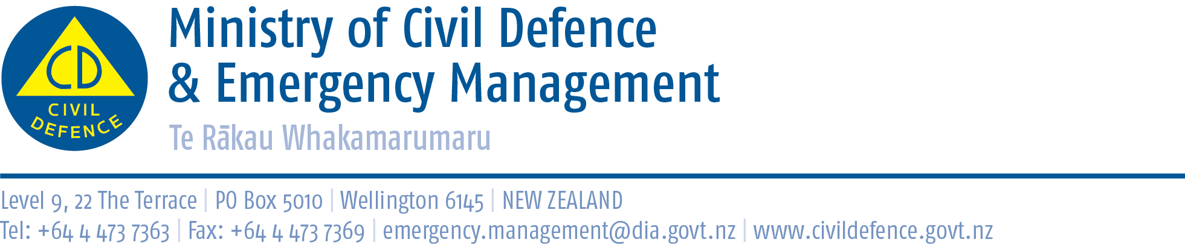

Media Release 12 January 2011

NZ Response Team stood down for the day

Members of the 15-strong New Zealand Civil Defence Response Team assisting with flood relief in Queensland have been stood down today for a well-earned rest.

The team, operating in hot, humid conditions, has been undertaking physically demanding work relocating the contents of entire households to avoid water damage following severe flooding in the area of Condamine.

Team Leader, Shane Biggs, explained that Queensland State Emergency Services operate a three-day on, one day off regime for emergency workers.

“Australian emergency workers are often sent home following three days of service. As we’re likely to be here until 22 January, we’re using this down time to undertake equipment maintenance” said Shane.

Team members have been encouraged by the strong community support extended to them by the residents of Miles, 30km north of Condamine where the team was originally based.

“The presence of the New Zealand team members in the town has had an extremely positive impact on residents” said Shane. “We feel were doing what we’ve trained for and this has really boosted morale.”

It is likely the team will remain in the area around Condamine, however the final decision on where they work next rests with Emergency Management Queensland.

The Red Cross has set up a phone number for New Zealanders concerned about the welfare of relatives in Queensland: 0061 39328 3991. Information is also available on www.redcross.org.au

Media contact for the Response Team:
Public Information Duty Officer,
Telephone: 04 494 6951
E-mail: pim@ncmc.govt.nz
Follow the Ministry on Twitter or subscribe to our RSS feed
 If a disaster happened now, would you be ready? www.getthru.govt.nz

