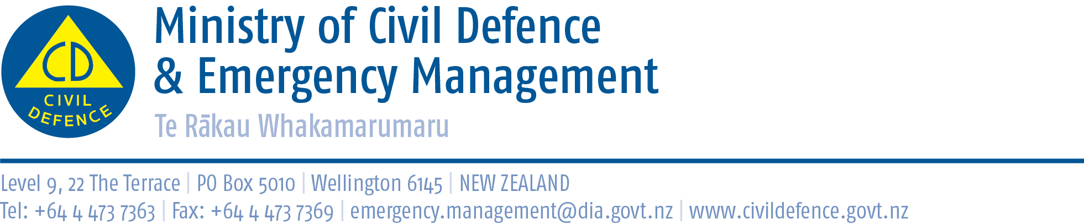

Media Release 11 January 2011

NZ Response Team return to Condamine

Additional flooding in the Queensland town of Condamine has resulted in the New Zealand Civil Defence Response Team returning to help residents cope.

Late last night the team had relocated to Miles, about 30km north of Condamine, having completed its work in Condamine. However further heavy rain in the area has caused additional flooding in the already badly-affected town.

The team, comprising 15 emergency personnel from around the country, is now working alongside Australian emergency management staff to help relocate the worst-affected Condamine residents to Miles.

The Director of Civil Defence Emergency Management, John Hamilton, said that at present access from the west to Toowomba and Brisbane is cut by flooding but “our team is safe and in good spirits”.

The New Zealand team is assigned tasks by the Queensland state authorities and Mr Hamilton expects the team to be involved in helping the clean-up in the Dalby and Toowomba area during the coming days.

The team is expected to remain in Queensland until 22 January.

Media contact for the Response Team:
Public Information Duty Officer,
Telephone: 04 494 6951
E-mail: pim@ncmc.govt.nz

Follow the Ministry on Twitter or subscribe to our RSS feed
 If a disaster happened now, would you be ready? www.getthru.govt.nz

