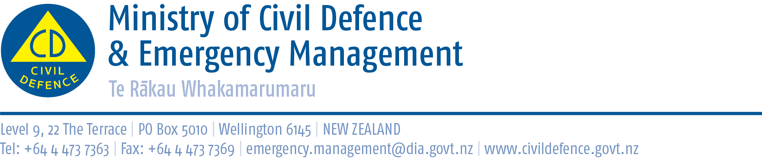

Media release 23 December 2010

New Zealanders more aware and better prepared?

The Director of Civil Defence Emergency Management, John Hamilton, said that, anecdotally, New Zealanders seem to be more aware and better prepared after a year of emergencies and disasters here and overseas.

“After the Canterbury earthquake retailers around the country reported increased demand for survival items like non-perishable food, torches, and first aid kits,” Mr Hamilton said.

“We have been told that Canterbury stores sold 19,000 battery-powered radios after the earthquake.

“After emergencies overseas and particularly after those that hit New Zealand, we see spikes in visitors to our websites and our staff receive many more calls and emails asking for information.

“I sincerely hope the measures that people have taken will not be tested over the holidays and we all have a safe, uneventful Christmas and New Year.”

Advice for the holidays

If you are going away for the holidays, plan ahead for what you would do if you were in your car should a disaster strike. In some emergencies you may be stranded in your vehicle for some time. A flood, storm or major traffic accident could make it impossible to proceed.

- Consider having essential emergency survival items in your car.
- Store a pair of walking shoes, warm clothes, waterproof jacket, essential medicines, snack food, water and a torch in your car.
- When planning travel, keep up to date with weather and road information.

Before going away on holiday find out about the possible hazards in the area you will be visiting. If you are holidaying in a coastal area ask for information on evacuation routes and local warning arrangements for tsunami. Know what radio stations to tune in to in the area for civil defence announcements

Information for the public

- Getting prepared: www.getthru.govt.nz
- Weather: www.metservice.com
- State highways: www.nzta.govt.nz then click on “highway information”
- Local roads: contact the local city or district council
- Radio: In case of emergency, find a radio station broadcasting civil defence information and stay tuned to it.
- Local emergency information: contact the local city or district council
- National emergency information: www.civildefence.govt.nz

Media contact
Public Information Duty Officer,
Telephone: 04 494 6951
E-mail: pim@ncmc.govt.nz

Follow the Ministry on Twitter or subscribe to our RSS feed

 If a disaster happened now, would you be ready? www.getthru.govt.nz

- ENDS -

