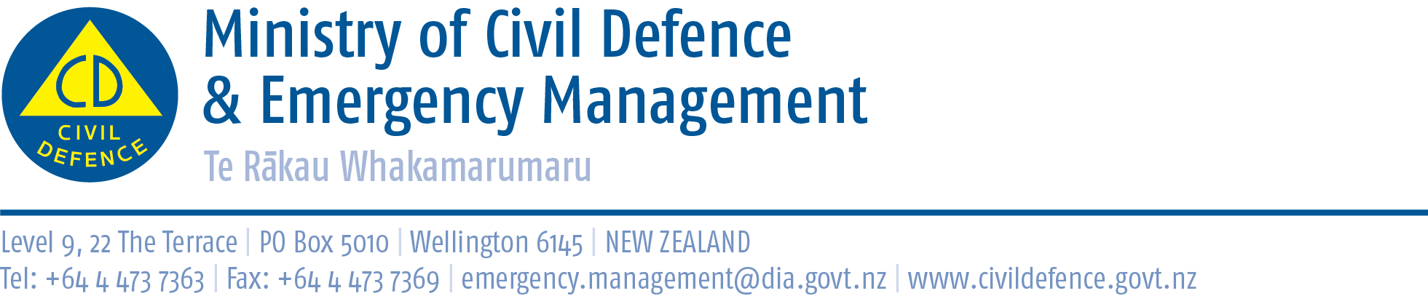

Media Release 11 December 2010

Civil defence memorandum includes 24/7 contact with U.S.A

The Ministry of Civil Defence & Emergency Management and the United States Federal Emergency Management Agency (FEMA) today signed a memorandum of cooperation that includes 24/7 contact between the agencies.

The memorandum was signed in Washington D.C. this morning New Zealand time by New Zealand’s Ambassador to the United States, the Right Honourable Mike Moore, and the Secretary of the United States Department of Homeland Security, Janet Napolitano.

While our countries have offered each other assistance in the past, the memorandum formalises arrangements between New Zealand and United States emergency management agencies.

The memorandum with FEMA is similar to the formal administrative arrangement the Ministry signed with the Attorney-General’s Department of Australia in May 2009. Emergency management is one of the functions of the Attorney-General’s Department.

“Few, if any, countries in the world can respond on their own to a national disaster,” the Director of Civil Defence Emergency Management, John Hamilton, said.

“Given our hazards and geographical isolation it is important that we have strong relationships that help us manage risks and seek assistance in a major disaster. Having the relationships, knowing how to immediately contact each other and understanding how to work together are crucial to a speedy, well-directed response. The bigger the disaster, the more important the prior-arrangements and planning become.

“The memorandum with FEMA is not only about better response to a disaster. It is also about sharing information, expertise and experiences to help reduce risks and improve readiness.”

Summary of memorandum

In summary, the purposes of the memorandum are to:

- strengthen disaster resilience and reduce risk in New Zealand and United States communities
- enhance response and recovery in both New Zealand and the United States.

The memorandum involves the Ministry and FEMA agreeing to:

- exchange and update emergency contact details, including 24/7 contact points
- create a schedule of regular exchanges of information through teleconferences and in-person meetings, where feasible
- share lessons learned from disasters and exercises
- arrange for response observation, where feasible, after disasters
- exchange information about assistance to disaster response in other countries
- facilitate participation in conferences, workshops and exercises
- exchange information on best practices in emergency management
- consider opportunities for joint research on emergency management
- coordinate multi-lateral relationships on issues of common interest in the Pacific region.

Media contact

Ministry of Civil Defence & Emergency Management
Public Information Duty Officer
Telephone: 04 494 6951
E-mail: pim@ncmc.govt.nz

Follow the Ministry on Twitter or subscribe to our RSS feed

 If a disaster happened now, would you be ready? www.getthru.govt.nz

