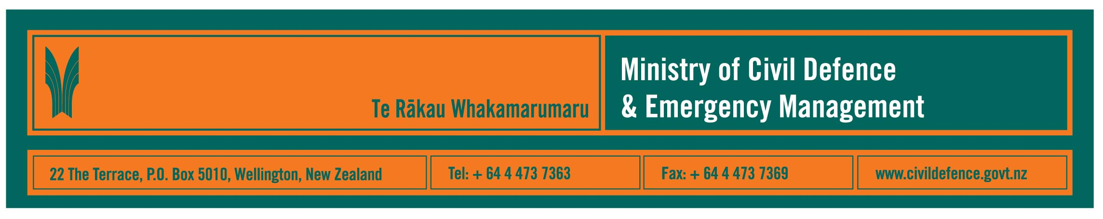

Media Release 18 October 2010

Exercise Tangaroa to test national civil defence response

New Zealand’s ability to respond to a warning of a potentially destructive tsunami will be tested by Exercise Tangaroa on Wednesday, 20 October 2010.

The Director of Civil Defence Emergency Management, John Hamilton, said more than 100 agencies will be taking part in the nationwide exercise.

The national Tsunami Advisory and Warning Plan has been updated and the new plan, which was published in the last fortnight, will be used in the exercise.

Mr Hamilton said that the biggest change in the plan is that with new scientific modelling threat indications can now be provided for 43 coastal zones when tsunami warnings are issued by the Ministry.

“Previously we have not had the science to give this important regional detail,” Mr Hamilton said. “It is the result of research and modelling done by GNS Science for the Ministry. It is a good example of how science can help response to an emergency.”

Note: In case of a real tsunami people need to know that the largest expected wave is not always the first to arrive. Waves are likely to continue for many hours, often getting larger and higher.
Also, the 43 zones are regional. Waves within a zone will vary up to the expected maximum. Local and regional civil defence organisations still have to use their local knowledge to decide appropriate response.

Exercise background

Exercise Tangaroa is led by the Ministry and will be supported by all 16 regional civil defence emergency management groups, most of the country’s local authorities, central government departments, emergency services, science agencies, welfare organisations, utilities, the transport sector and some media.

The exercise will be run in real time, beginning with a simulated Pacific Tsunami Warning Centre (PTWC) bulletin that an earthquake off the coast of South America may have generated a major tsunami.

National warnings, clearly labelled “Exercise Tangaroa message only”, will be issued by the Ministry to activate the participants and the National Crisis Management Centre beneath the Beehive. The exercise will end when the tsunami reaches New Zealand at 7pm.

Tangaroa is the god of the sea, rivers, lakes and all life within them.

Links to documents

- Tsunami Advisory and Warning Plan (see page 11 “Further assessment for national warnings” for regional threat forecasts
http://www.civildefence.govt.nz/memwebsite.NSF/wpg_URL/For-the-CDEM-Sector-Publications-National-Tsunami-Advisory-and-Warning-Plan?OpenDocument
- general information about Exercise Tangaroa
http://www.civildefence.govt.nz/memwebsite.nsf/wpg_URL/For-the-CDEM-Sector-CDEM-Exercises-Exercise-Tangaroa?OpenDocument

Media contact:
Public Information Duty Officer,
Telephone: 04 494 6951
E-mail: pim@ncmc.govt.nz
www.civildefence.govt.nz

Follow the Ministry on Twitter or subscribe to our RSS feed

 If a disaster happened now, would you be ready? www.getthru.govt.nz

- ENDS -

