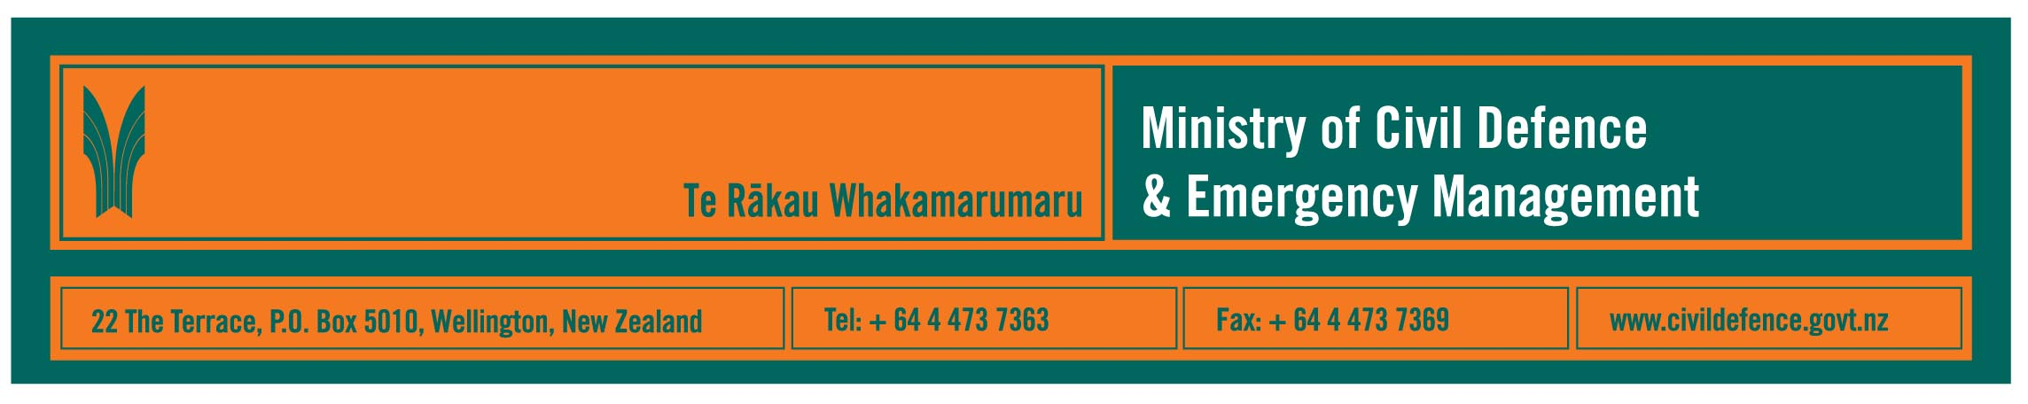

Media Release 12 October 2010

Volcanic Eruption in Auckland, 8:30pm tomorrow

Eruption screens on TV3 at 8:30pm tomorrow. It is a New Zealand-made drama that follows several Auckland families in the days before a volcanic eruption in their city.

The Director of Civil Defence Emergency Management, John Hamilton, said, while Eruption is a drama, the science that drives it is real and the wider messages about preparedness for disasters are relevant to all the country.

The show’s producers, Gibson Group, worked with the Ministry of Civil Defence & Emergency Management, GNS Science, the University of Auckland and civil defence organisations in Auckland in developing the script.

For Auckland, the warning signs of volcanic unrest shown in Eruption are realistic – the volcanic field is closely monitored, and scientists and civil defence officials would be able to provide early warning if magma began moving towards the surface, again.

Likewise, the other areas of New Zealand living with volcanoes – Taranaki, the central North Island and Bay of Plenty – are closely monitored and the precautions people need to take are similar.

“On a national level, watching a preview of Eruption last week reinforced for me that there are steps we can all take to be better prepared for any natural disasters,” Mr Hamilton said.

“We need to have a household emergency plan, including what we will do when we are not at home, and to have stored enough food and water to last three days or more.

“A disaster will damage roads, railways, bridges and other infrastructure; it will affect emergency services and civil defence staff; and access will be limited. That is when we will be most vulnerable and must be prepared to help protect ourselves, our loved ones and our communities.

“Watch and enjoy Eruption as a drama,” Mr Hamilton said, “but also think about what it says about our preparedness for disasters.”

Media contact
Public Information Duty Officer,
Telephone: 04 494 6951
E-mail: pim@ncmc.govt.nz

Useful websites

- www.getthru.govt.nz information about emergency preparedness
- www.geonet.org.nz reports of earthquakes, volcanoes, landslides and tsunami
- www.civildefence.govt.nz the Ministry’s website is frequently updated during major emergencies
- the civil defence pages on your local council’s website should give you specific local information key local contacts in case of civil defence emergency.

Follow the Ministry on Twitter or subscribe to our RSS feed

- END -

