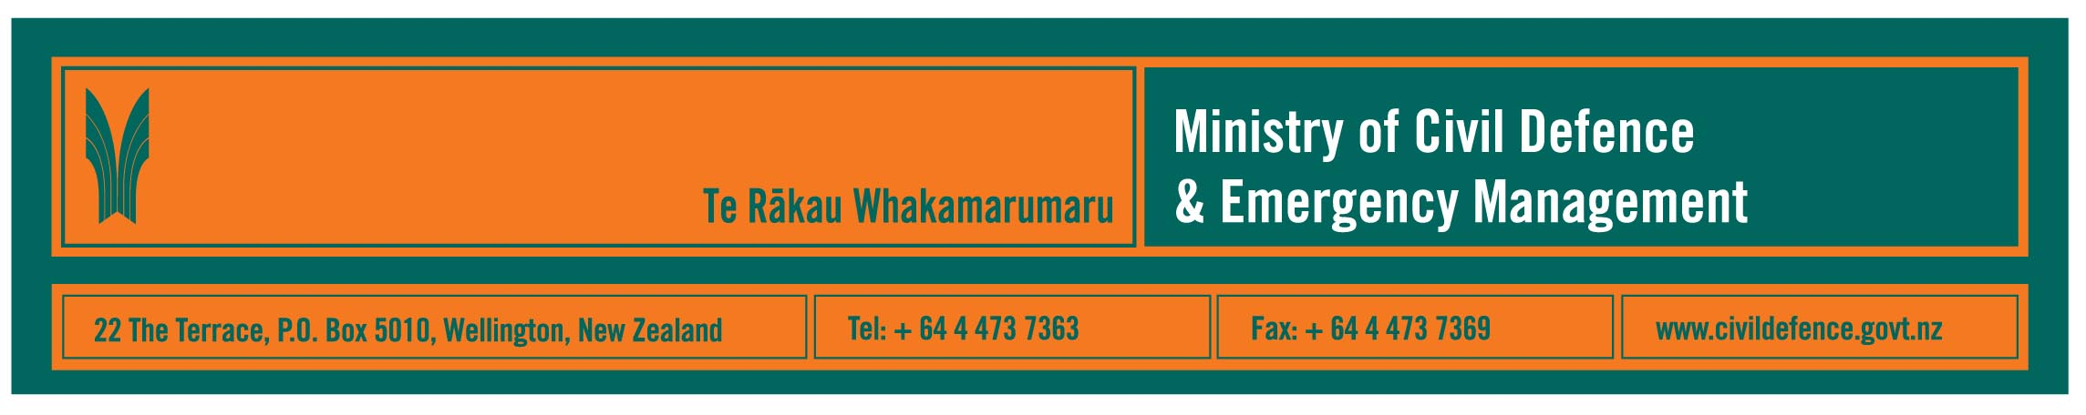

Media Release 17 June 2010

Positive lessons from massive Chile earthquake
Initial summary of New Zealand/Australian engineering visit to Chile

The fifth biggest earthquake ever recorded in the world hit Chile on 27 February 2010. Intense shaking and the following tsunami caused many tragedies and hundreds of deaths, yet it has not resulted in “scorched earth” devastation and despondency.

“Without a doubt, planning, preparation and practice for emergencies saved many lives,” the Director of Civil Defence Emergency Management, John Hamilton, said after visiting Chile. “What happened in Chile is a most powerful example that taking practical steps before an emergency helps save lives and helps recovery.”

Mr Hamilton was Chief of Party of a New Zealand Society for Earthquake Engineering and Australian Earthquake Engineering Society mission to Chile. While the mission’s full report is being prepared, Mr Hamilton has given a summary of its observations and his personal views in the June issue of the civil defence magazine, Impact.

Preparatory work that saved lives in Chile included:
- identifying hazards
- household and neighbourhood emergency arrangements
- businesses’ emergency plans
- building codes and practices
- redundancies and back-up systems for key infrastructure
- local and central government emergency planning
- local, national and international links between businesses, government agencies and non-government organisations.

“For many, preparation was the difference between surviving or not. Chile’s experience shows that we can do things as households, neighbourhoods, businesses, NGOs and governments that will help us in a disaster,” Mr Hamilton said.

“It also shows that we cannot be complacent. We cannot stop and think of ourselves as ‘prepared’. Instead, we are ‘preparing’ – continuing to learn and improve.

“We do not, and cannot, know everything about nature and how a disaster will play out.

“In a major disaster there will be casualties and destruction of property. People in the hardest hit areas will not have access to emergency services for days and it will take weeks and even months to restore services.

“But what I saw in Chile was not the scorched earth I was prepared for. Life goes on. Services were being restored, shops open with some adaptations made, and the people seemed confident.”

“I have returned with a strong view that planning, initiative and leadership are a potent mix to help reduce the impact of a disaster and increase the speed of recovery.

“The worst thing we can do is to become complacent or fatalistic and do nothing.”

Mr Hamilton’s comments are published in the editorial and the article “Chile earthquake and tsunami” in the June 2010 issue of Impact. Copies are available:
- from the Ministry of Civil Defence & Emergency Management website
- from the Ministry’s offices in Auckland, Wellington and Christchurch
- by calling the Ministry’s Public Information Manager.

Media contact
Public Information Manager, Vince Cholewa
Telephone 04 494 6951
E-mail: pim@ncmc.govt.nz
www.civildefence.govt.nz

Follow the Ministry on Twitter or subscribe to our RSS feed

 If a disaster happened now, would you be ready? www.getthru.govt.nz

- ENDS -

