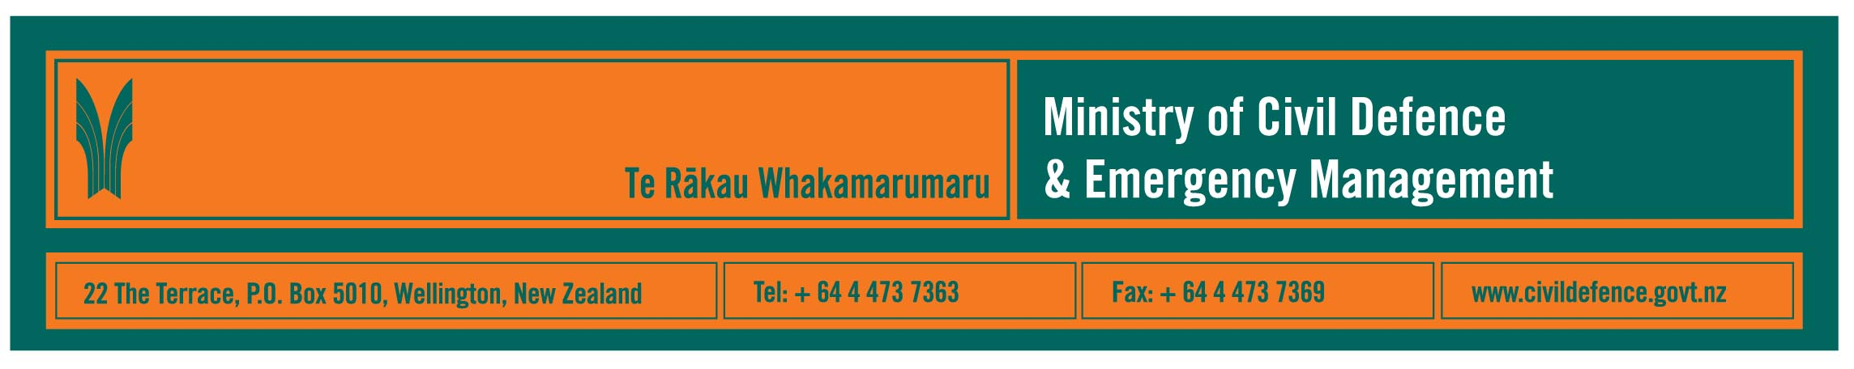

Media Release 31 May 2010

Civil defence emergency “sting” broadcast on radio

From Monday (31 May 2010) people might hear electronic civil defence emergency alarms on their radios.

The Director of Civil Defence Emergency Management, John Hamilton, said that at first the alarms will be new radio commercials. Later, they could be the alarm signalling an emergency public safety message.

Mr Hamilton said the Ministry has made the commercials to help people recognise the distinctive electronic “sting” that radio stations will use before broadcasting official civil defence emergency messages.

What has been found overseas is that where there is no clear signal or alarm, public safety messages blend into the surrounding advertising and programming.

“That had tragic consequences in the Victorian bush fires,” Mr Hamilton said. “In the aftermath, authorities learned that many people did not respond to evacuation and other messages broadcast on their radios because they ‘heard’ them as commercials or other programmes, not as official warnings.”

In Victoria use of an alarm before a civil defence message is broadcast on the radio has now been made mandatory.

“We have not gone that far in New Zealand,” Mr Hamilton said. “We have worked with Radio New Zealand, The Radio Broadcasters’ Association, Radio Live and The Radio Network. They all take their emergency responsibilities seriously and have told us they want public safety messages to be as clear as possible.

“We are happy to look at how we could work with other broadcasters too.”

The Ministry has existing memorandums of understanding with radio and television broadcasters to broadcast official messages during emergencies.

Get Ready Get Thru

The new radio commercials promoting the “sting” are part of the Ministry’s Get Ready Get Thru public education programme. The next step of the campaign is three weeks of radio and television advertising starting on television on Sunday, 30 May 2010, and on radio on Monday, 31 May 2010.

New radio commercials can be heard on the downloads page of the Get Ready Get Thru website, and will feature:
- The “sting” – the alarm radio stations can play before official civil defence messages.
- The natural warnings of a local tsunami – a tsunami caused by an earthquake near the coast could arrive within minutes, long before a formal warning could be issued. People need to know the natural warnings that might come before a local tsunami.
- Have a battery-powered radio. If there are power cuts during an emergency a battery powered radio is likely to be the only way many people would receive official messages.
- Mandarin, Cantonese, Korean, Samoan and Hindi language on ethnic radio. The Get Ready Get Thru website can already be viewed in nine different languages, English, Te Reo, Samoan, Tongan, Korean, simplified and traditional Chinese, Hindi and Arabic.

Existing commercials will continue to be broadcast. They promote the need to have emergency items and water to last at least three days and an emergency plan that includes what to do when not at home as well as at home.

“The message throughout our campaign – in the advertising, schools’ resources, Yellow Pages notices, and all our other promotions – remains consistent,” Mr Hamilton said:
“Get ready now so you can get through.”

Media contact
Public Information Manager, Vince Cholewa
Telephone 04 494 6951
E-mail: pim@ncmc.govt.nz
www.civildefence.govt.nz

Follow the Ministry on Twitter or subscribe to our RSS feed

 If a disaster happened now, would you be ready? www.getthru.govt.nz

- ENDS -

