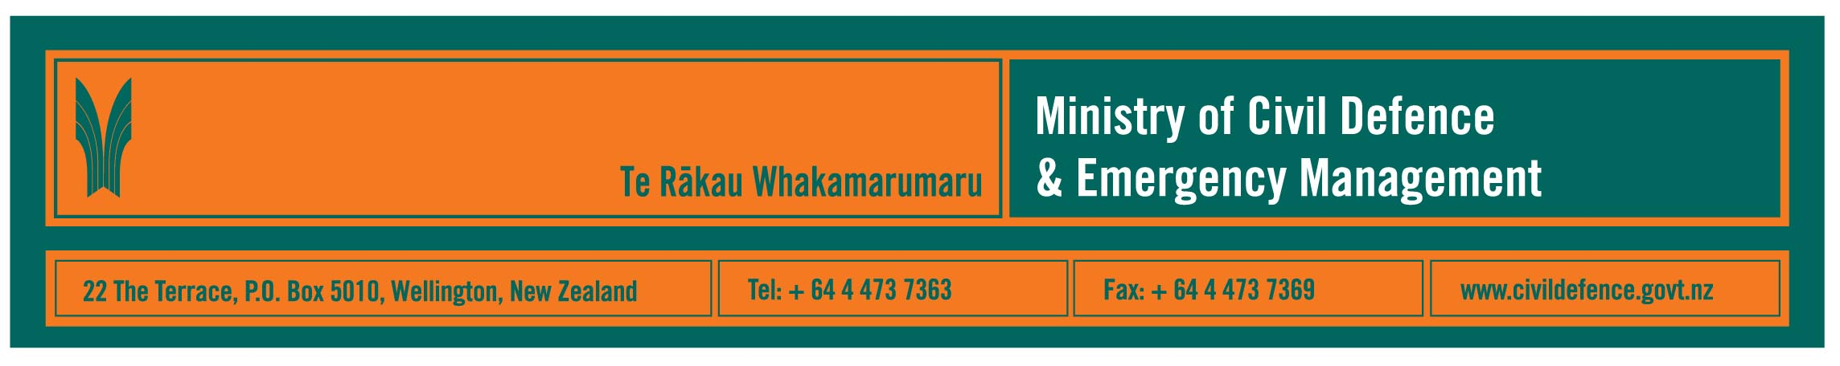

Media Release 4 March 2010

Statistics NZ survey reinforces need to be prepared

Statistics New Zealand’s General Social Survey, released today, shows that 15% of households are prepared for a natural disaster, i.e. they have enough food and water stored to last three days, and they have an emergency plan.

The Director of Civil Defence Emergency Management, John Hamilton, said that the Ministry’s market research linked to its Get Ready Get Thru public education campaign showed that 10% to 12% of households were well prepared.

“The numbers are very similar and show that we need to do more,” Mr Hamilton said. “The Ministry and other civil defence and emergency organisations will continue to provide education and information but households and workplaces have to take the messages on board.

“Ultimately, we need to cut through public apathy. Our research tells us that about 76% of people know that they need food, water and a plan. We know many have some of that, but most don’t have all three. The Ministry will do what we can but people must also take responsibility to do their part to prepare themselves and their families at home, at school and at work.”

Events like the weekend’s earthquake in Chile and the subsequent Pacific tsunami warning cause increases in awareness and preparedness. However, on its own, such an event only causes a spike in the statistics. Preparedness levels start dropping again soon after.

“For our part, the Ministry aims to maintain a steady flow of information and education to support families and communities,” Mr Hamilton said.

“It is important that we work well with the media. They are big help in educating about risks and preparedness and are crucial for providing information during an emergency. Publicity, like this about the just released Statistics NZ report, is part of that work.

“We are also planning events to provide information to agencies that we work with and the public.”

Other Ministry events and activities include:
- March 15, conference for the 16 regional Civil Defence Emergency Management Groups and local authorities, to explain and discuss the Emergency Management Information System (EMIS) to be installed in the National Crisis Management Centre beneath the Beehive
- planning for a media demonstration of EMIS (date to be confirmed)
- April – May; the Ministry and GNS Science will conduct nationwide series of tsunami preparedness seminars for local authorities, civil defence agencies, emergency services and other organisations involved in response to a tsunami warning
- “Get Ready Get Thru” television, radio, Yellow Pages and community newspaper advertising
- continued use and development of “What’s the Plan Stan” school’s resource
- October 10-16, Disaster Awareness Week
- October 20, nationwide tsunami response exercise, Exercise Tangaroa.

The 16 regional Groups and local authorities carry out various education and information activities in their own areas.

Further information

- Fact sheet: New Zealand General Social Survey 2008, Natural Disaster Preparation at Home
http://www.stats.govt.nz/Publications/SocialConditions/natural-disaster-preparation-at-home-factsheet and information about the General Social Survey www.stats.govt.nz/nzgss
- Website supporting the Ministry’s Get Ready Get Thru public education campaign www.getthru.govt.nz
- Website supporting the school’s resource, What’s the Plan Stan? www.whatstheplanstan.govt.nz
- Ministry of Civil Defence & Emergency Management website www.civildefence.govt.nz

Media contact:
Public Information Manager, Vince Cholewa
24/7 media duty telephone 04 494 6951
E-mail: pim@ncmc.govt.nz

Follow the Ministry on Twitter or subscribe to our RSS feed

 If a disaster happened now, would you be ready? www.getthru.govt.nz

- END -

