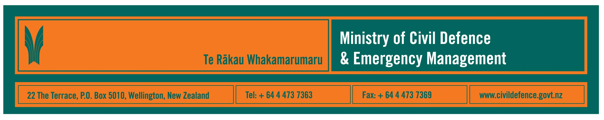

Media Release 23 February 2010

Tsunami risk management programme
updated Tsunami Advisory and Warning Plan and next steps
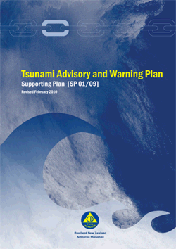
New Zealand’s tsunami risk management programme has taken another step forward with the announcement today of a revised national Tsunami Advisory and Warning Plan.

The plan sets out national procedures to issue a tsunami warning or advisory. In doing that it explains the possible sources of tsunami that could reach New Zealand, risks to different parts of the country, thresholds for response, the responsibilities of national and regional agencies, and explains what information the Ministry will provide in warnings and advisories.

The Director of Civil Defence and Emergency Management, John Hamilton, said that the revisions to the plan are part of the work being done to apply lessons learned from last year’s response to the Samoan tsunami.

“The revisions focus on getting better information to the media, faster. We have changed our templates, action guides for our staff, when we will use our memorandum of understanding with radio and TV and some of the thresholds for when we will issue a warning or advisory,” Mr Hamilton said.

Next steps after publishing the revised plan include:
- April – May; the Ministry and GNS Science will conduct a nationwide series of tsunami preparedness seminars for local authorities, civil defence agencies, emergency services and other organisations involved in response to a tsunami warning.
- Mid-year; completion of tsunami modelling by GNS Science. This work will enhance the information available in warnings and will be incorporated into future versions of the plan.
- October; national tsunami response exercise, Exercise Tangaroa. The exercise will involve central government agencies, the 16 regional civil defence emergency management groups, science agencies, emergency services and other organisations.
Mr Hamilton said that, flowing down from the national plan, it is important that those organisations with roles to play ensure that they understand the national arrangements, have their own plans in place for their regions and specific responsibilities, and exercise their plans and arrangements.

It is still critical that communities and families also have their own household and workplace emergency plans. This is the personal question of, “what will my family and I do if a tsunami warning is issued?”

The Ministry provides public education information through its Get Ready Get Thru programme, GNS Science provides scientific information, and regional and local information is available from the 16 regional civil defence emergency management groups and their associated local authorities.

“We hope that publicity, like this about the tsunami plan, will also encourage people to do more about their own personal emergency planning,” Mr Hamilton said.

The tsunami risk management programme is ongoing. To date its work includes:
- the national Tsunami Advisory and Warning Plan
- Tsunami Evacuation Zones guidelines
- Mass Evacuation Planning guidelines
- the technical standard, National Tsunami Signage
- a public brochure, Get to High Ground or Go Inland
- scientific research and modelling about possible sources of tsunami and their threats to New Zealand
- revising the work processes used by the Ministry’s staff
- upgrading the national warning system.

Media contact:
Public Information Manager, Vince Cholewa
24/7 media duty telephone 04 494 6951
E-mail: pim@ncmc.govt.nz

Follow the Ministry on Twitter or subscribe to our RSS feed

 If a disaster happened now, would you be ready? www.getthru.govt.nz

- END -

