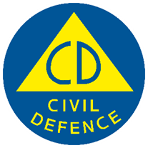
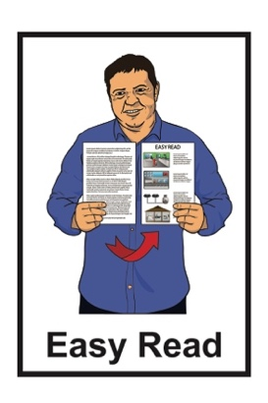

Getting support in an emergency: Immediate support
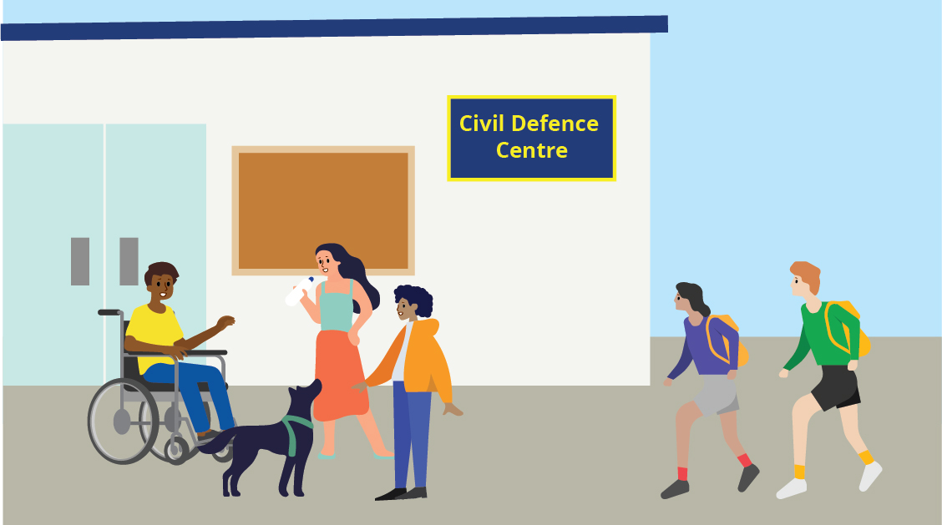

Version 1
Published: November 2025

Before you start

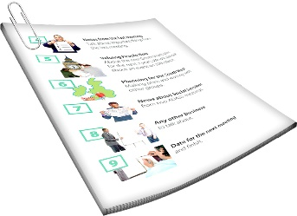
This is a long document.

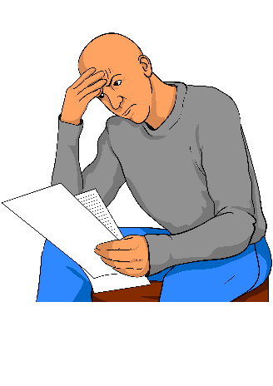
It can be hard for some people to read a document this long.

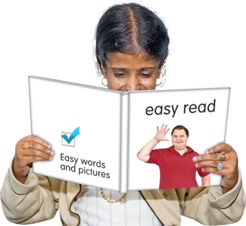
Some things you can do to make it easier are:
read it a few pages at a time
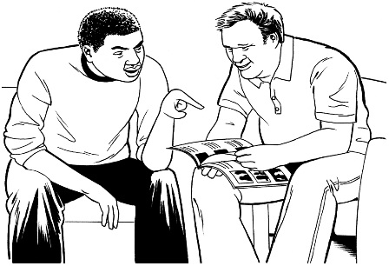
set aside some quiet time to look at it
have someone read it with you to support you to understand it.

What you will find in here

Page number:


About this Easy Read 3

What to do right now 6

Evacuation 9

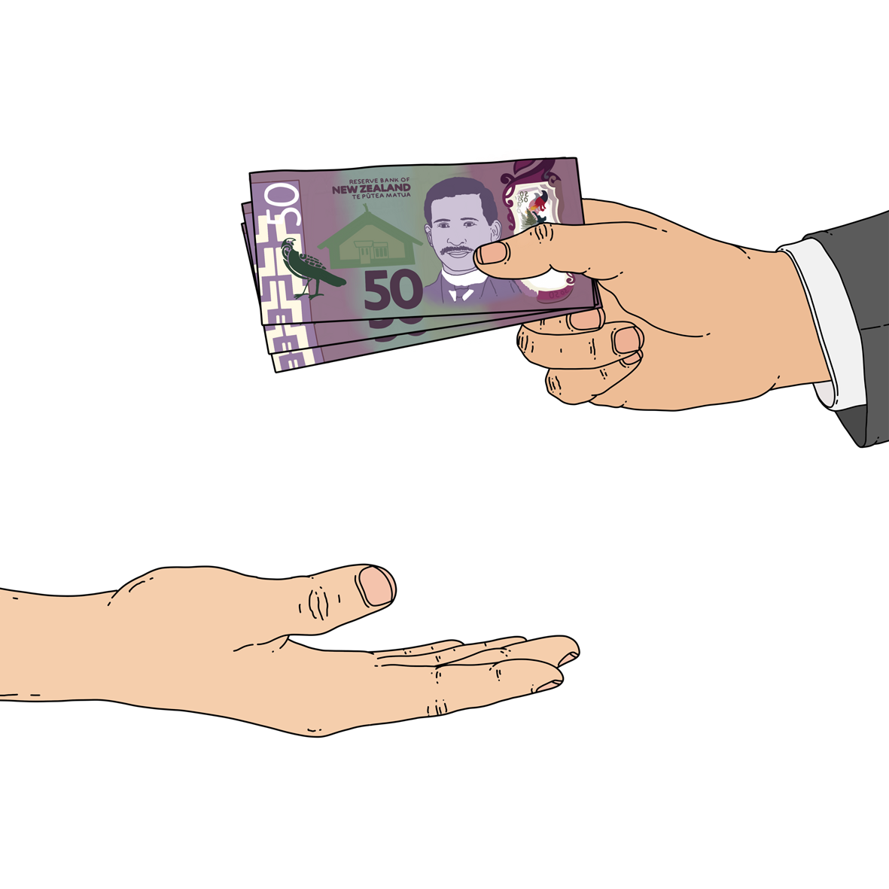
Road travel 13

Financial support 16

About this Easy Read

This Easy Read tells you what support you can get after an emergency.

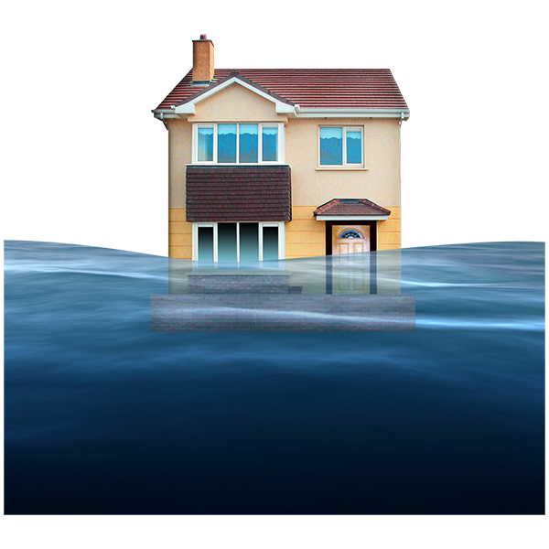
An emergency is when something dangerous happens that can put people at risk like:
an earthquake
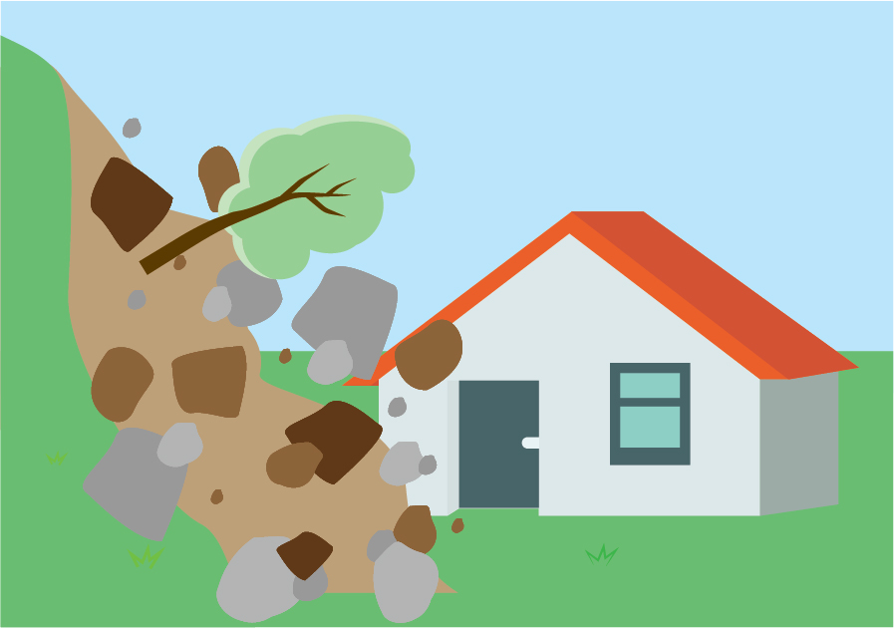
a flood
a storm
a landslide.

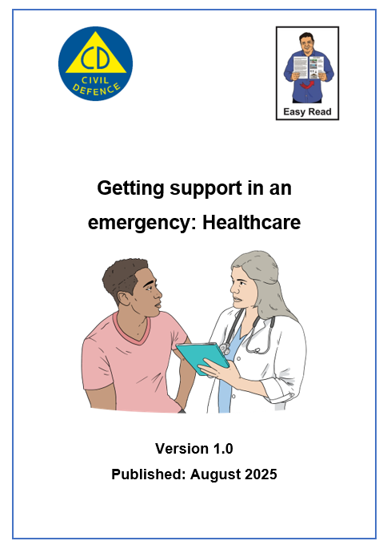
You can find information about how to get healthcare after an emergency in Easy Read at:

https://tinyurl.com/aog-health

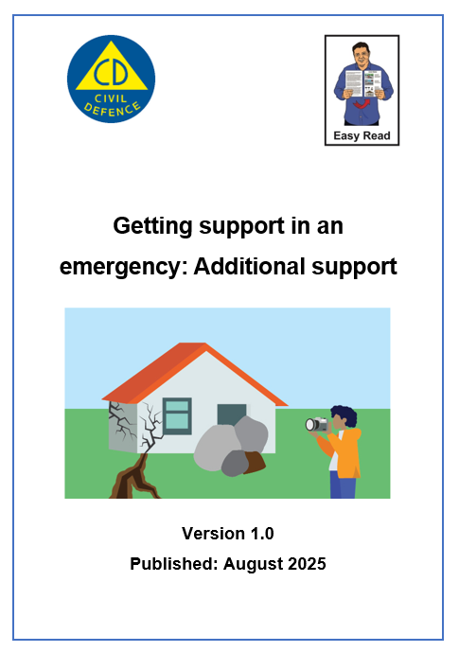
You can find other information about what happens after an emergency in Easy Read at:

https://tinyurl.com/aog-adsupport

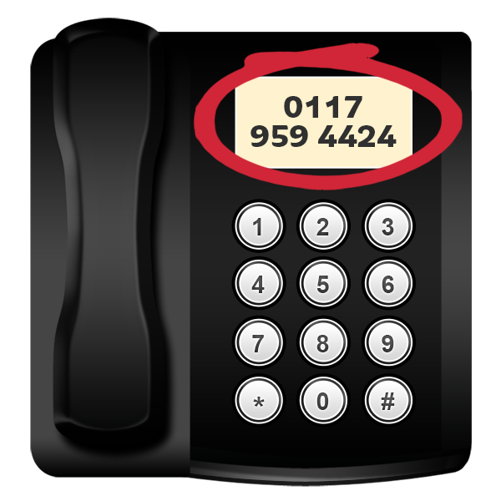
This Easy Read has lots of phone numbers in it.


If you find it hard to use the phone the New Zealand Relay service is for people who are:

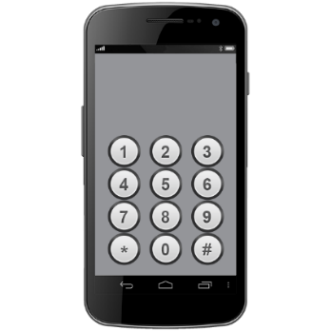
- Deaf / hard of hearing

- deafblind

- speech impaired / find it hard to talk.

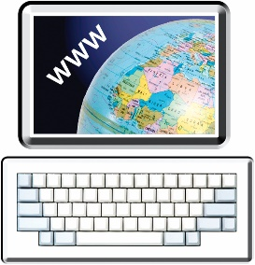
You can find out more about the New Zealand Relay service at:

www.nzrelay.co.nz/index

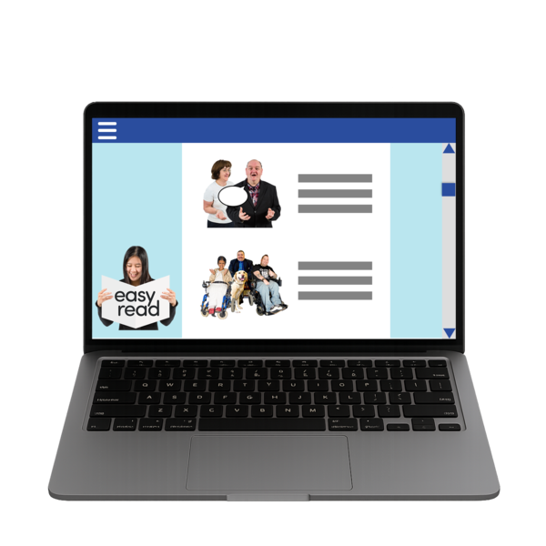
You can find out more about how to get ready for an emergency in Easy Read at:

https://tinyurl.com/2w2ykrzu

What to do right now

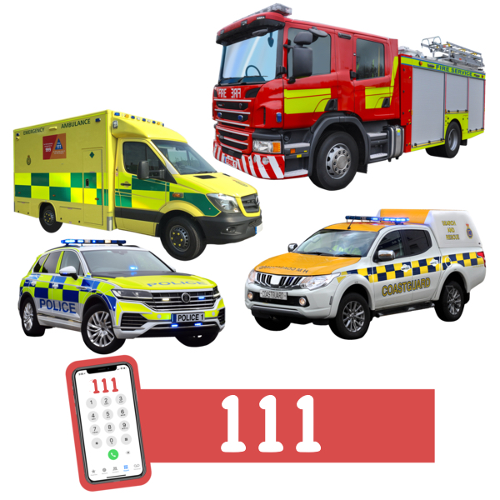
Phone 111 if you are in danger right now.

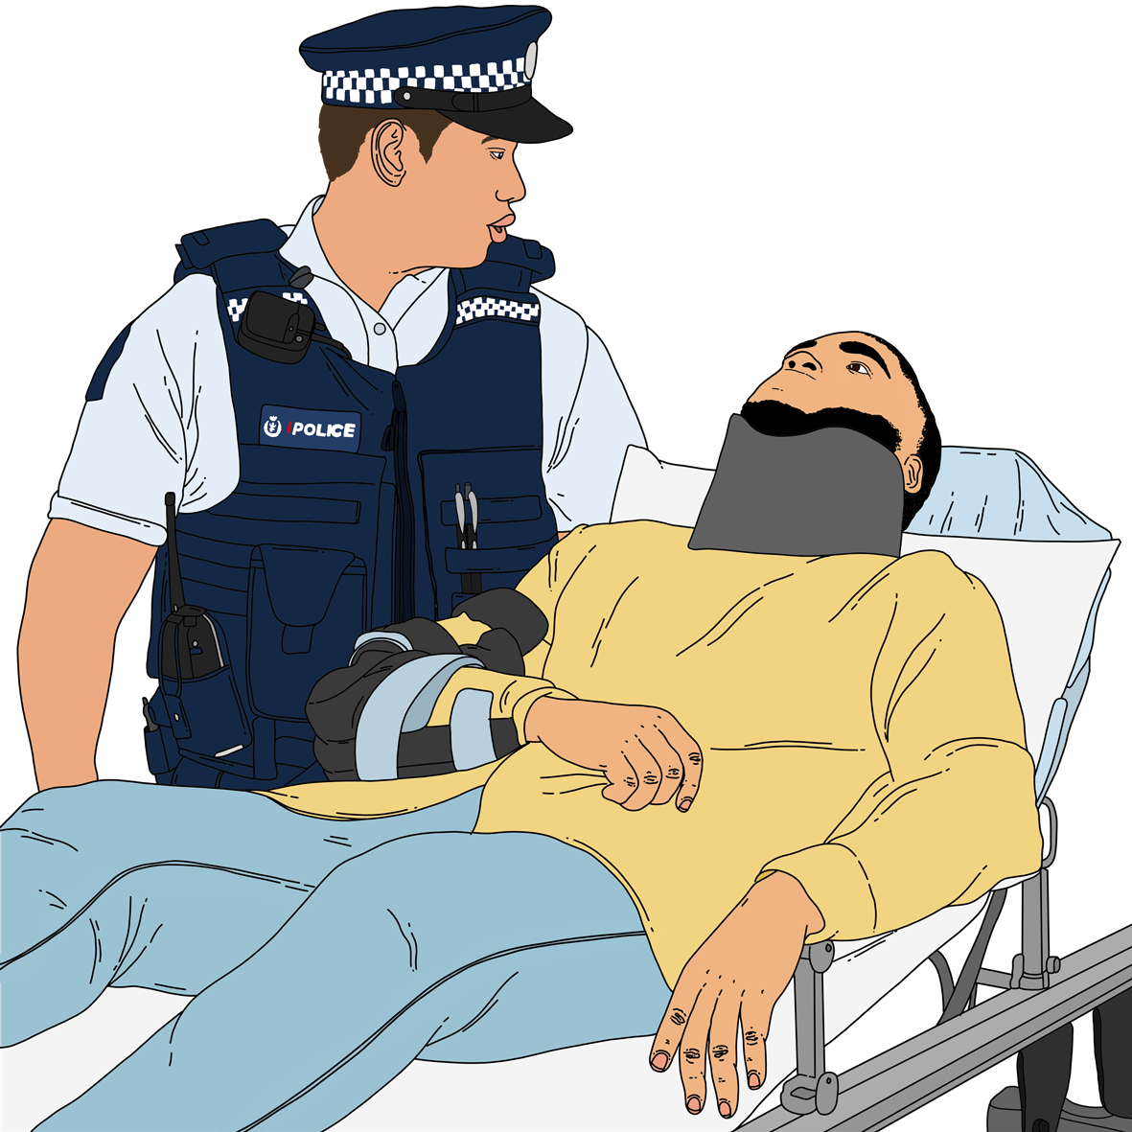
Being in danger means you might:
die
get badly hurt.

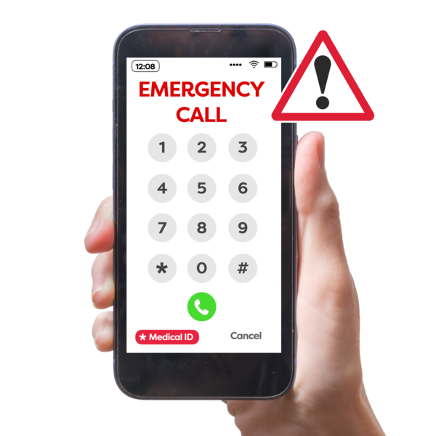
You can sign up to text 111 if you find it hard to:
hear
talk on the phone.


You can sign up to text 111 on this website:

www.police.govt.nz/111-txt

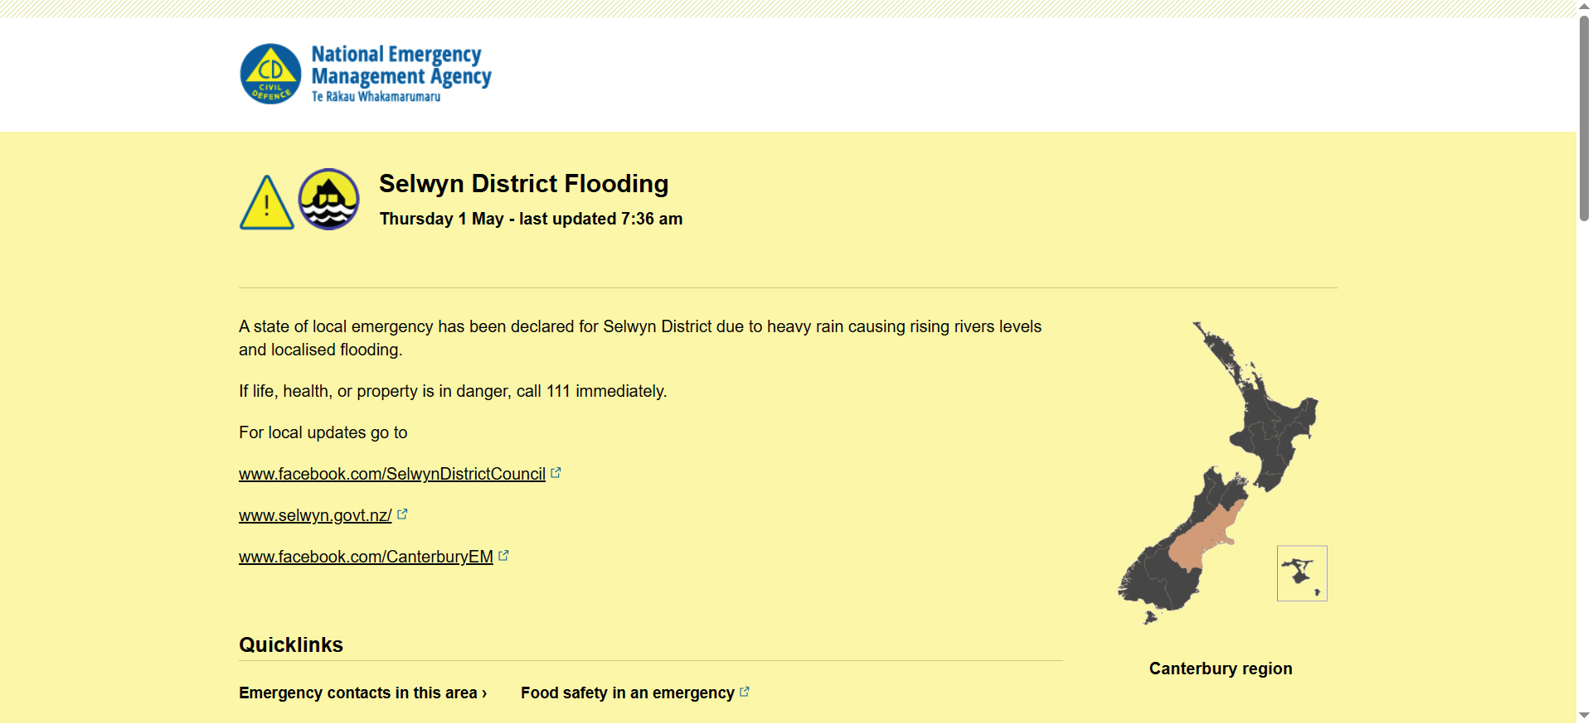
You can find new information about what is happening on this website:

www.civildefence.govt.nz/
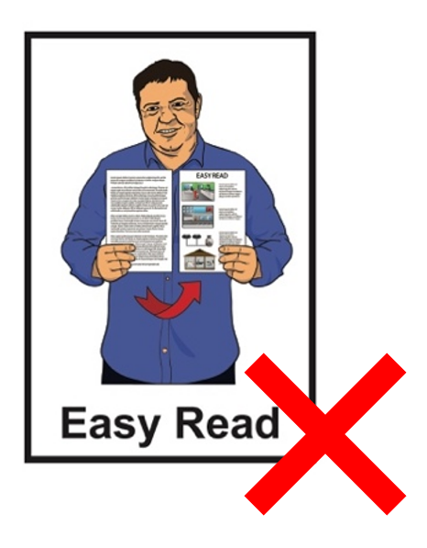

These websites are not in Easy Read.


You can also find new information about what is happening by following your local Civil Defence Emergency Management Group on their:
website
social media.

Your local Civil Defence
Emergency Management Group is the part of the government that is in charge after an emergency.


Social media means websites /
apps like:
Facebook
X / Twitter.

You can find out how to contact your local Civil Defence Emergency Management Group on this website:

https://tinyurl.com/4u4bnp26

This website is not in Easy Read.

Evacuation
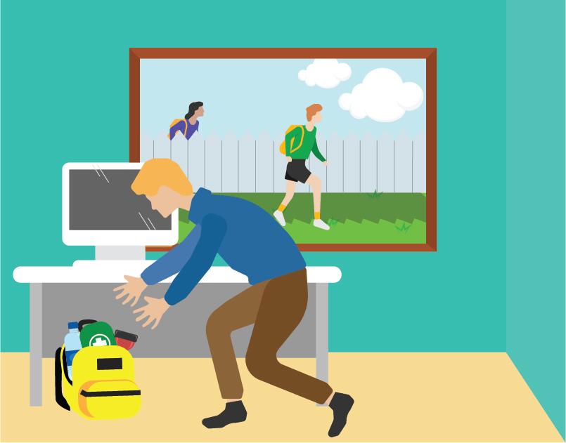

You might need to evacuate after an emergency.
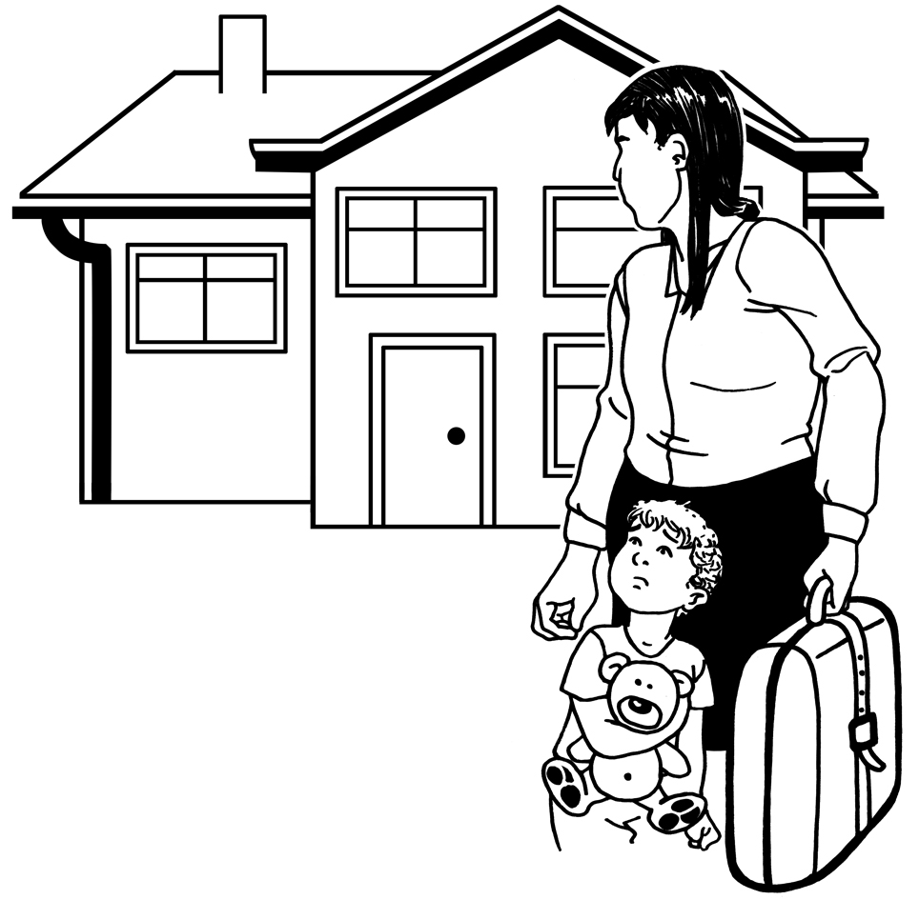

Evacuate means leaving your home when it is not safe to stay there.

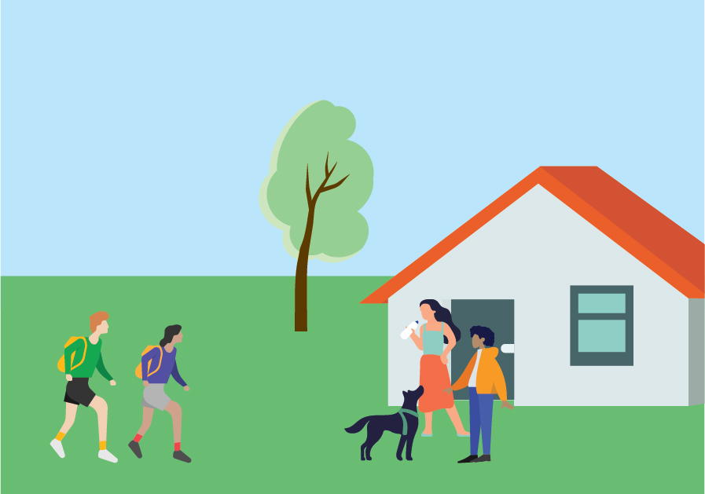
If you can it is best to go to stay with:
friends
whānau / family.

You can go to a Civil Defence Centre if you have nowhere else to go.

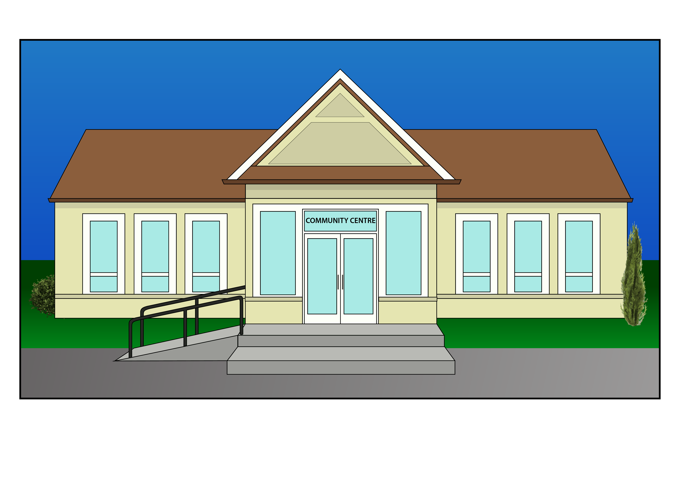
A Civil Defence Centre is a place where you can stay if you have nowhere else to go.

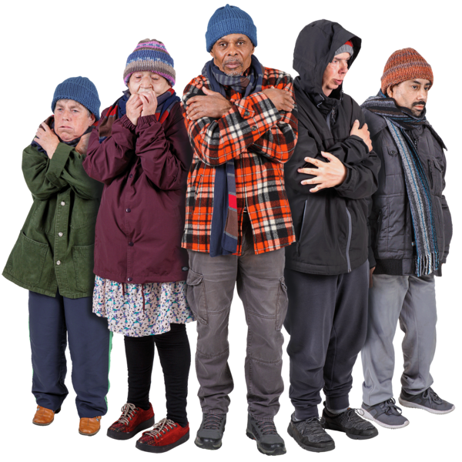
The Civil Defence Centre might have things you need like:
food
warm clothes.

You can find where the Civil Defence Centres are on your local Civil Defence Emergency Management Group website.

You can find your local Civil Defence Emergency Management Group website on this website:

https://tinyurl.com/4u4bnp26

This website is not in Easy Read.

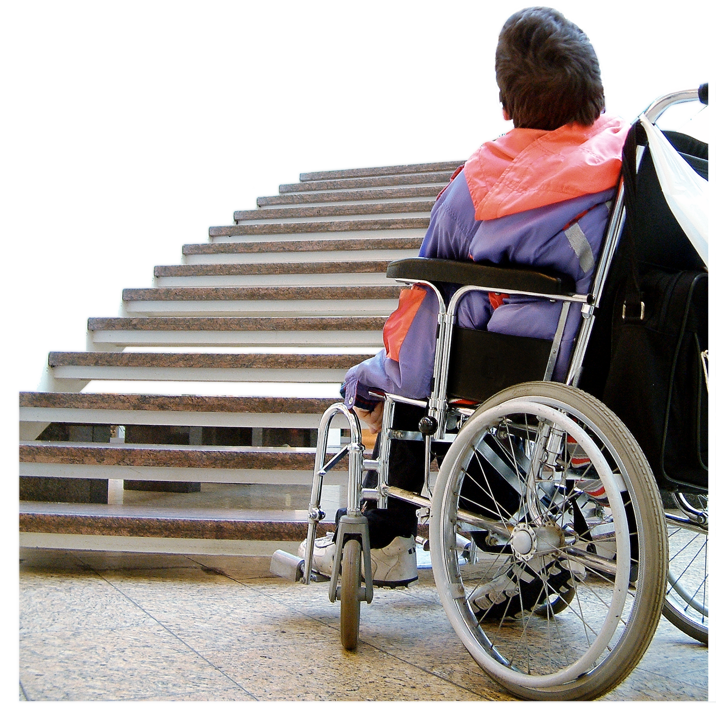
Contact your local Civil Defence Emergency Management Group if you cannot get to a Civil Defence Centre.
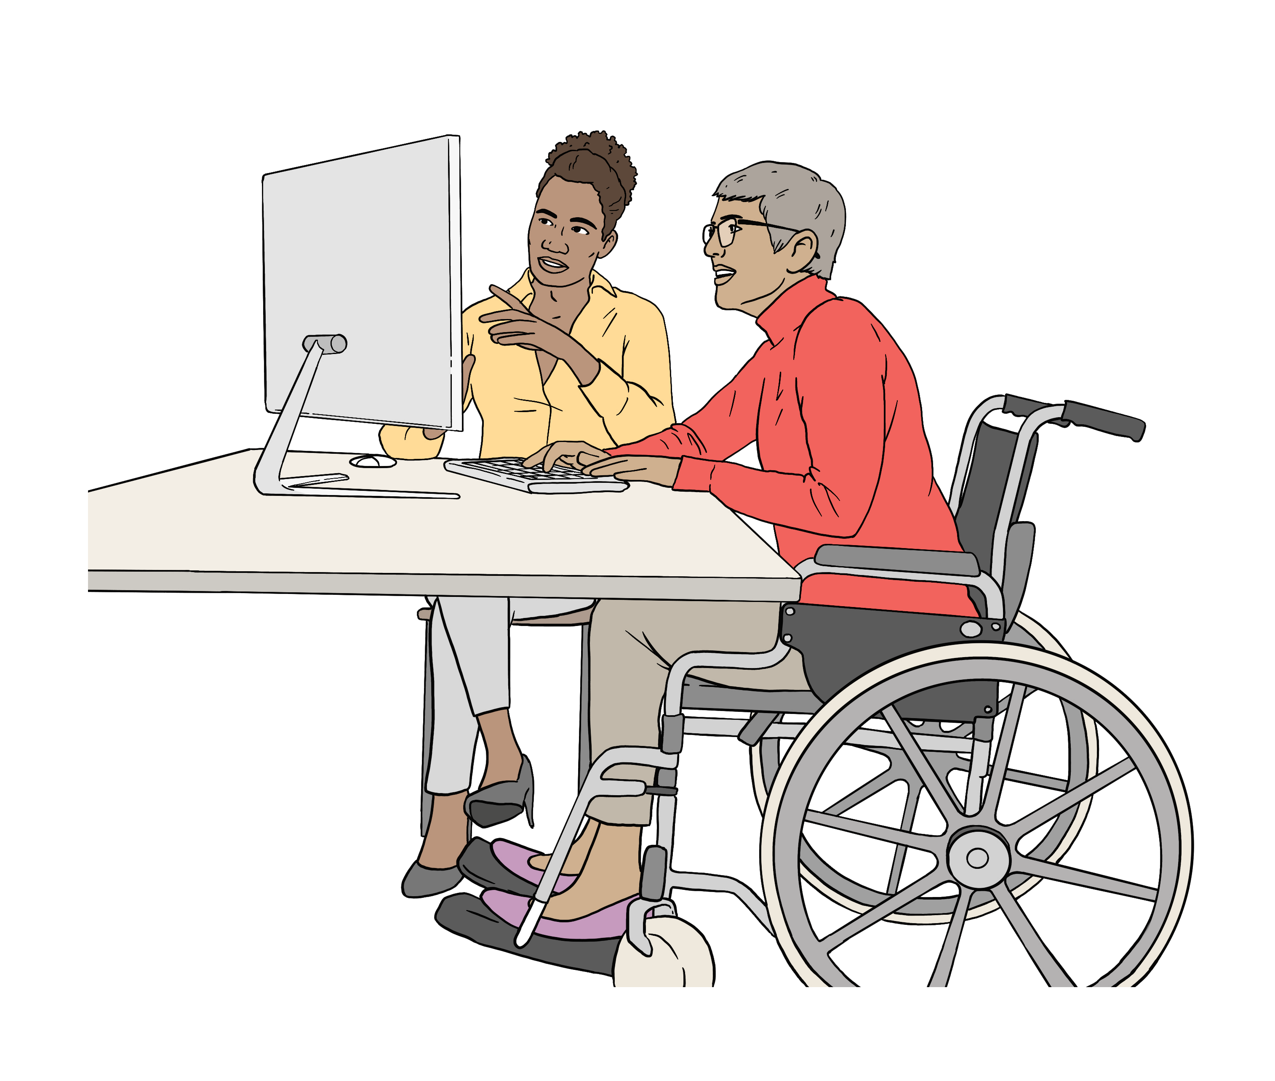

You can find out how to contact your local Civil Defence Emergency Management Group on their website.

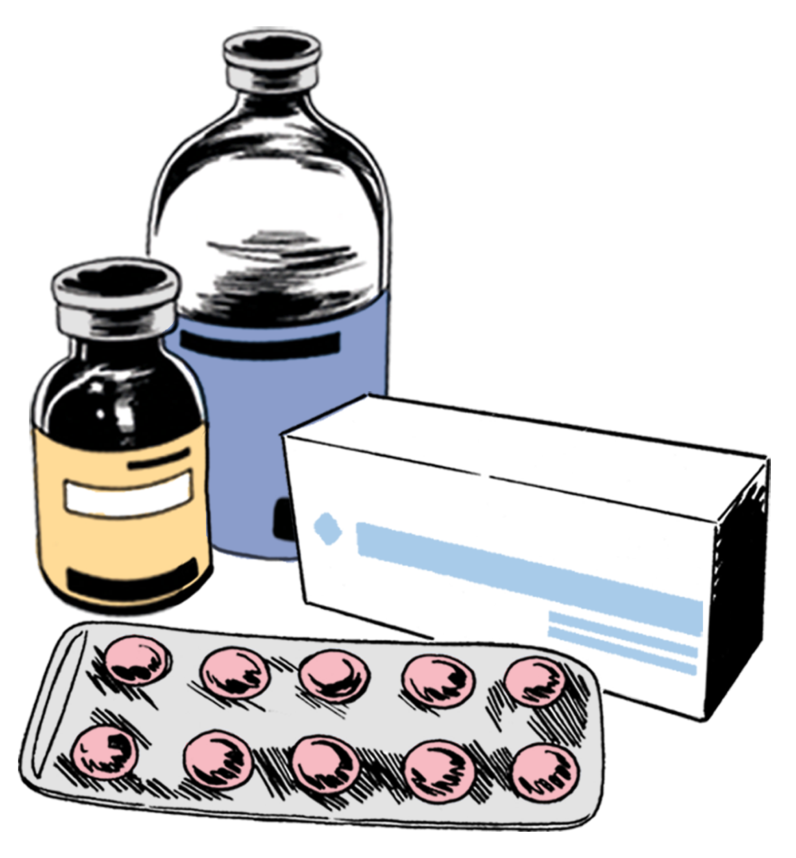
When you evacuate you should take important things you need like:
medicine
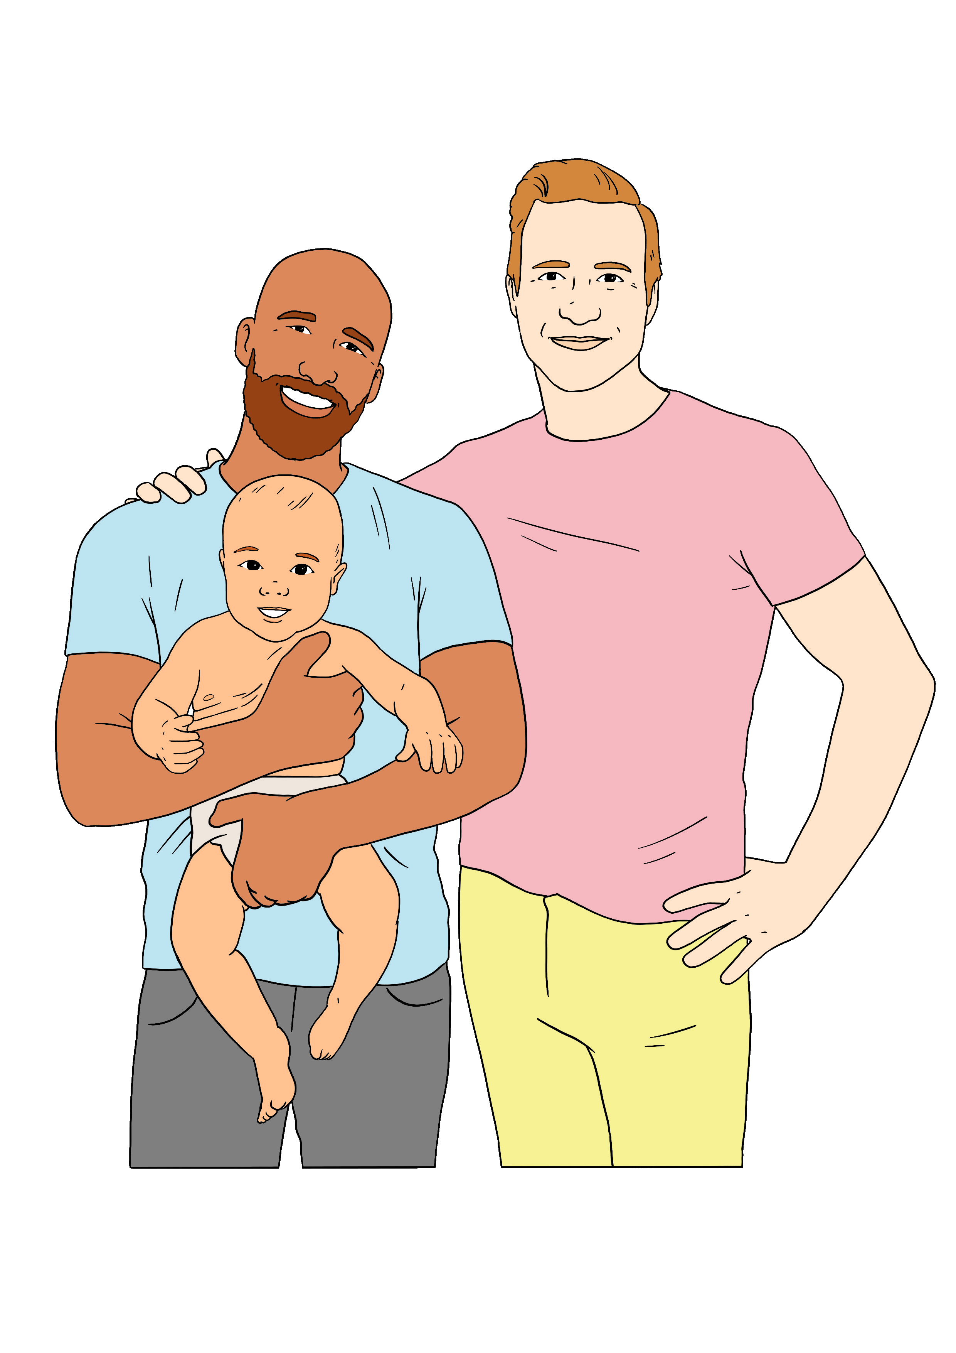
warm clothes
things for your baby if you have one.

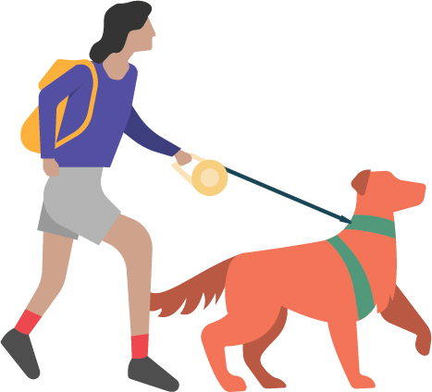
Take your disability assist dog if you have one.

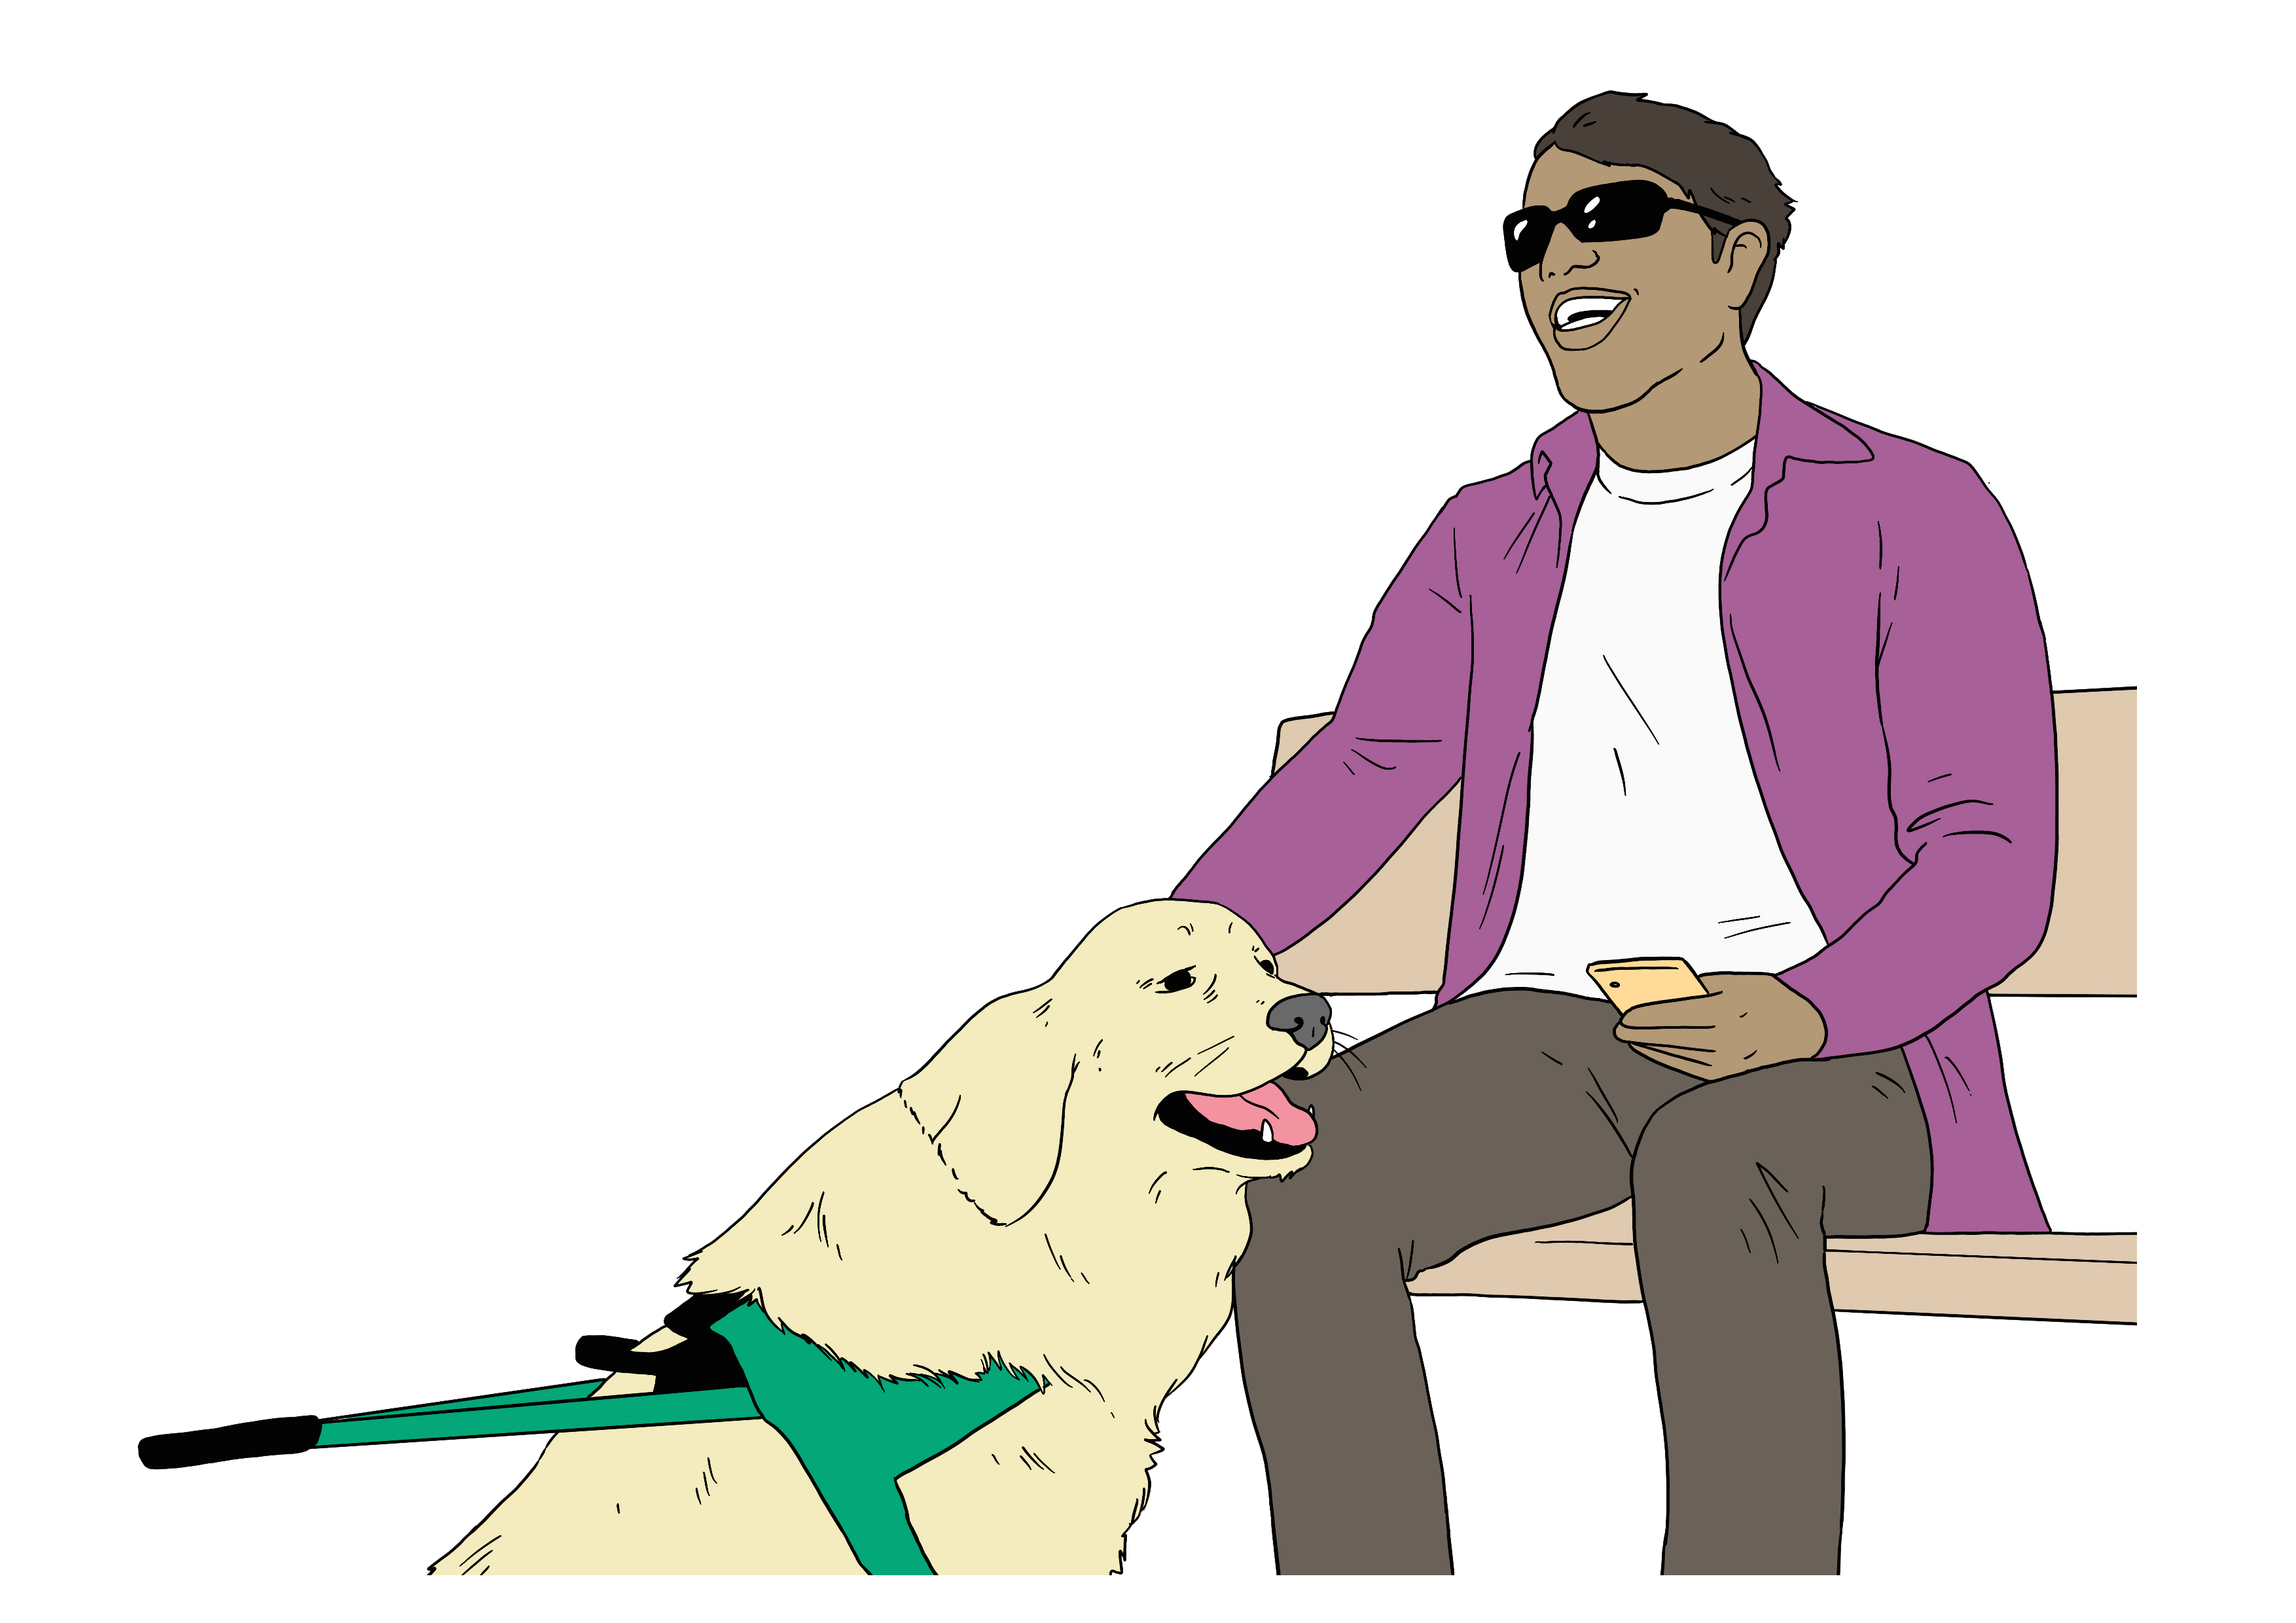
A disability assist dog is a dog that supports a disabled person like a guide dog for a blind person.

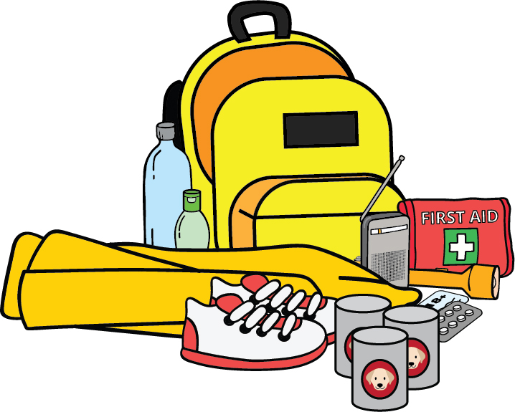
Take important things your dog needs like food.

Road travel


You should check it is safe before travelling on the road.

To find out if it is safe you can check with your local:
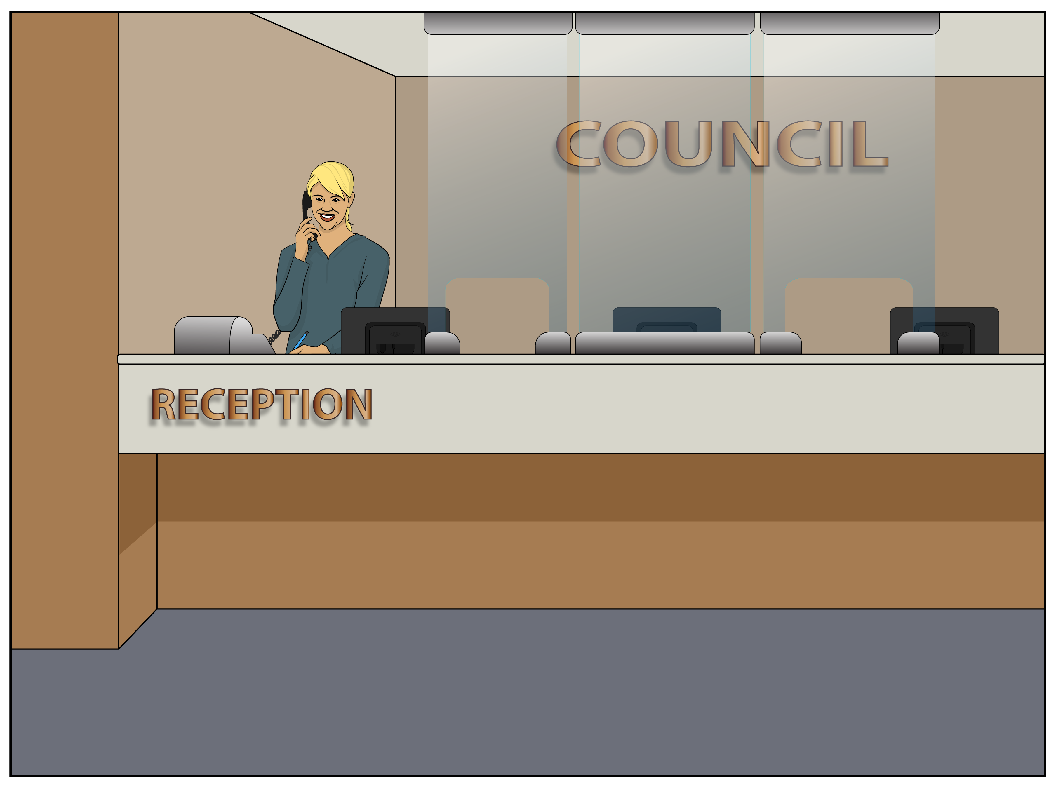
Civil Defence Emergency Management Group
council.
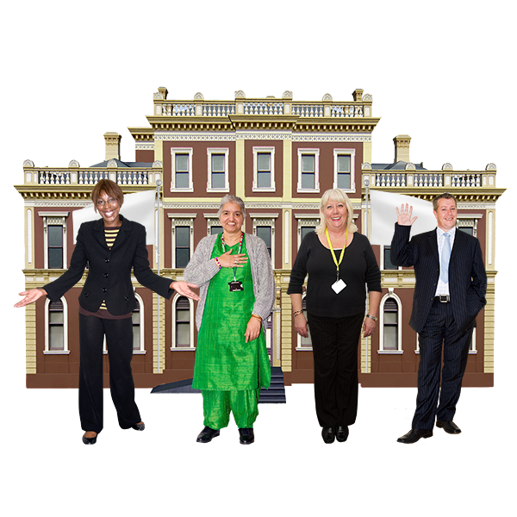

Your council is the people who
make choices about how to run your town / city.

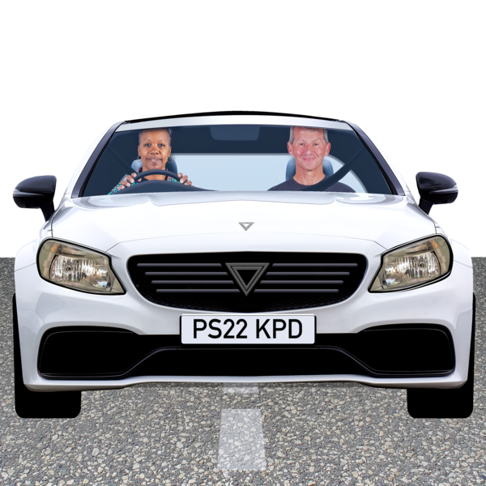
The New Zealand Transport Agency has information about things like:

which roads are open
how long it might take to drive somewhere.



The New Zealand Transport Agency is the part of the
government in charge of things like:
building some roads
road safety.

You can find information on the New Zealand Transport Agency website:

https://tinyurl.com/38uzxm78

You can also find information on the New Zealand Transport Agency Facebook page:

www.facebook.com/nztransportagency

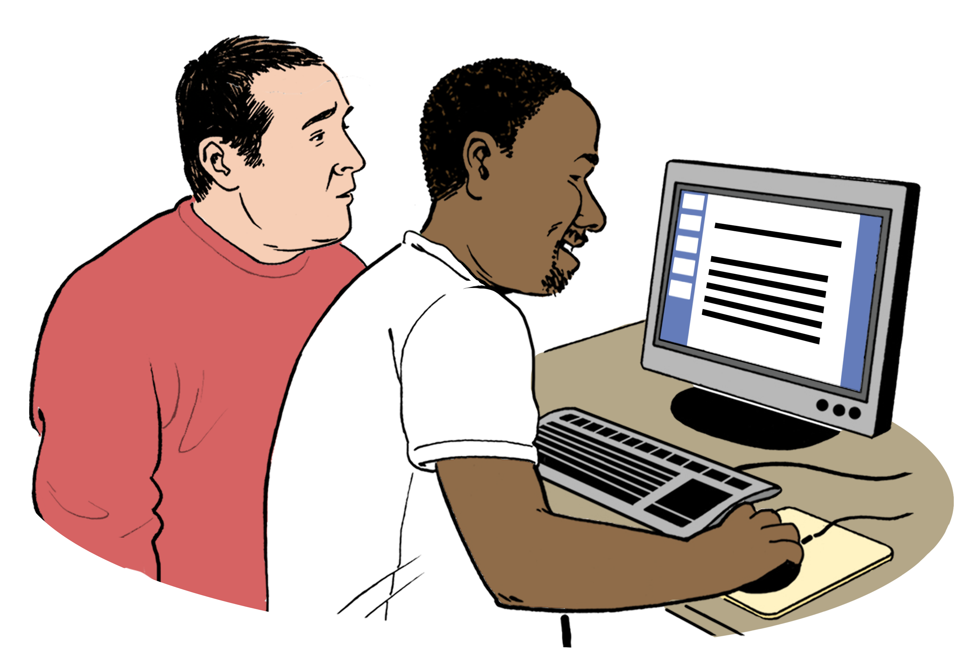
Use this website to plan a trip:

https://tinyurl.com/y7wcn2dx

These websites are not in Easy Read.

Financial Support

You might need financial support after an emergency.


Financial support means the government gives you money so
you can pay for things you need.


Work and Income might be able to give you money to pay for things like:

sheets / blankets
food
rent

power bills
repairs.

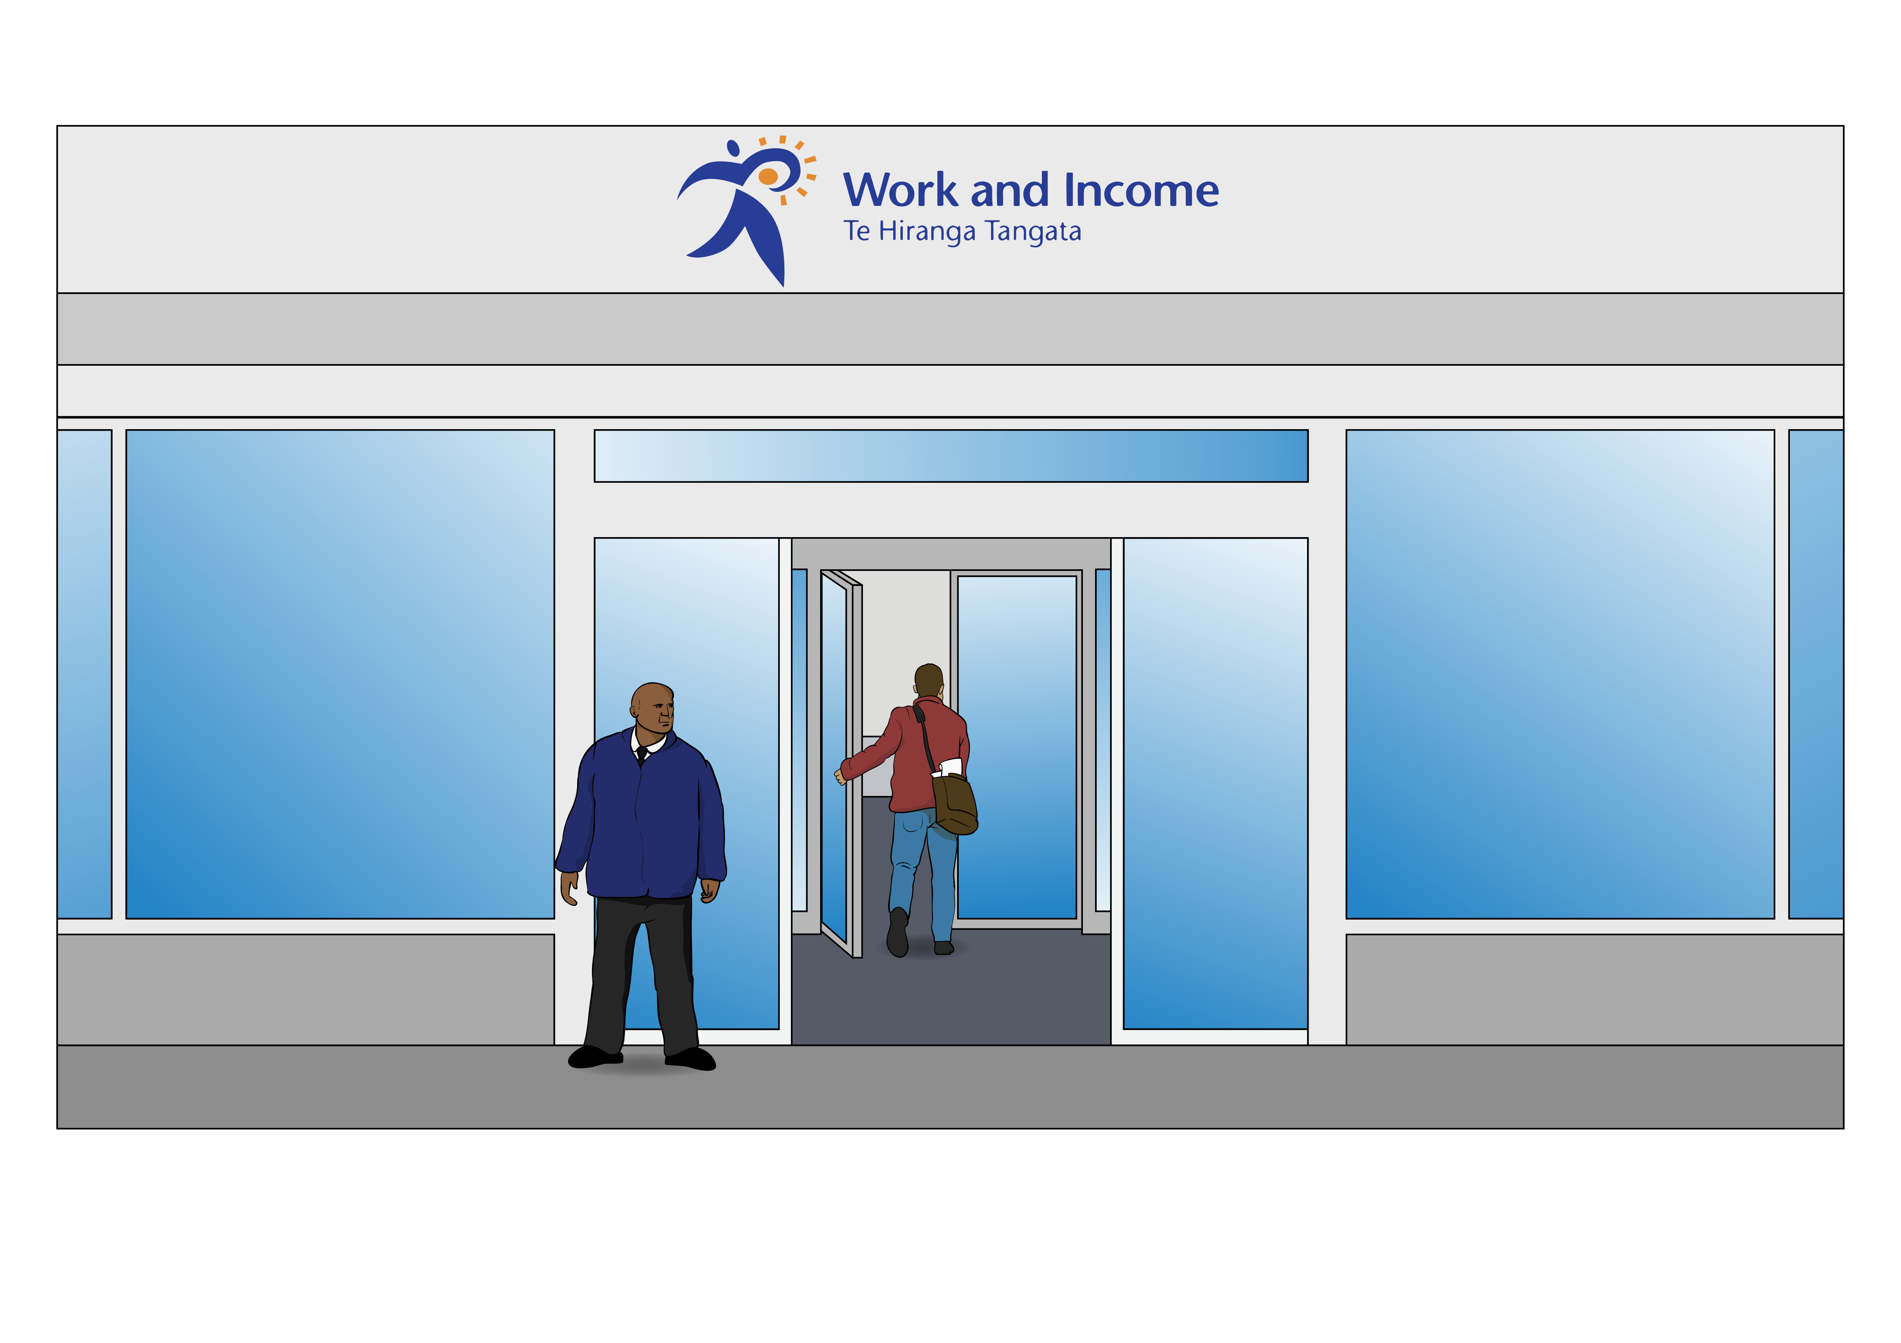
Work and Income is the part of the government that:

gives people money when they do not have a job
supports people to find jobs.

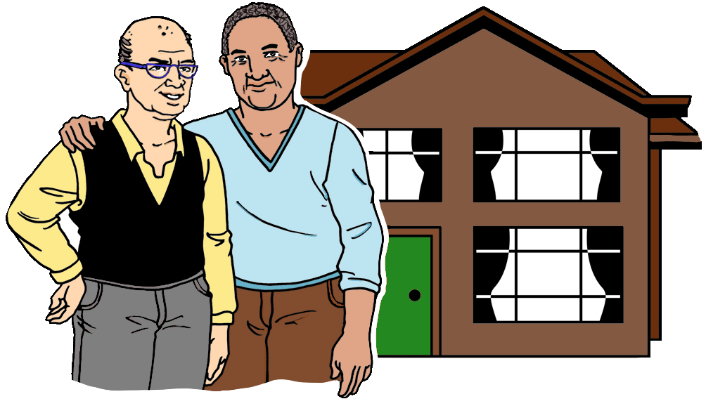
Rent is money you pay to live in a house you do not own.

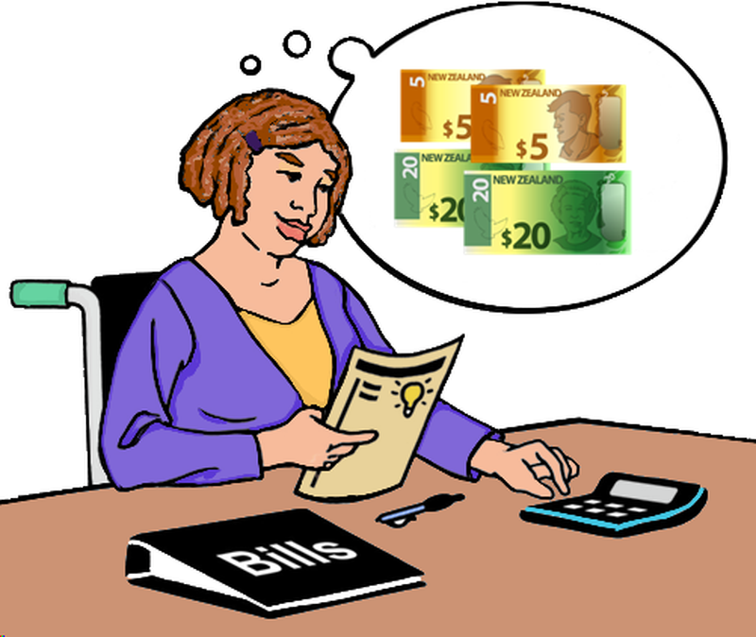
Power bills are how you pay for
your home to have power so you
can use things like the:
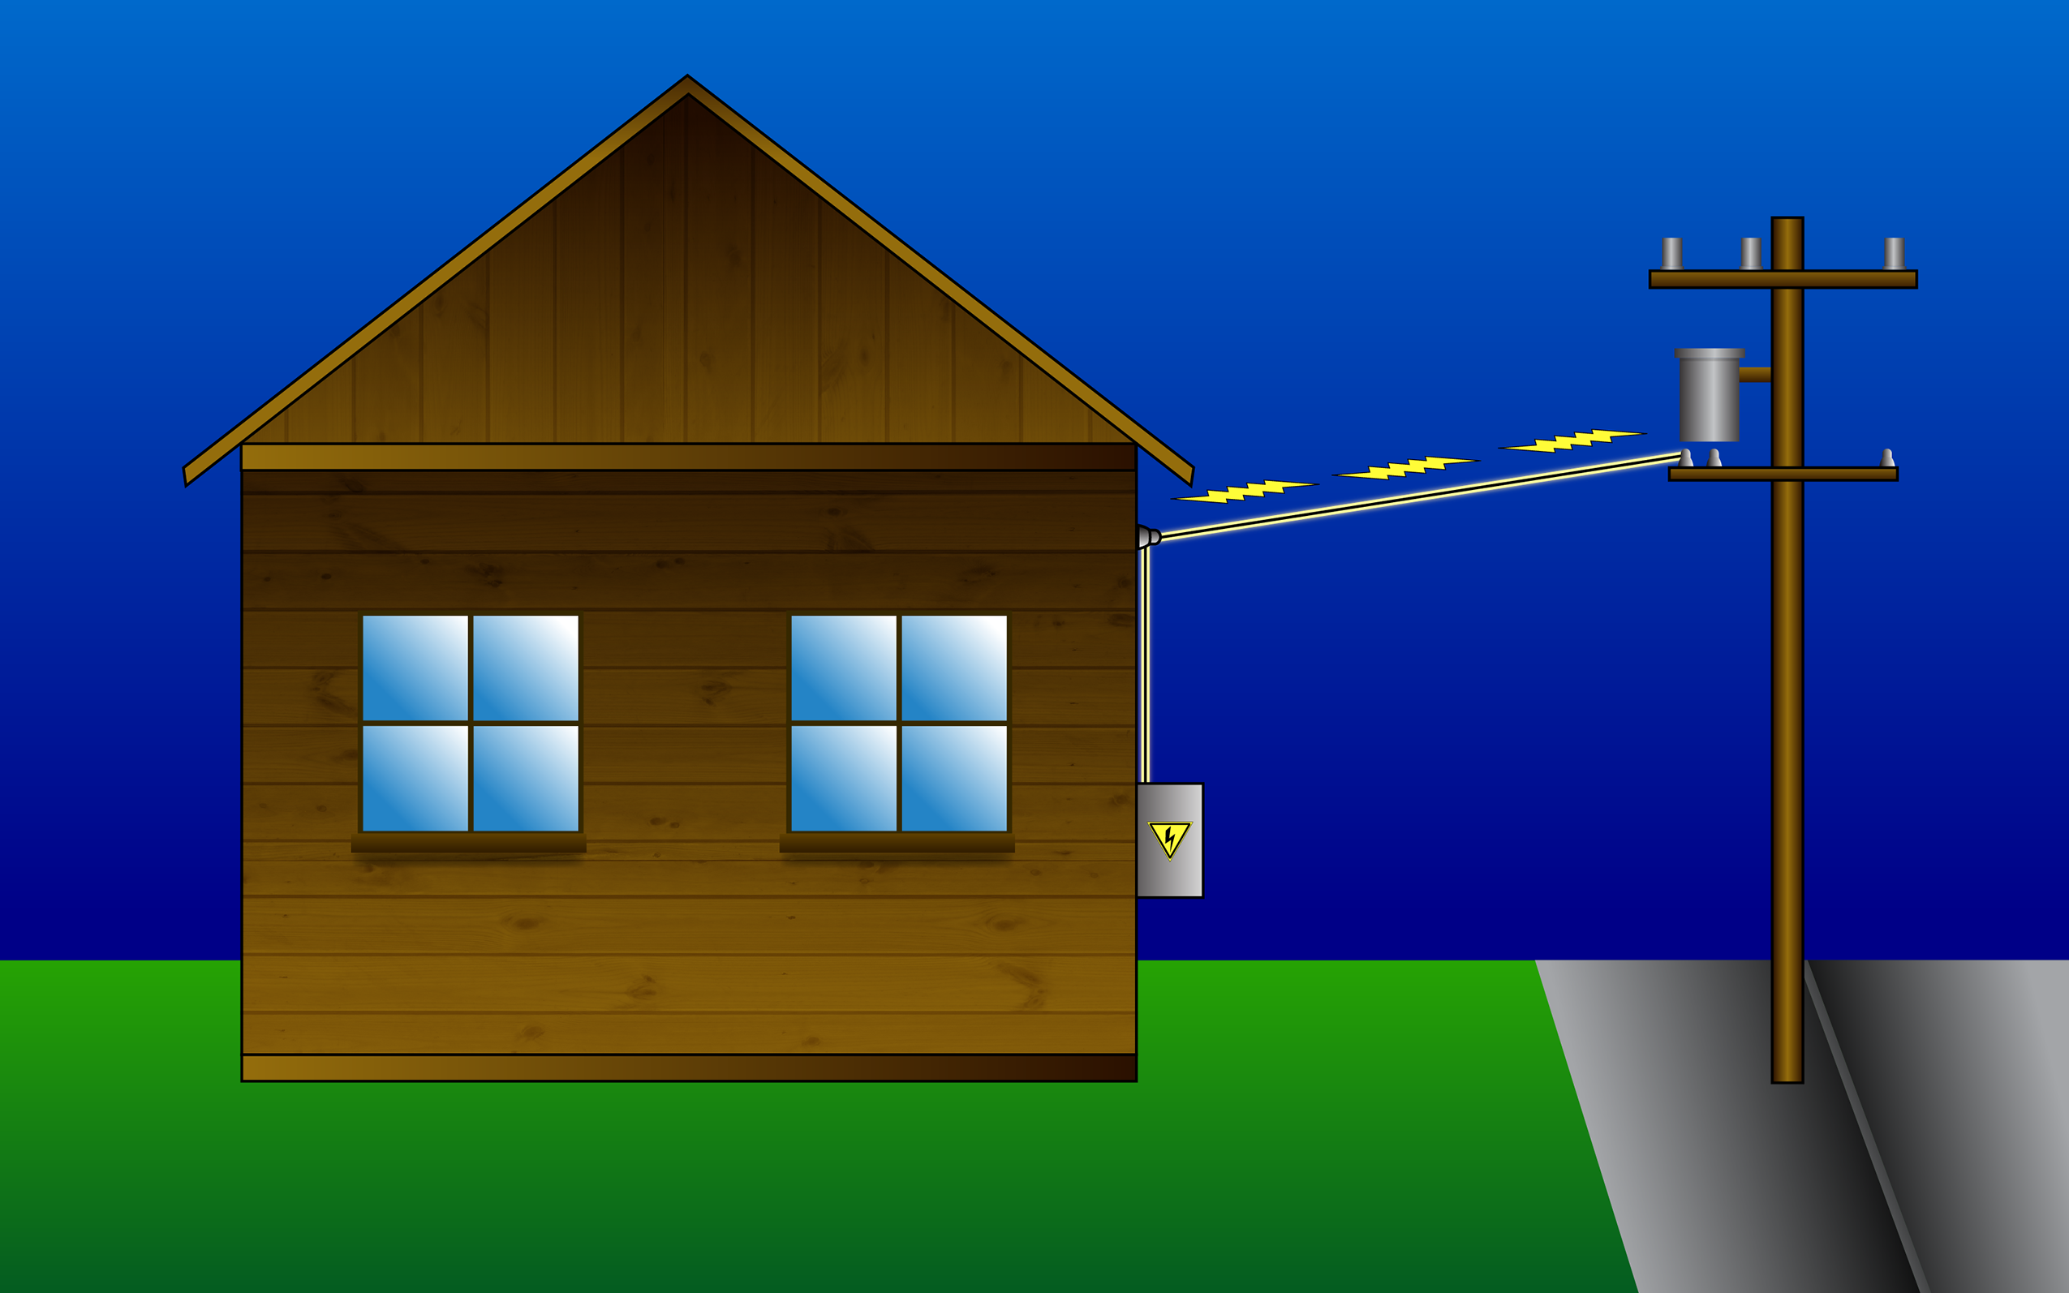
heater
internet.

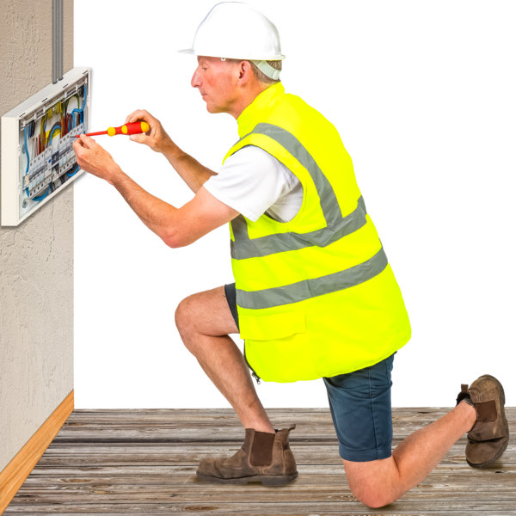
Repairs means fixing something broken.

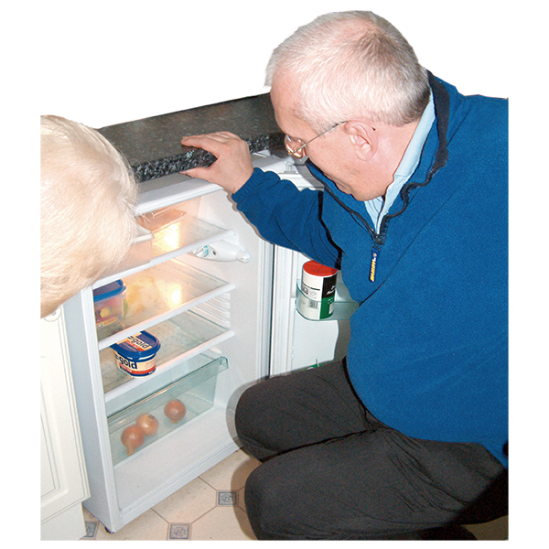
Work and Income might also be able to pay for new appliances if your old ones were damaged.
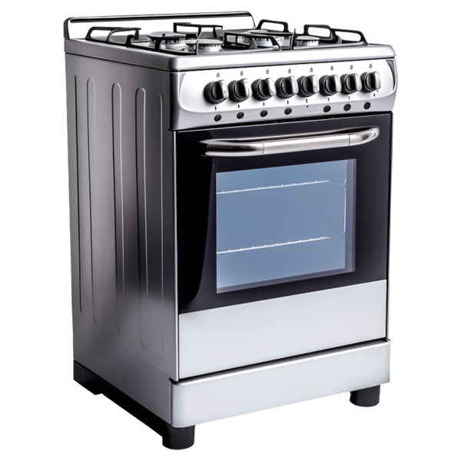

Appliances are things like:
fridges
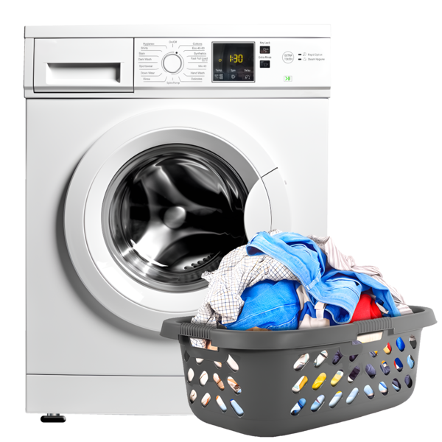
ovens
washing machines.
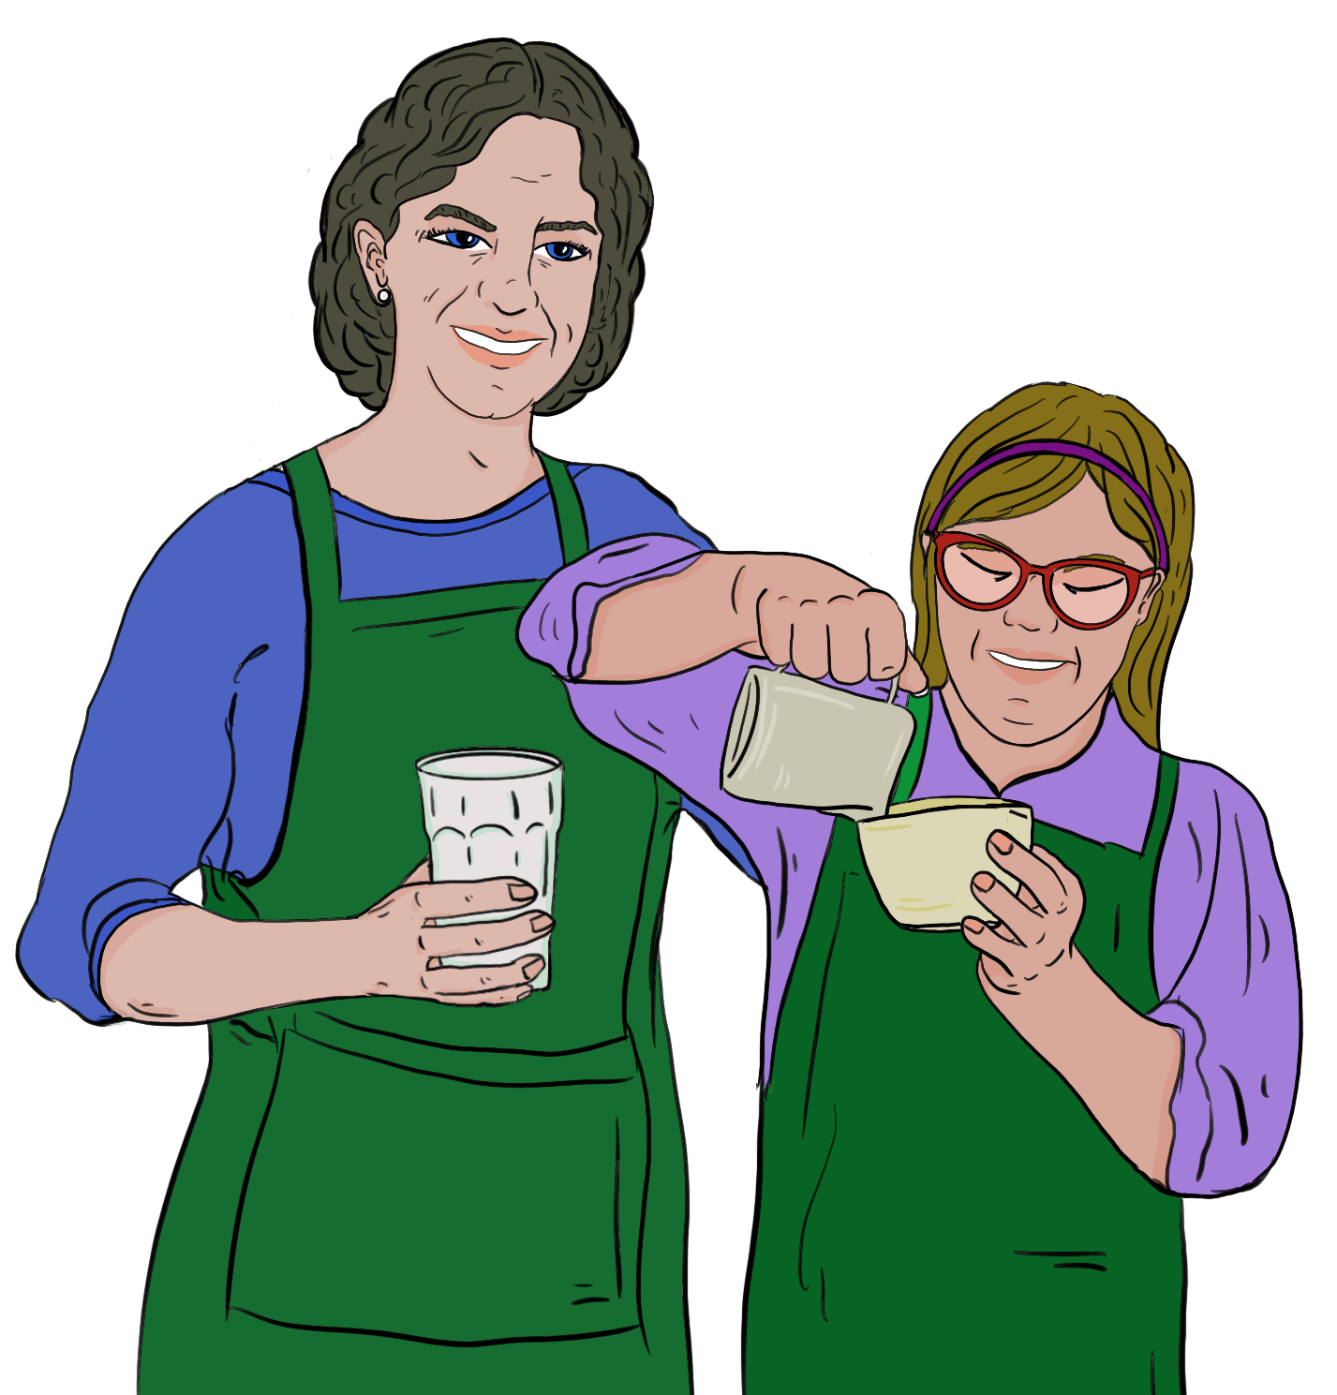

Work and Income might be able to support you even if you have a job.

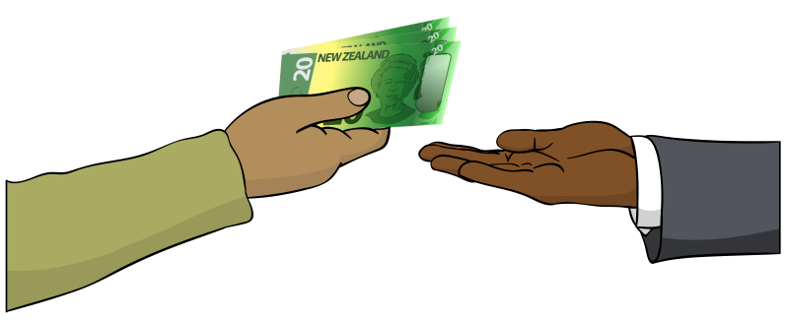
Sometimes you have to pay the money back to Work and Income.

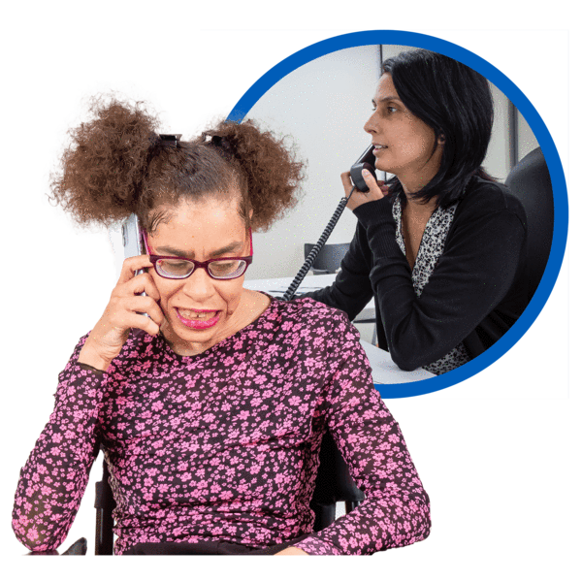
Talk to Work and Income to find out:
what support they can give you
if you have to pay the money back.


You can phone Work and Income on:

0800 559 009

You can visit their website at:

www.workandincome.govt.nz/

This website is not in Easy Read.

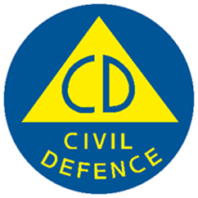
This information has been written by the National Emergency Management Agency and contributed to by participating agencies.


It has been translated into Easy Read by the Make it Easy Kia Māmā Mai service of People First New Zealand Ngā Tāngata Tuatahi.

The ideas in this document are not the ideas of People First New Zealand Ngā Tāngata Tuatahi.

All images used in this Easy Read document are subject to copyright rules and cannot be used without permission.


Make it Easy uses images from:


- Photosymbols

- Change Images


- Huriana Kopeke-Te Aho

- SGC Image Works

- T Wood


- Studio Rebeko

- Inga Kramer.

