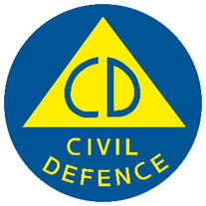
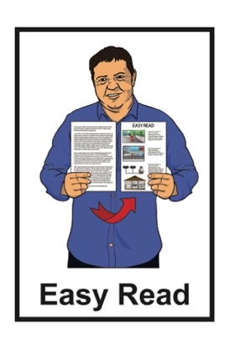

Getting support in an emergency: Healthcare
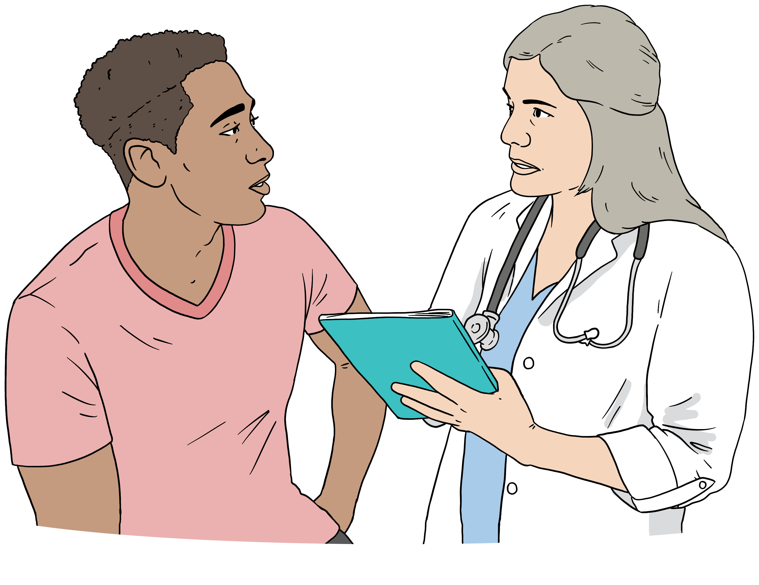

Version 1
Published: November 2025

Before you start

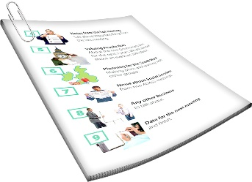
This is a long document.

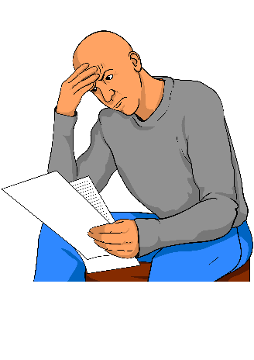
It can be hard for some people to read a document this long.

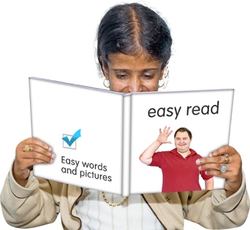
Some things you can do to make it easier are:
read it a few pages at a time
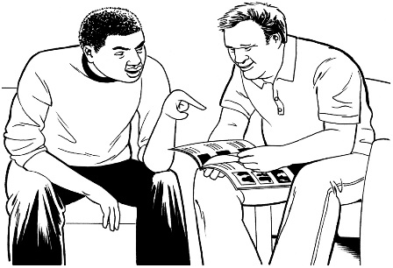
set aside some quiet time to look at it
have someone read it with you to support you to understand it.

What you will find in here


Page number:

About this Easy Read 3
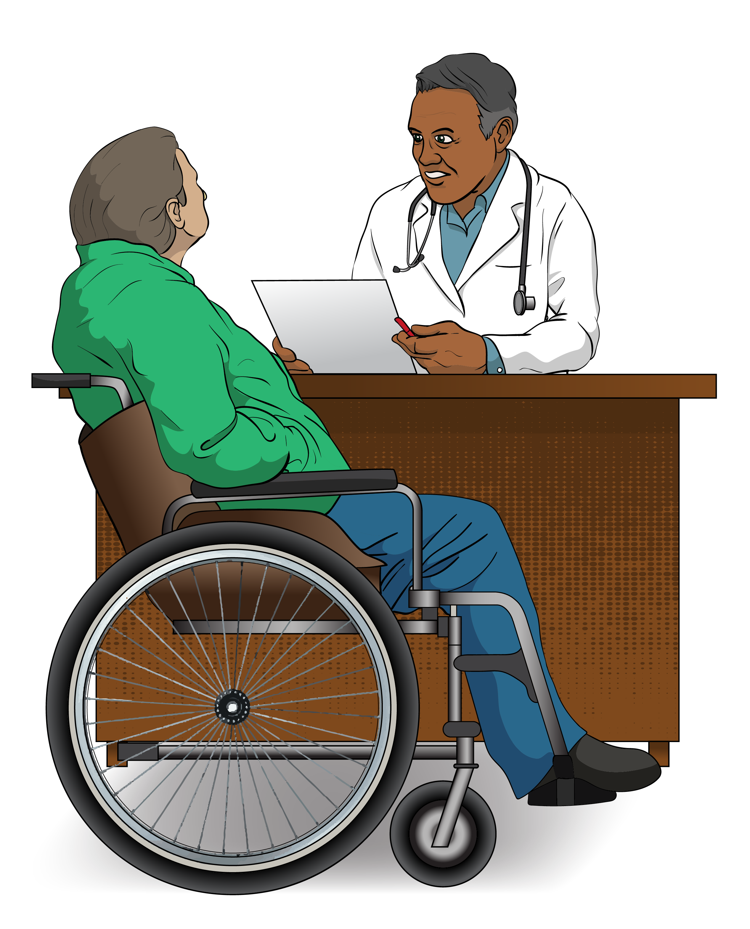

What to do right now 6

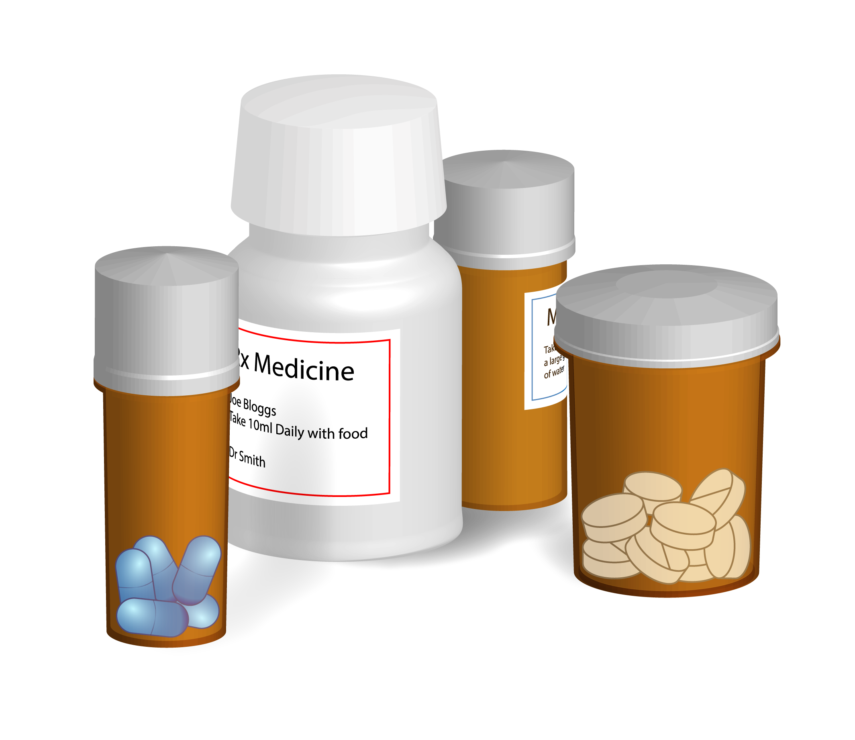
Talking to a doctor / nurse 9

Prescription medicine 15
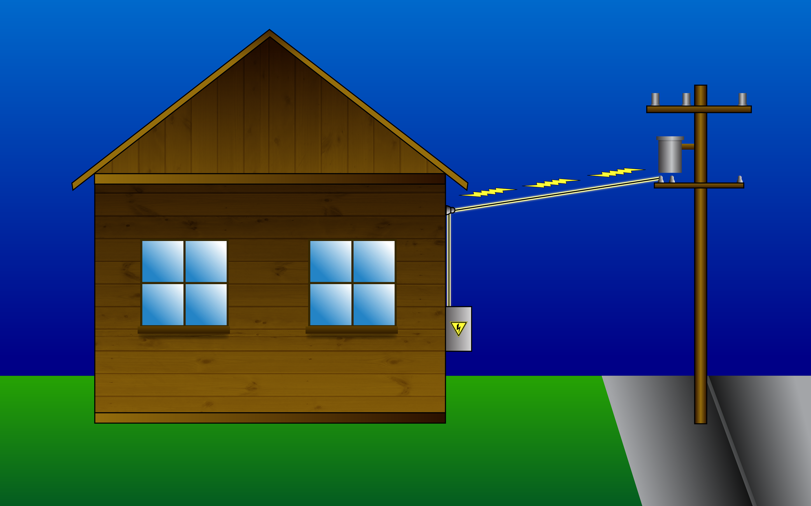

Power 17
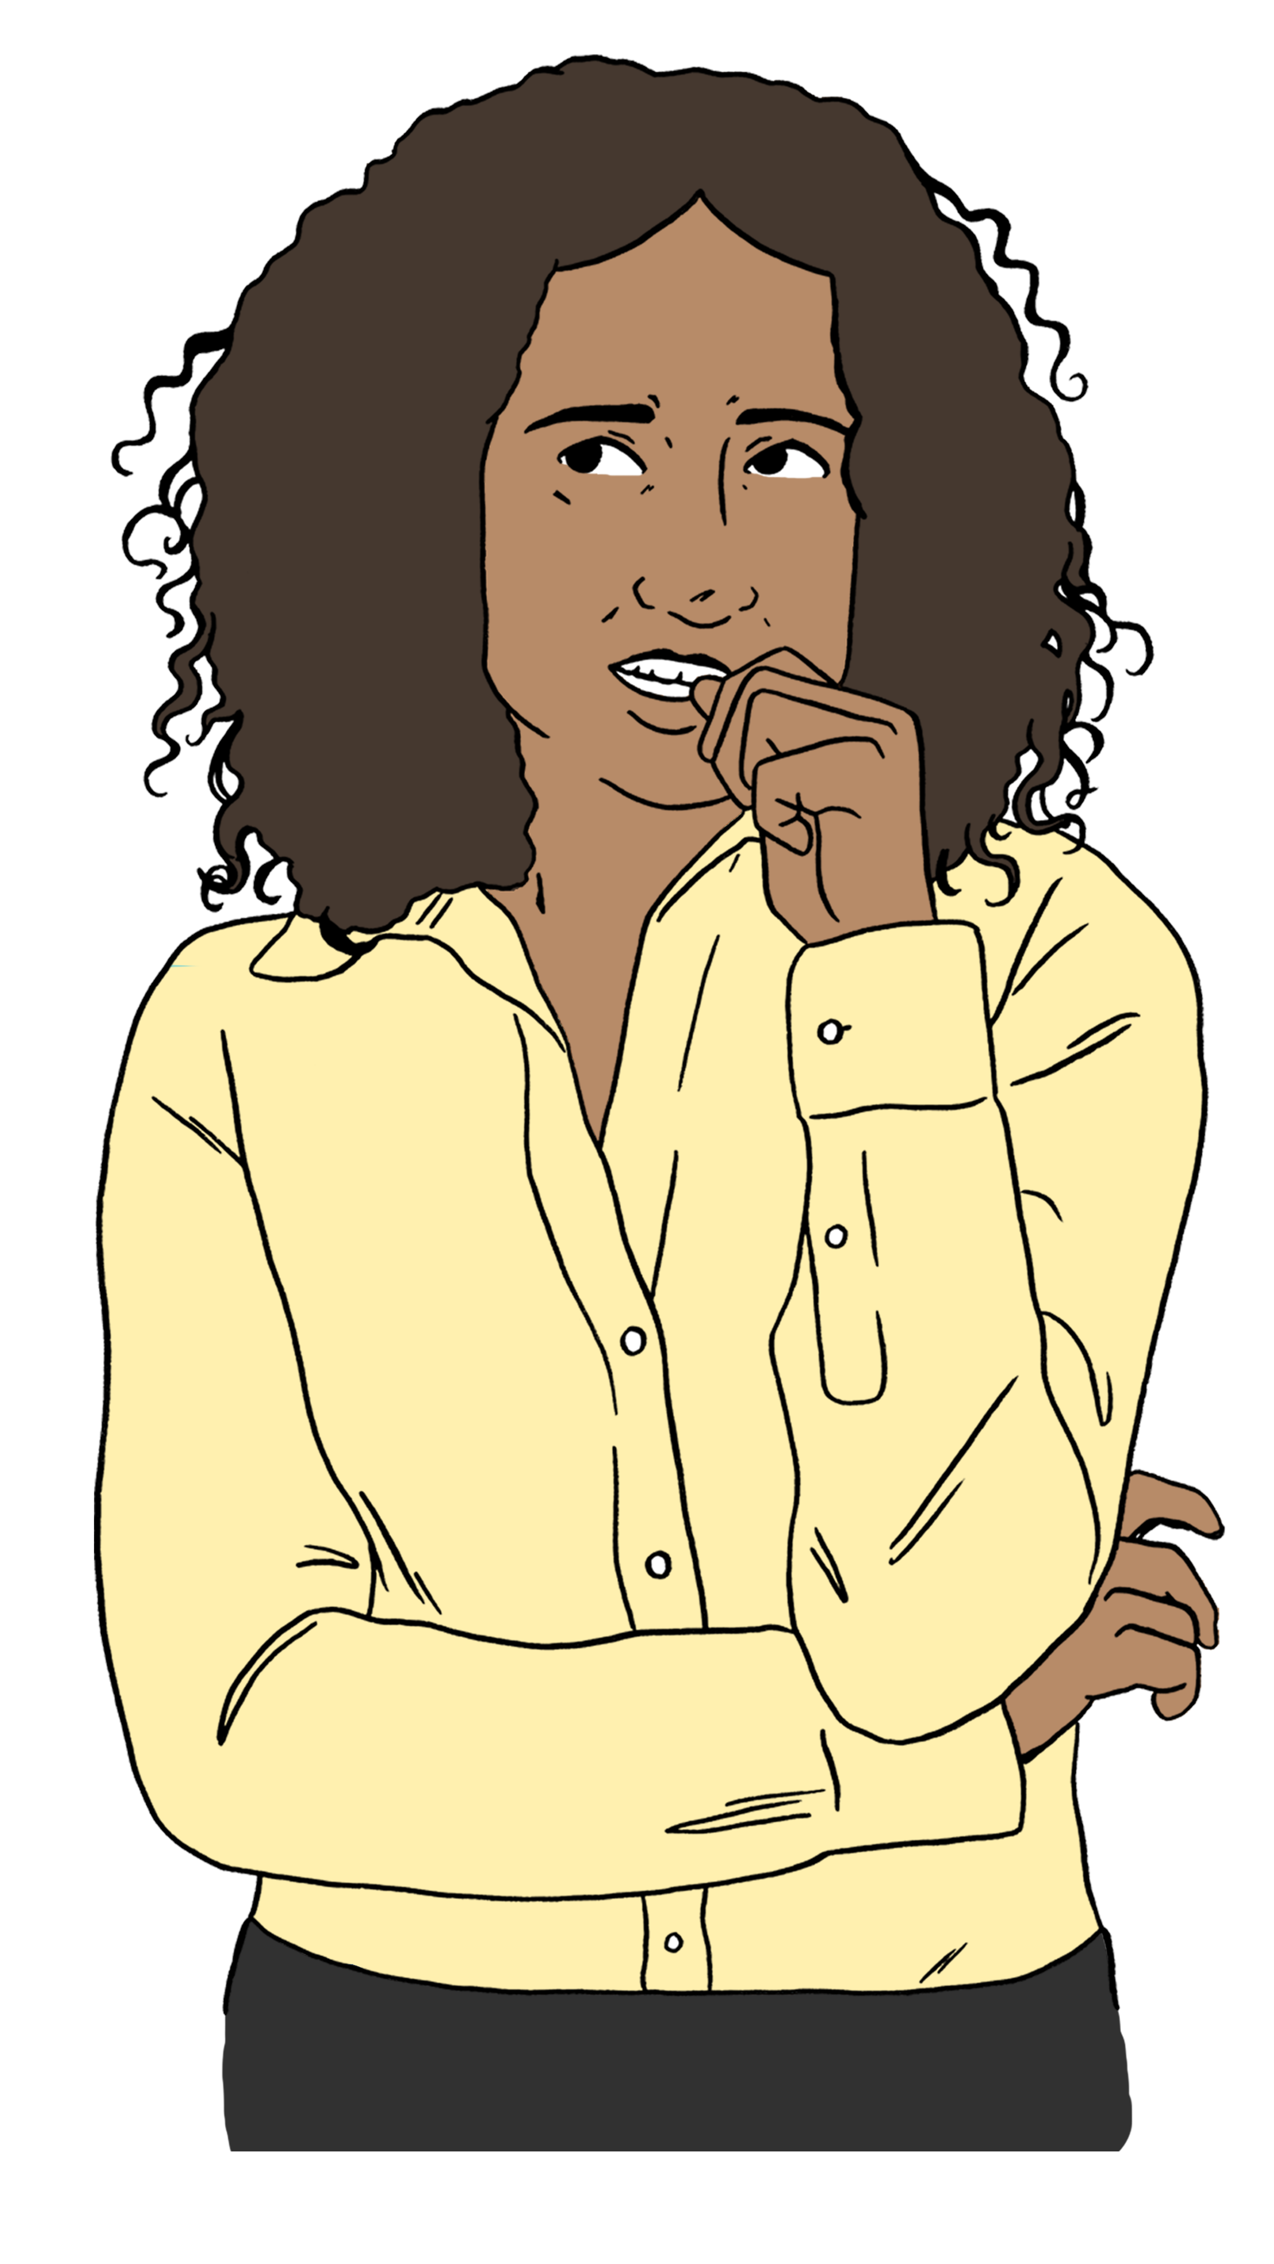

Mental health 19

About this Easy Read

This Easy Read tells you how to get healthcare after an emergency.

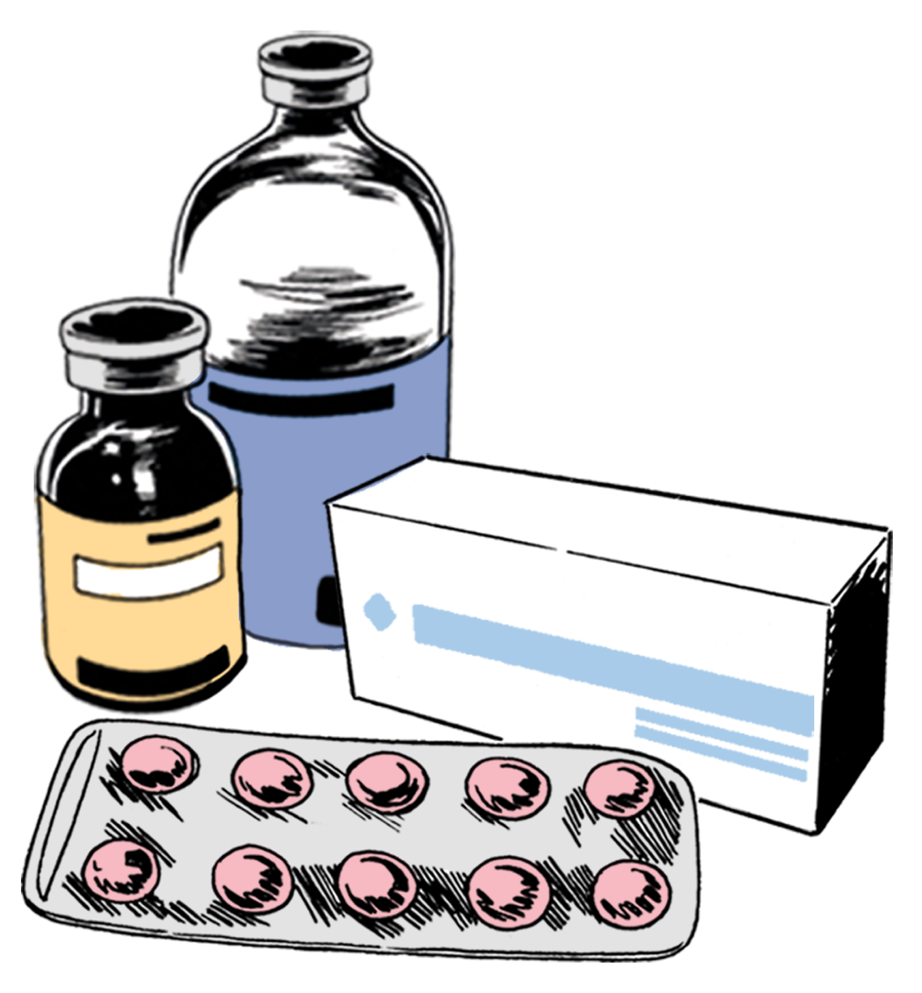
Healthcare means looking after
your health like:
going to the doctor
taking medicine.

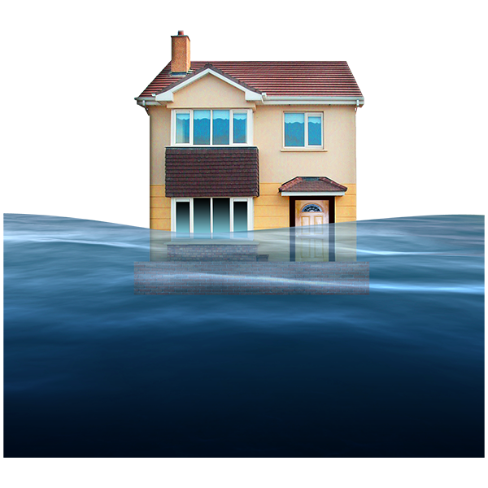
An emergency is when something dangerous happens that can put people at risk like:
an earthquake
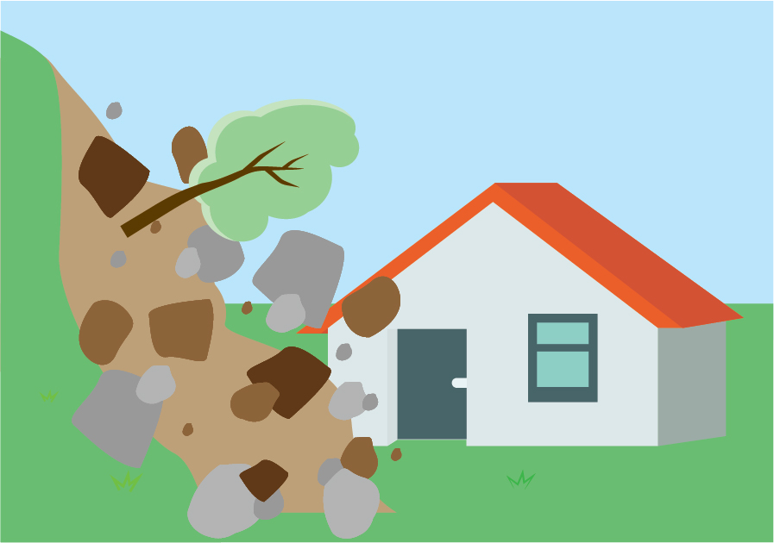
a flood
a storm
a landslide.

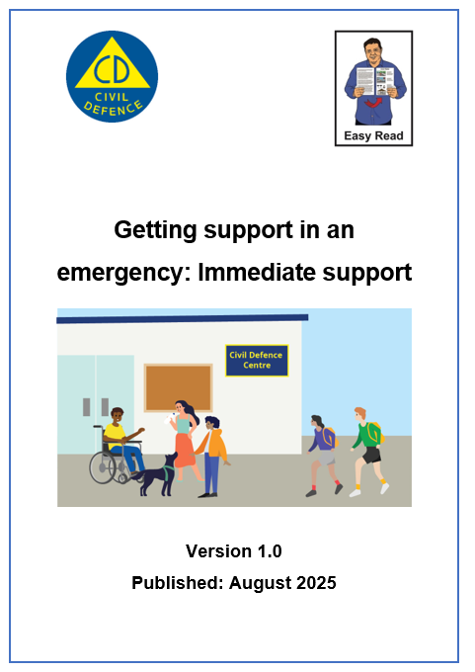
You can find important information about what happens after an emergency in Easy Read at:

https://tinyurl.com/aog-immediate

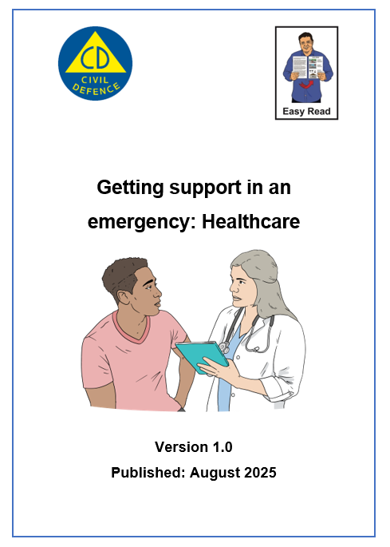
You can find information about how to get healthcare after an emergency in Easy Read at:

https://tinyurl.com/aog-health
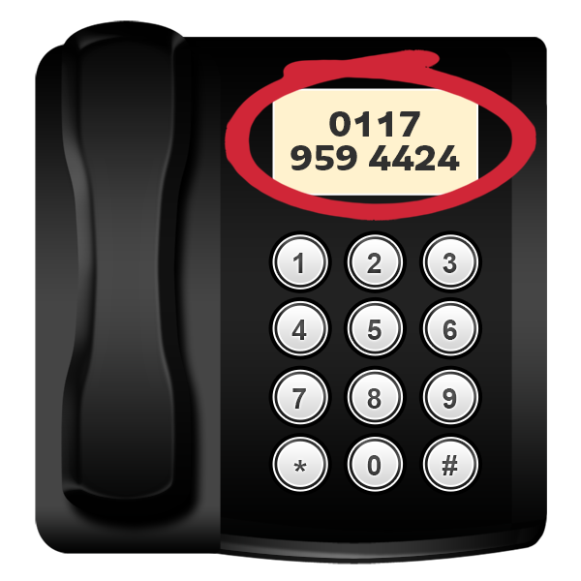
This Easy Read has lots of phone numbers in it.


If you find it hard to use the phone the New Zealand Relay service is for people who are:

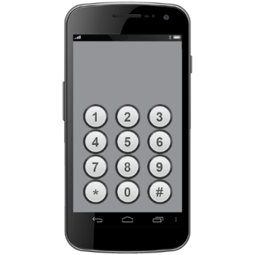
- Deaf / hard of hearing

- deafblind

- speech impaired / find it hard to talk.

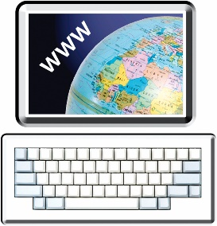
You can find out more about the New Zealand Relay service at:

www.nzrelay.co.nz/index

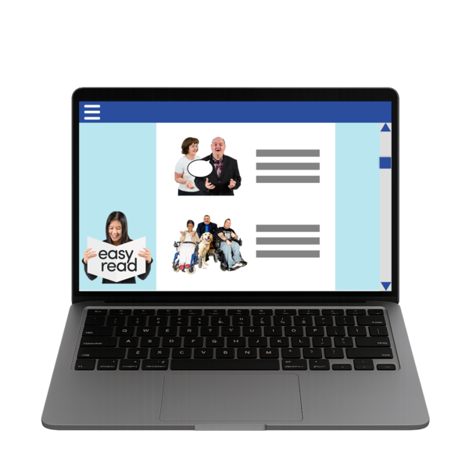
You can find out more about how to get ready for an emergency in Easy Read at:

https://tinyurl.com/2w2ykrzu

What to do right now

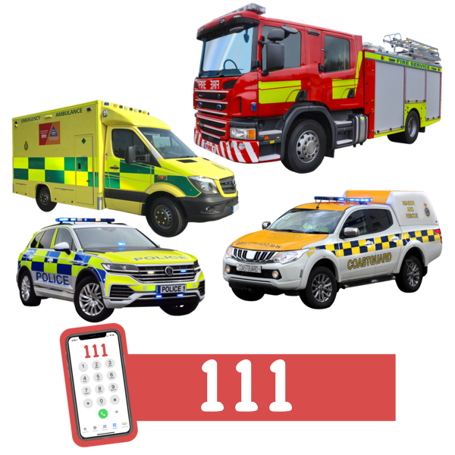
Phone 111 if you are in danger right now.

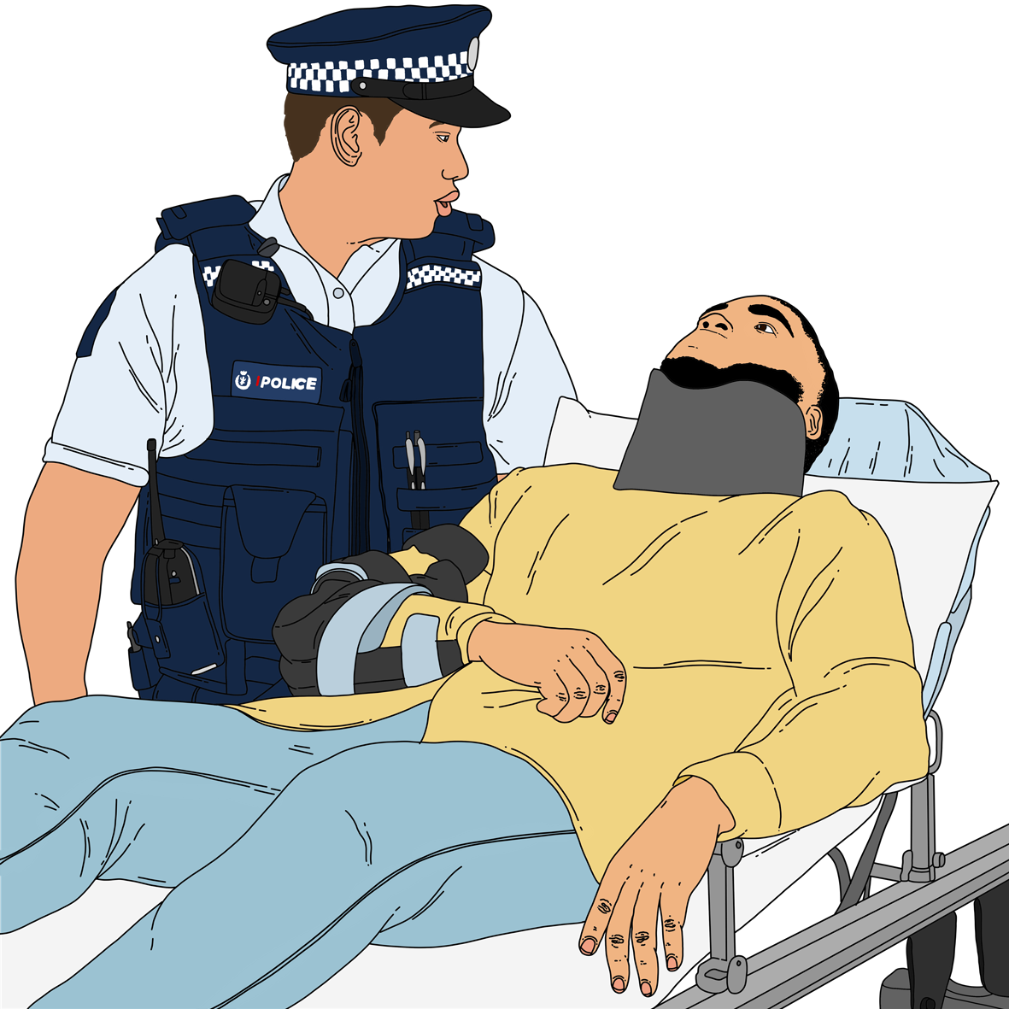
Being in danger means you might:
die
get badly hurt.

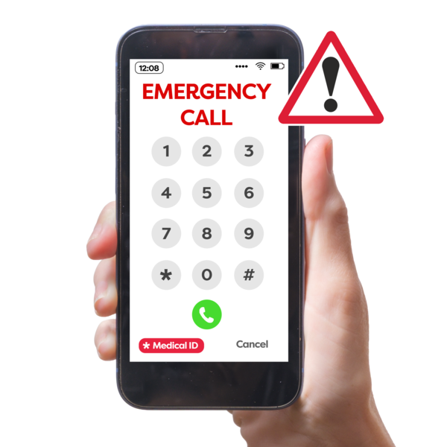
You can sign up to text 111 if you find it hard to:
hear
talk on the phone.


You can sign up to text 111 on this website:

www.police.govt.nz/111-txt

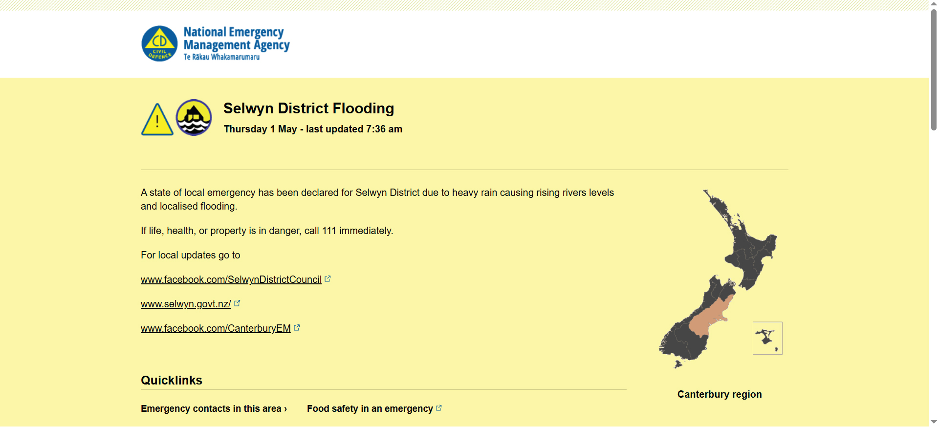
You can find new information about what is happening on this website:

www.civildefence.govt.nz/
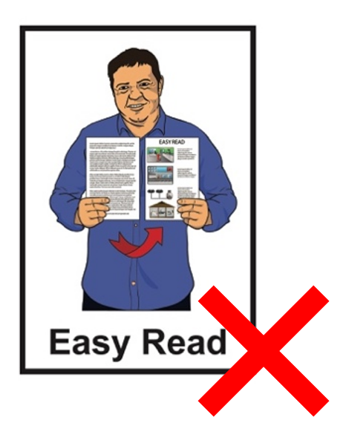

These websites are not in Easy Read.

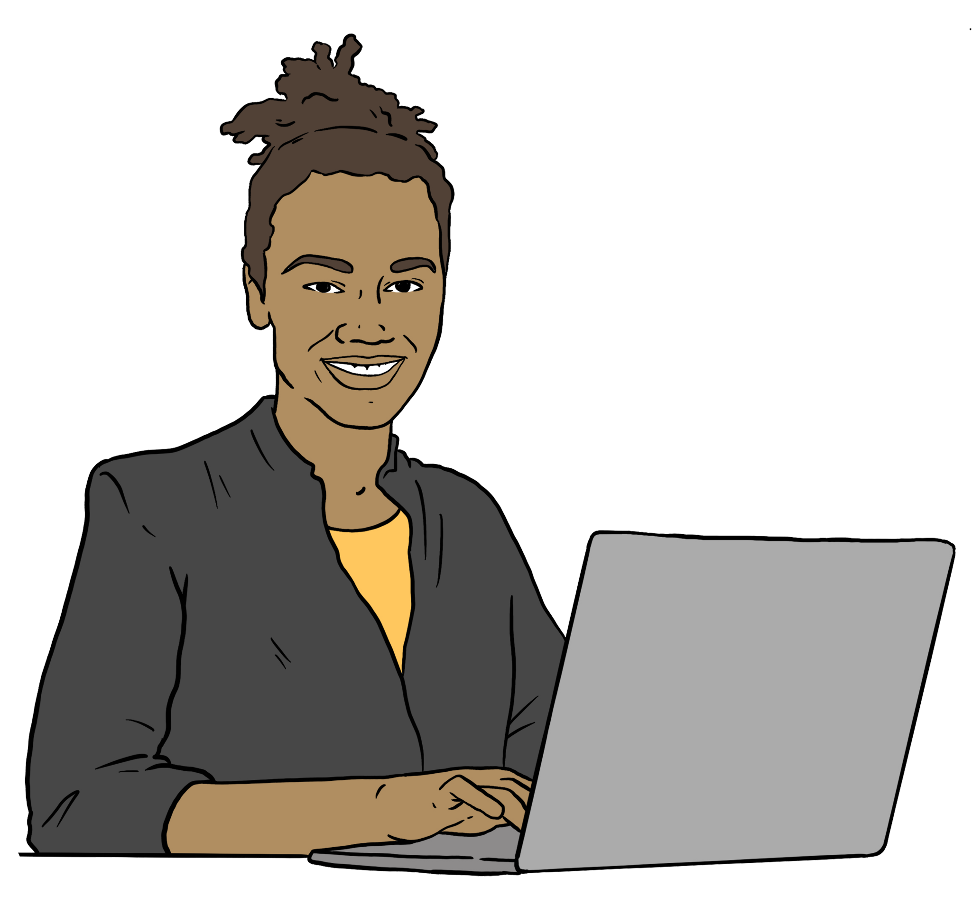
You can also find new information about what is happening by following your local Civil Defence Emergency Management Group on their:
website
social media.

Your local Civil Defence
Emergency Management Group is the part of the government that is in charge after an emergency.


Social media means websites /
apps like:
Facebook
X / Twitter.

You can find out how to contact your local Civil Defence Emergency Management Group on this website:

https://tinyurl.com/4u4bnp26

This website is not in Easy Read.

Talking to a doctor / nurse

You can talk to a health professional if you need to after an emergency.

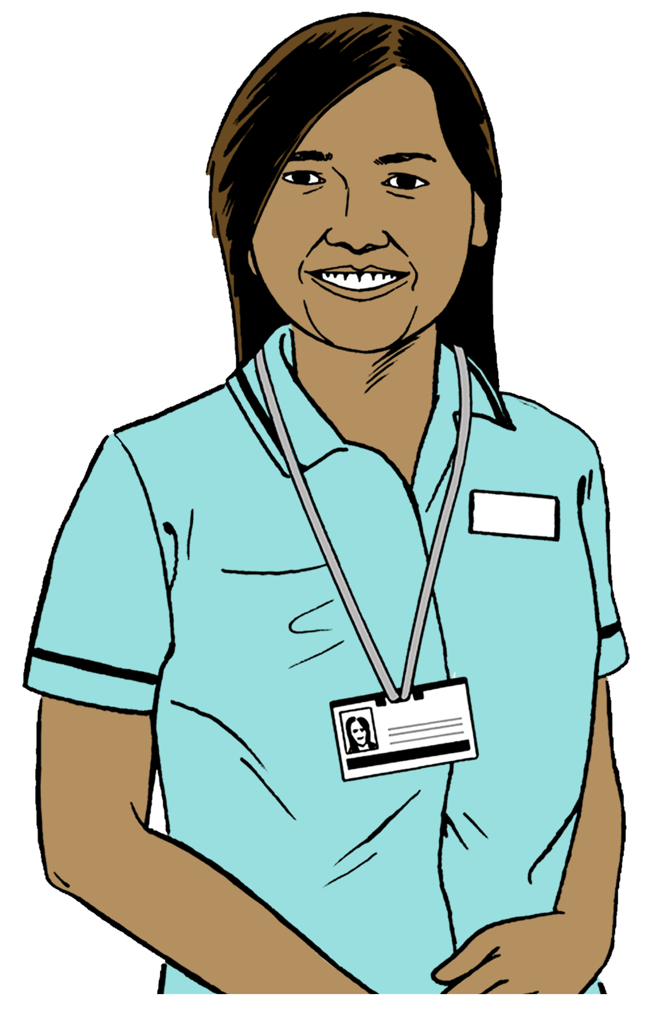
A health professional means someone who supports people with their health like a:
doctor
nurse.
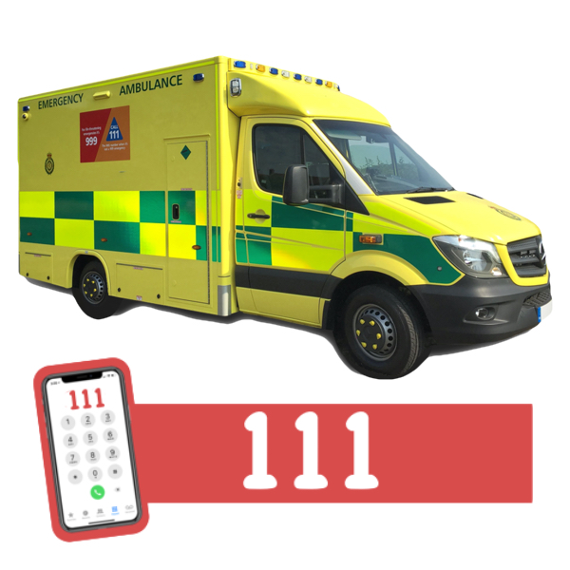

In an emergency:
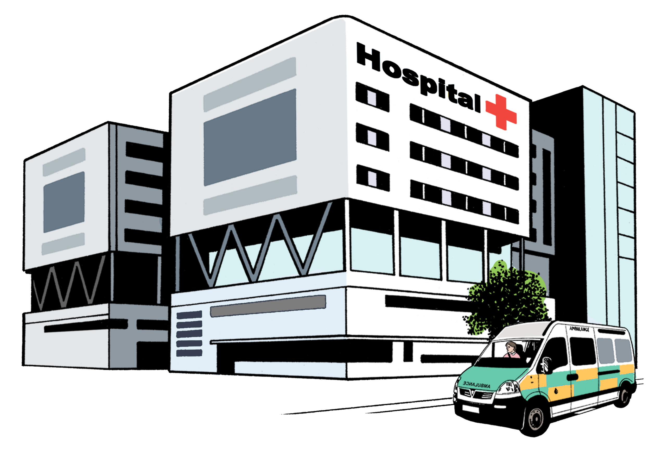
call 111
go to your nearest hospital.

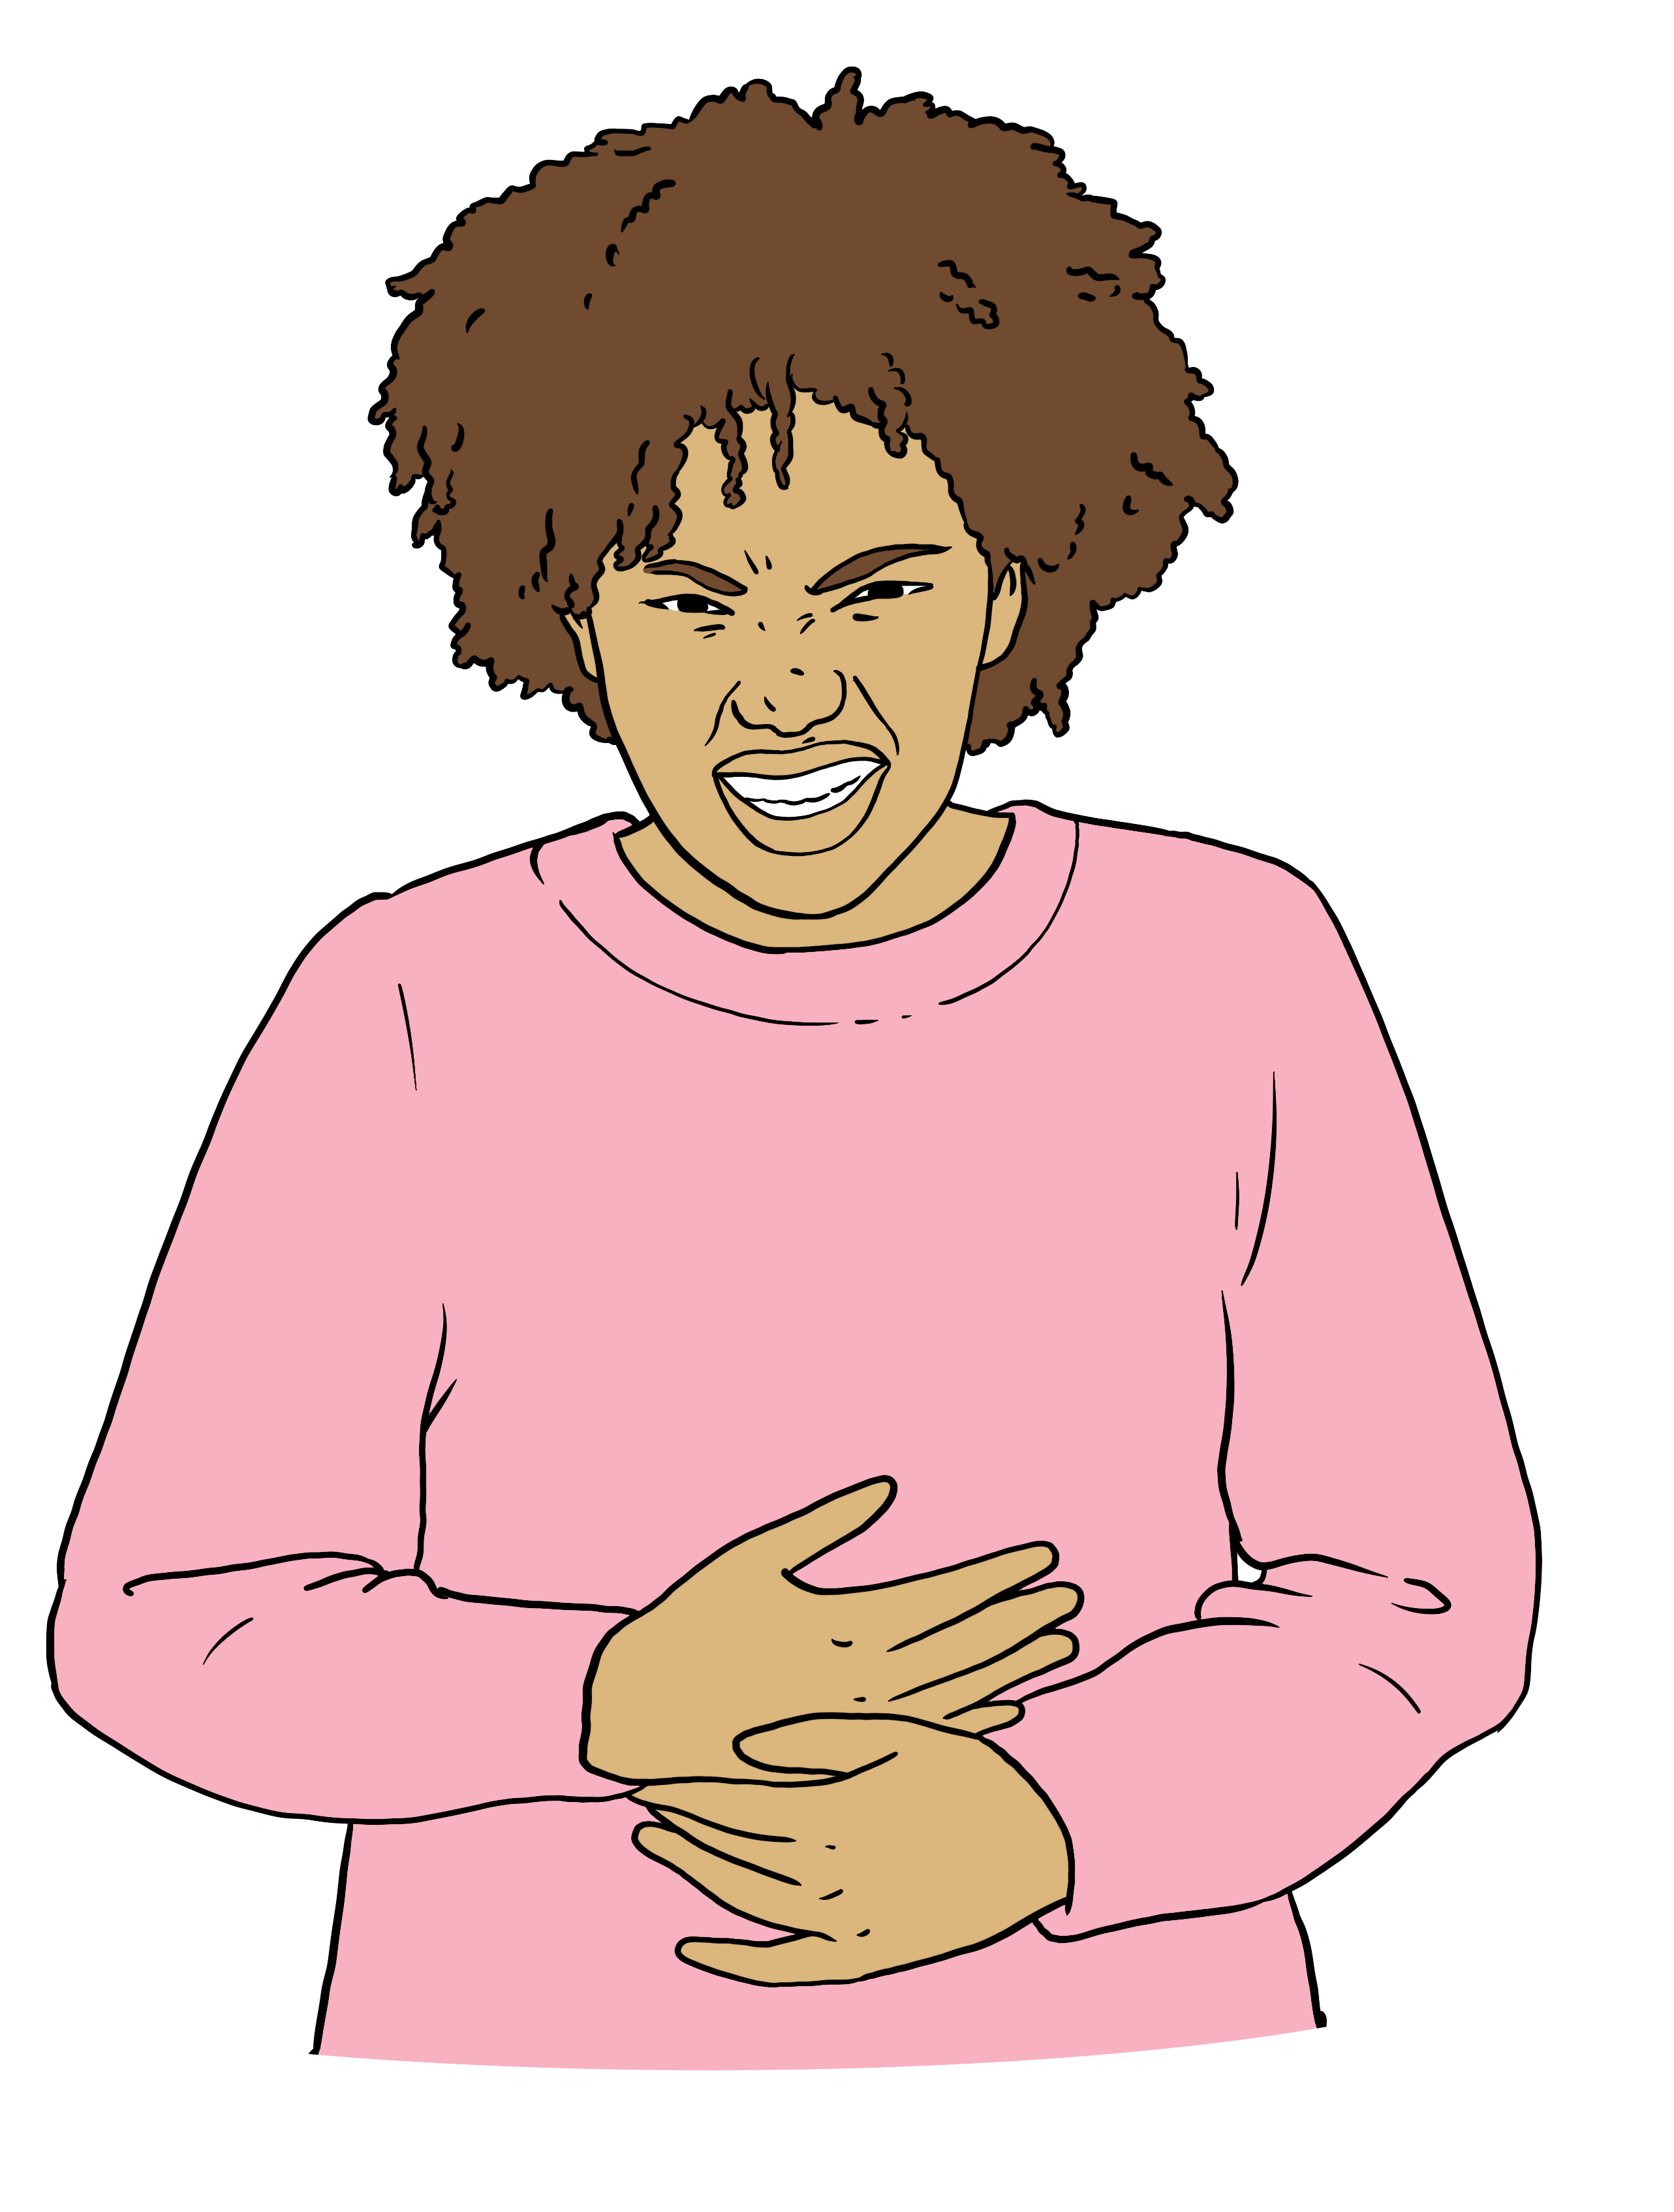
Here an emergency means you:
feel very sick
are badly hurt
need to see a doctor right now.

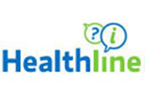
You can call Healthline if it is not an emergency.

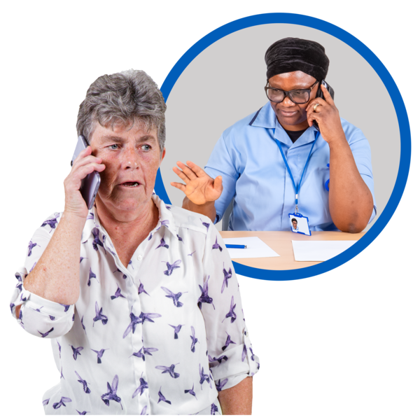
Healthline is a phone number you can call to talk to a health professional like a nurse.

They can tell you what to do if you have a health problem.

They will tell you if you need to go to the doctor.

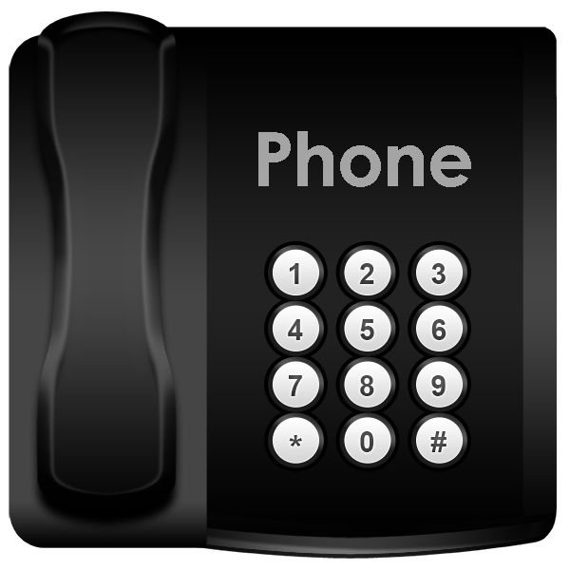
You can phone Healthline on:

0800 611 116
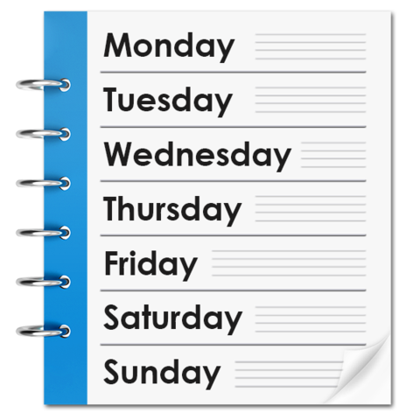

You can phone Healthline:
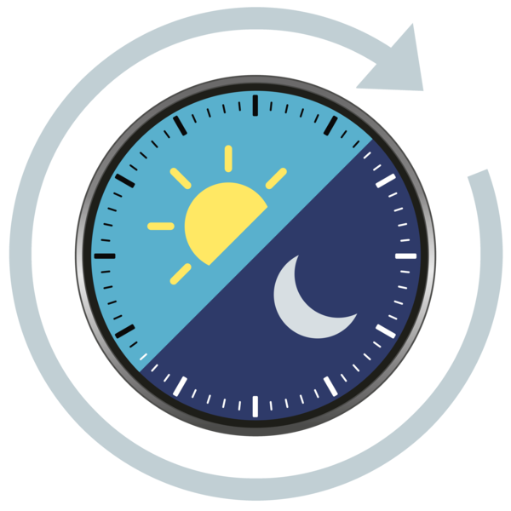
every day of the week
at any time of day / night.



It does not cost money to phone Healthline.

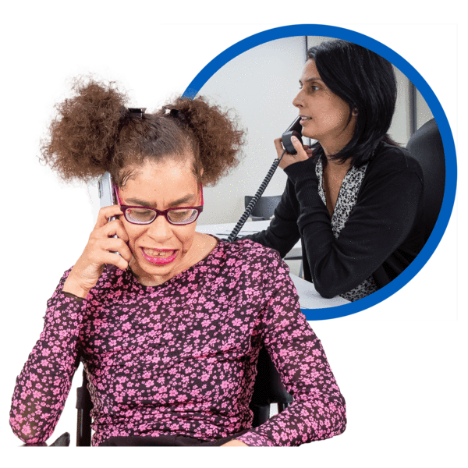
If you are disabled you can contact Whakarongorau Aotearoa.

Whakarongorau Aotearoa gives disabled people support with their health.

You can phone Whakarongorau Aotearoa on:

0800 111 213

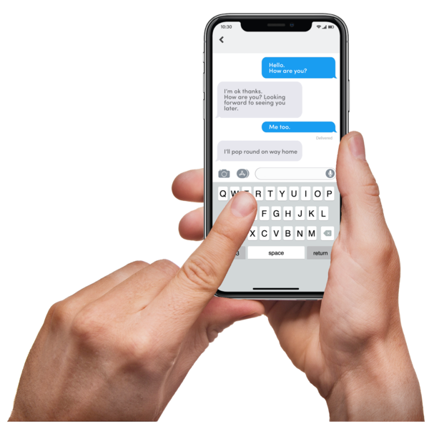
You can text Whakarongorau Aotearoa on:

8988

You can talk to your usual doctor if you have one.
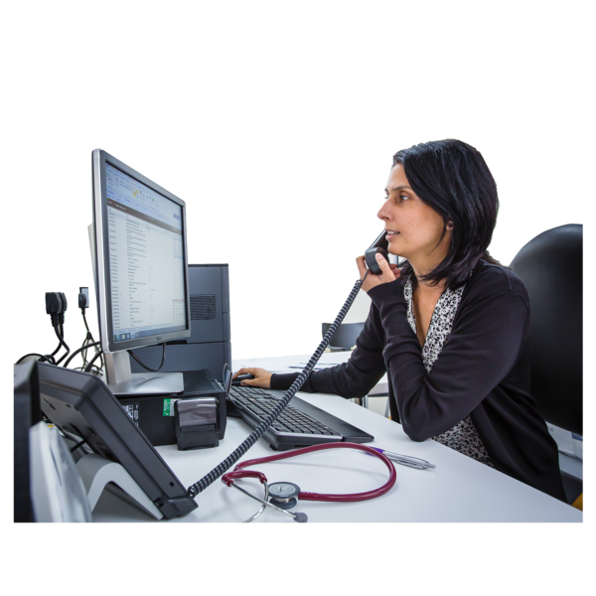

Phone your usual doctor to make a time to see them.
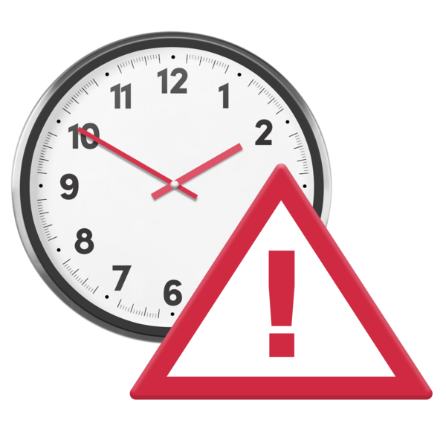

Tell them what is wrong so they can see you quickly if they need to.

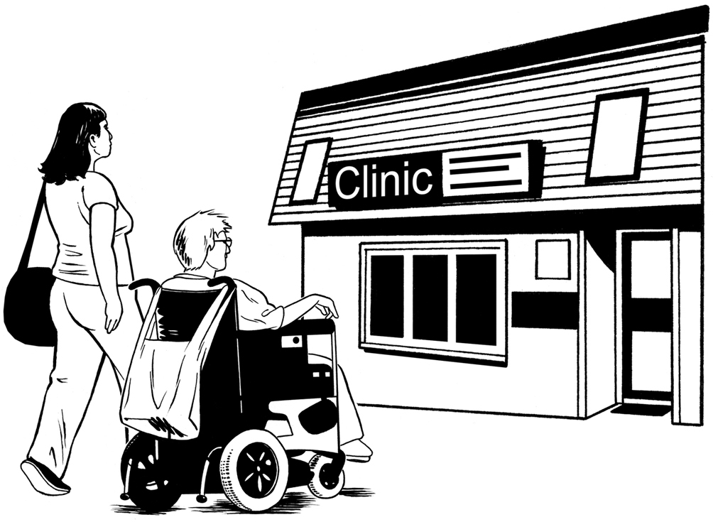
You can go to your local urgent care centre if:

you do not have a usual doctor
it will take too long to see your usual doctor.

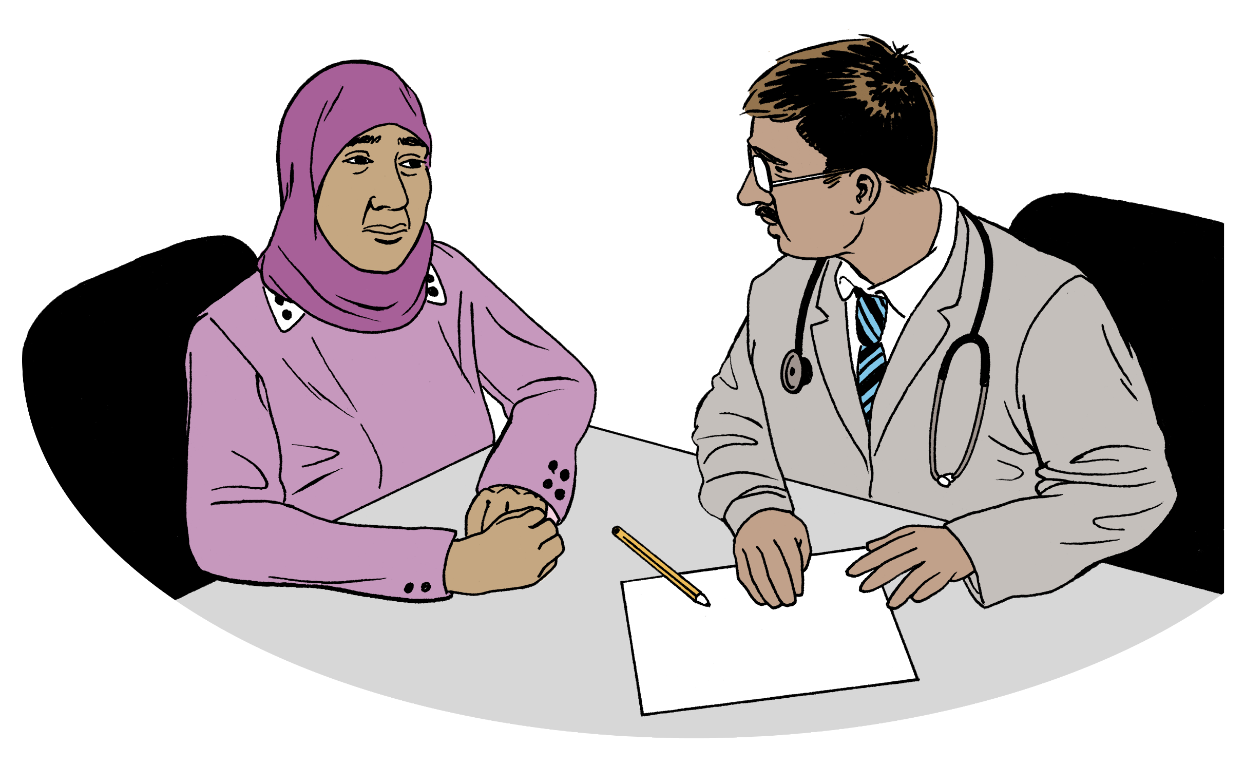
An urgent care centre is a place
you can see a doctor when you cannot see your usual doctor.

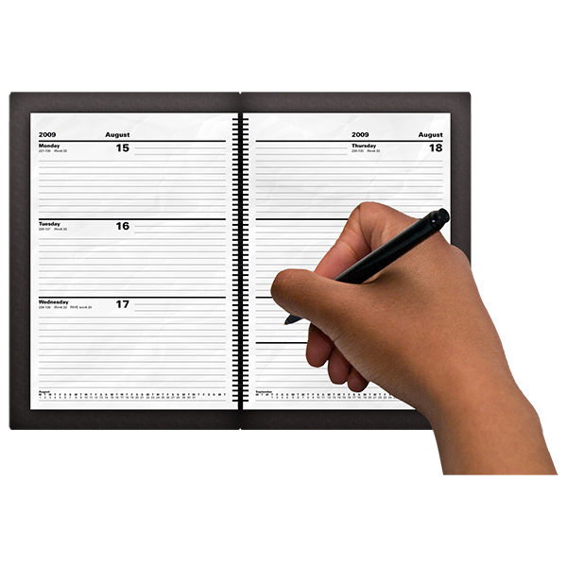
You do not need an appointment to go to an urgent care centre.

An appointment is when you set up a time to see someone like a doctor.
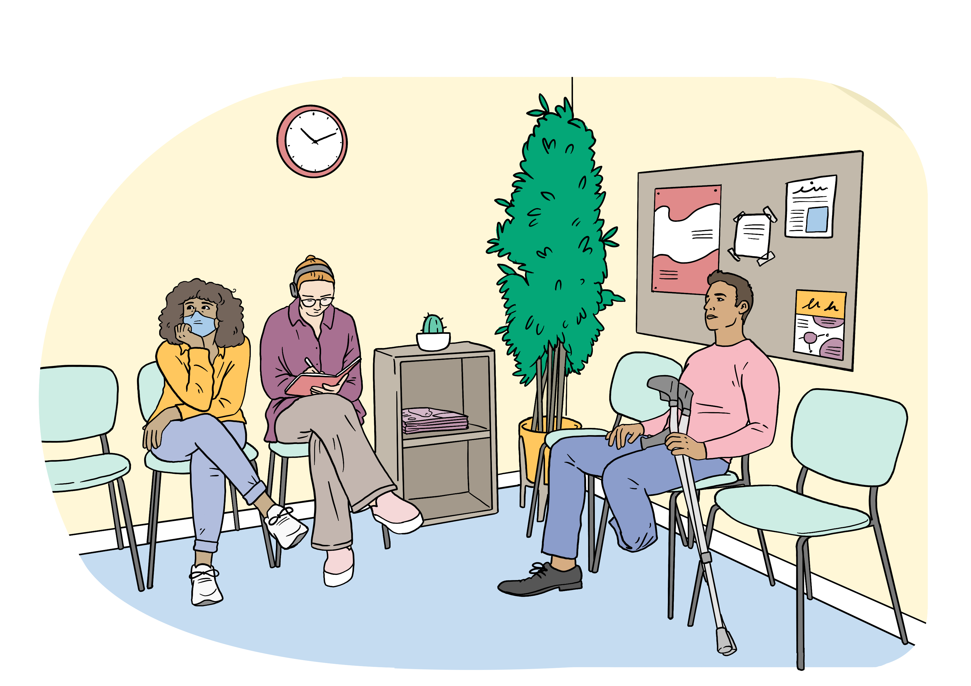

You might have to wait to see a doctor at the urgent care centre.

You can find an urgent care centre on this website:

https://tinyurl.com/yk29tnz3

This website is not in Easy Read.

Prescription medicine

Talk to a doctor if:
you run out of prescription medicine
you cannot get your prescription medicine.

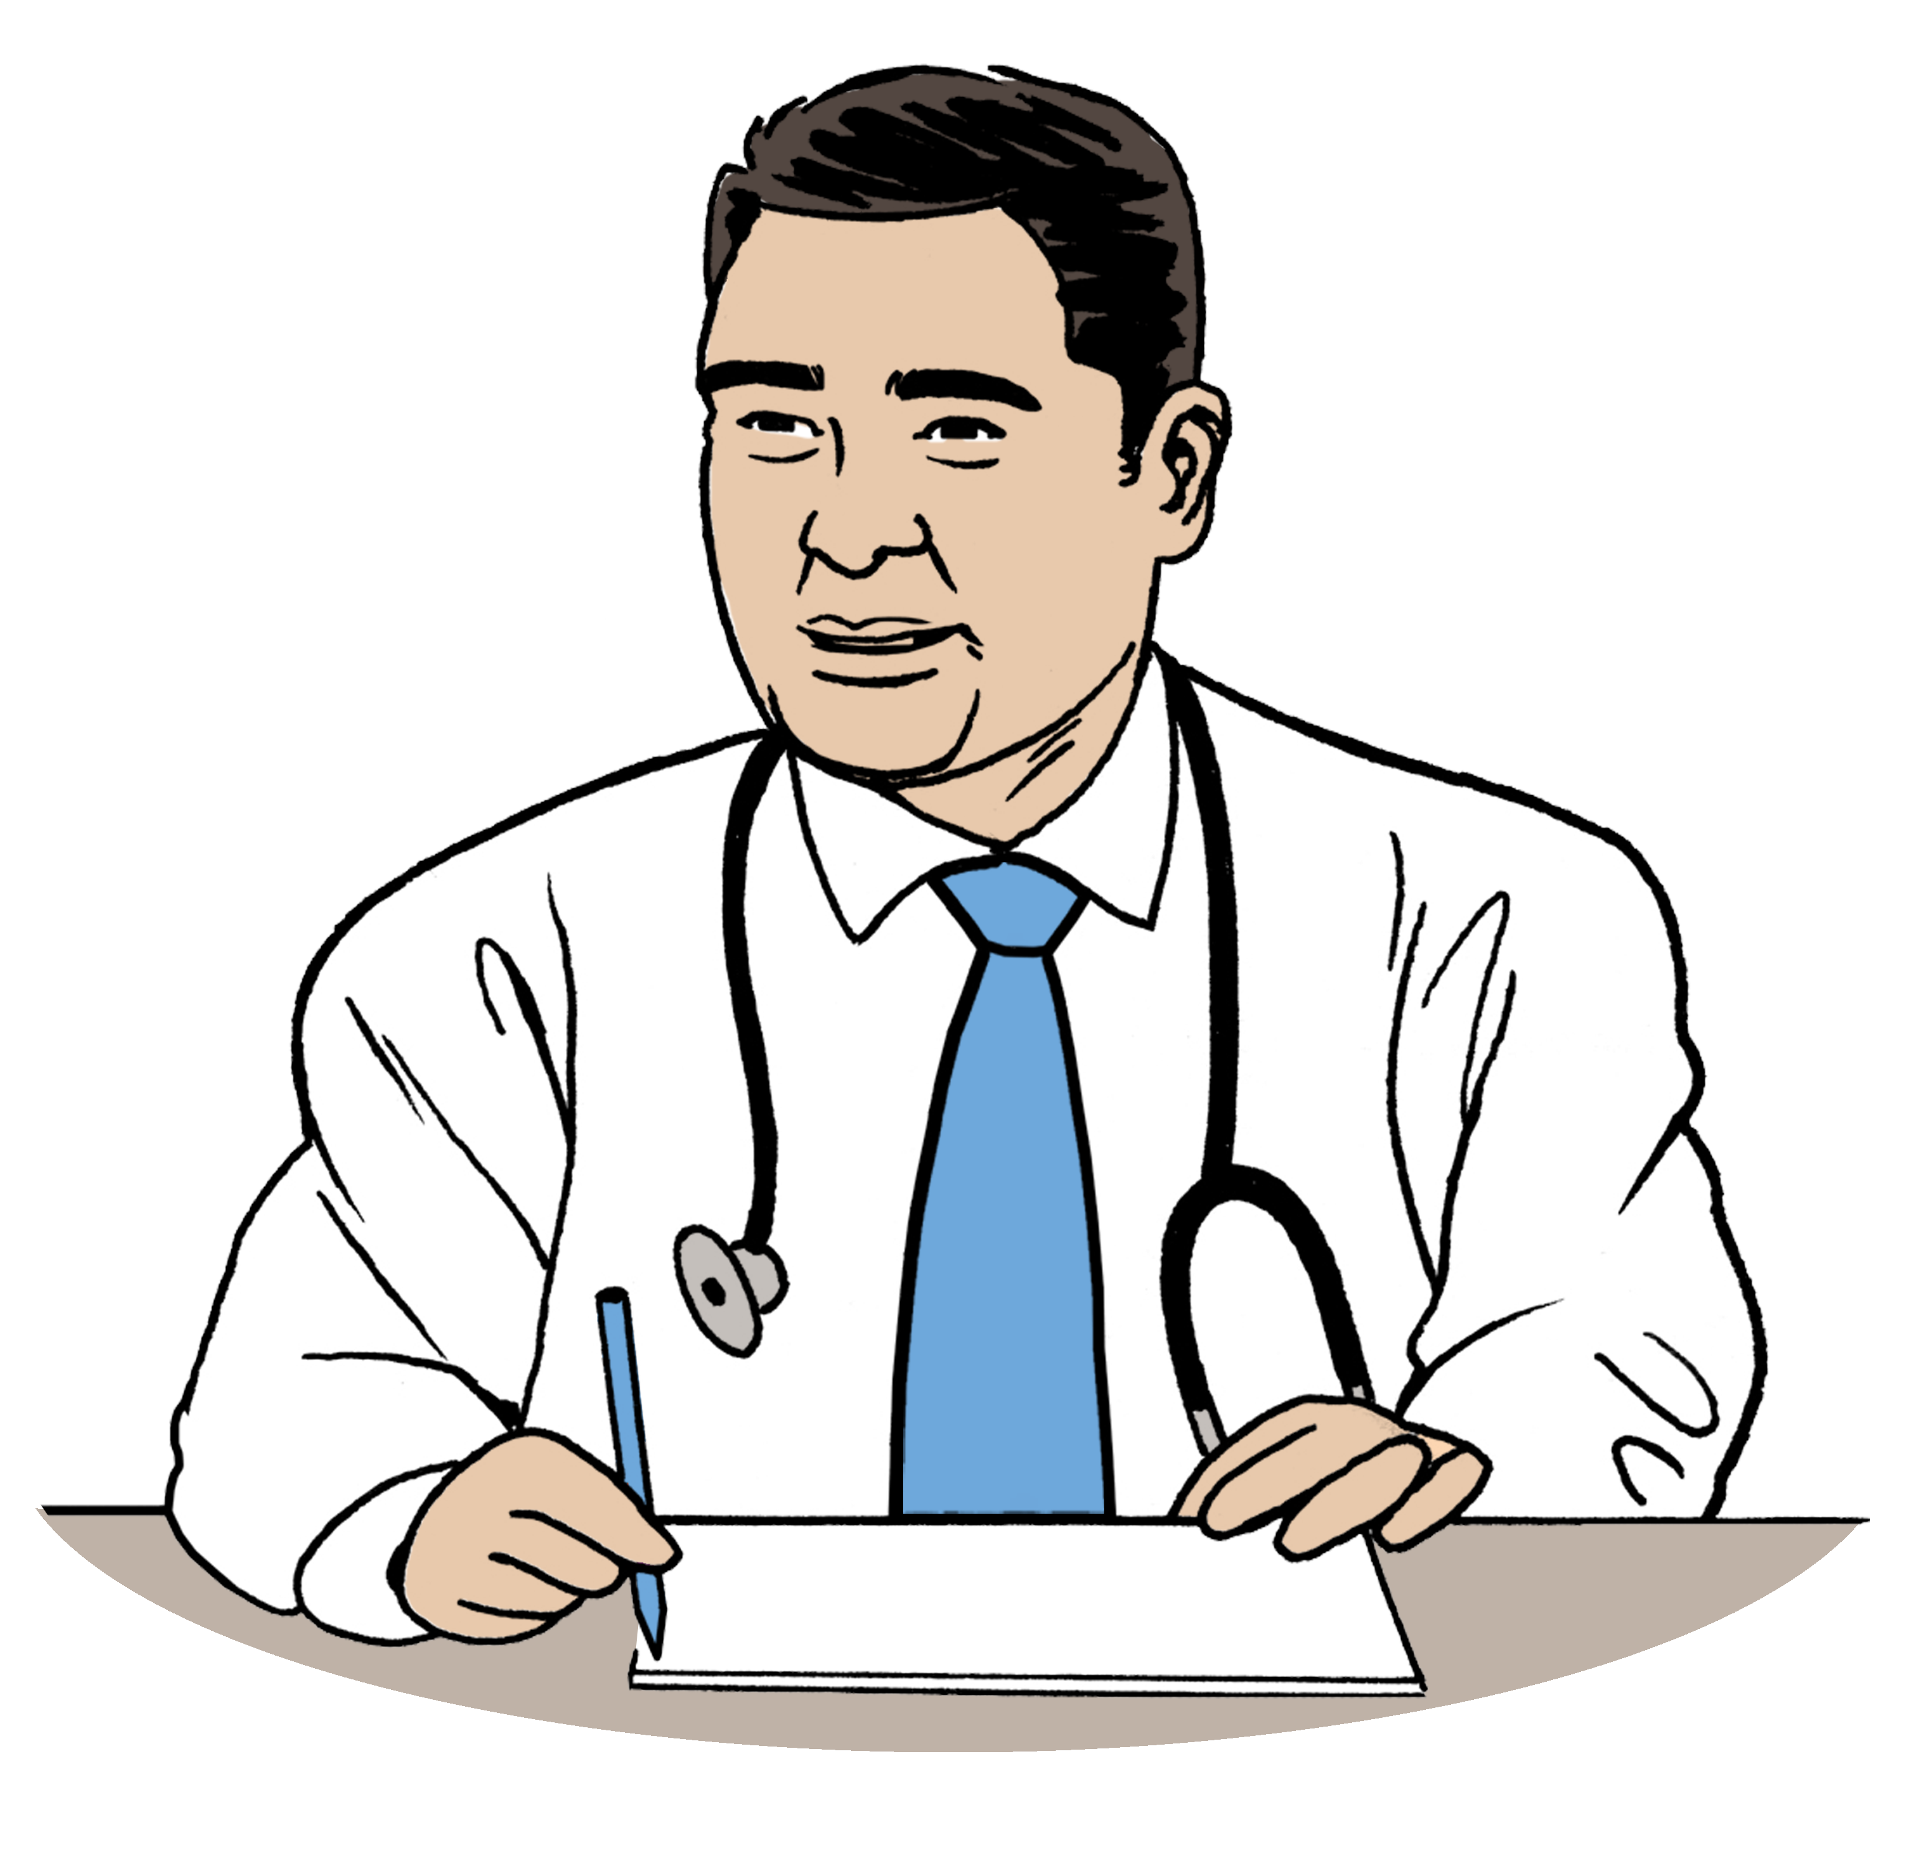
Prescription medicine is medicine
a doctor decides you need.

The doctor writes a note called a script so you can get the
prescription medicine.

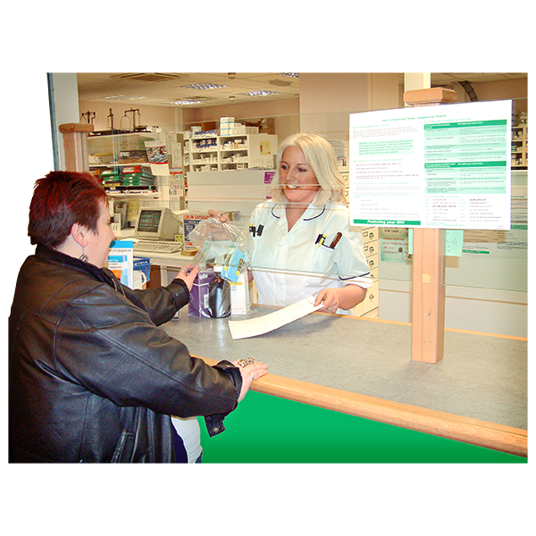
If you cannot talk to a doctor a pharmacy might be able to support you.
A pharmacy is a shop where you
get medicine.

The pharmacy can give you an emergency supply of medicine.

An emergency supply is enough medicine for 3 days.
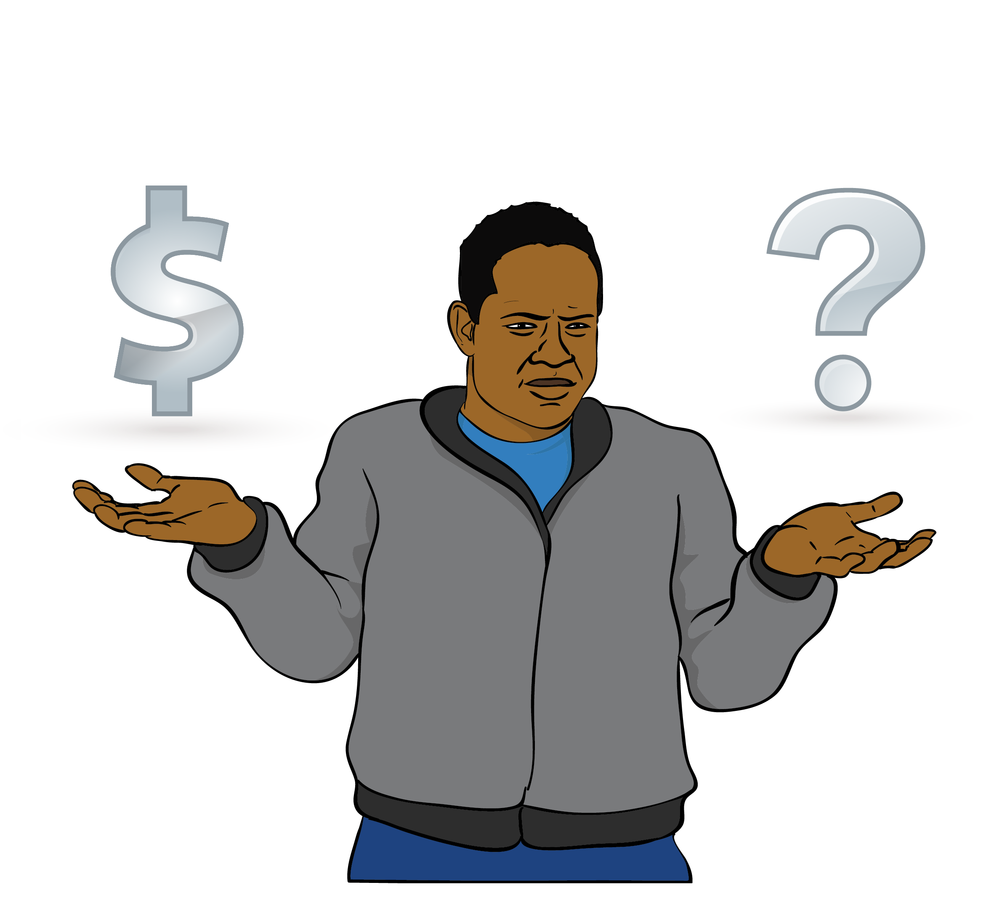

The government does not pay for the emergency supply so it might cost a lot of money.

You can find a pharmacy on this website:

https://tinyurl.com/tus4tvc2

This website is not in Easy Read.

Power

You might need power:
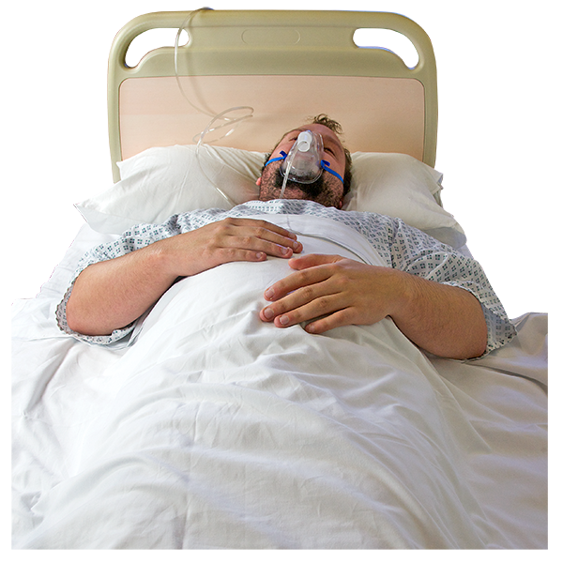
for your medical equipment like a machine that helps you breathe
for your medicines
to stay alive.
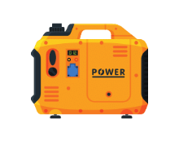

You can use a back-up generator for power.

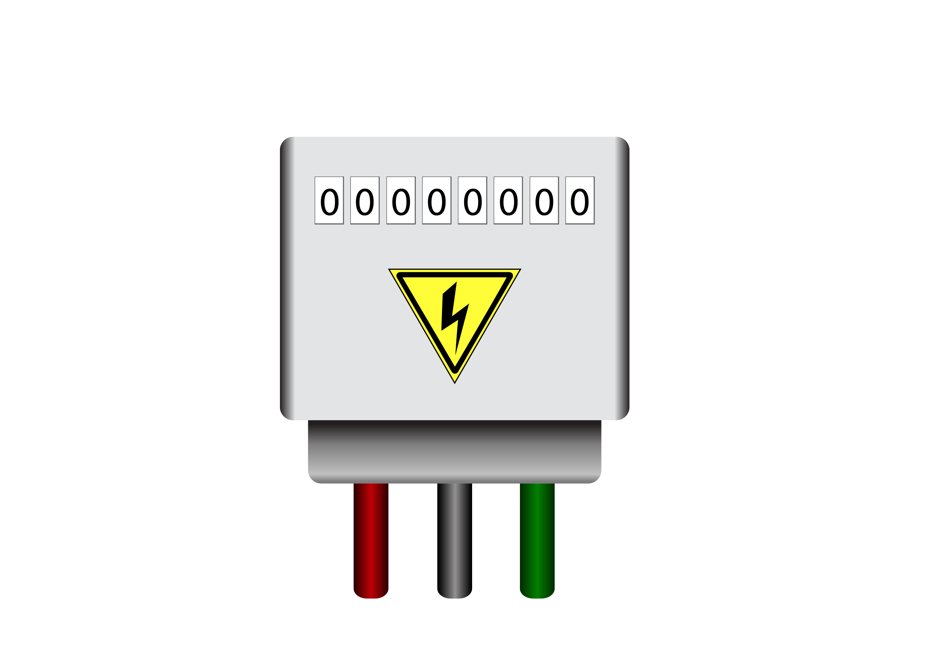
A back-up generator is a machine that uses a fuel like diesel to make power when the power
in your house goes out.

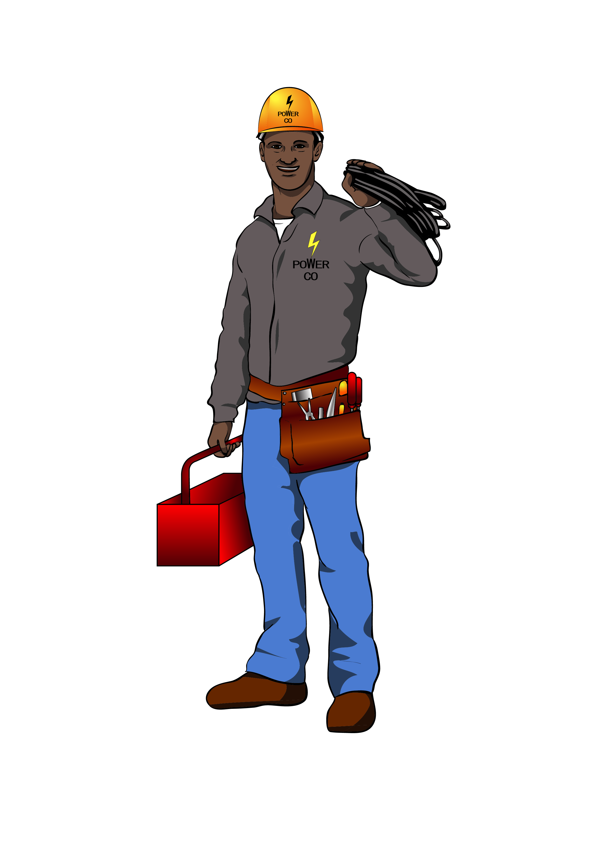
Phone your power company if you do not have a back-up generator.

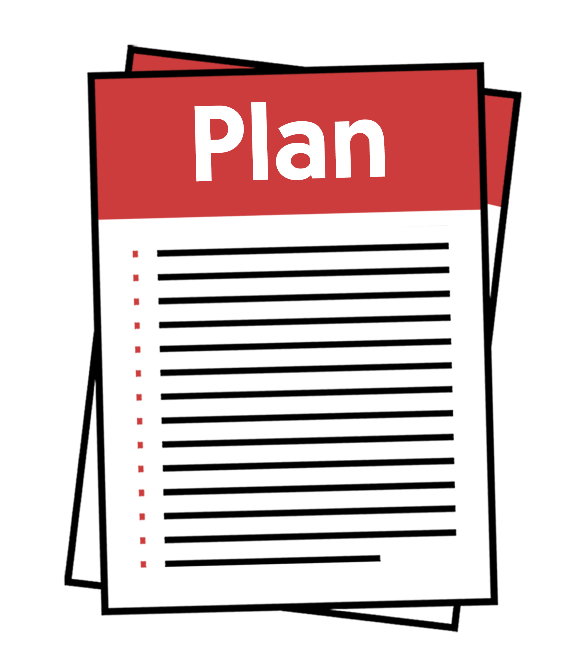
You might already have a plan with your power company to make sure you can still get power in an emergency.

Follow this plan if you have one.

Phone the company that gave you the equipment if your power company cannot support you.

Phone 111 if the company that gave you the equipment cannot support you.

Mental health

It is normal to feel anxious after an emergency.

Feeling anxious means feeling very worried.

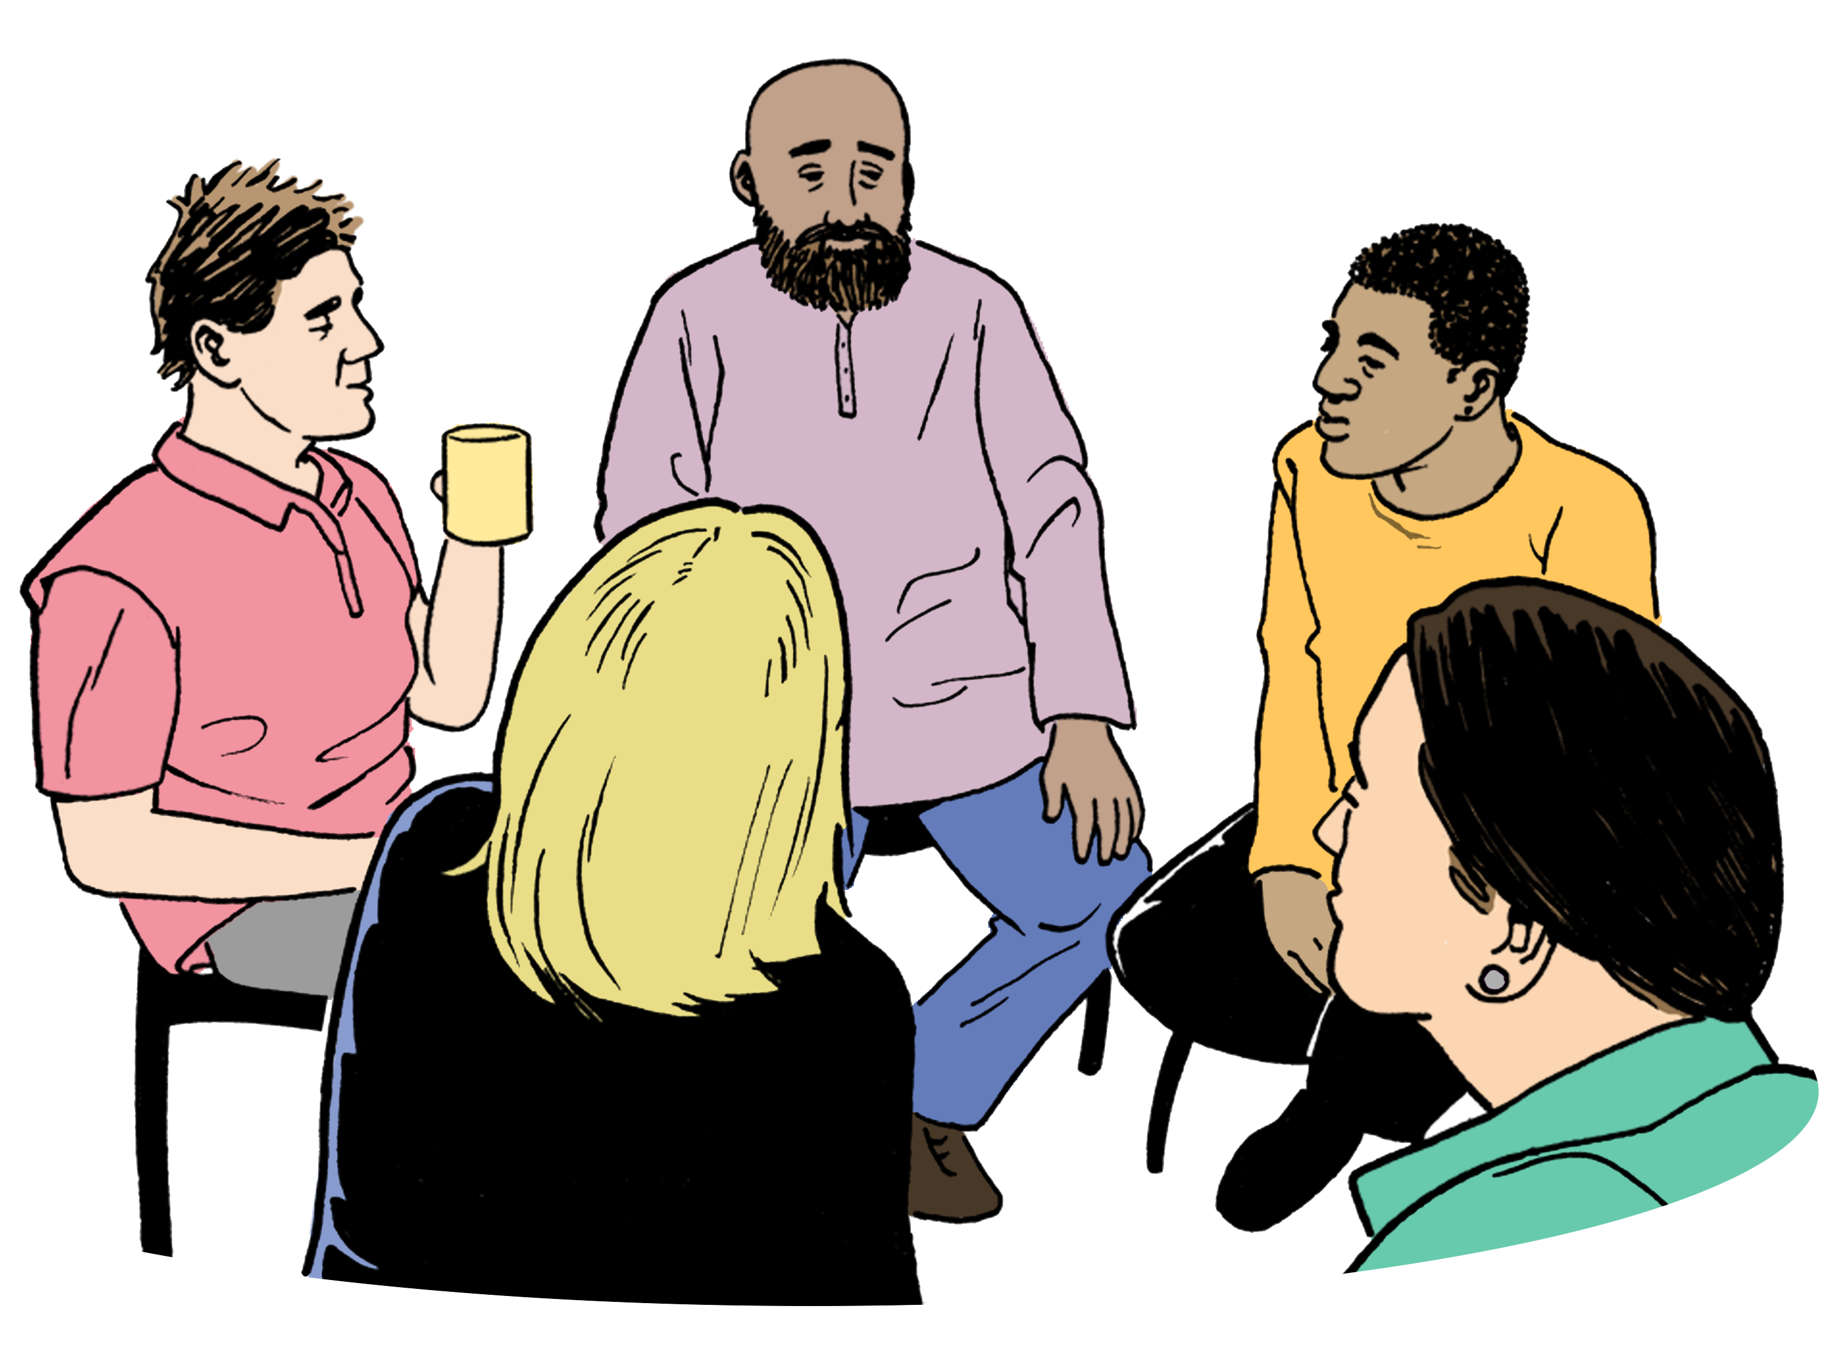
When you feel anxious it can be useful to:
talk to other people
support other people.


You can use Need to Talk to talk to a trained counsellor.

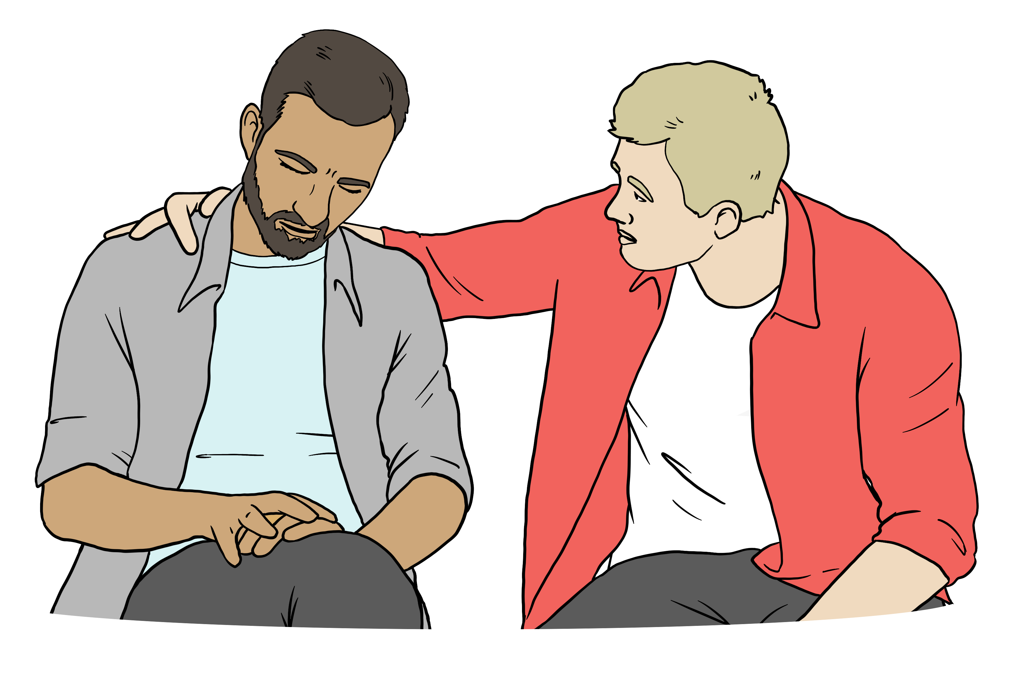
Need to Talk supports people with their mental wellbeing.

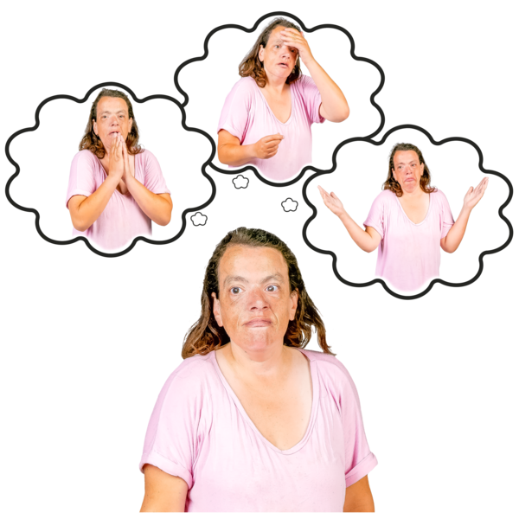
Here mental wellbeing means coping with feelings like being:
anxious
very sad.

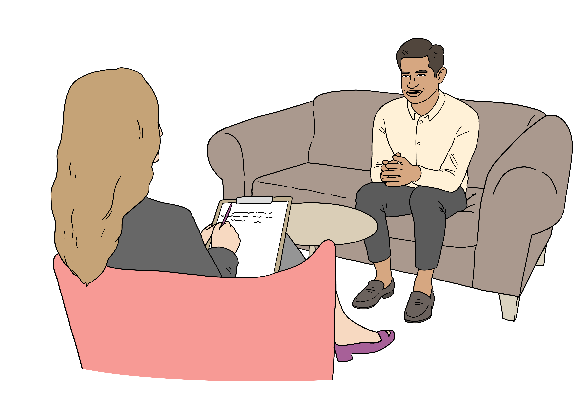
A counsellor is someone who is trained to support people with their feelings.

You can phone Need to Talk on:

1737

You can text Need to Talk on:

1737
You can phone Need to Talk:
every day of the week
at any time of day / night.

It does not cost money to phone / text Need to Talk.


You can find someone to talk to in person using this website:

www.wellbeingsupport.health.nz/

It does not cost money to talk to someone you find using this website.

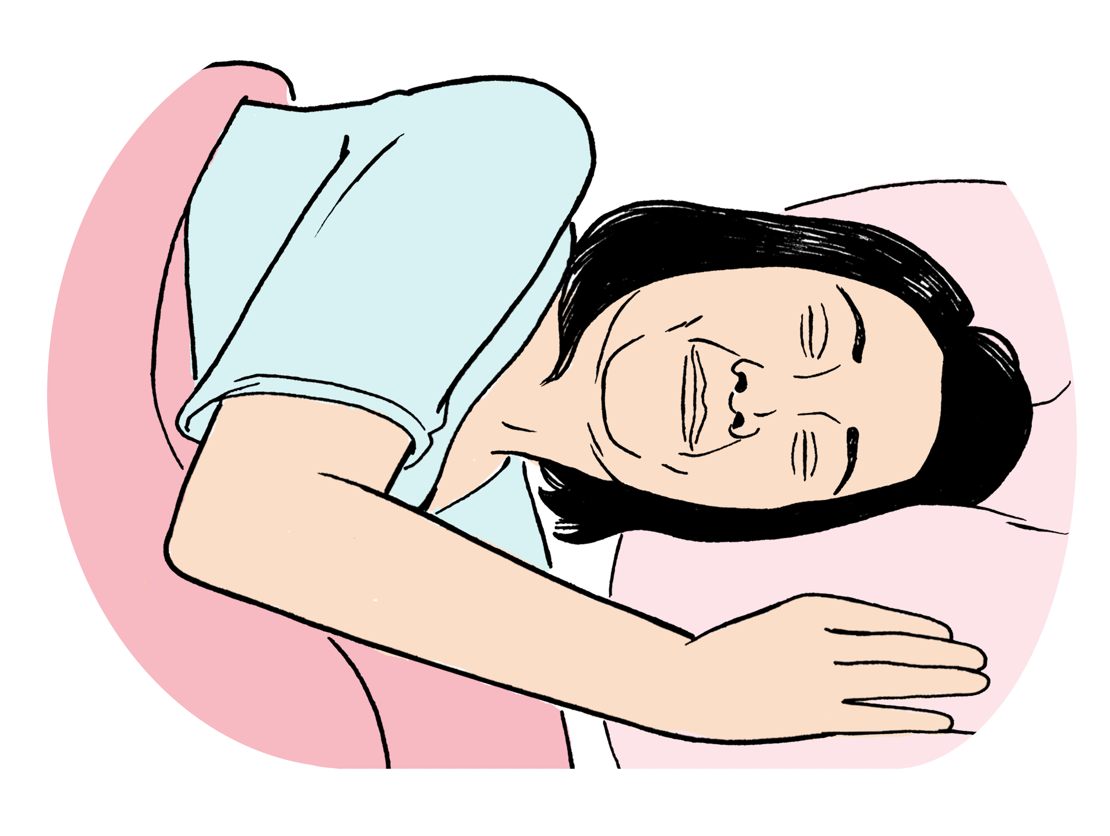
It is important to get enough sleep when life is hard.

You can find tips on getting enough sleep on this website:

https://tinyurl.com/4ayyvv7c
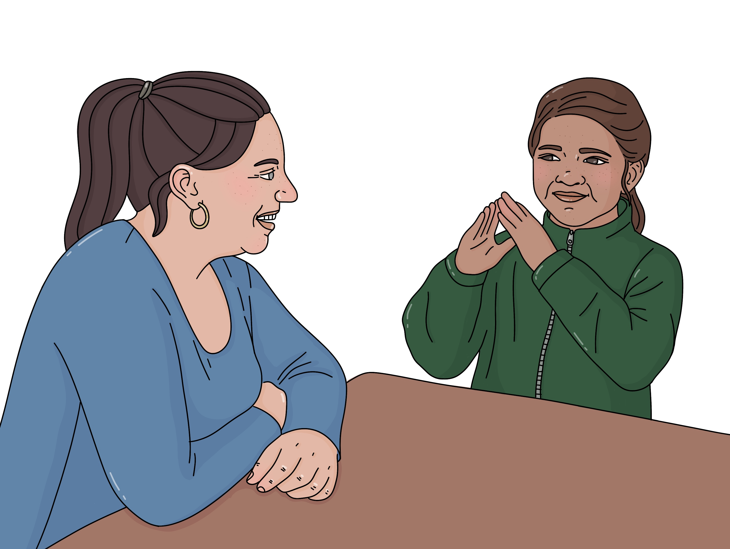

Talk to your children about what is happening.

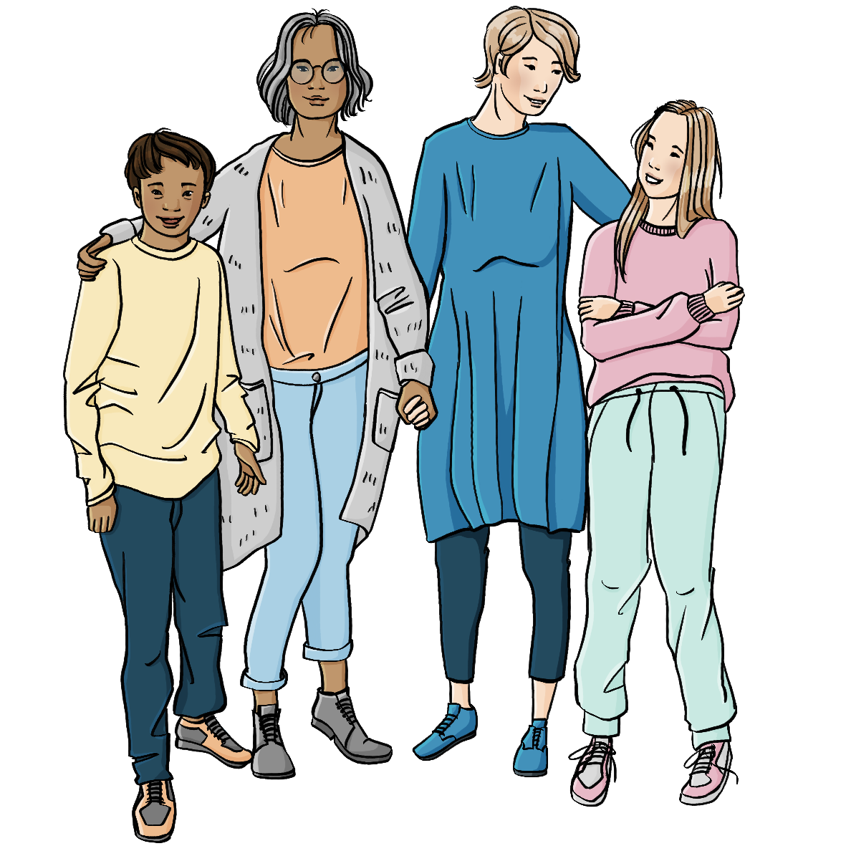
You can find tips on talking to children about an emergency on this website:

https://tinyurl.com/22u78cau

These websites are not in Easy Read.


You can find more information about looking after your mental wellbeing on this website:

https://tinyurl.com/mrbnnff7

This website is in Easy Read.


If you are a farmer you can get support from the Rural Support Trust.

The Rural Support Trust supports people who live in the country like farmers.

You can phone the Rural Support Trust on:

0800 787 254

You can visit their website at:

www.rural-support.org.nz/

This website is not in Easy Read.

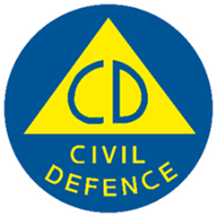
This information has been written by the National Emergency Management Agency and contributed to by participating agencies.


It has been translated into Easy Read by the Make it Easy Kia Māmā Mai service of People First New Zealand Ngā Tāngata Tuatahi.

The ideas in this document are not the ideas of People First New Zealand Ngā Tāngata Tuatahi.

All images used in this Easy Read document are subject to copyright rules and cannot be used without permission.


Make it Easy uses images from:


- Photosymbols

- Change Images


- Huriana Kopeke-Te Aho

- SGC Image Works

- T Wood


- Studio Rebeko

- Inga Kramer.

