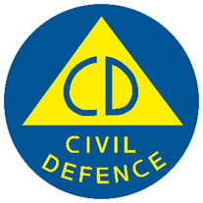
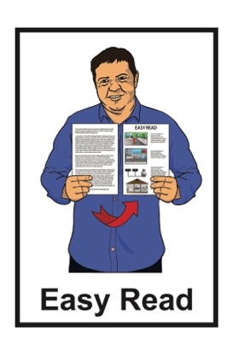

Getting support in an emergency: Additional support
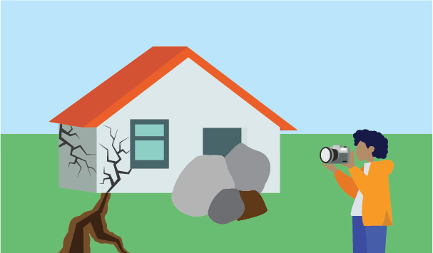

Version 1
Published: January 2026

Before you start

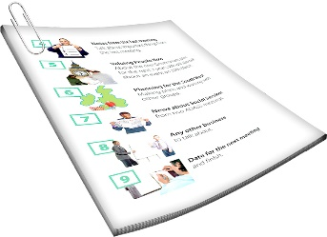
This is a long document.


It can be hard for some people to read a document this long.

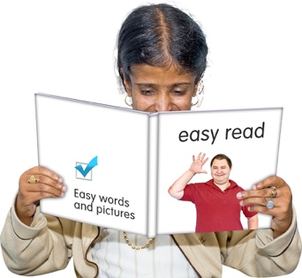
Some things you can do to make it easier are:
read it a few pages at a time
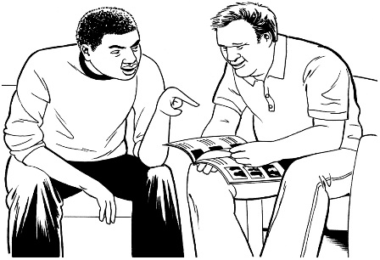
set aside some quiet time to look at it
have someone read it with you to support you to understand it.

What you will find in here

Page number:


About this Easy Read 4

What to do right now 8
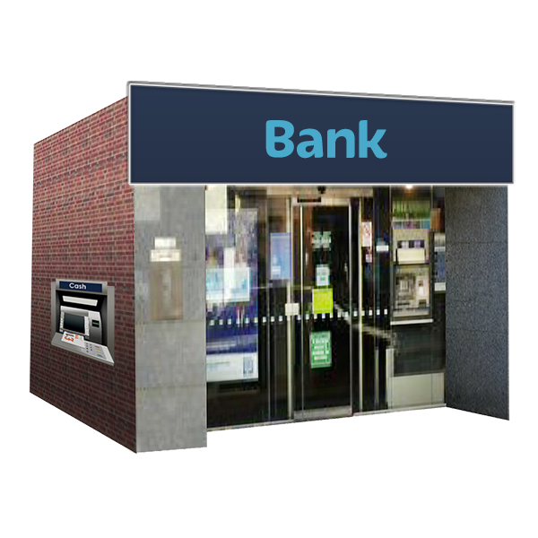

Support from banks 11

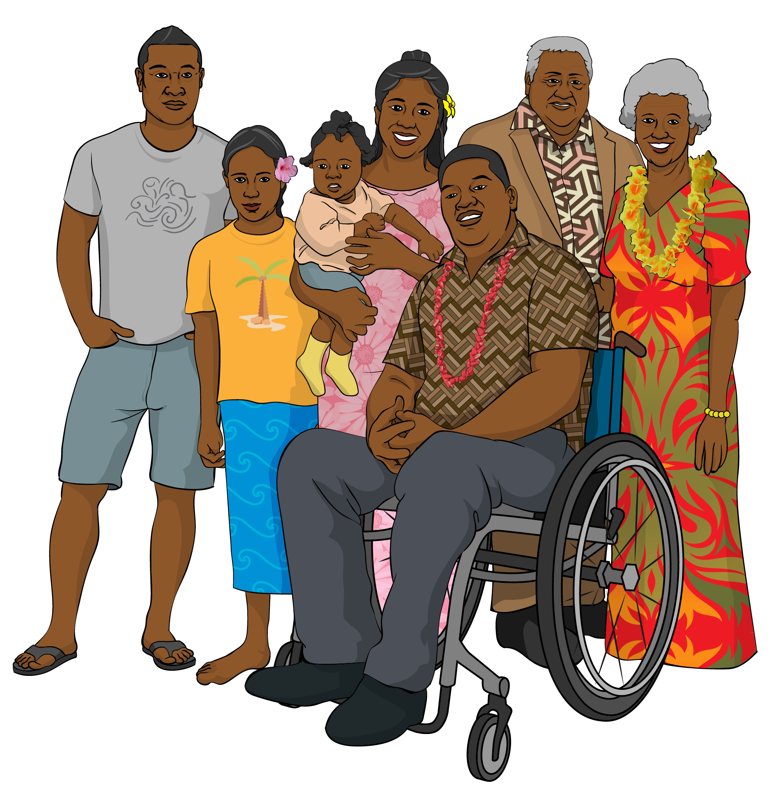
Support for whānau Māori 14

Support for Pacific peoples 15


Support for
Ethnic communities 17

Page number:
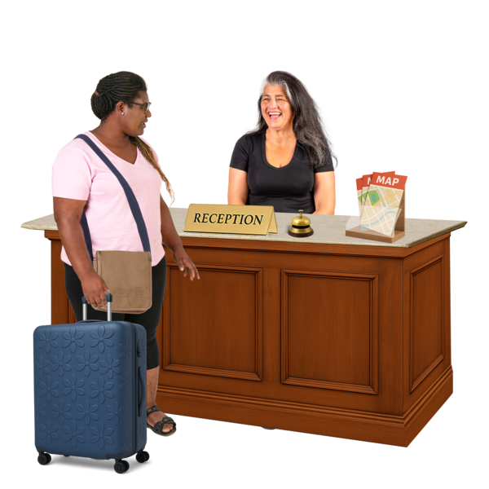
Support for
foreign nationals 21

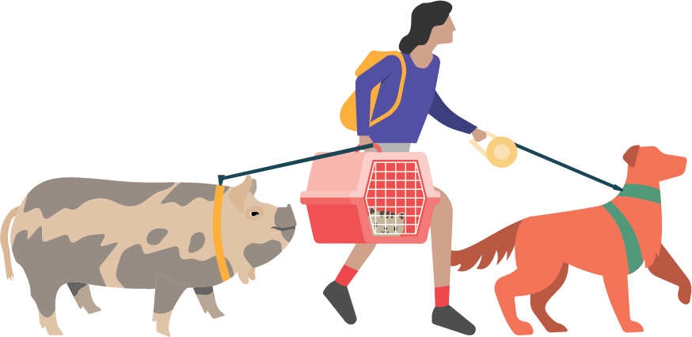
Looking after animals 25

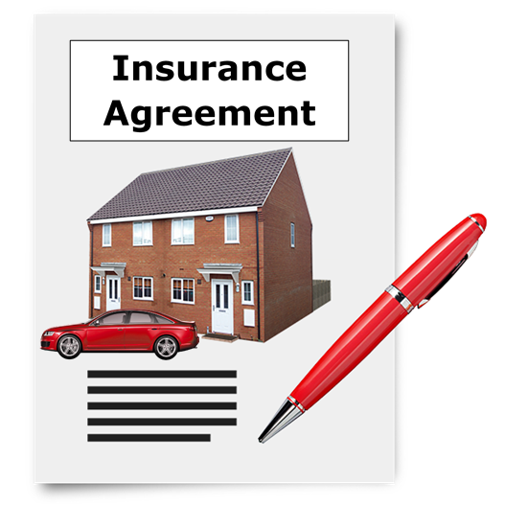
Insurance 28

Renting 39

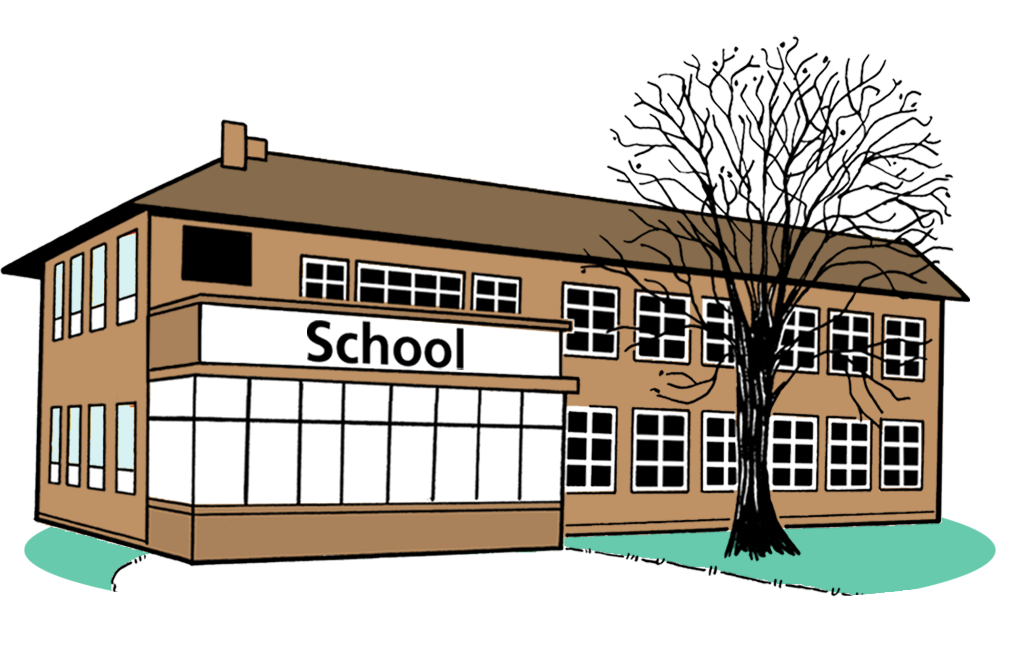
Schools / Early Childhood
Centres 41

About this Easy Read

This Easy Read tells you what support you can get after an emergency.

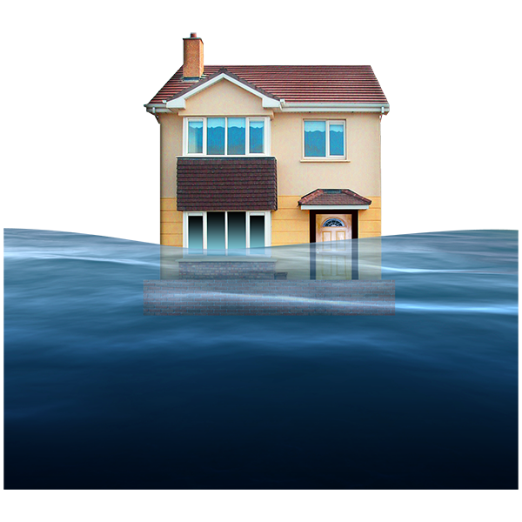
An emergency is when something dangerous happens that can put people at risk like:
an earthquake
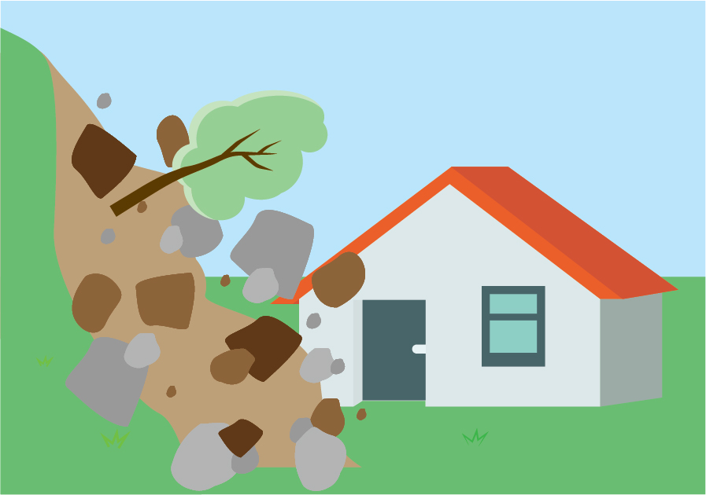
a flood
a storm
a landslide.

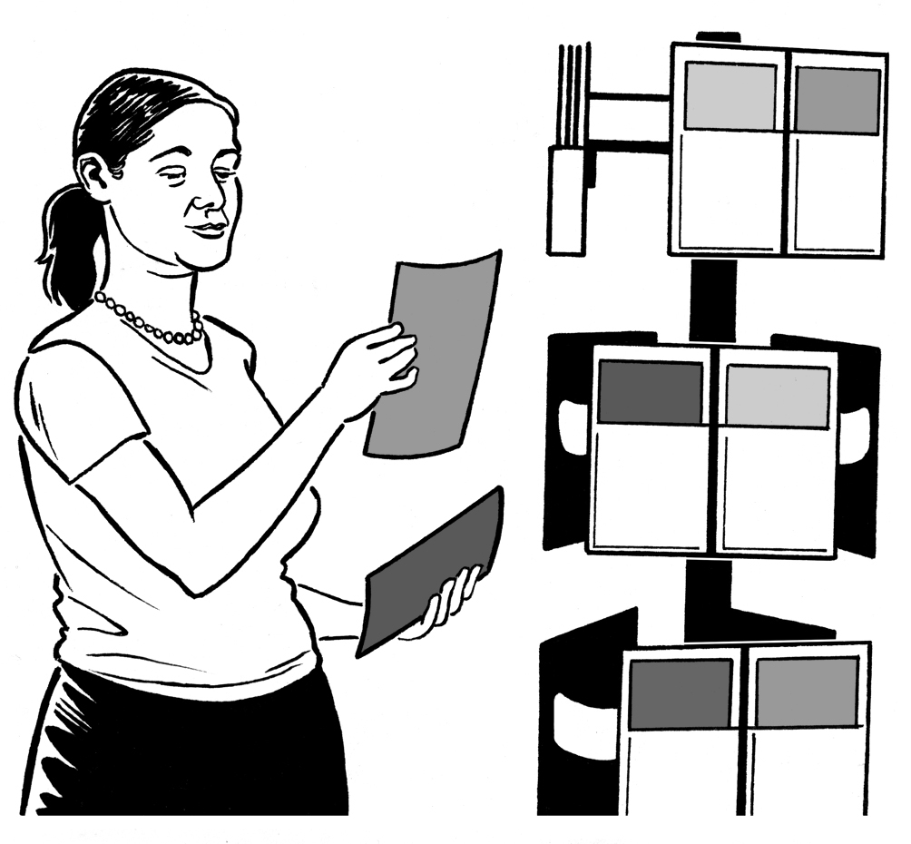
This Easy Read has information that is:
helpful to know
not the most important information.

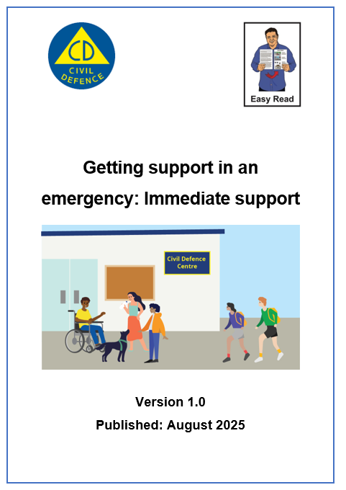
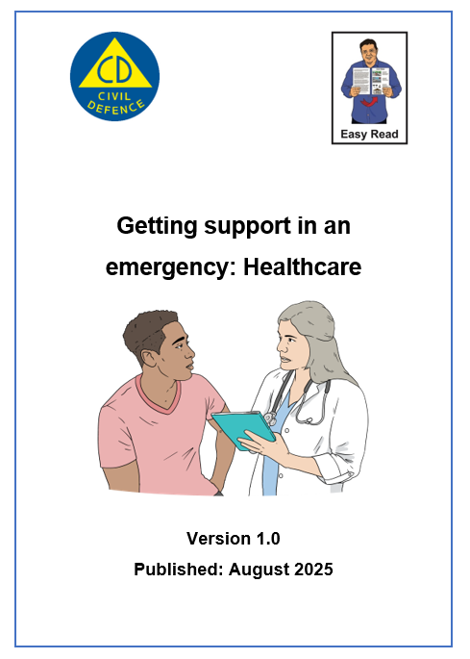
You can find information about how to get healthcare after an emergency in Easy Read at:

https://tinyurl.com/aog-health

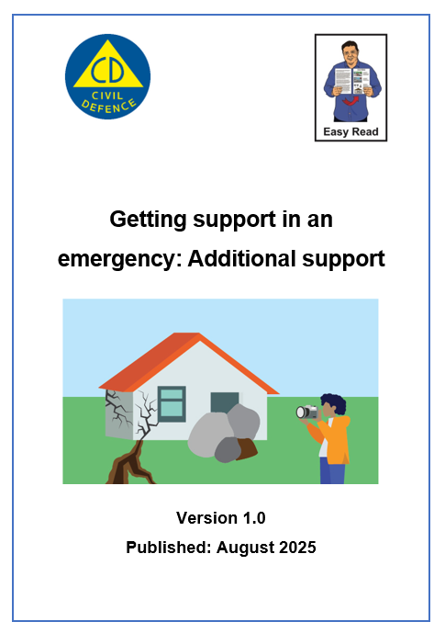
You can find other information about what happens after an emergency in Easy Read at:

https://tinyurl.com/aog-adsupport

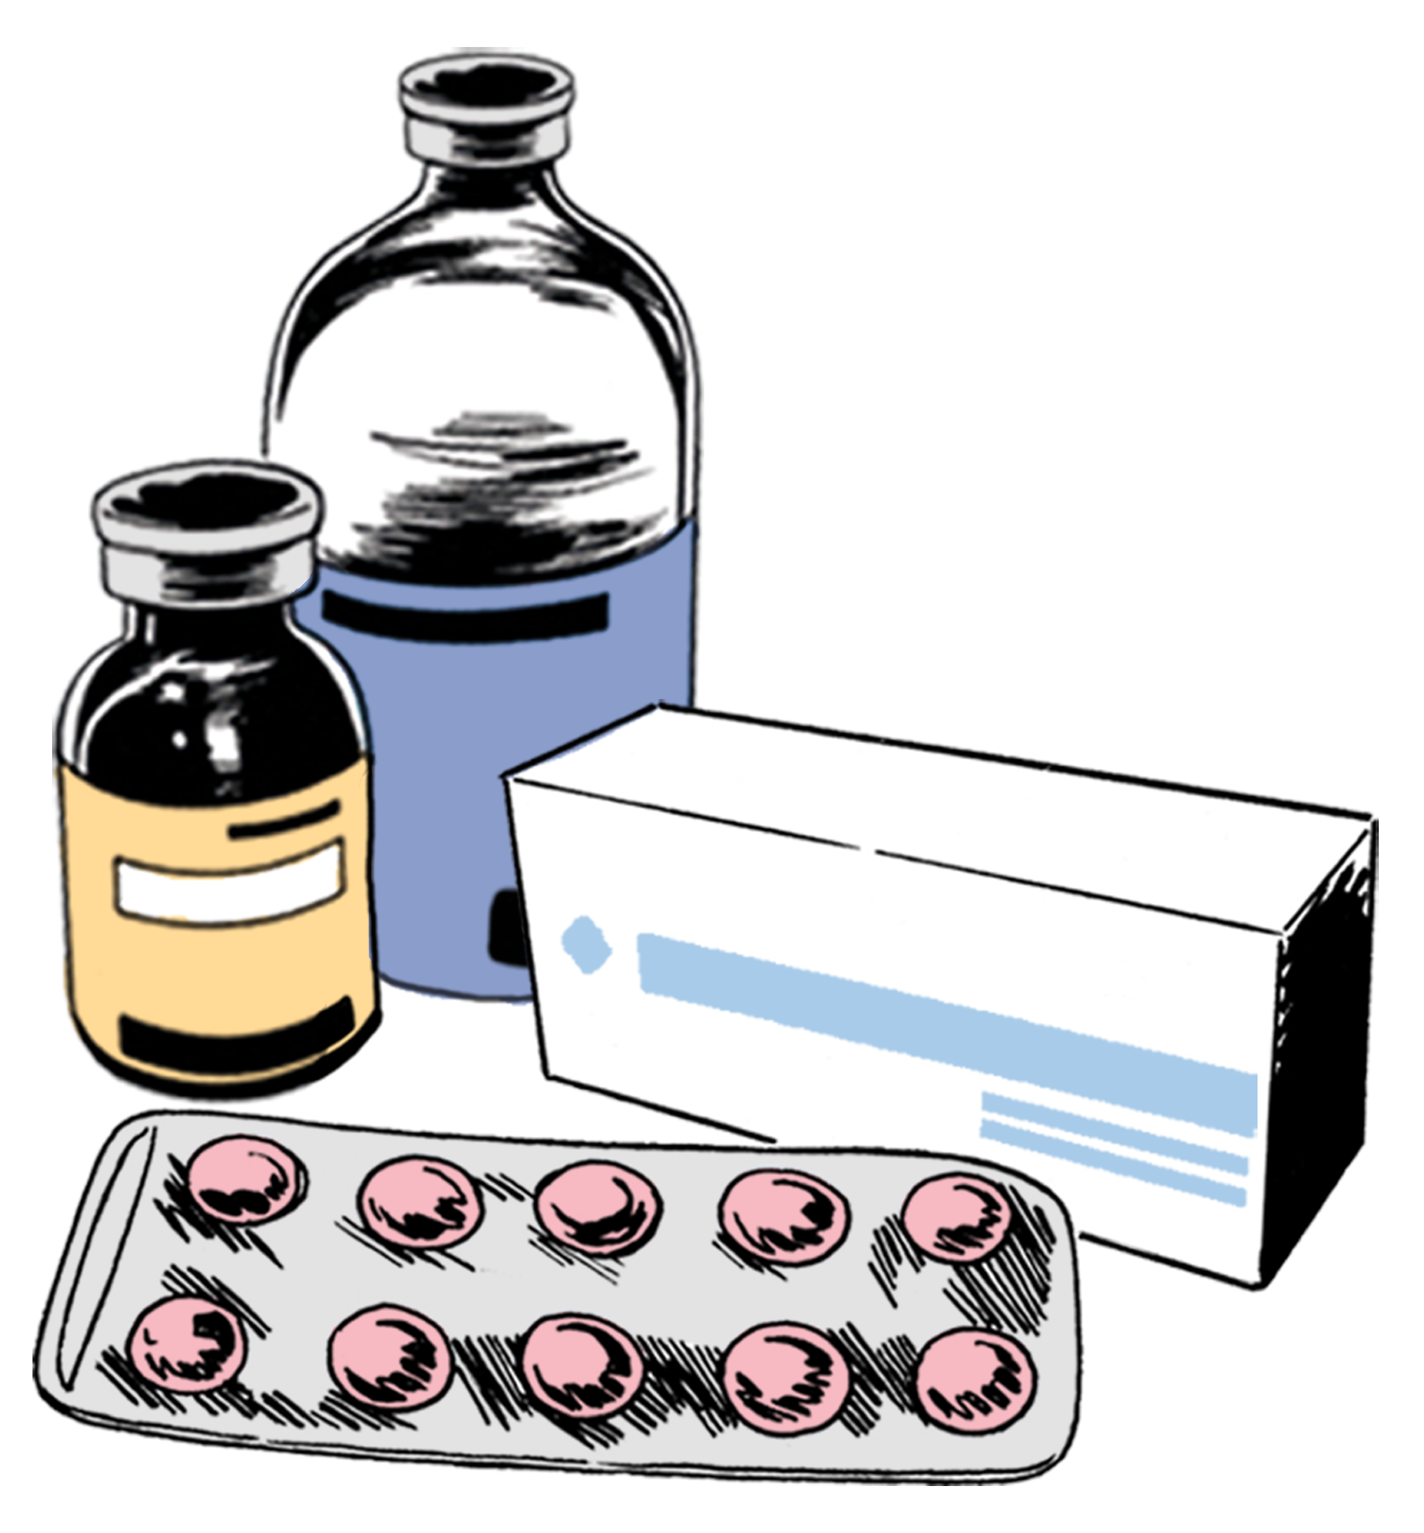
Healthcare means looking after
your health like:
going to the doctor
taking medicine.

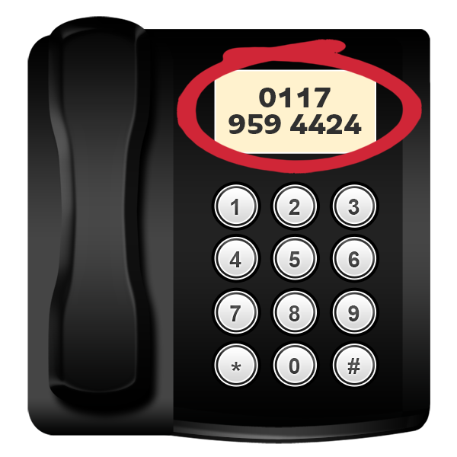
This Easy Read has lots of phone numbers in it.


If you find it hard to use the phone the New Zealand Relay service is for people who are:

- Deaf / hard of hearing
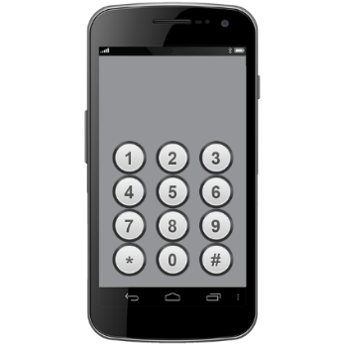
- deafblind

- speech impaired / find it hard to talk.

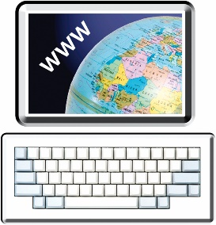
You can find out more about the New Zealand Relay service at:

www.nzrelay.co.nz/index


You can find out more about how to get ready for an emergency in Easy Read at:

https://tinyurl.com/2w2ykrzu

What to do right now

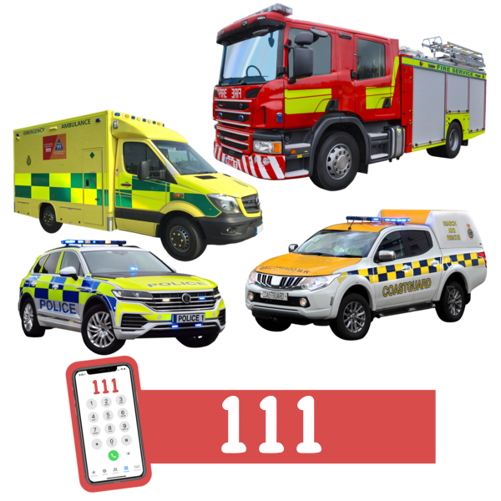
Phone 111 if you are in danger right now.

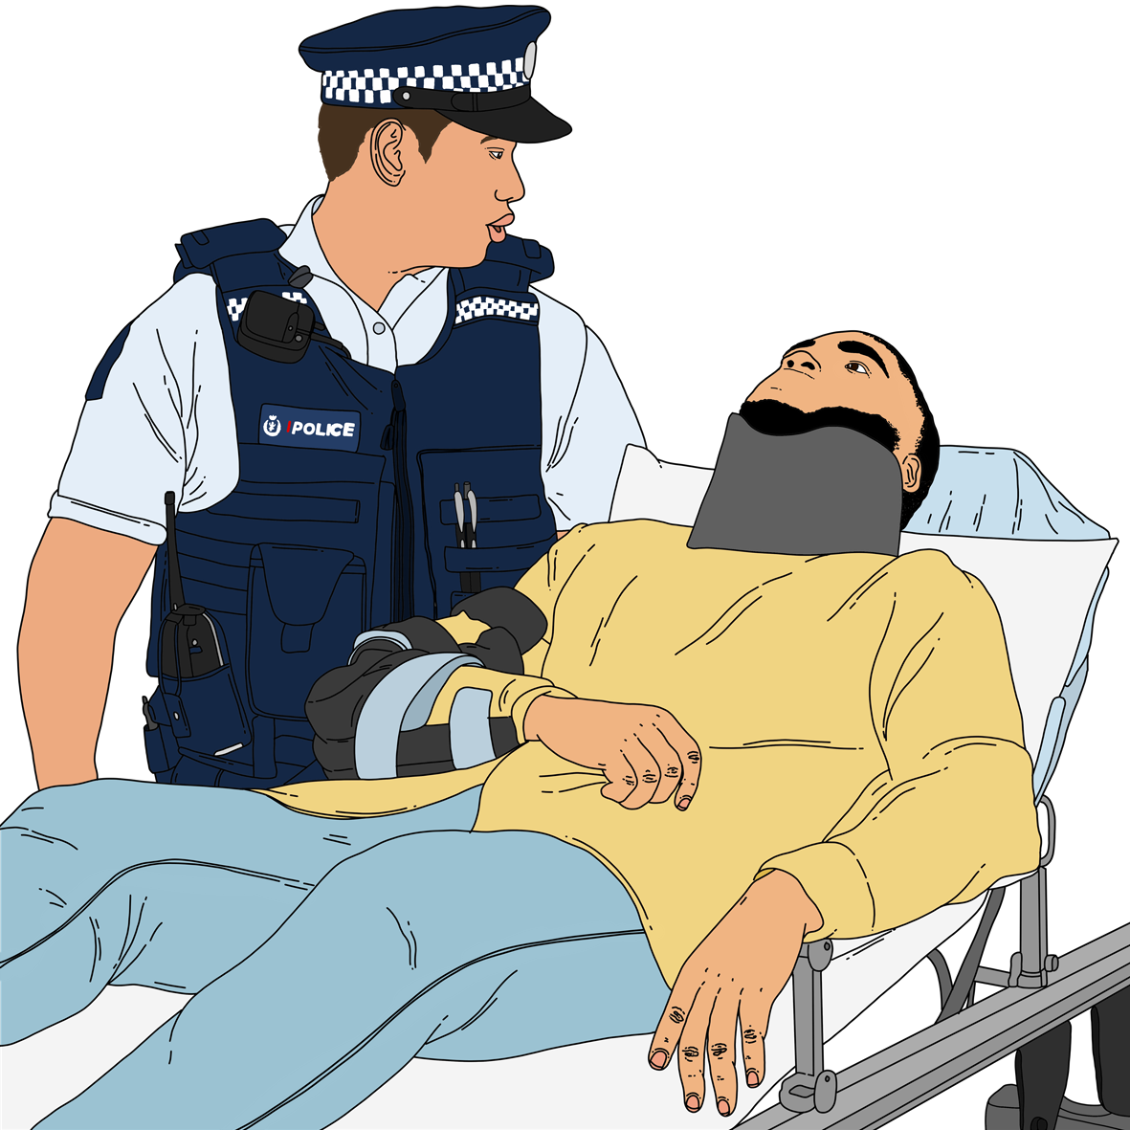
Being in danger means you might:
die
get badly hurt.

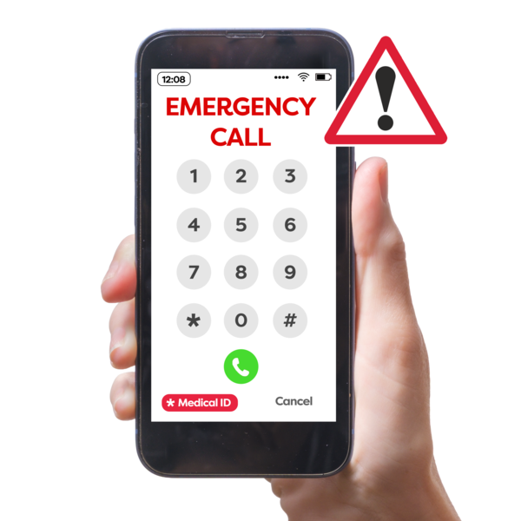
You can sign up to text 111 if you find it hard to:
hear
talk on the phone.


You can sign up to text 111 on this website:

www.police.govt.nz/111-txt

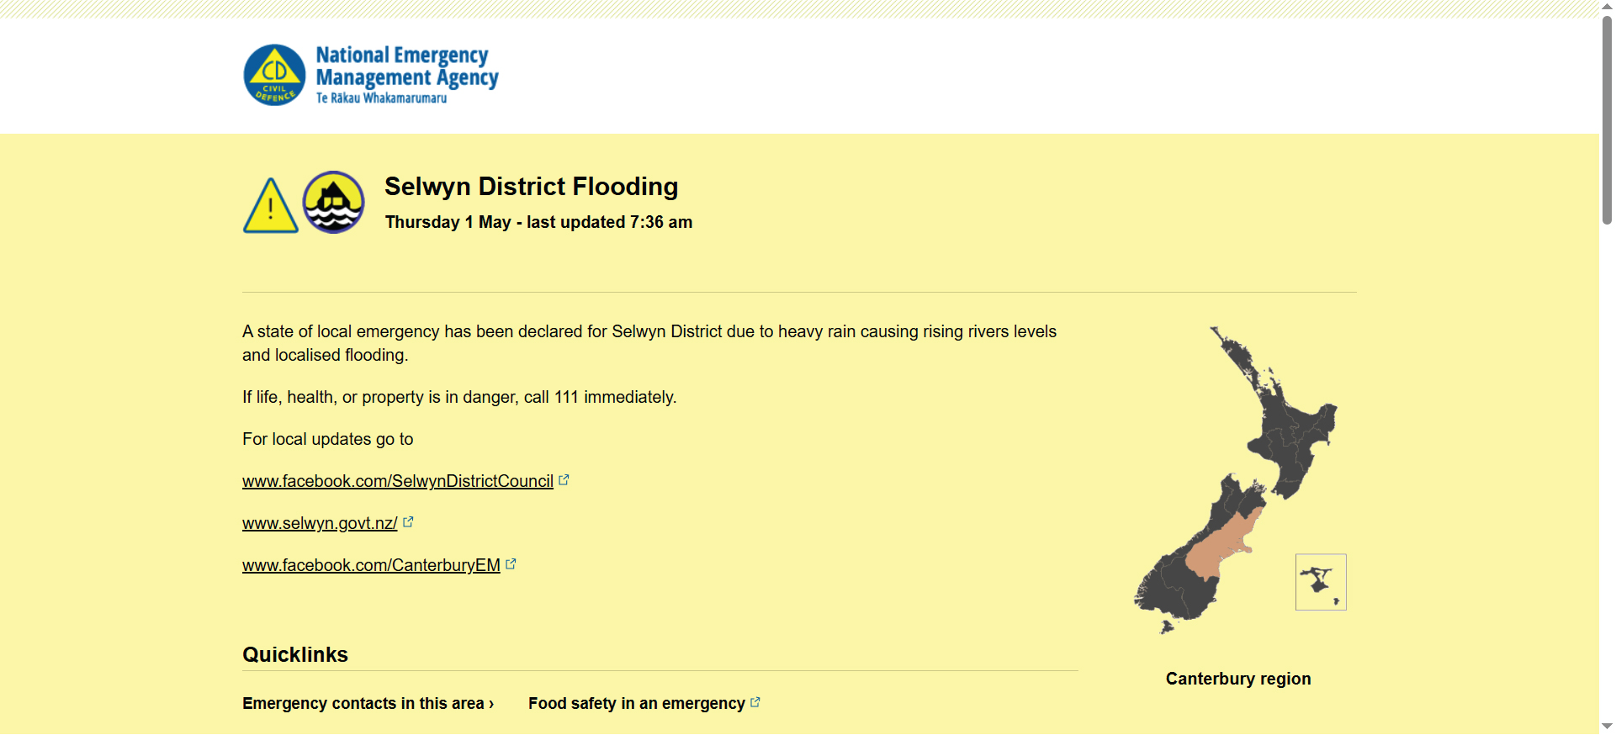
You can find new information about what is happening on this website:

www.civildefence.govt.nz/
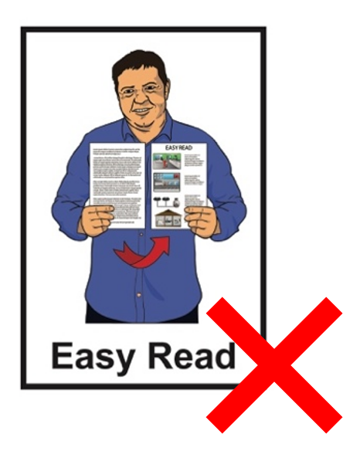

These websites are not in Easy Read.


You can also find new information about what is happening by following your local Civil Defence Emergency Management Group on their:
website
social media.

Your local Civil Defence
Emergency Management Group is the part of the government that is in charge after an emergency.


Social media means
websites / apps like:
Facebook
X / Twitter.

You can find out how to contact your local Civil Defence Emergency Management Group on this website:

https://tinyurl.com/4u4bnp26

This website is not in Easy Read.

Support from banks


You might have a problem with money because of an emergency like not being able to work.

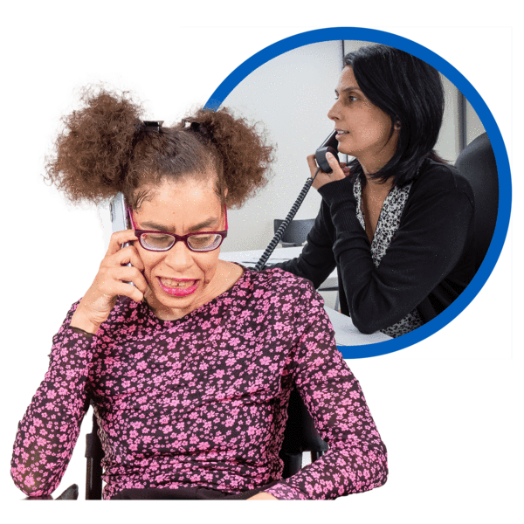
It is good to speak to your bank as soon as you can.

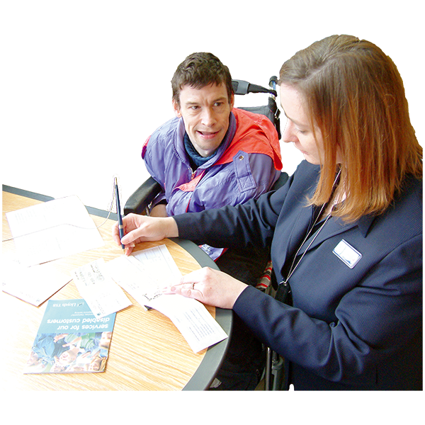
Banks have hardship teams who can tell you about the things you might be able to do.

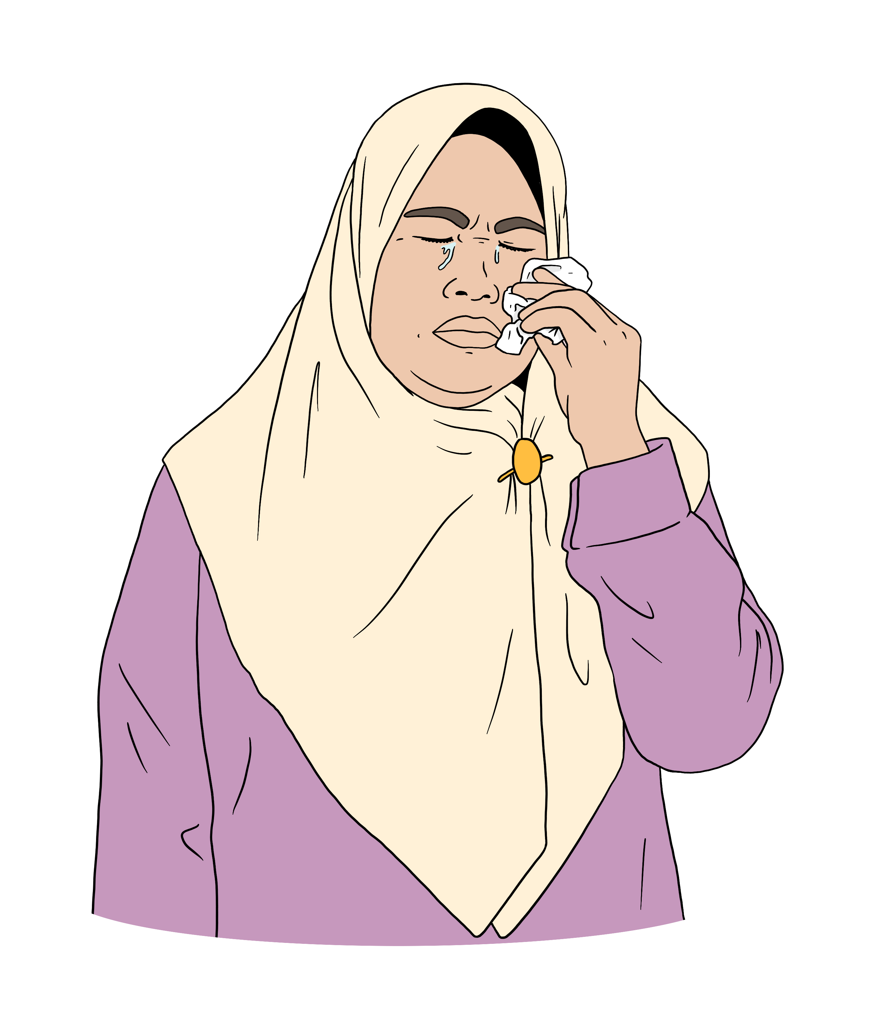
Hardship means going through something difficult.

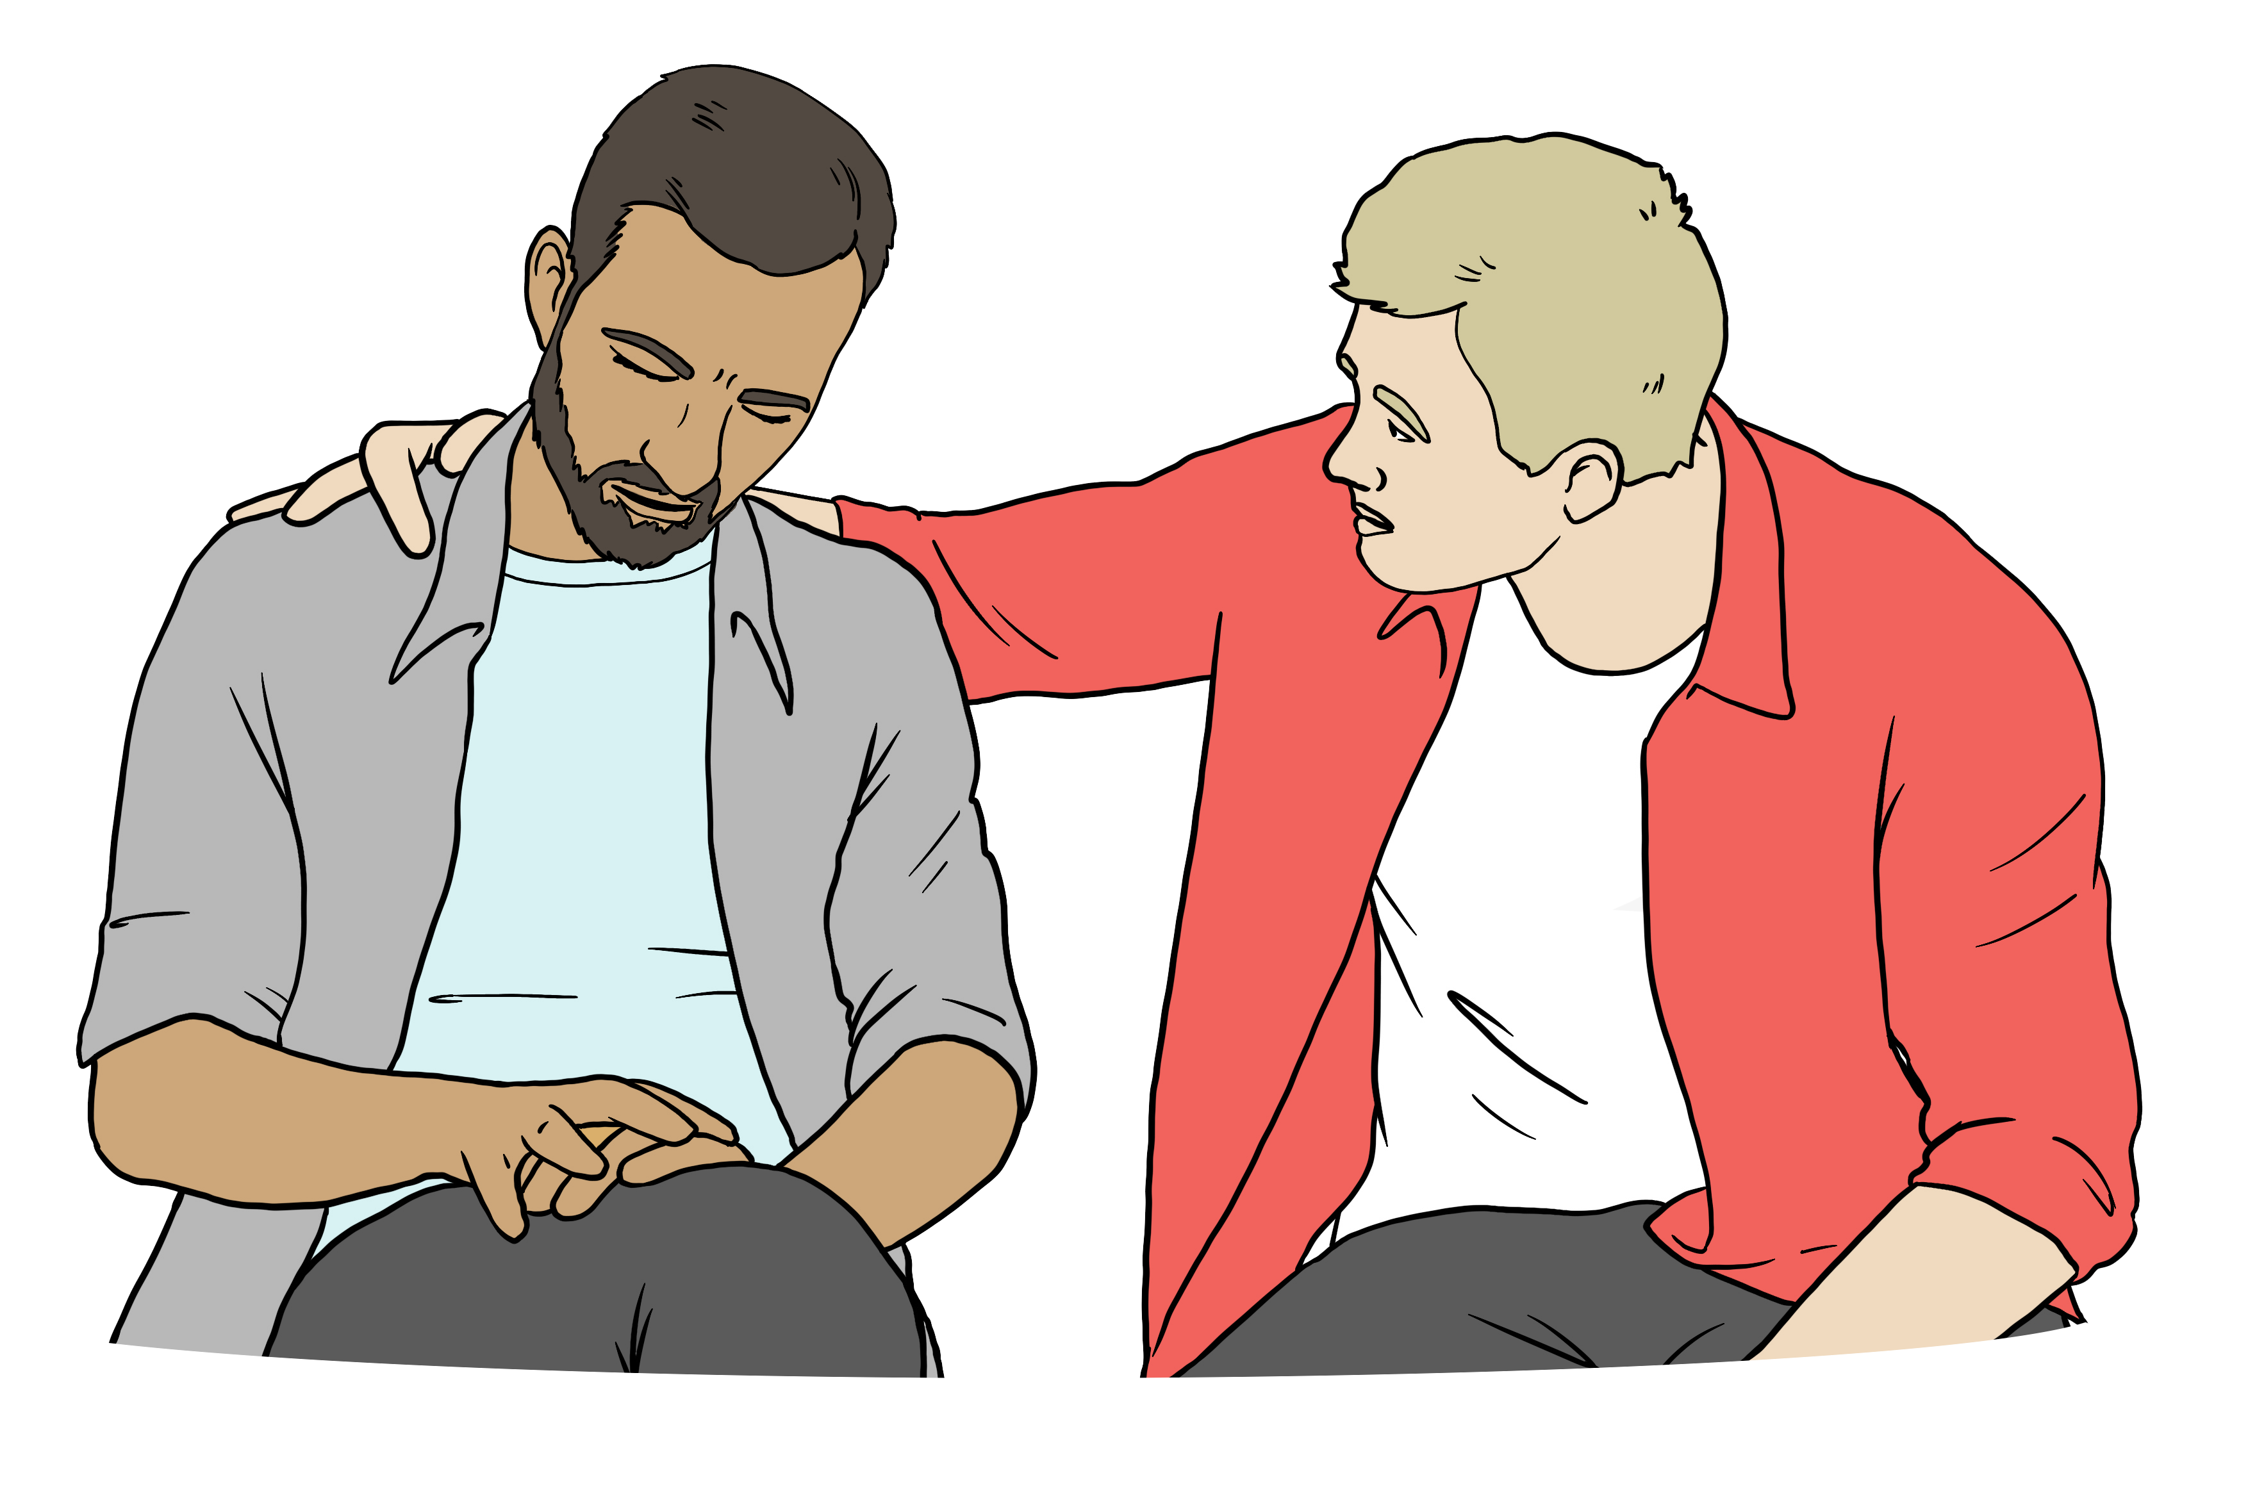
A hardship team is a group of people with the skills to support other people through a difficult time.
Banks can support you in many ways.


1 way your bank might be able to support you is changing your mortgage payments to interest-only for a short time.

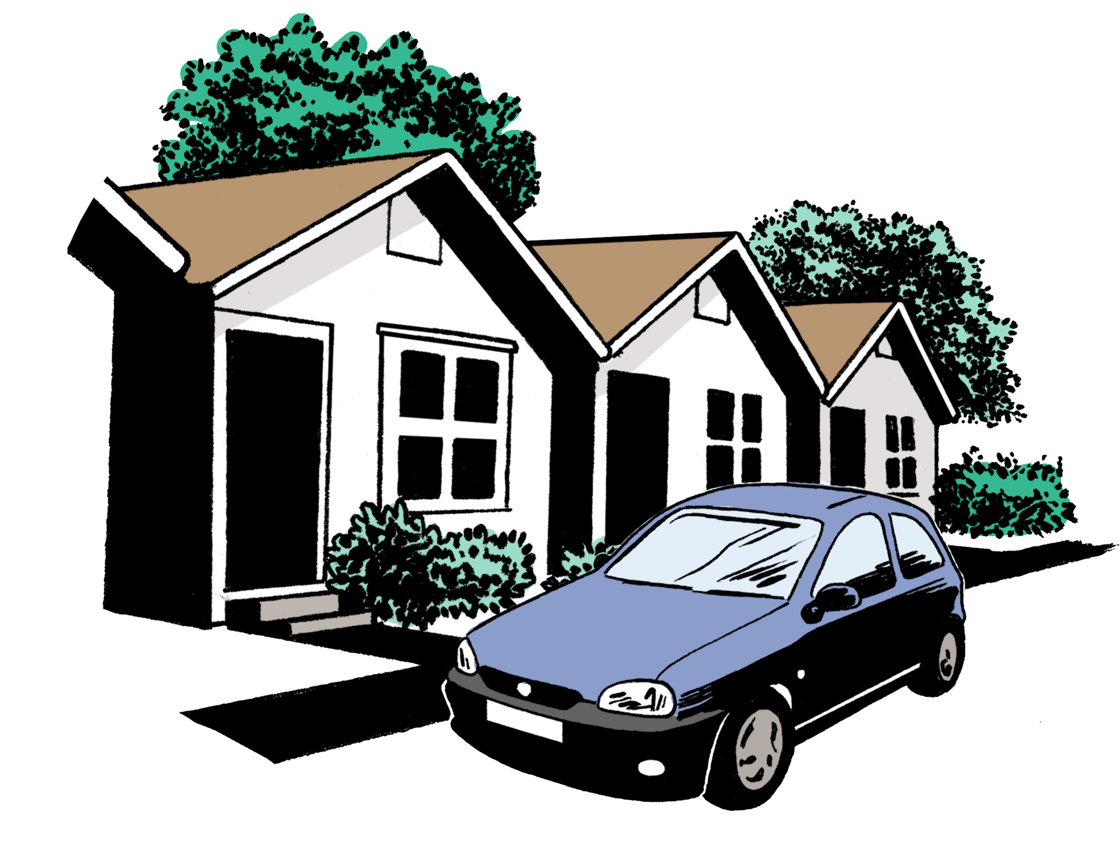

A mortgage is a loan you get to buy a house.

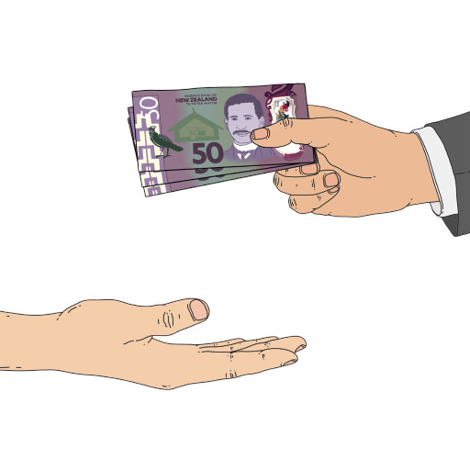
Here interest is money you pay to the bank for having a mortgage.

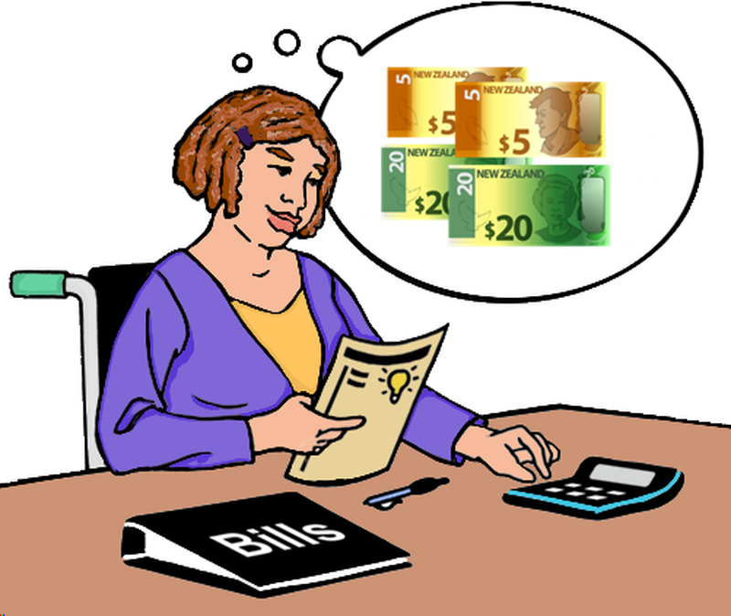
Interest is part of each payment you make to the bank to pay back your mortgage.

The rest of the payment is to pay back the money you borrowed.

Interest-only payments means you only pay the interest part of the mortgage payments for a short time.

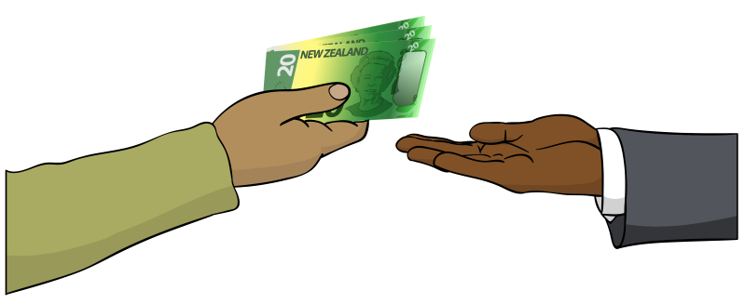
Another way your bank might be able to support you is by letting you get money from a term deposit without having to pay a break fee.


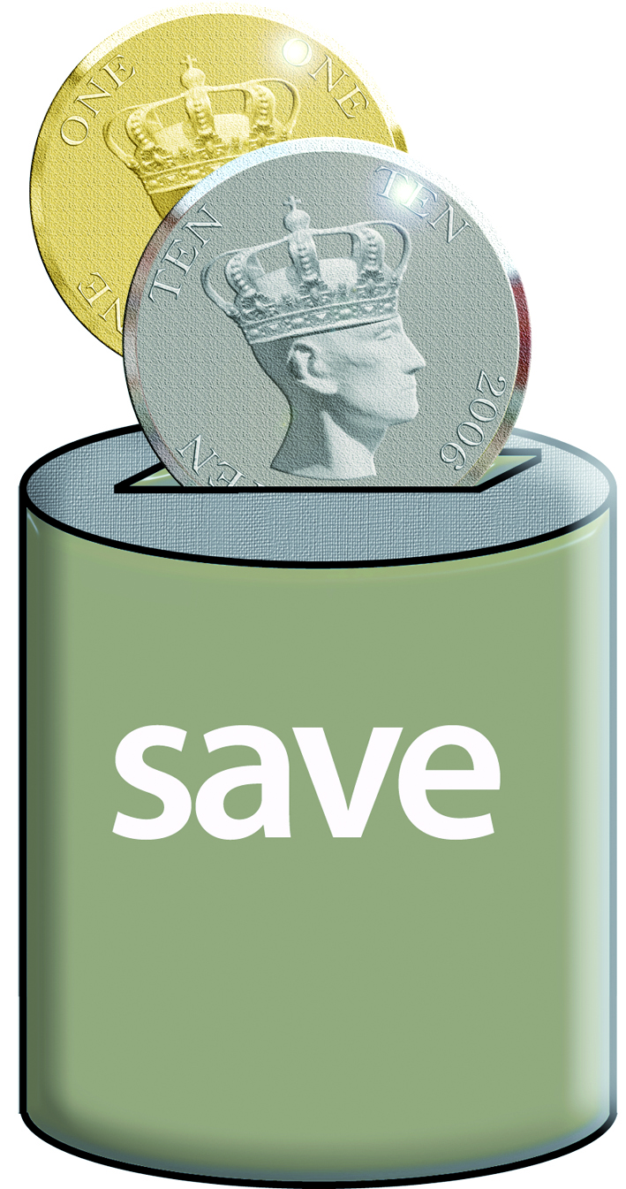
A term deposit is where you:
put money into a savings
account for a set amount of time
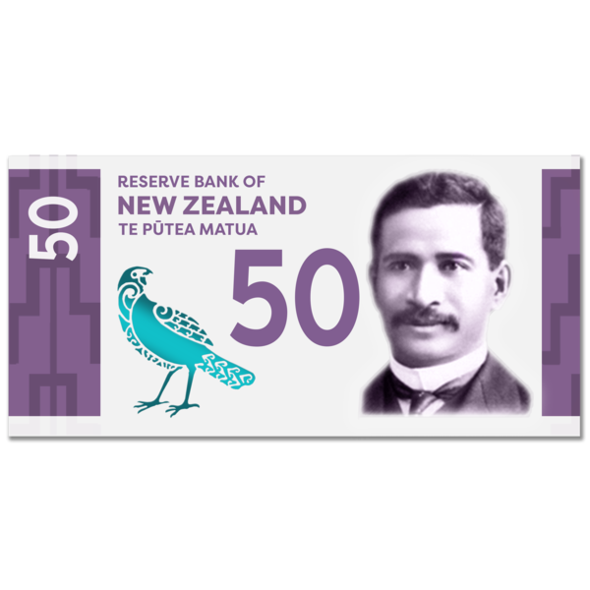

get your money back with extra money the bank pays you for using their bank.



A break fee is a fee you pay the bank if you need to get money from a savings account like a term deposit early.

Support for whānau Māori

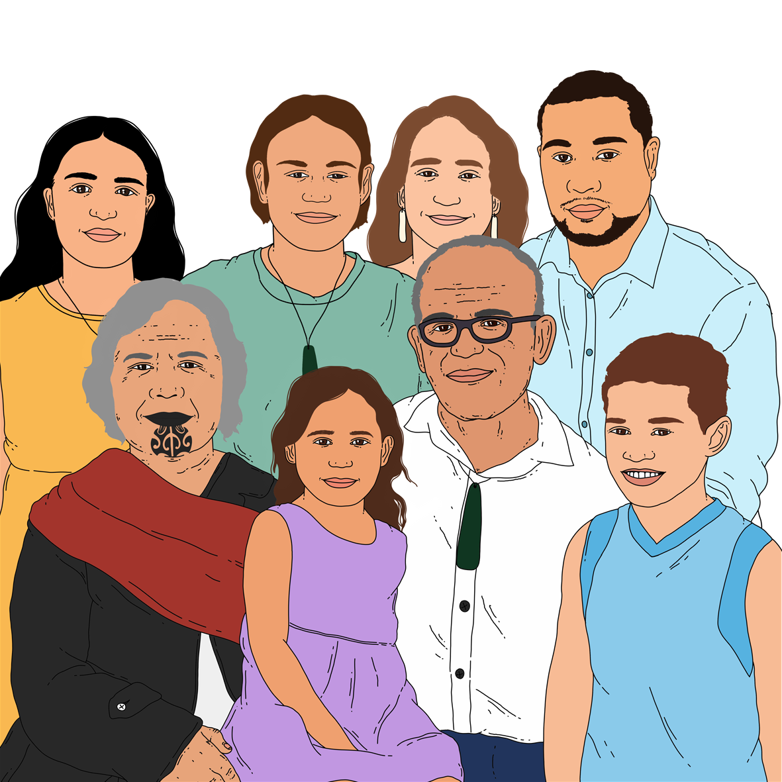
Civil Defence Emergency Management Groups will work with Te Puni Kōkiri to make sure Māori affected by an emergency get support.

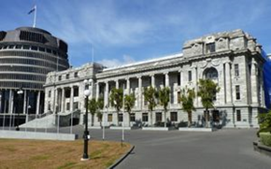
Te Puni Kōkiri is the part of the government in charge of making
sure the government works well for Māori.
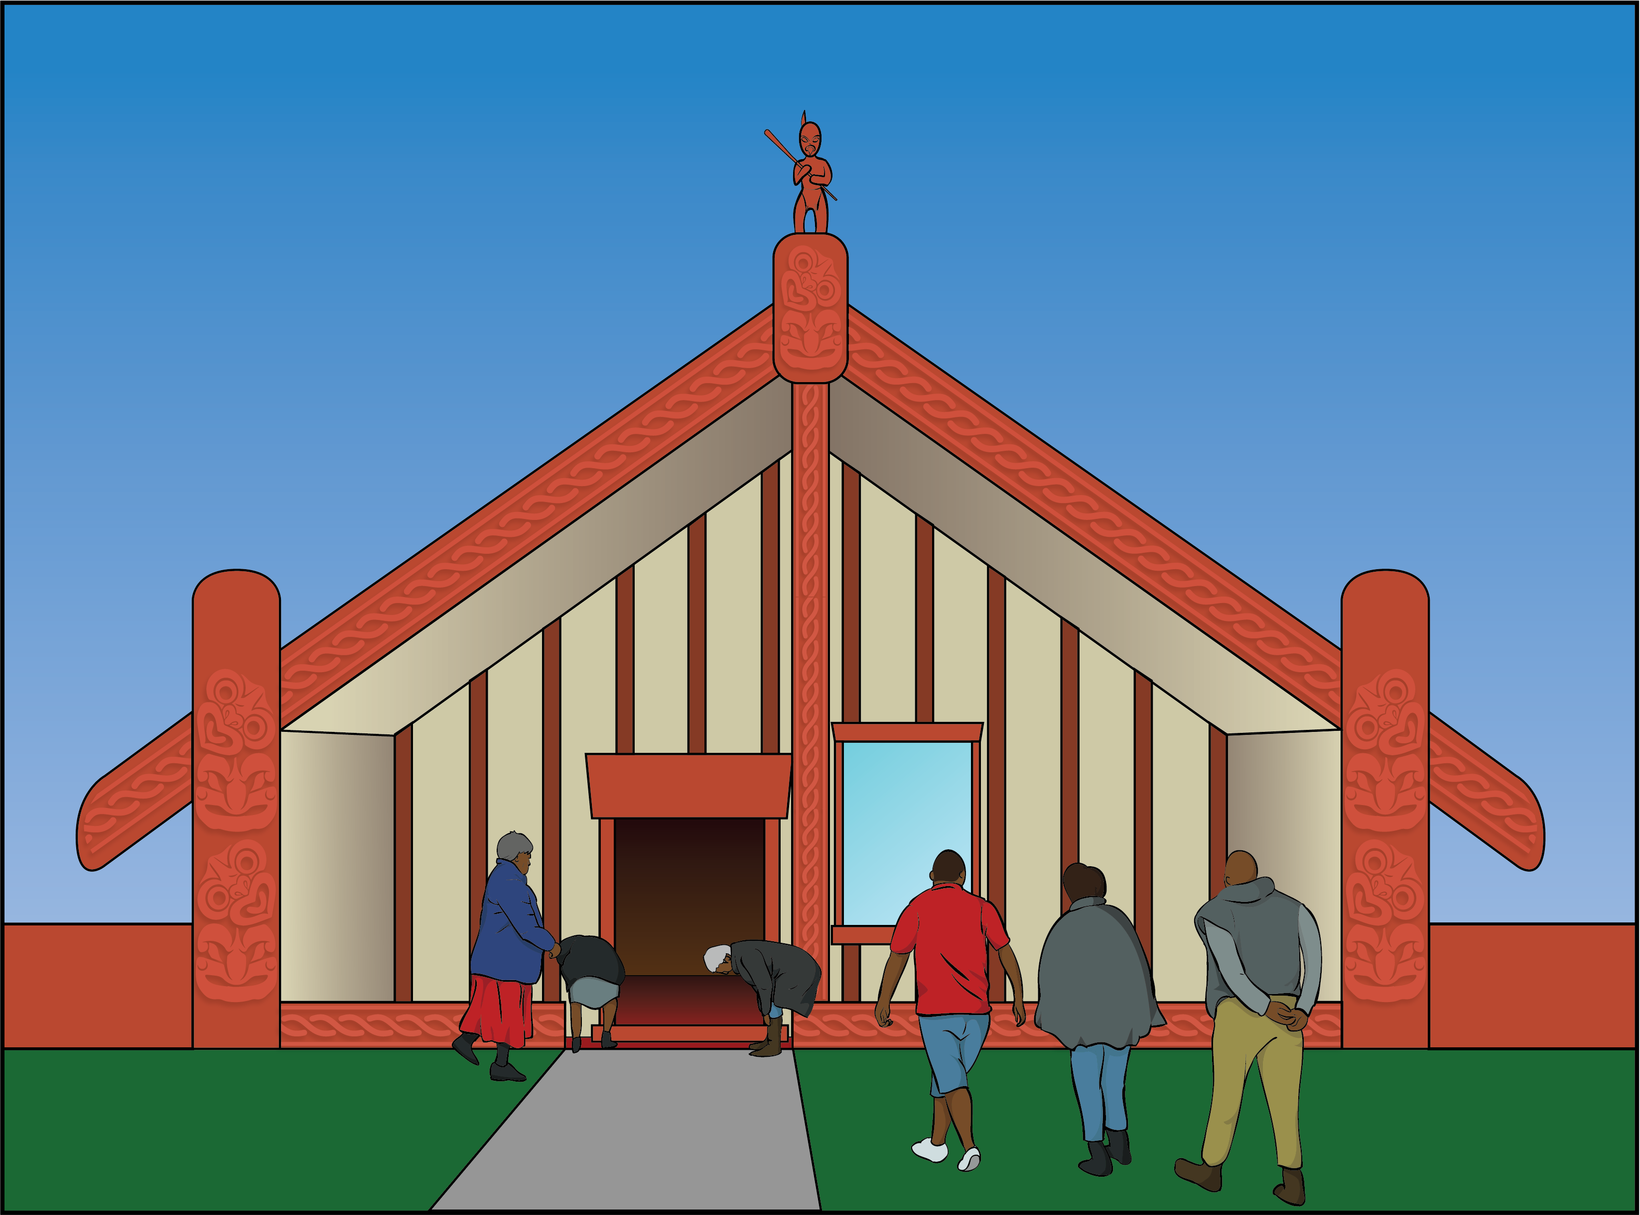

They will do this by working together with:
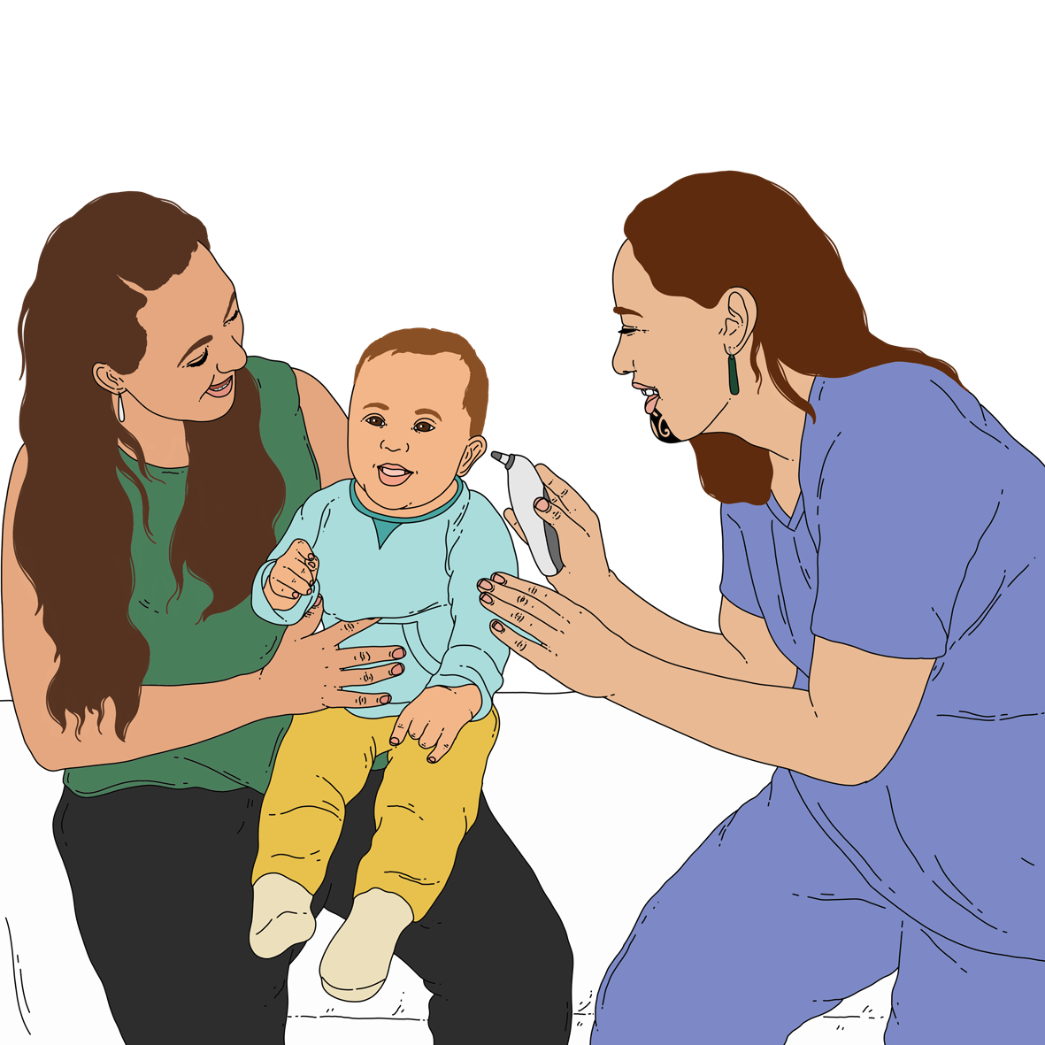
iwi / tribes
hapū / sub-tribes
Māori organisations.

Support for Pacific peoples

Civil Defence Emergency Management Groups will work with the Ministry for Pacific Peoples to make sure Pacific peoples affected by an emergency get support.

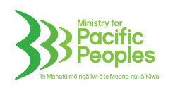
The Ministry for Pacific Peoples is the part of the government in charge of making sure the government
works well for Pacific peoples.

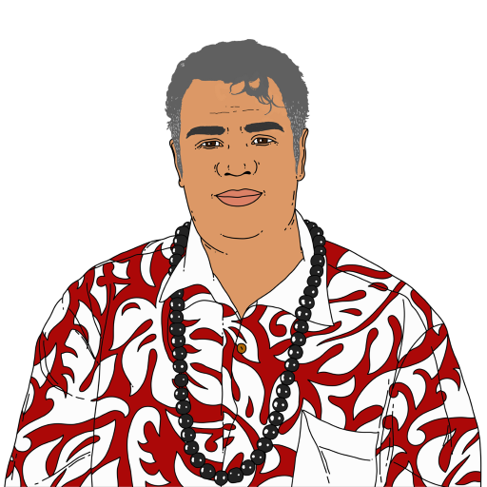
They will do this by working together with:
Pacific leaders
Pacific communities
Pacific community organisations.
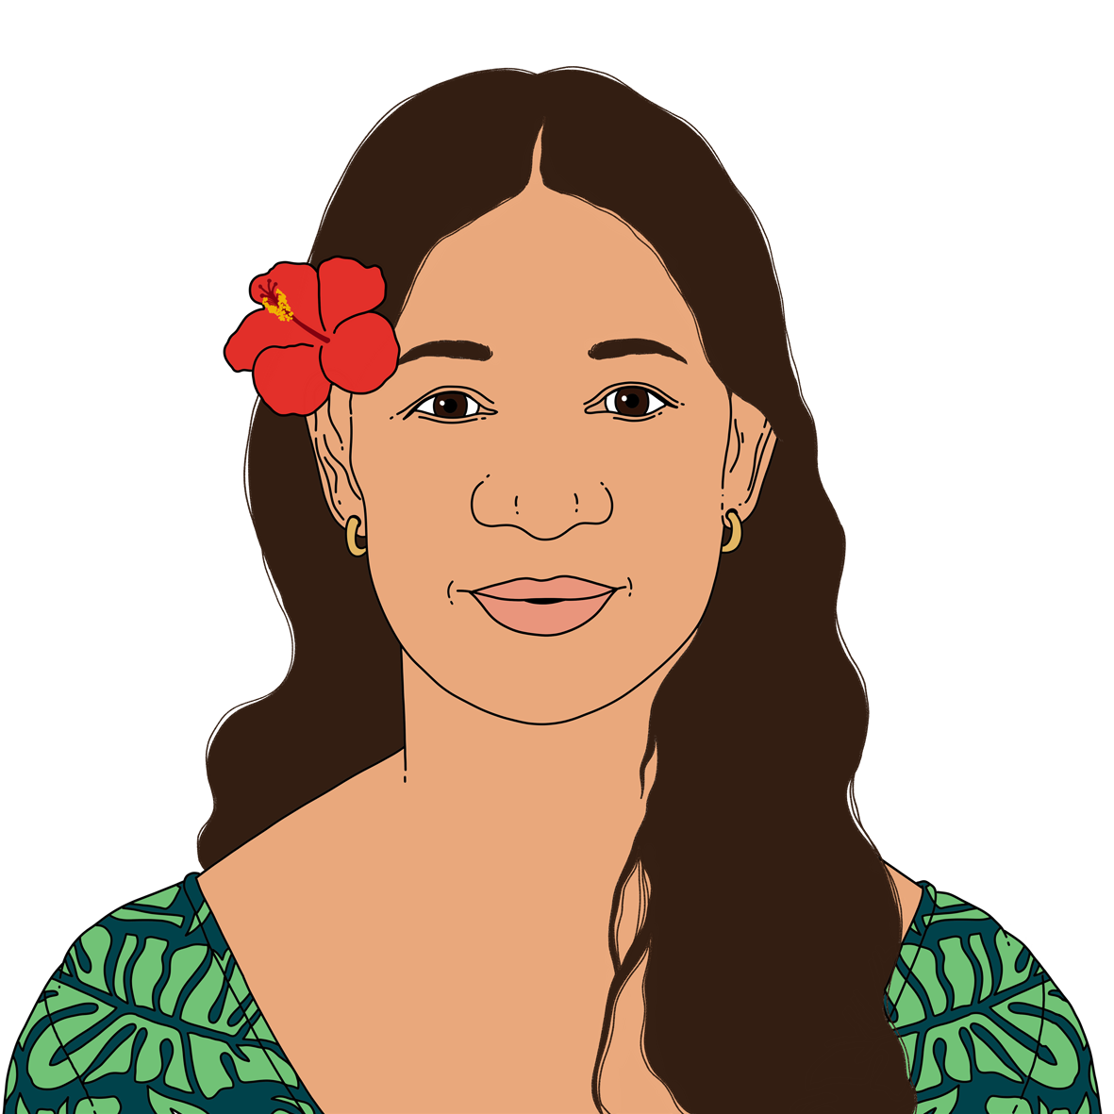
Here leaders means Pacific people who speak up for their communities.

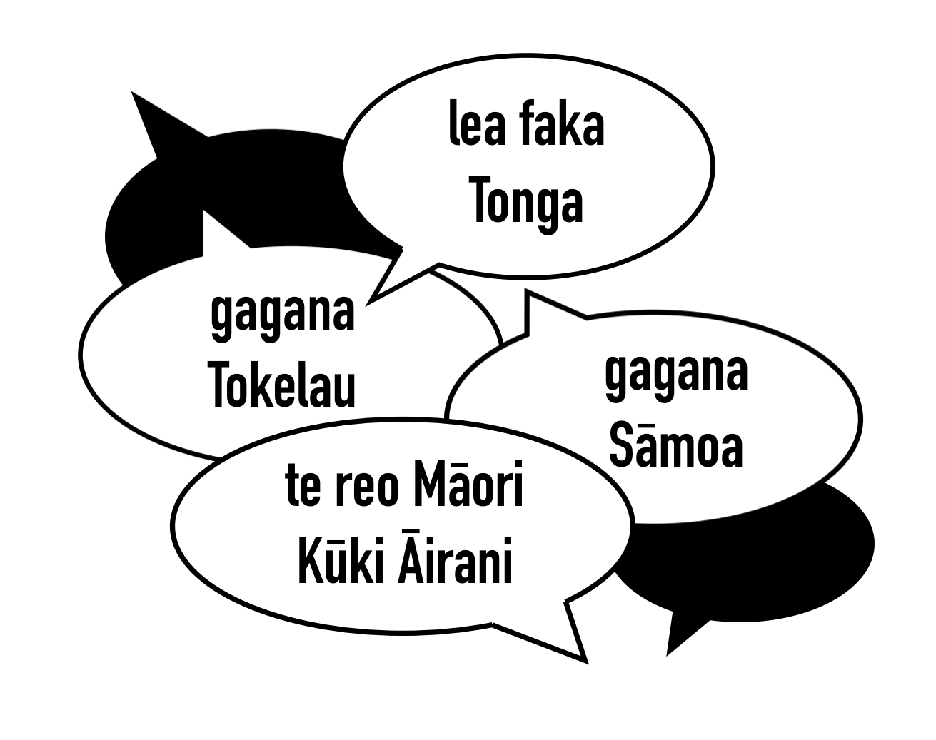
Here communities means Pacific people who have something the same about them like:
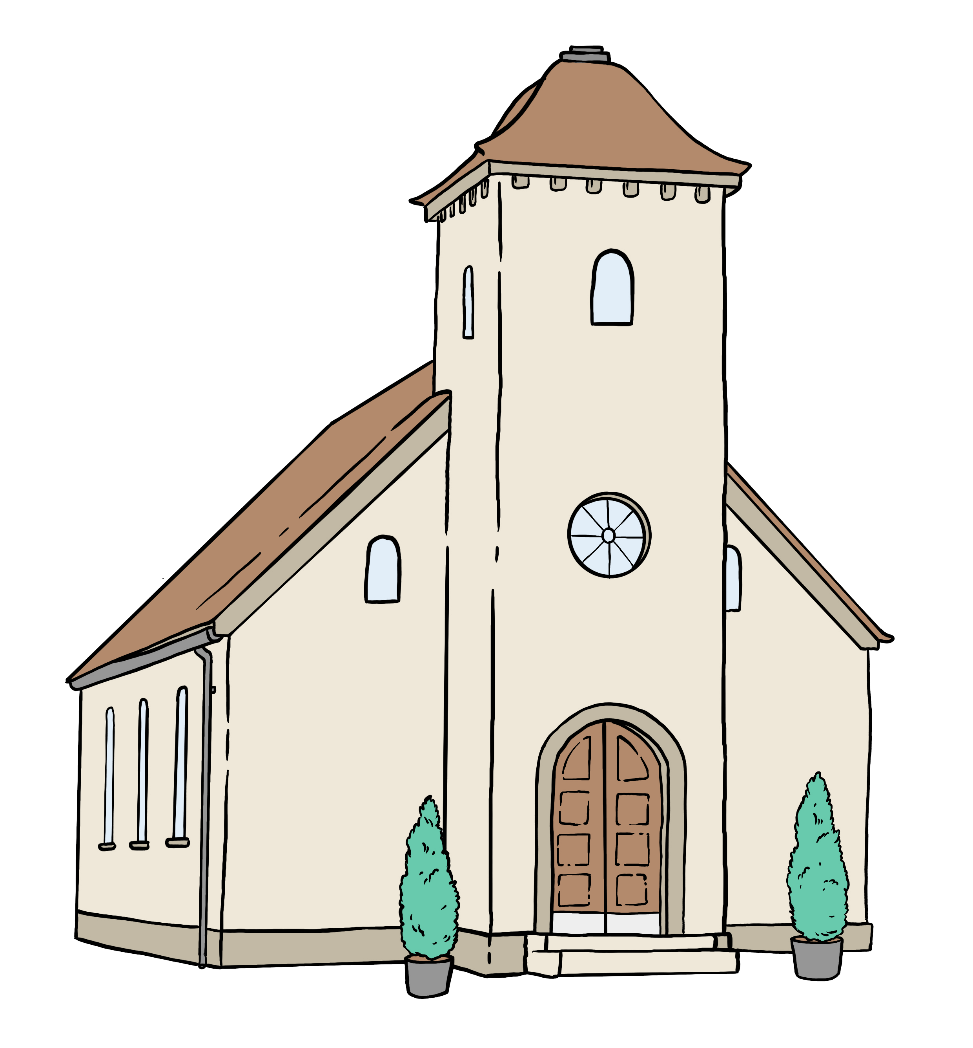
being from the same island
living in the same place
going to the same church.

You can find more information on the Ministry for Pacific Peoples Facebook page:

www.facebook.com/MinistryforPacificPeoples/

The Facebook page is not in Easy Read.

Support for Ethnic communities

Civil Defence Emergency Management Groups will work with the Ministry for Ethnic Communities to make sure Ethnic people affected by an emergency get support.
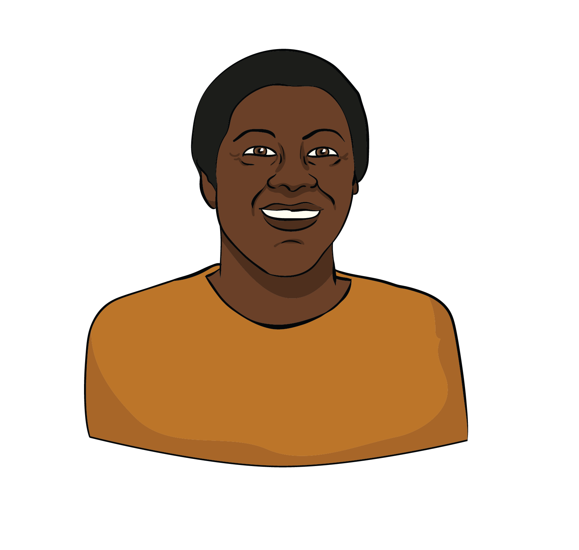

Here Ethnic people means people from:
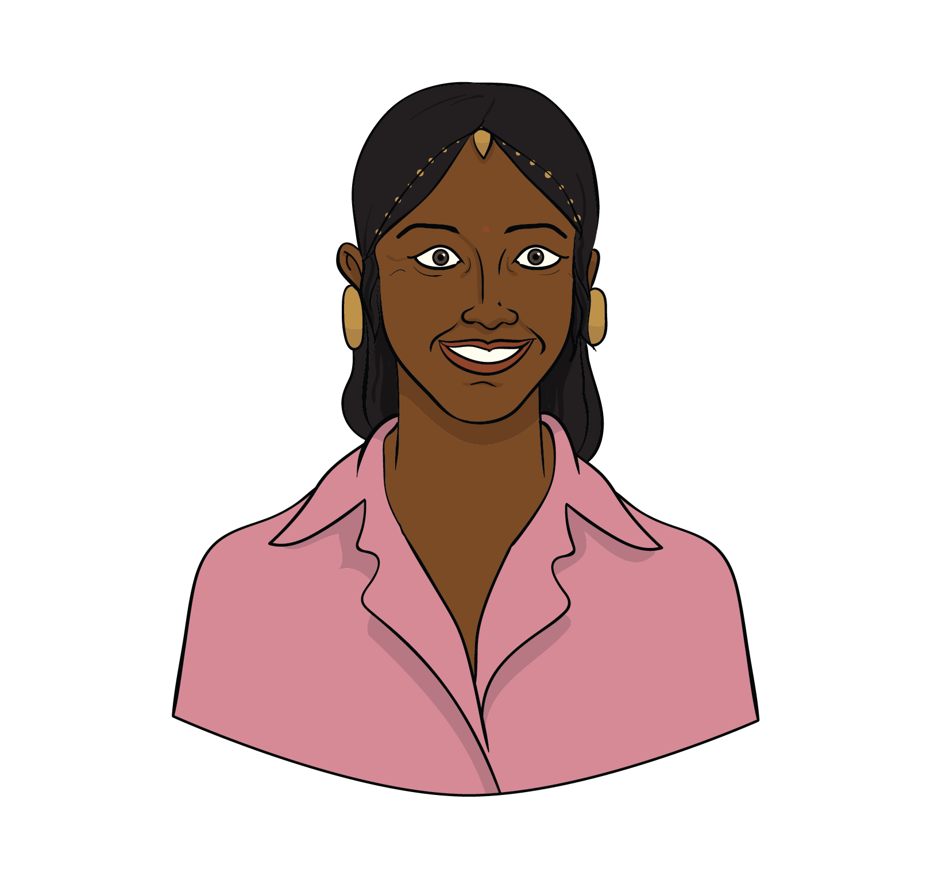
Africa
Asia
Europe
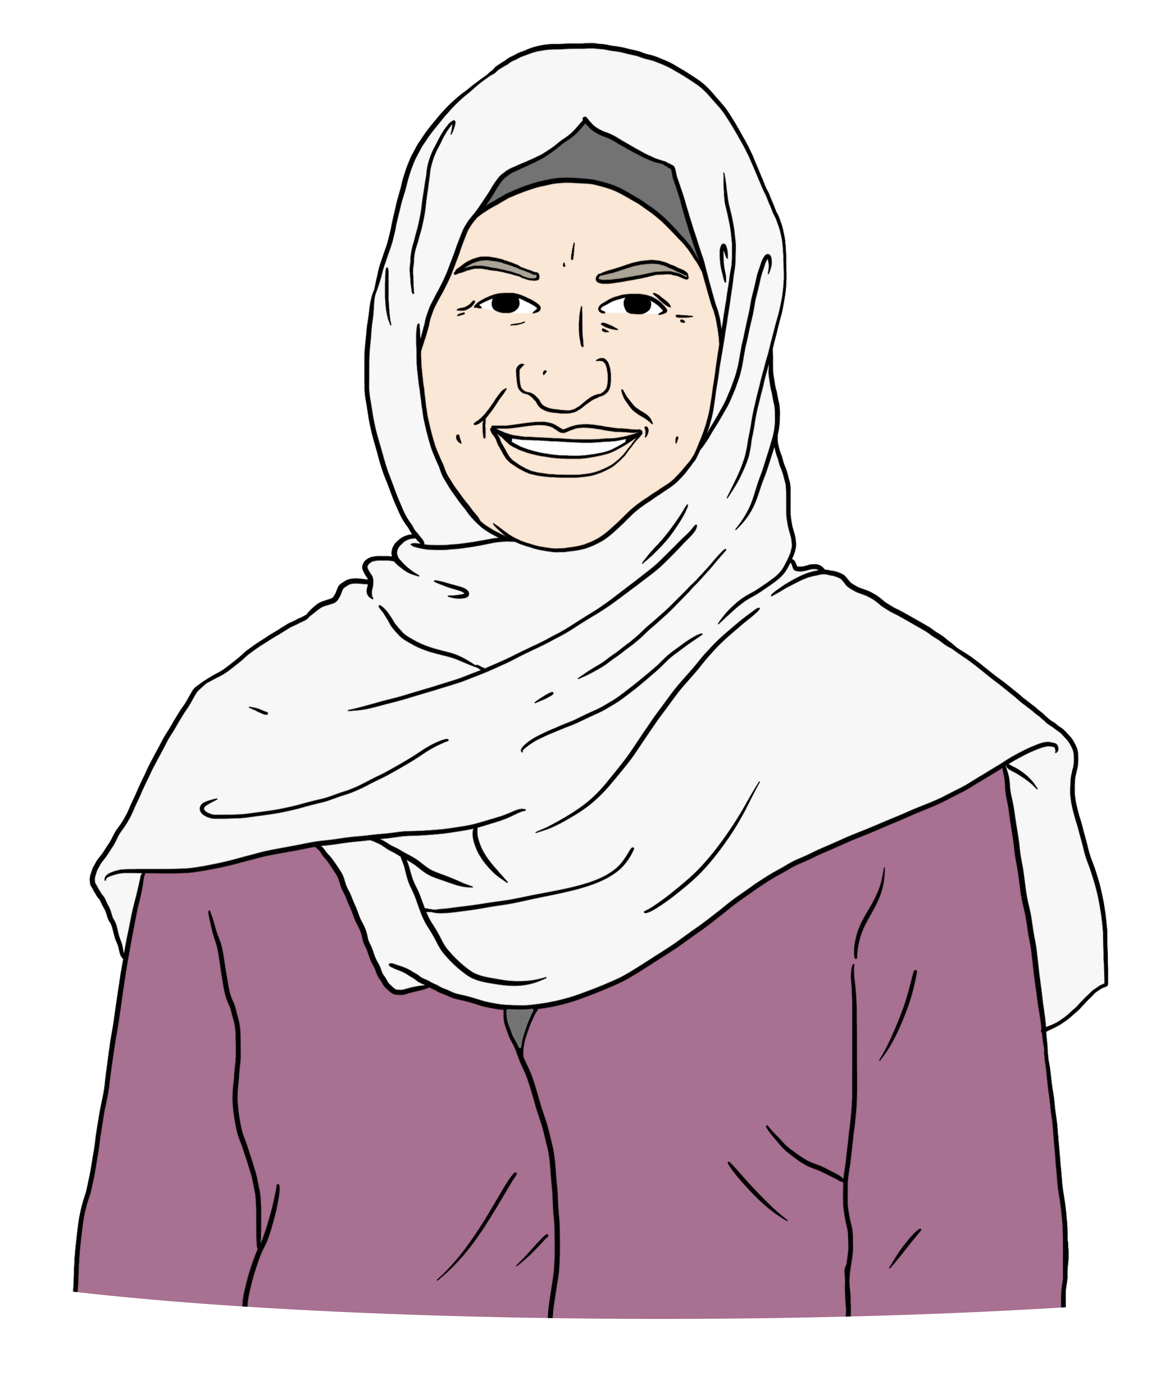
Latin America
the Middle East.

The Ministry for Ethnic Communities is the part of the government in charge of making
sure the government works well for Ethnic communities.

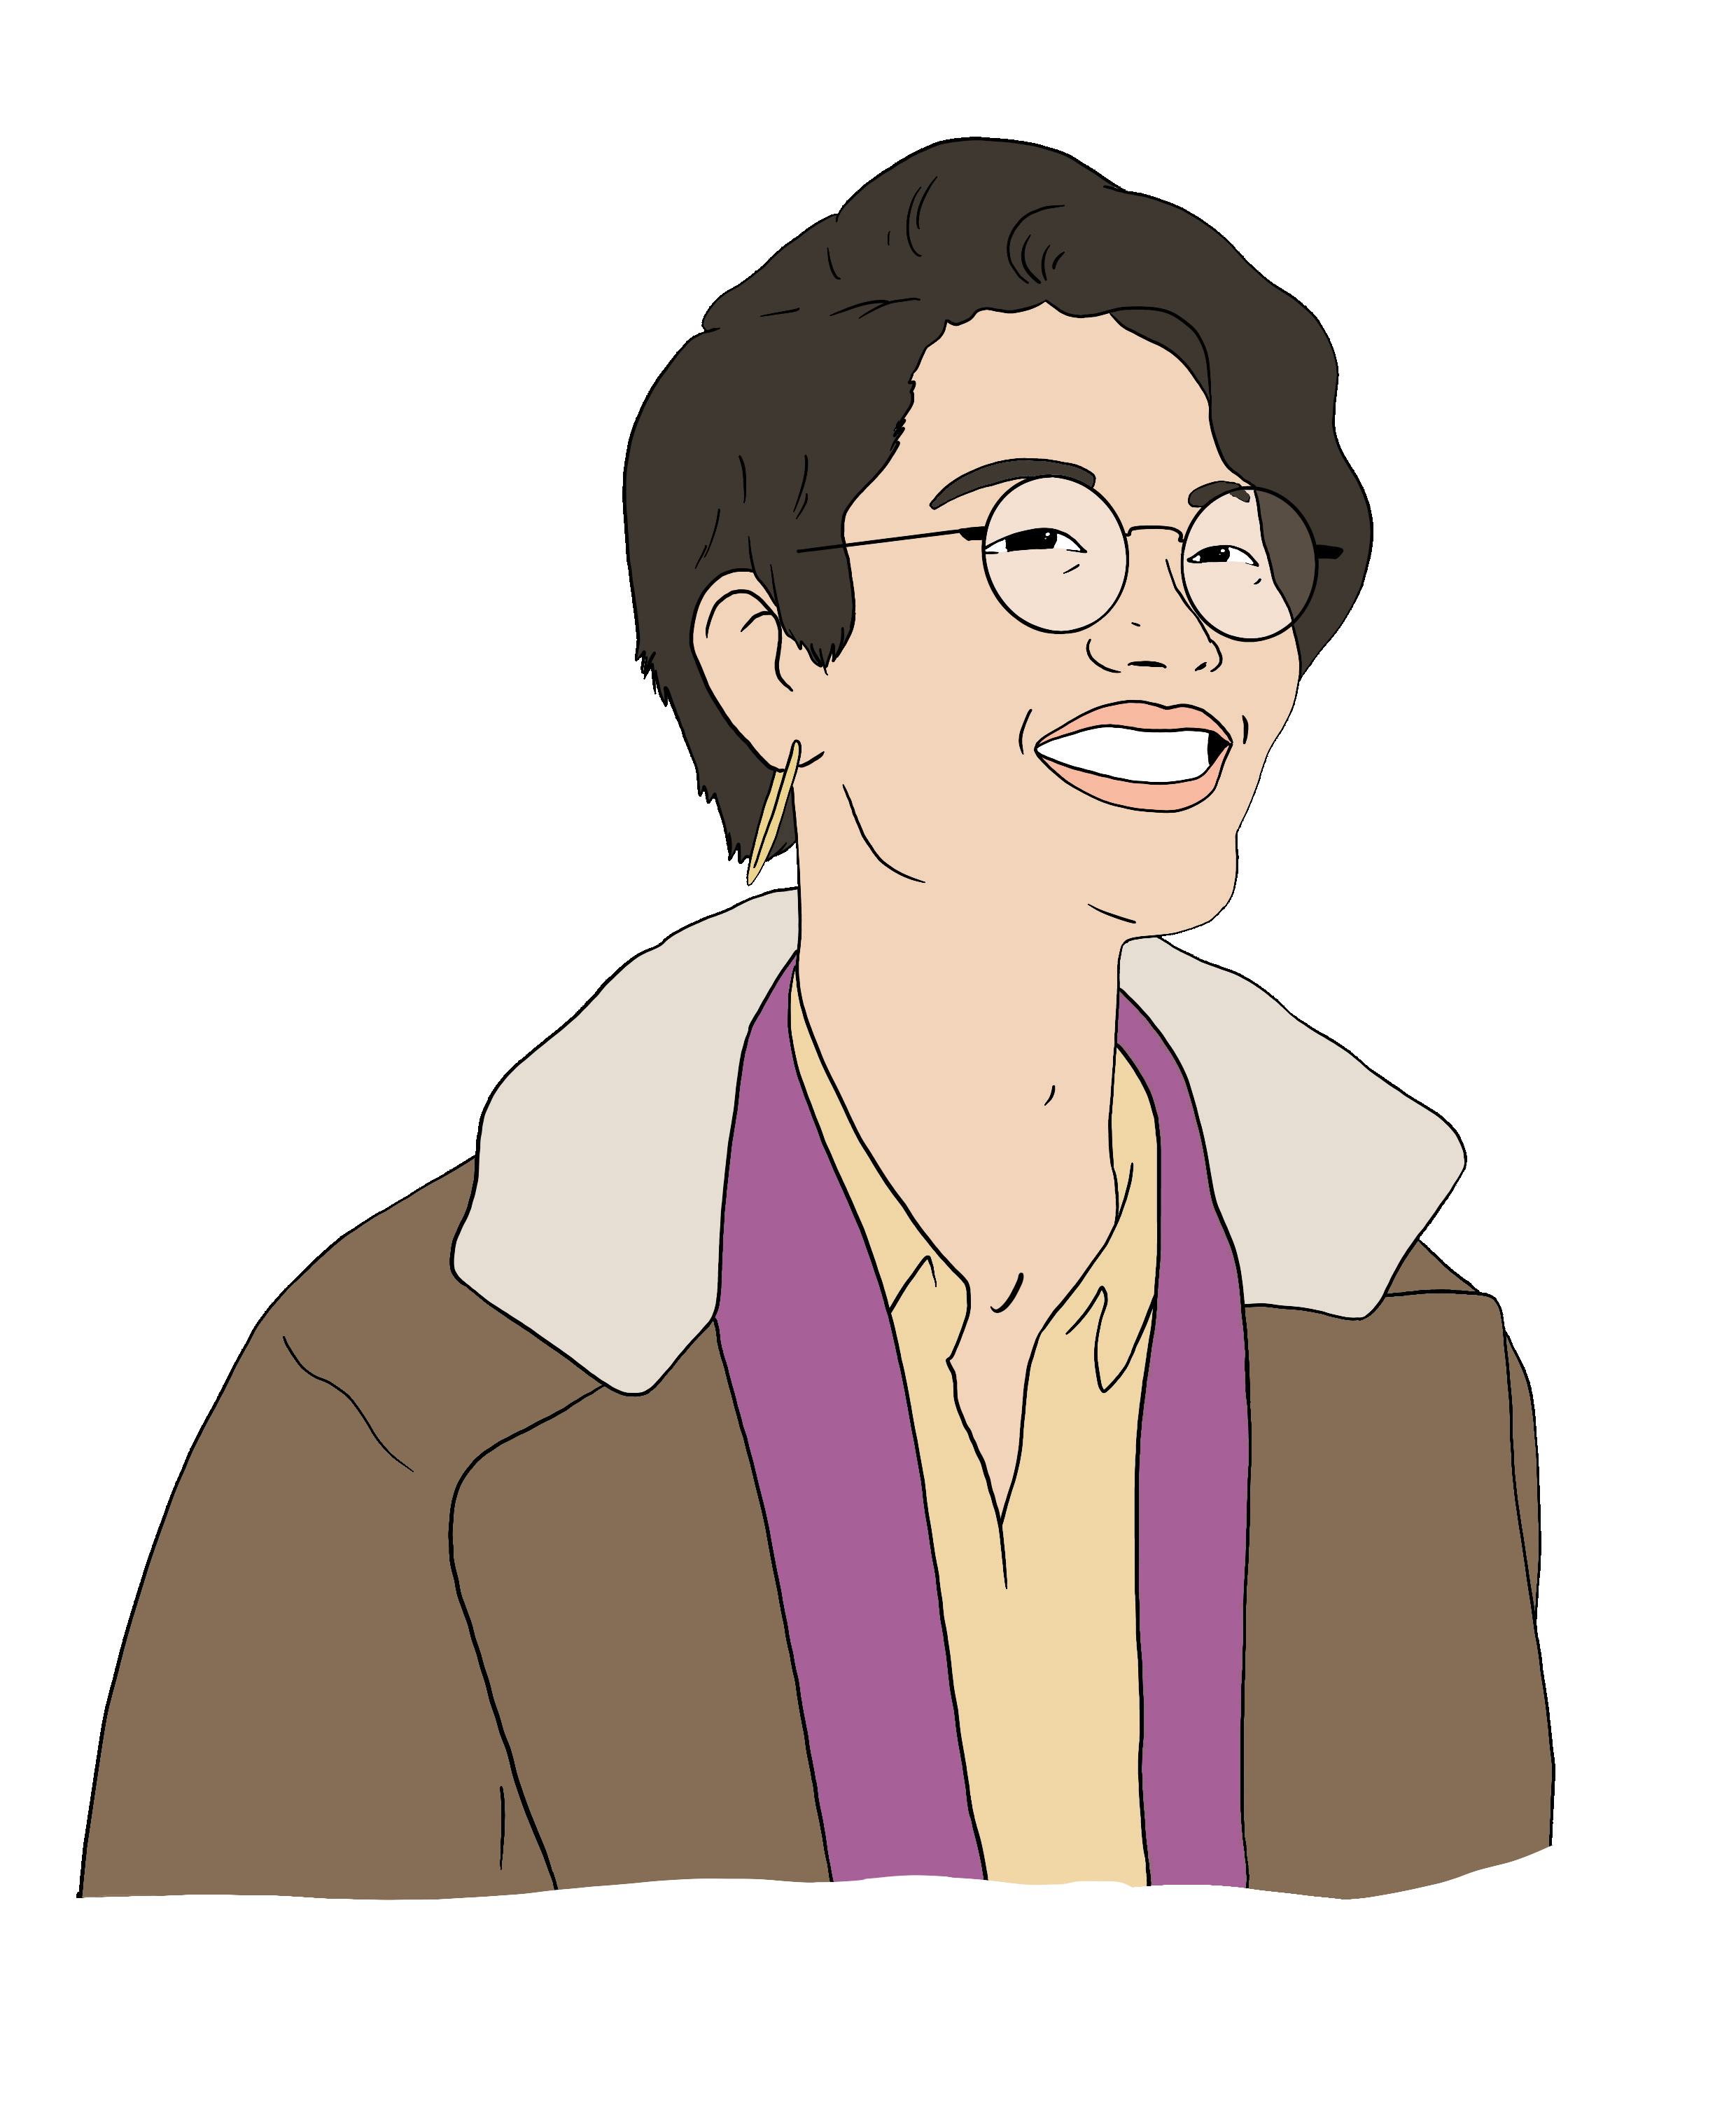
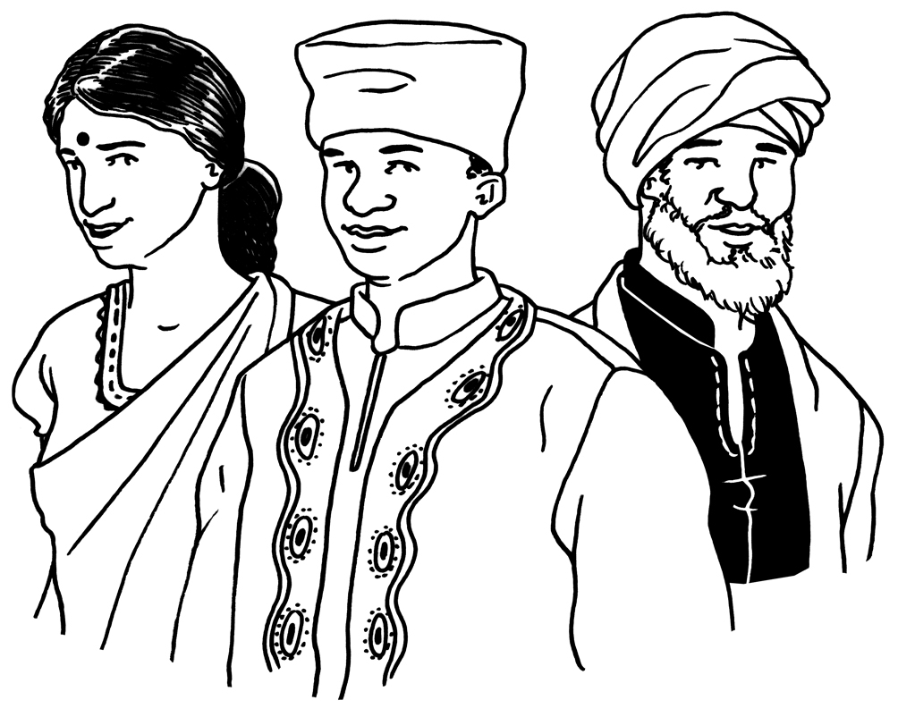
Civil Defence Emergency Management Groups and the Ministry for Ethnic Communities will support Ethnic people by working together with:
Ethnic community leaders
Ethnic communities
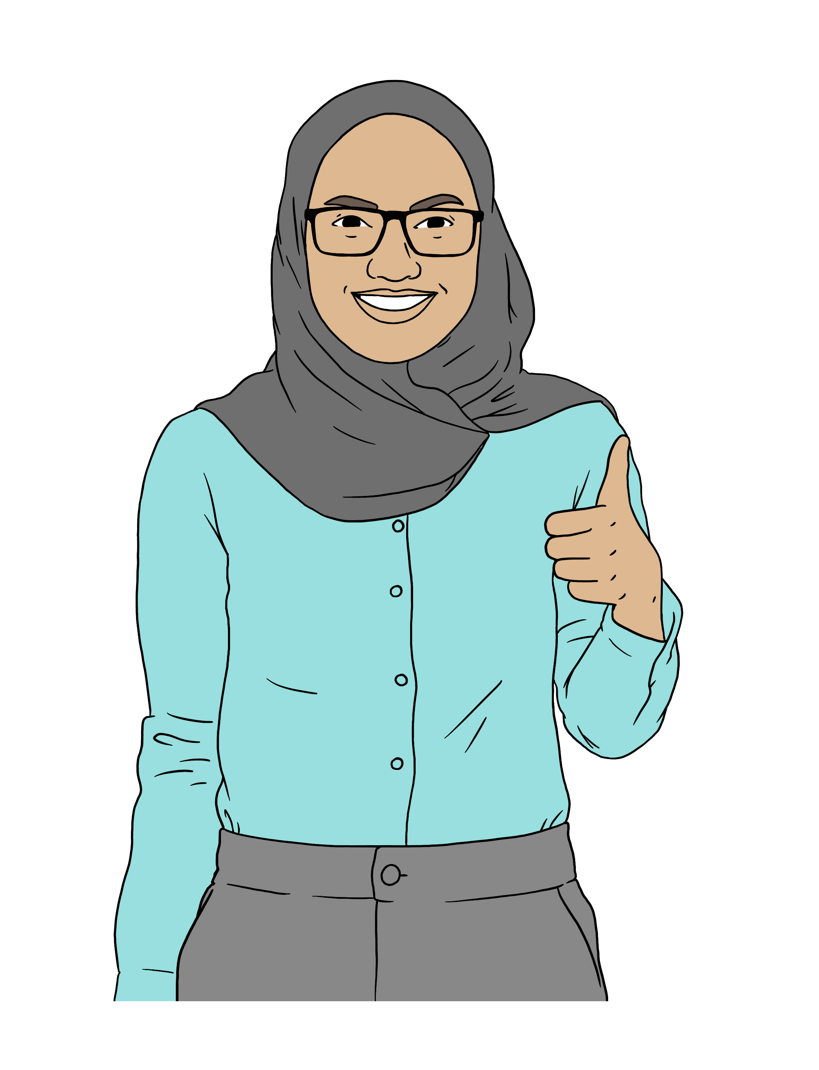
Ethnic community organisations.

Here leaders means Ethnic people who speak up for their communities.

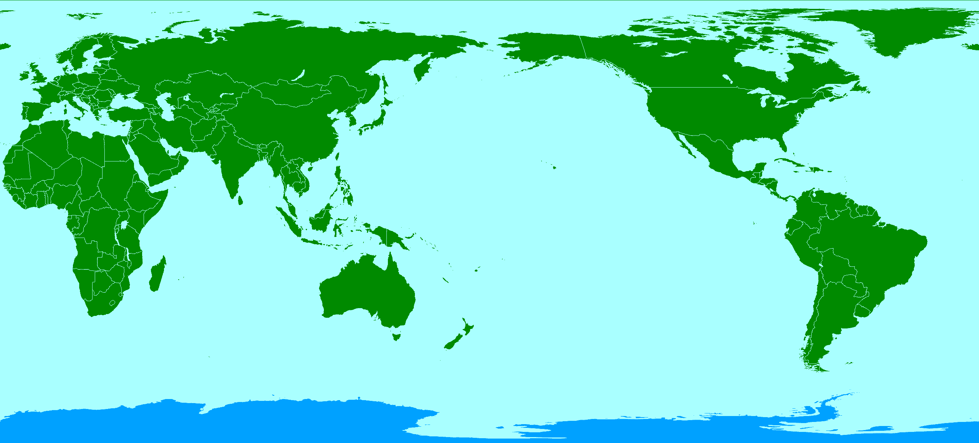
Here communities means Ethnic people who have something the same about them like:
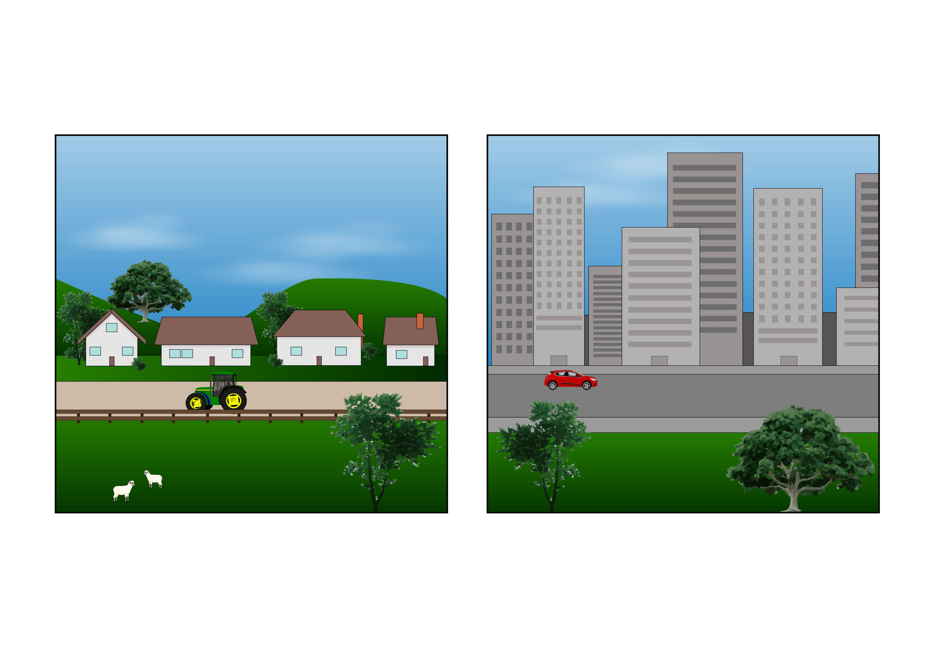
being from the same country
living in the same place
belonging to the same religion.

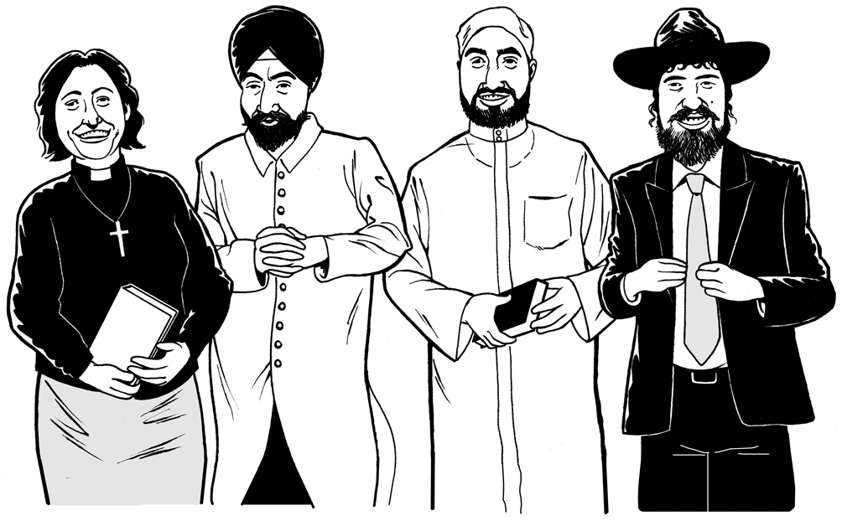
A religion is a group of people who believe similar things about ideas like:
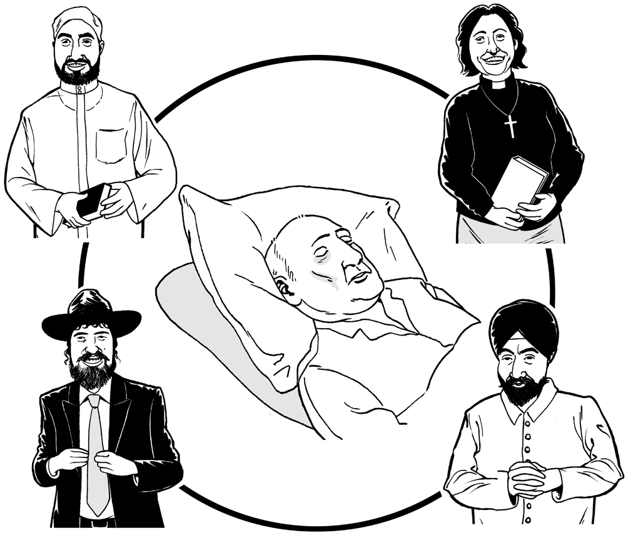
if there is a god or gods
what happens after we die.

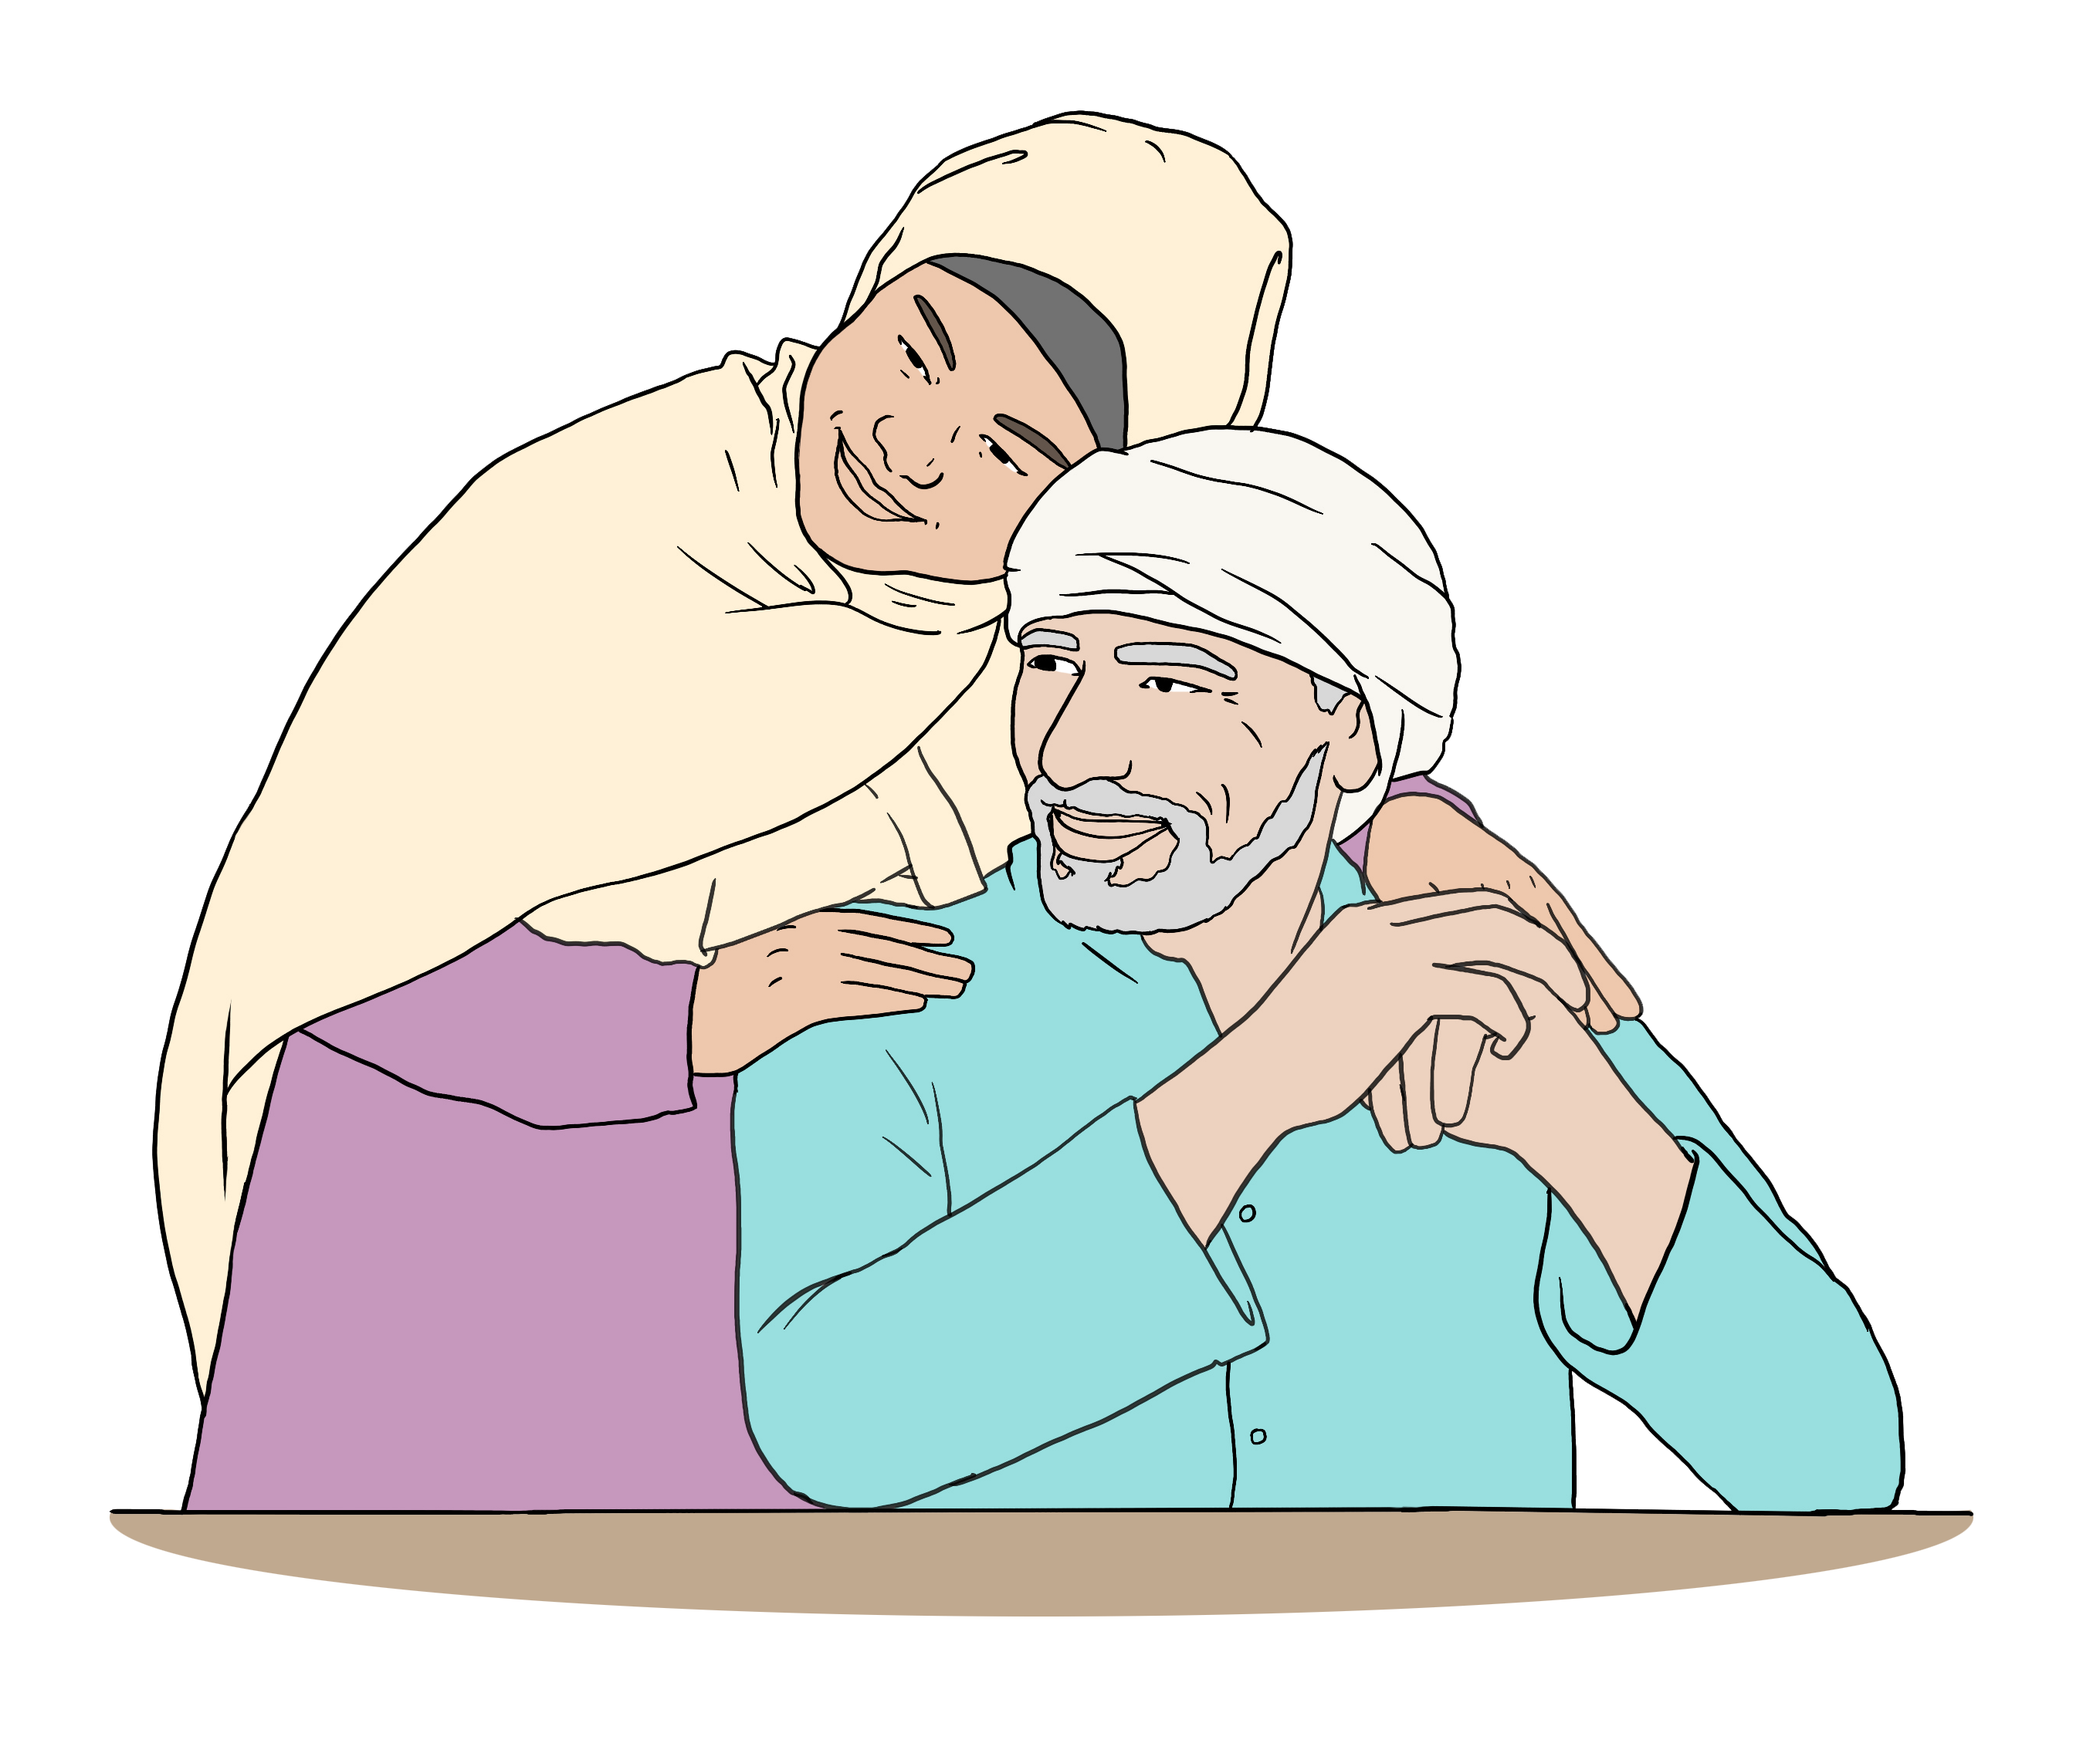
Some examples of religions are:
Islam
Buddhism.

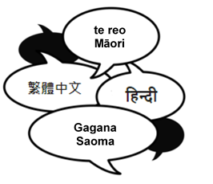
The Ministry for Ethnic Communities has information about what happens after an emergency in lots of languages.

You can find this information on their website:

www.ethniccommunities.govt.nz/

You can also find this information on their Facebook page:

www.facebook.com/ethniccommunities.govt.nz

These websites are not in Easy Read.

Support for foreign nationals

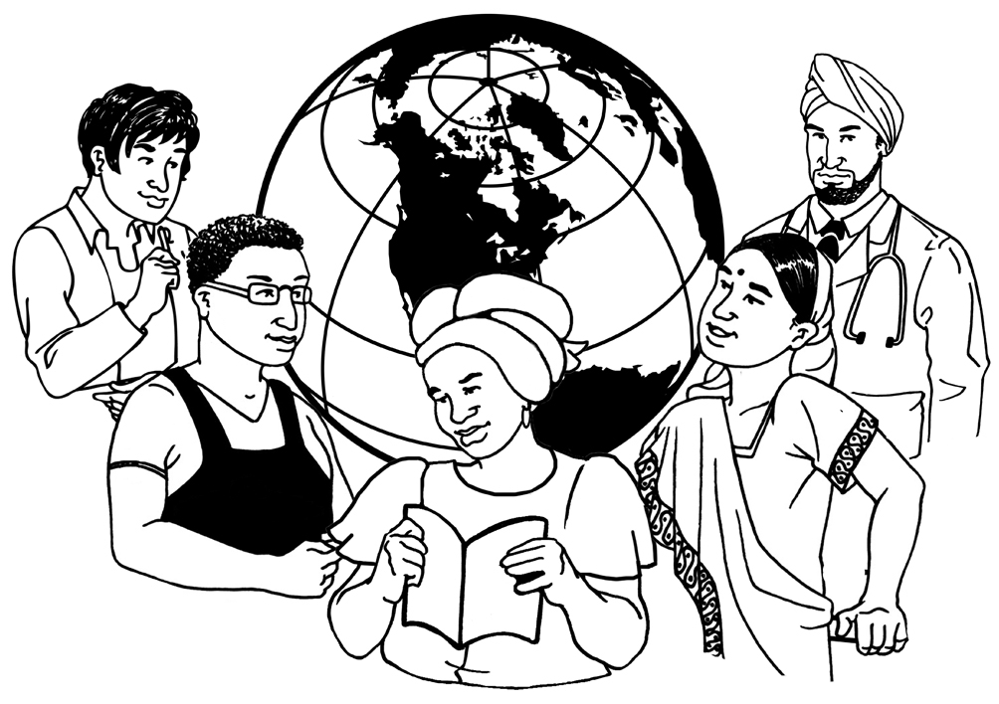
The places this Easy Read talks about can support you if you are a foreign national who has been affected by an emergency.

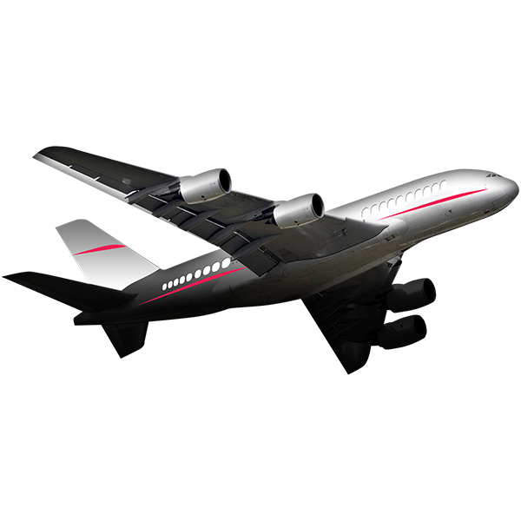
Here a foreign national is someone who is not:
from Aotearoa New Zealand
allowed to live in Aotearoa New Zealand all the time.

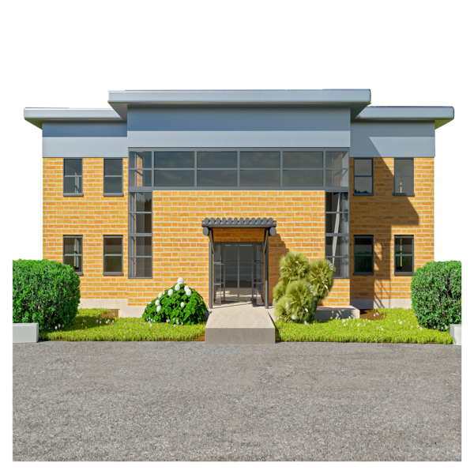
You can also get support from your:
Embassy
High Commission.

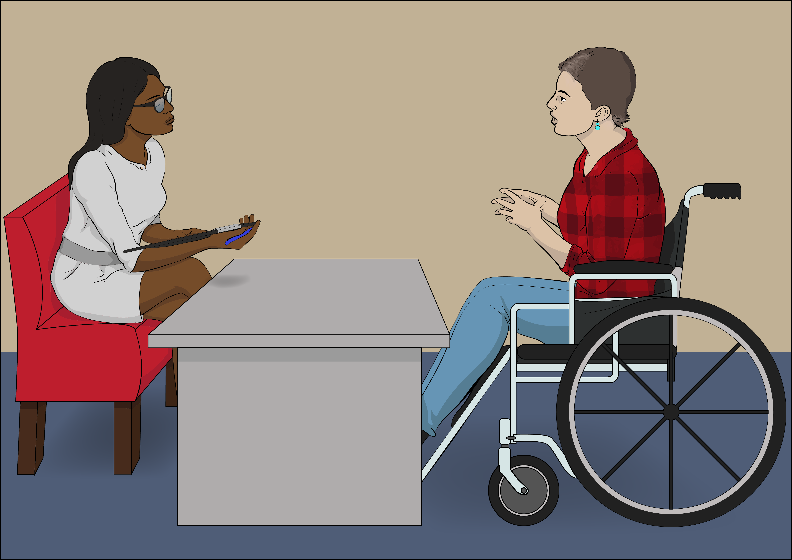
An embassy / high commission is
a place in Aotearoa New Zealand where people from other countries can get support from their government.

You can find your embassy / high commission on this website:

www.mfat.govt.nz/en/embassies

This website is not in Easy Read.

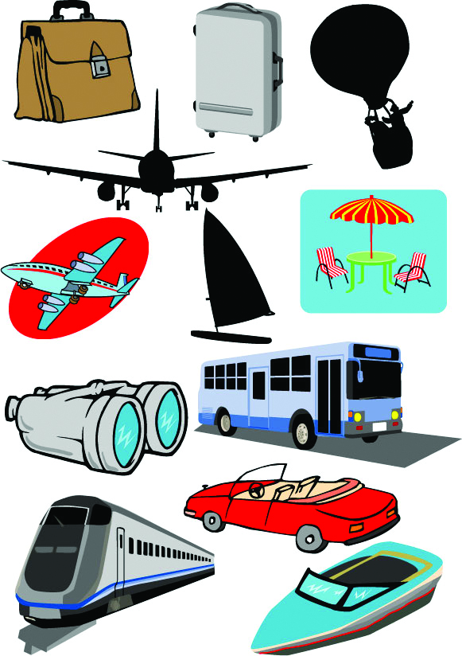
Talk to your travel insurance company if:
you are visiting Aotearoa New Zealand
there is a problem with your travel after an emergency.

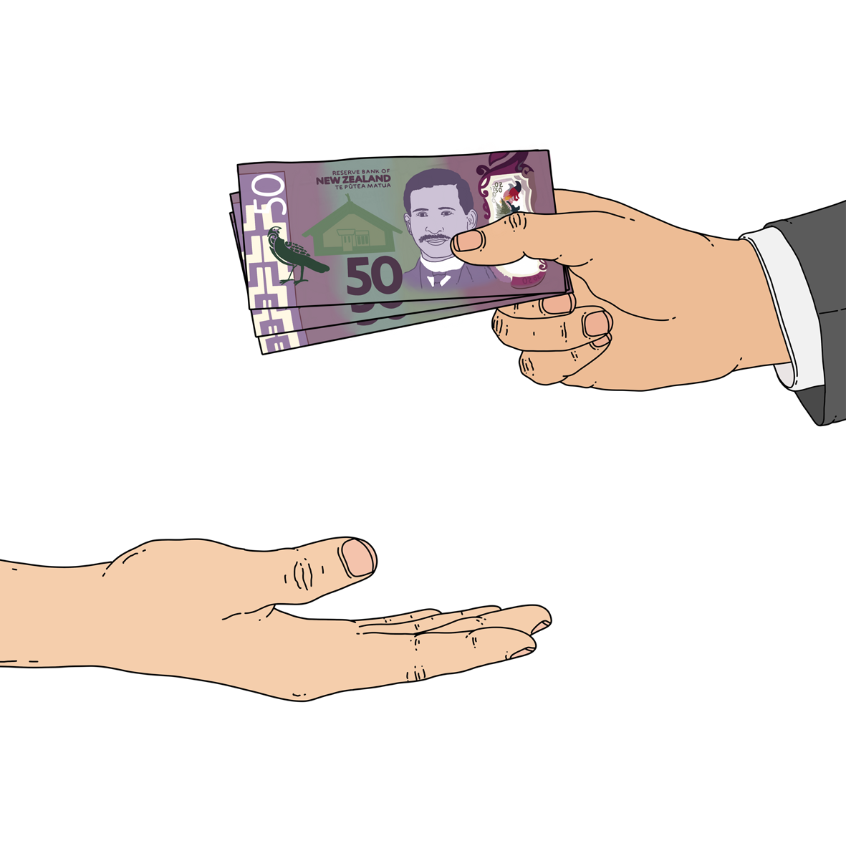
Insurance is money you pay so you can get support if something bad happens like:
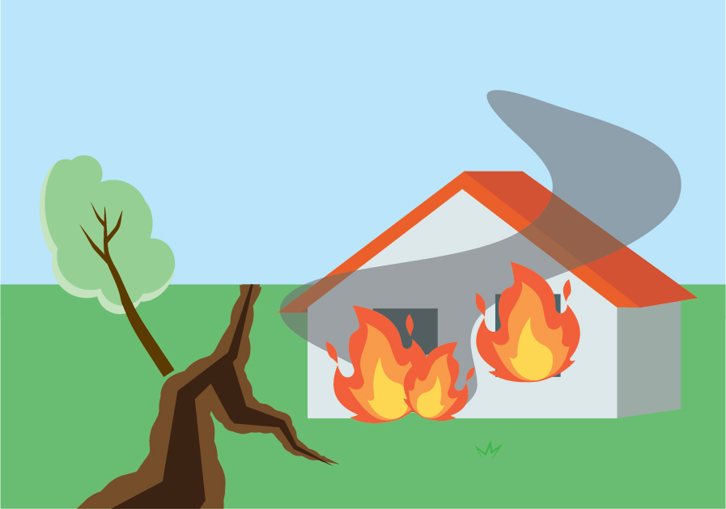
being robbed
an earthquake
your house burning down.

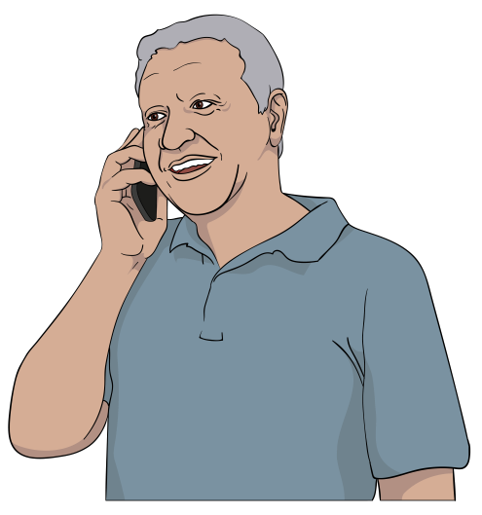
Contact Immigration New Zealand if your visa:
has expired
will expire soon.
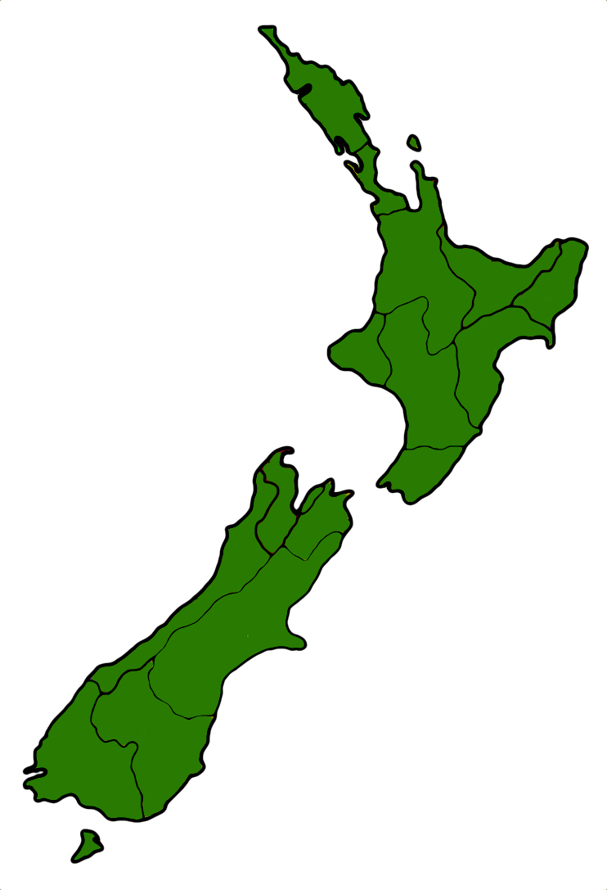

Immigration New Zealand is the part of the government that supports people who want to come to Aotearoa New Zealand.

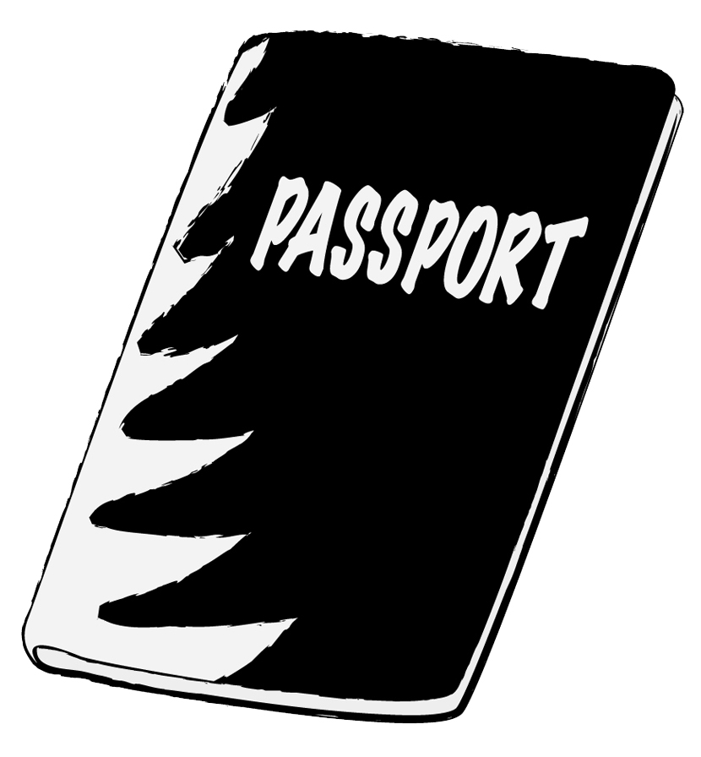
A visa says that you are allowed to enter a country.

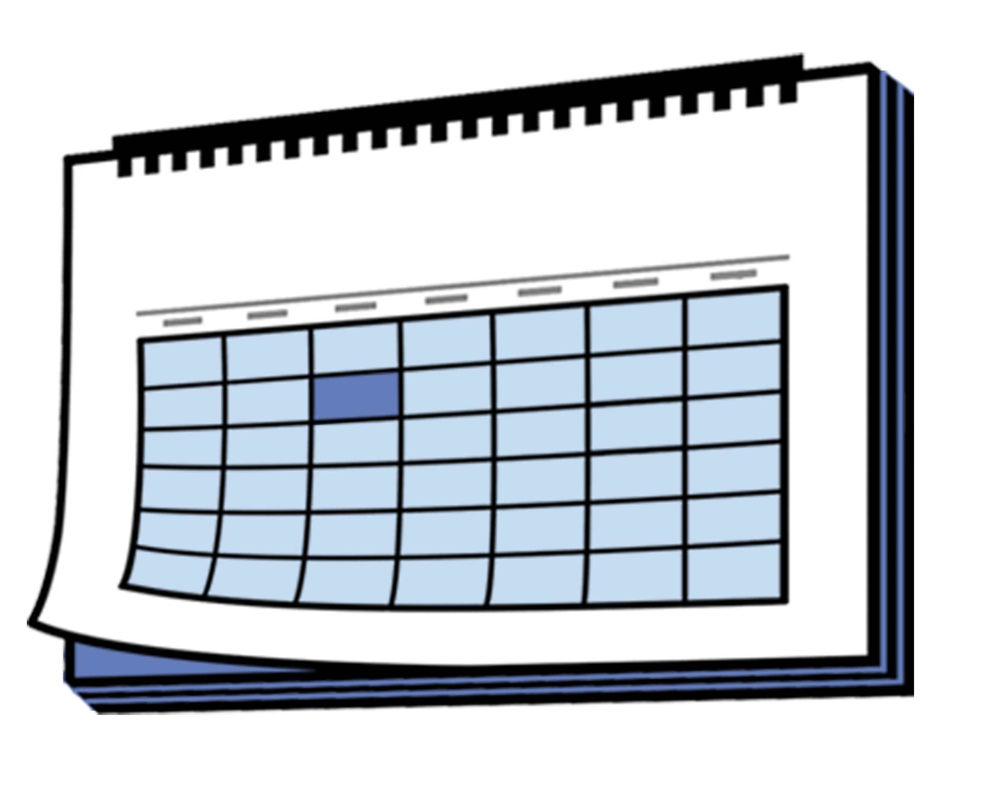
Most visas have a date when you have to leave the country by.
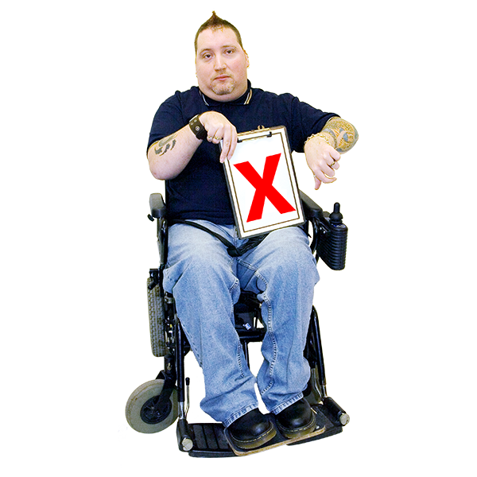

Your visa has expired after the date when you have to leave the country by.

You can find out how to contact Immigration New Zealand on this website:

www.immigration.govt.nz/contact-us/

This website is not in Easy Read.

Looking after animals


You are in charge of looking after your animals in an emergency.

Take your animals with you if:
you need to evacuate
it is safe to take your animals.

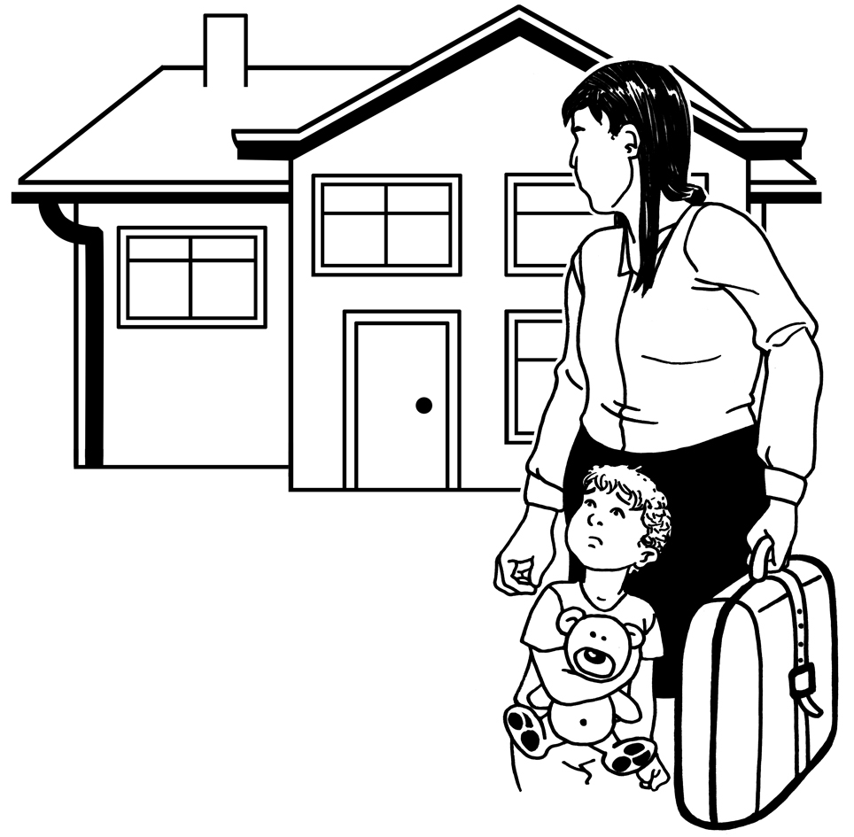
Evacuate means leaving your home when it is not safe to stay there.

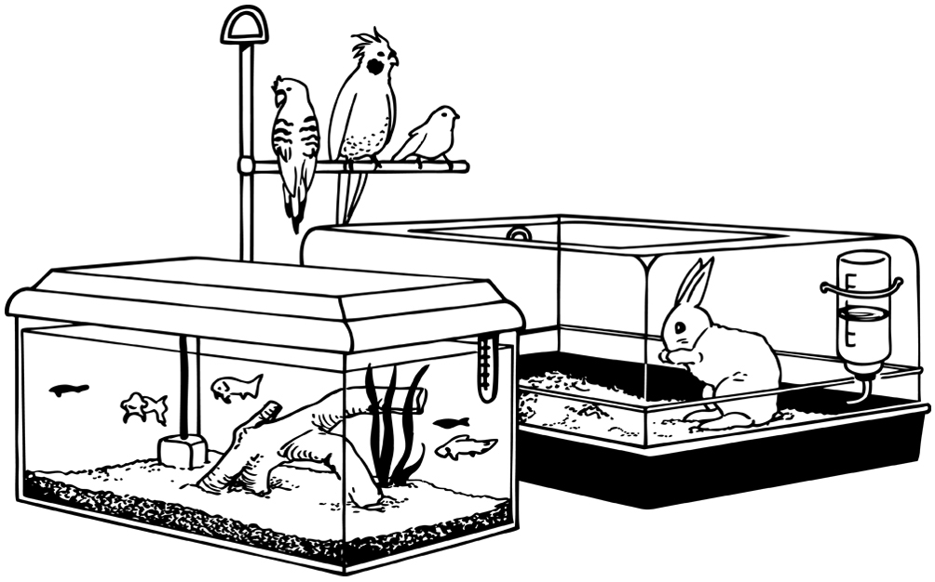
Make sure your animals are somewhere safe if you have to leave them behind.

You can find out more about how to look after your animals in an emergency on this website:

https://tinyurl.com/yc4fk9dc

This website is not in Easy Read.

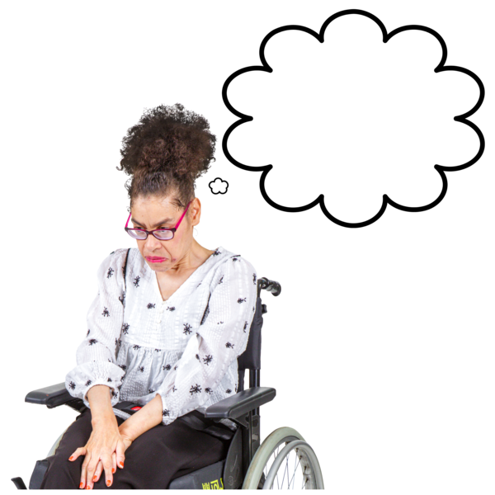

Tell your local Civil Defence Emergency Management Group if you are worried about any animals.


They will get the Ministry for Primary Industries to check on the animals.


The Ministry for Primary
Industries is the part of the government in charge of making
sure people look after animals well.

You can find out how to contact your local Civil Defence Emergency Management Group on this website:

https://tinyurl.com/4u4bnp26

This website is not in Easy Read.

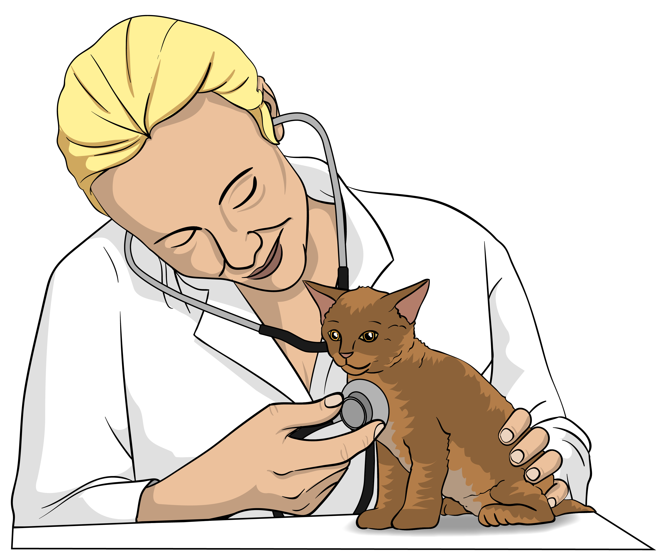
Talk to your vet if your animals are:
sick
hurt.

Insurance

You might have:
home insurance
vehicle insurance
contents insurance.

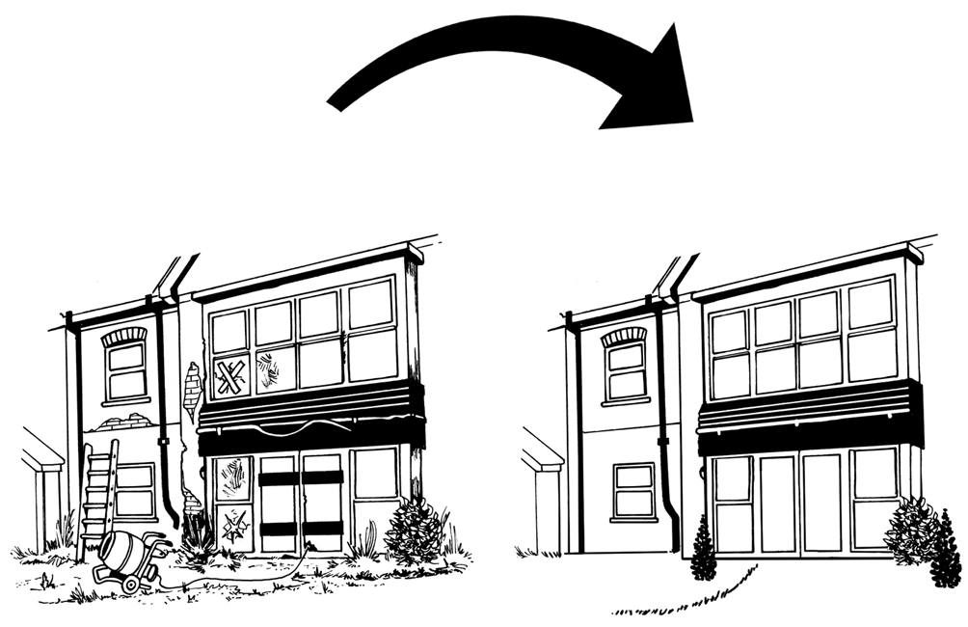
If your home is damaged home insurance pays for:
your home to be fixed
a new home.

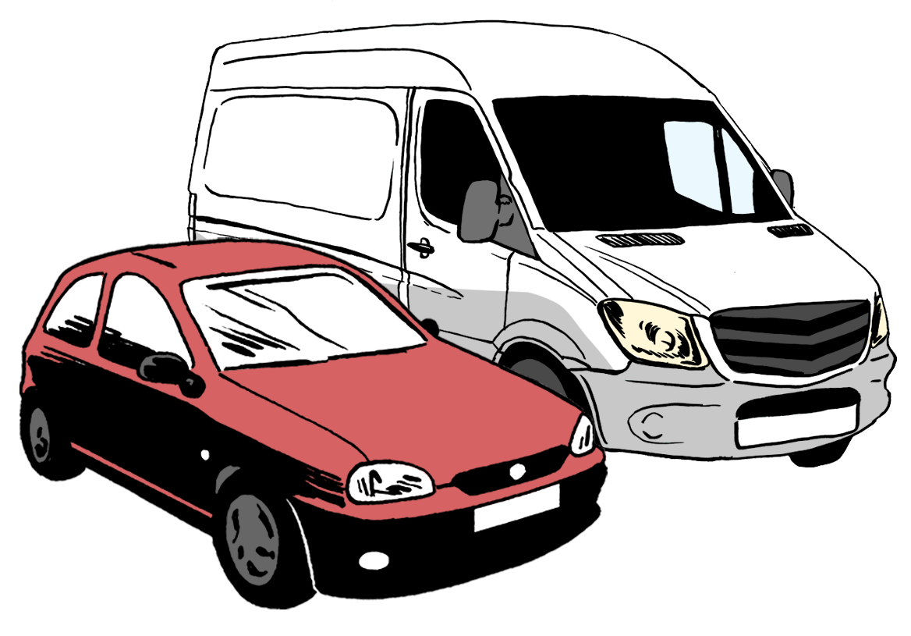
If your vehicle is damaged vehicle insurance pays for:
your vehicle to be fixed
a new vehicle.


Vehicles are things like:
cars
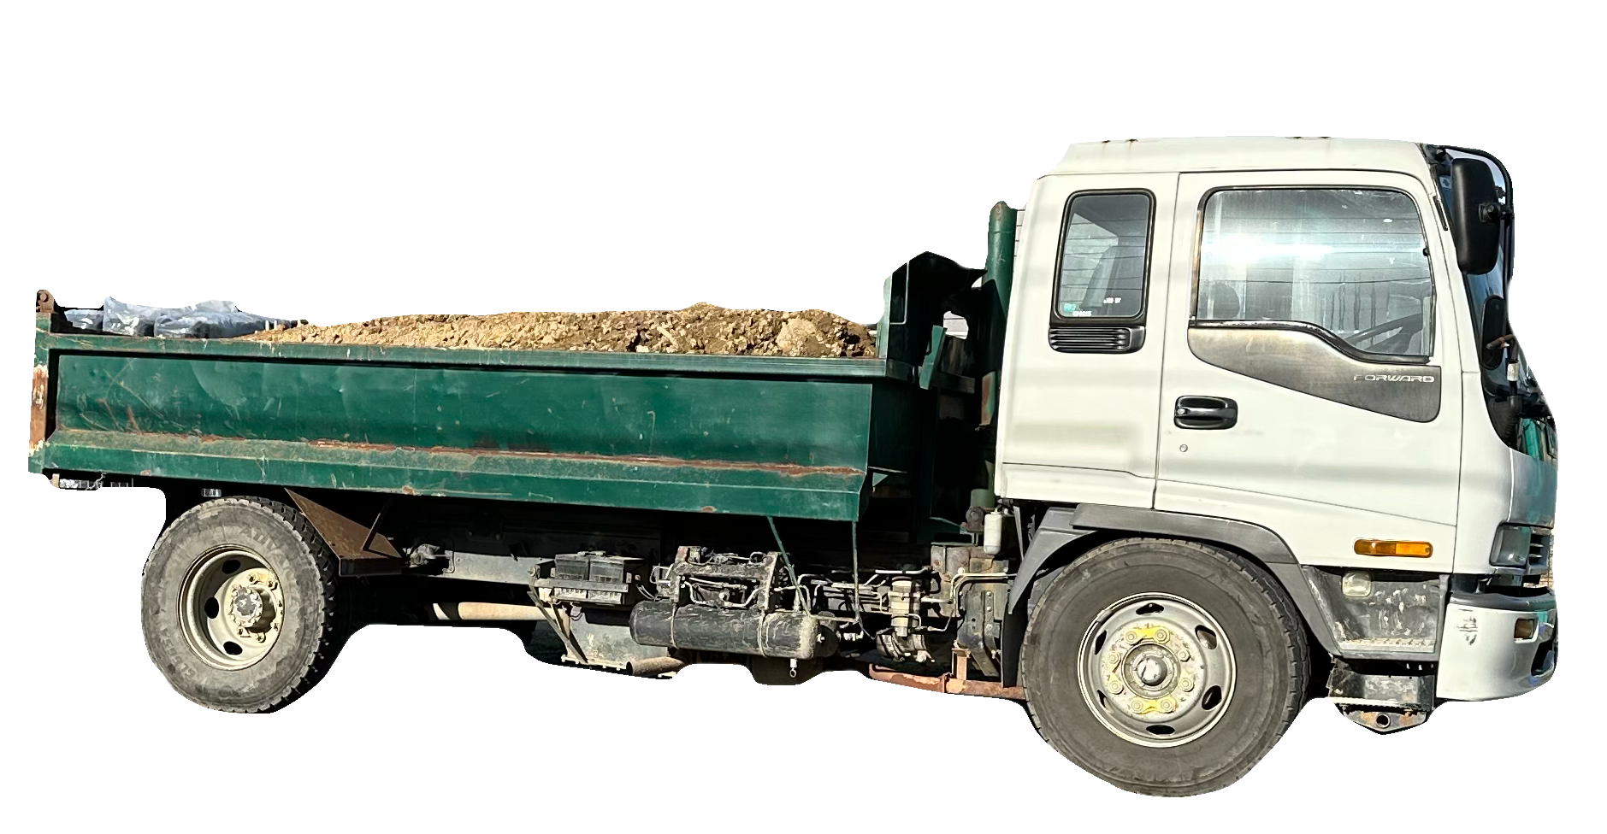
trucks
motorbikes.


If things in your home are damaged contents insurance pays for:
the things to be fixed
new things.


Here contents means anything in your home like:
computers
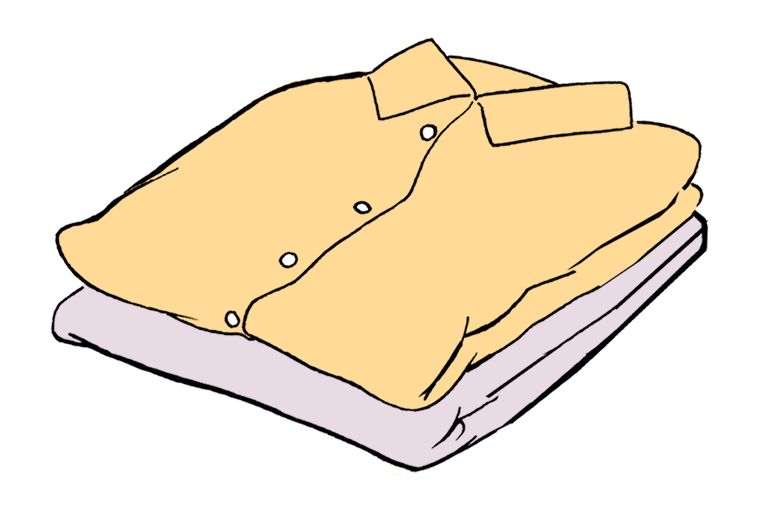
the fridge
clothes.

Take photos of the damage before you:
throw anything away
fix anything.

Tell your insurance company about the damage as soon as you can.

Your insurance company will tell you what to do next.

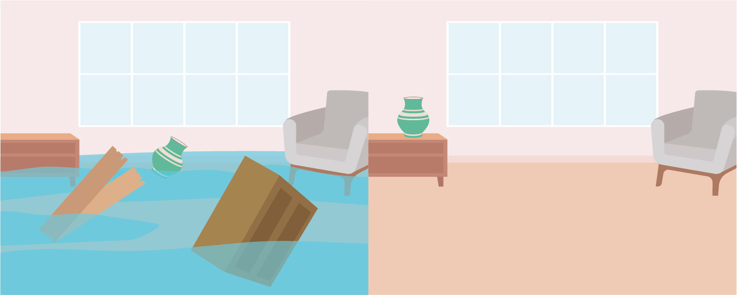
You might need to do work right now to make your home:

clean
safe.

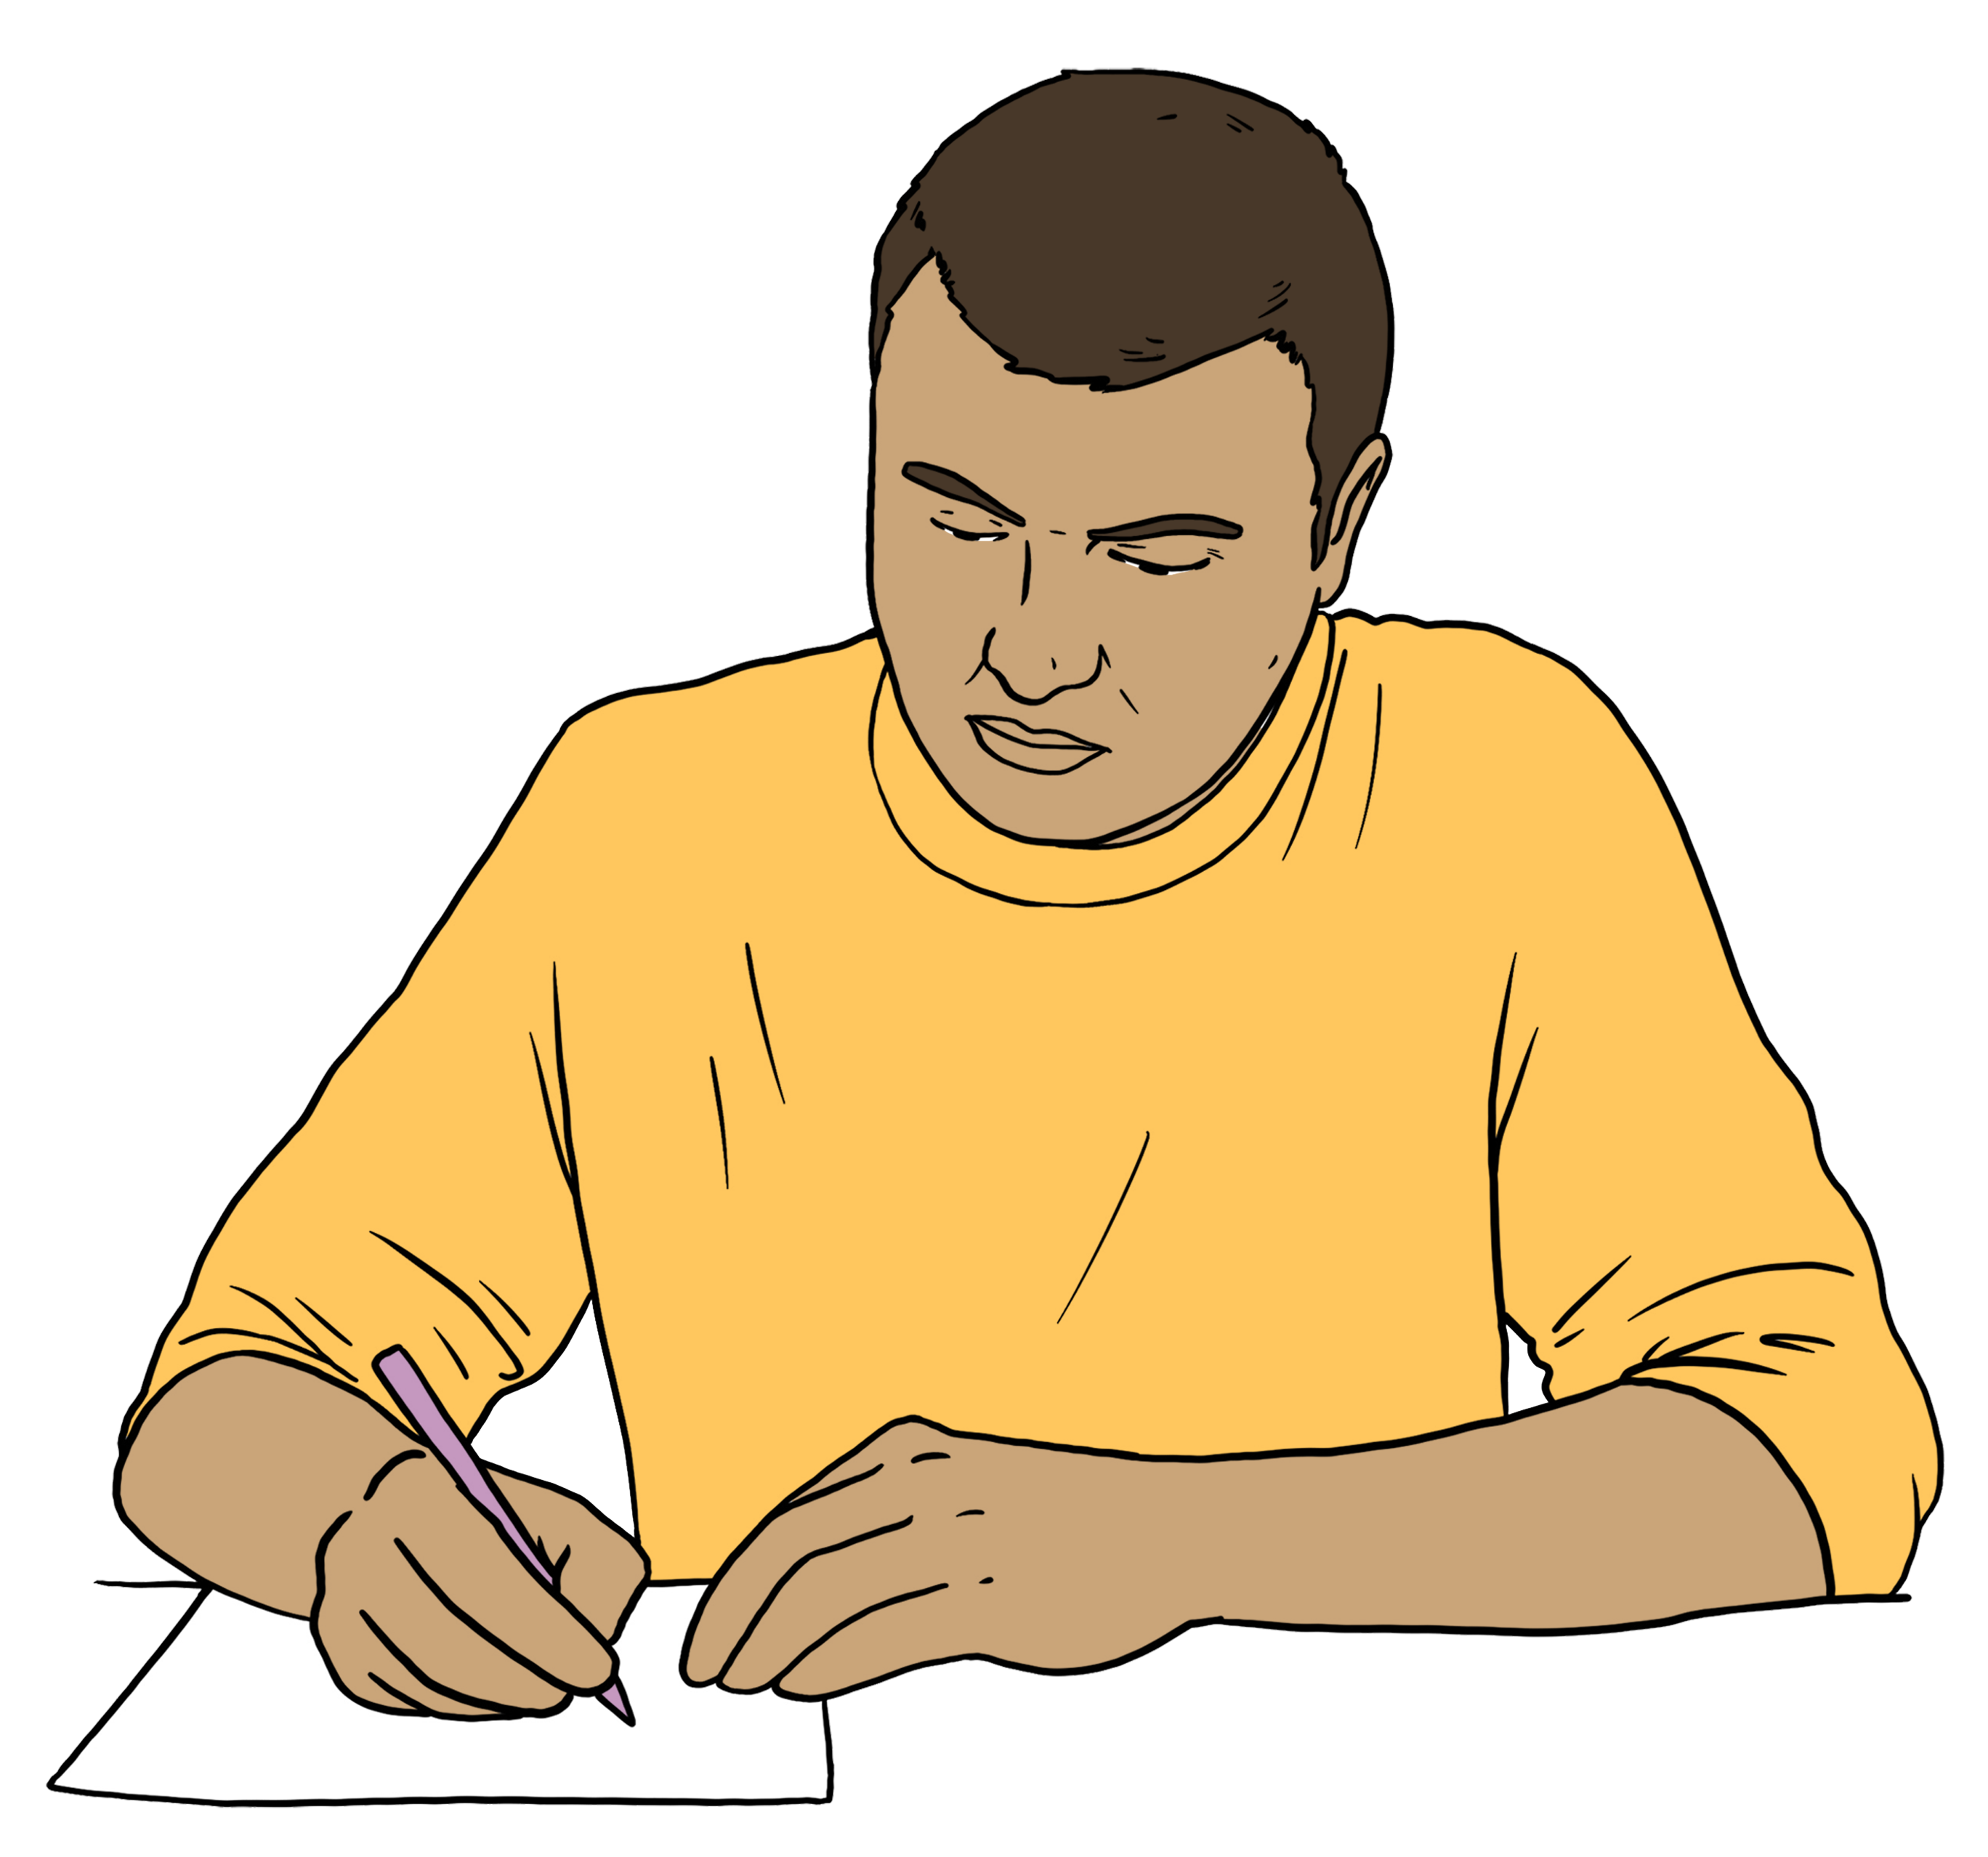
Keep a record of the work you do.

Here a record means information that shows your insurance company what work you did.

Take photos:
before you do the work
after you do the work.

Keep copies of any bills you pay.

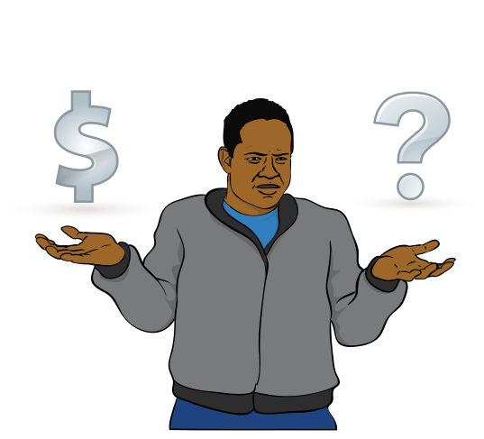
Some people:
have contents insurance
do not have home insurance.


If you are 1 of these people talk to your insurance company about what they can pay for.


Take lots of photos.

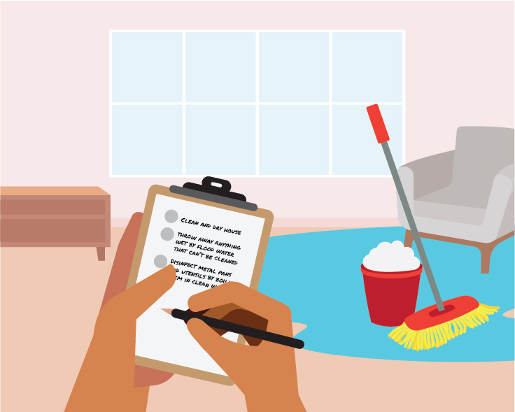
Keep a record of anything you throw away.

Most people who have insurance for their house have NHCover.

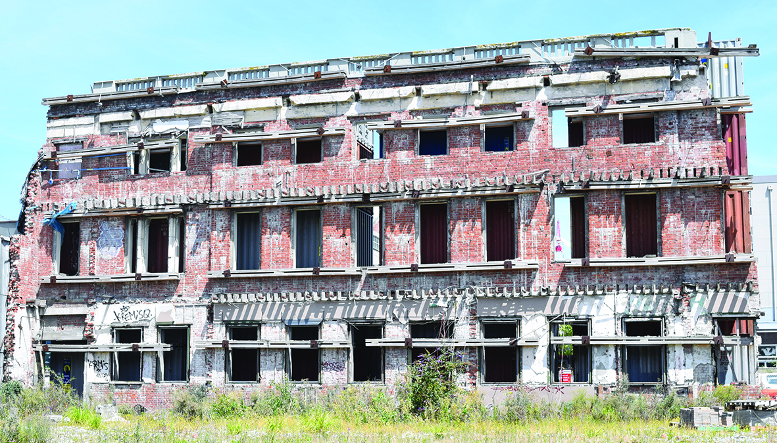
NHCover is insurance that pays for damage caused by:
earthquakes
natural landslides
volcanic eruptions
hydrothermal activity
tsunami.

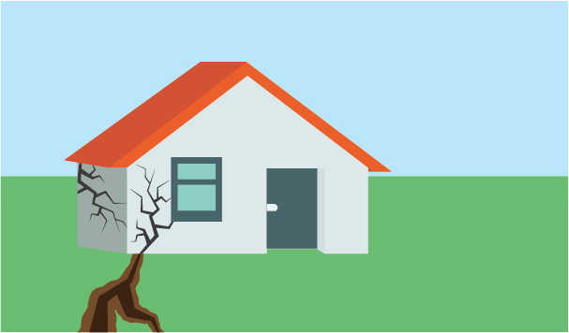
An earthquake is when the ground shakes.

A landslide is when lots of land falls down a hill.

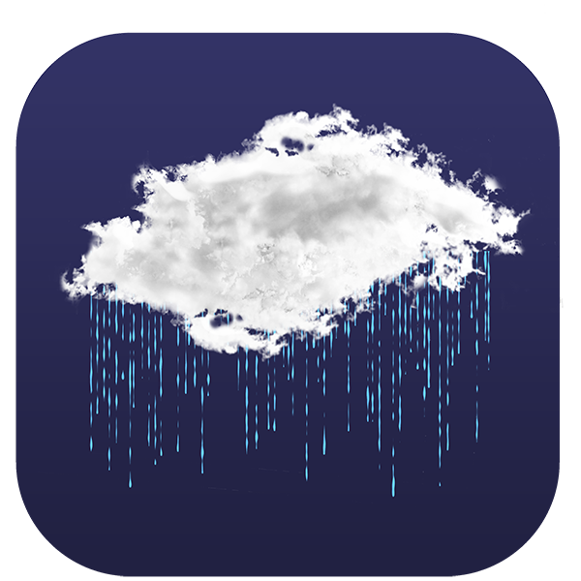
A natural landslide is when the
thing that made the landslide happen was something in nature like:
an earthquake
lots of rain.

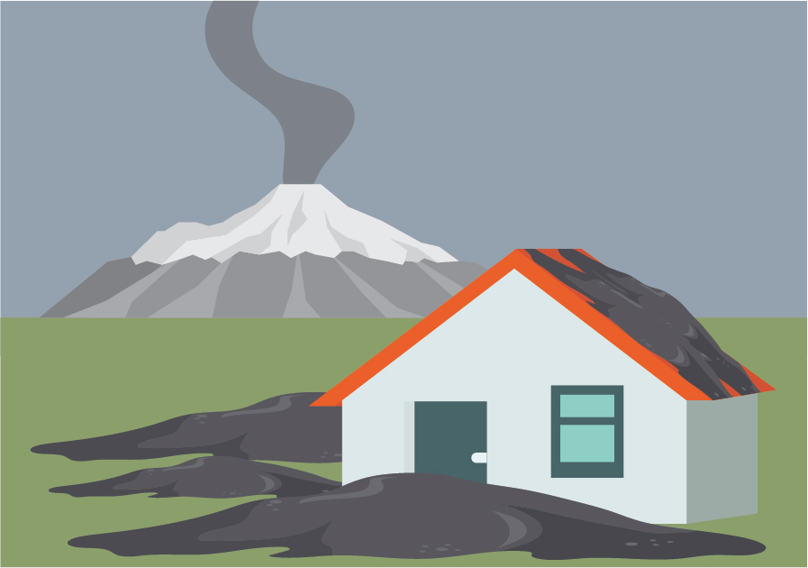
A volcanic eruption is when a type of mountain called a volcano does things like:
sending lots of ash into the air
sending rocks into the air
making hot melted rocks called lava come out of the mountain.
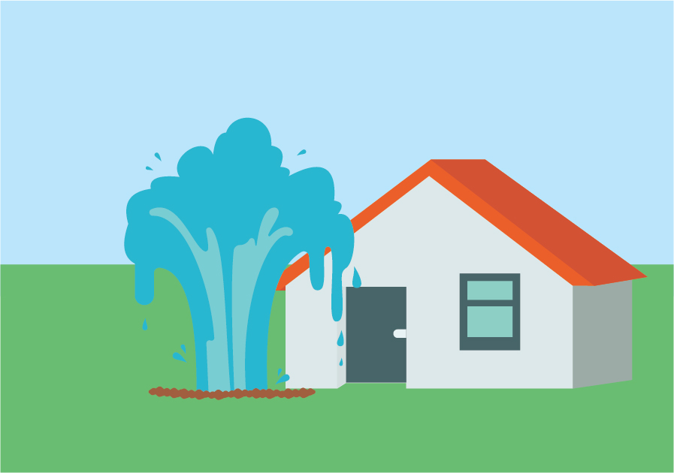

Hydrothermal activity is when very hot water comes out of the earth.

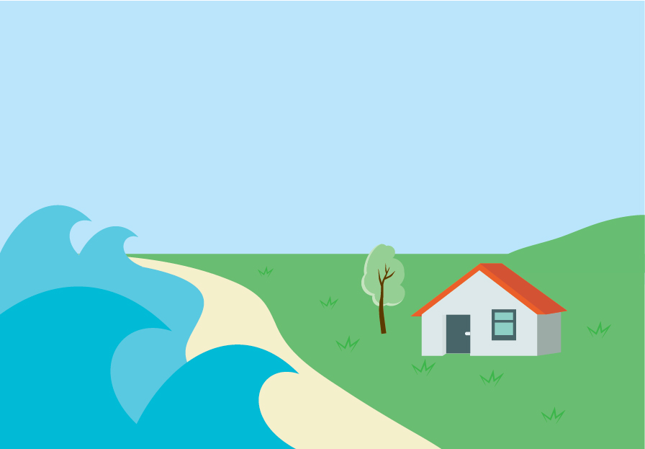
A tsunami is a wave that is:
very big
moves quickly.


NHCover can also pay for damage caused by a fire if the fire was started by:
an earthquake
a natural landslide
a volcanic eruption
hydrothermal activity
a tsunami.

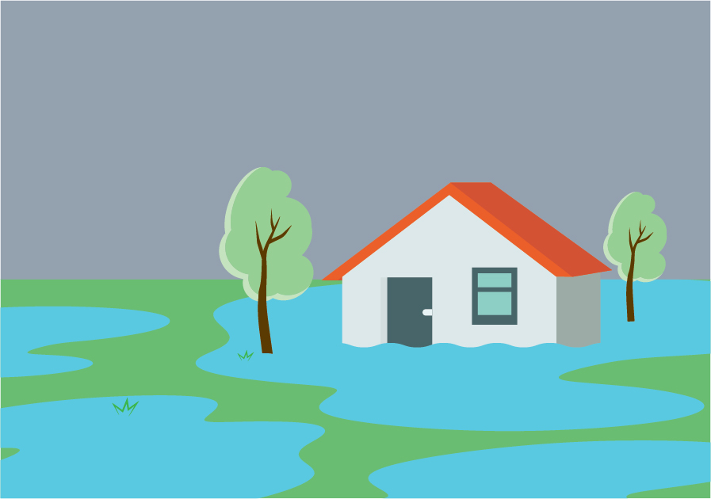
NHCover can also pay for land that gets damaged by:
storms
floods.

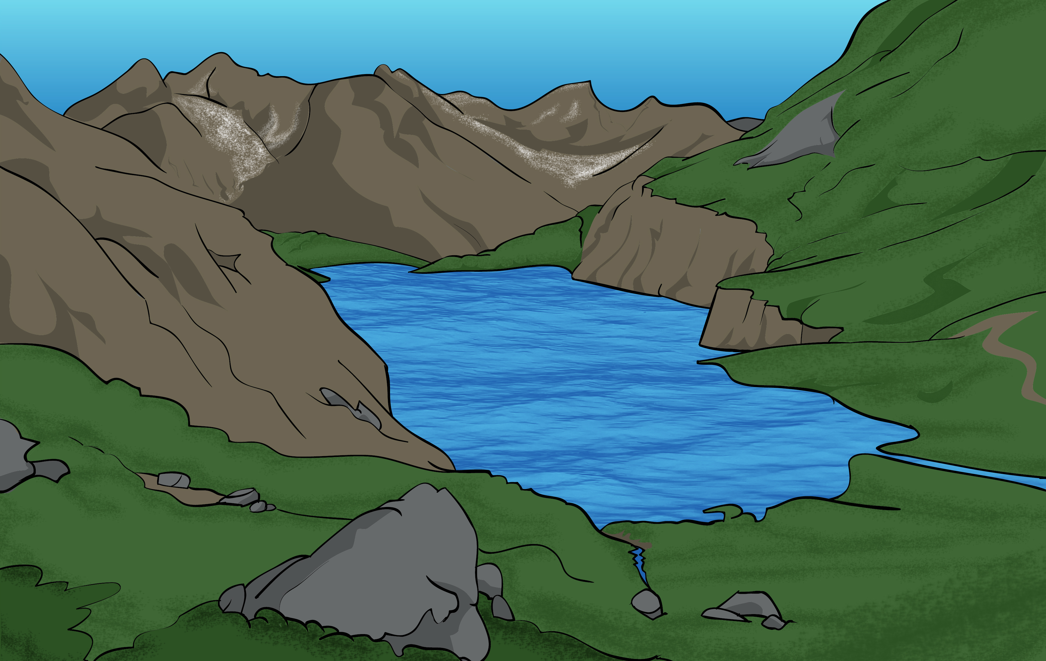
Some damaged land may not have NHCover.

You can read more about NHCover on this website:

https://tinyurl.com/hdyfk9dz

This website is not in Easy Read.


You can find information about NHCover in Easy Read on this website:

https://tinyurl.com/yeywwu9t

Talk to your insurance company if you want NHCover to pay for damage caused by an emergency.

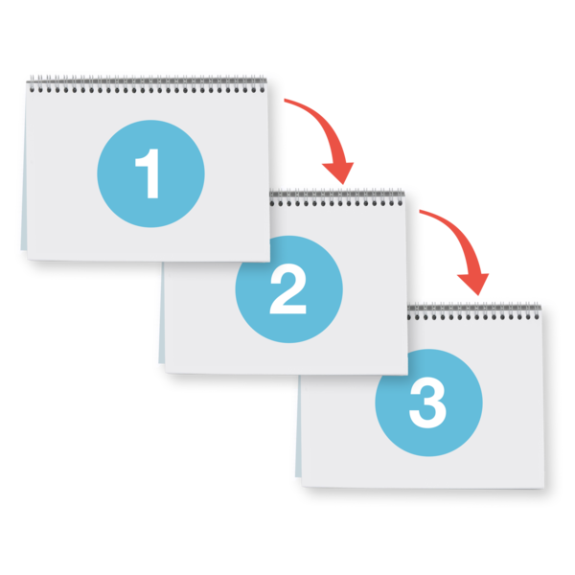
Your insurance company will tell you what to do next.


You can talk to the New Zealand Claims Resolution Service if you:
have questions about your insurance
are worried about your insurance.

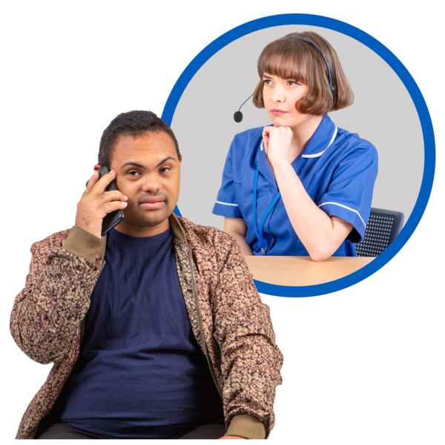
The New Zealand Claims Resolution Service supports
people who have home insurance problems after an emergency.


You can phone them on:

0508 624 327


You can email them at:

contact@nzcrs.govt.nz

You can visit their website at:

www.nzcrs.govt.nz/

This website is not in Easy Read.

Renting

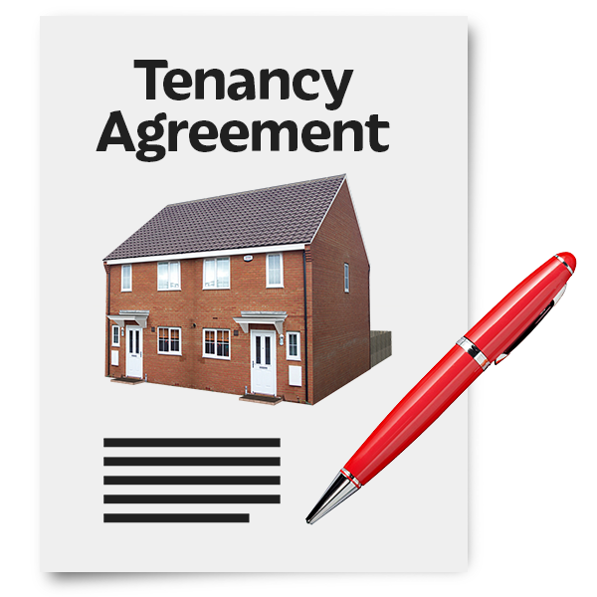
Tenancy Services has information about what to do after an emergency for:
tenants
landlords.

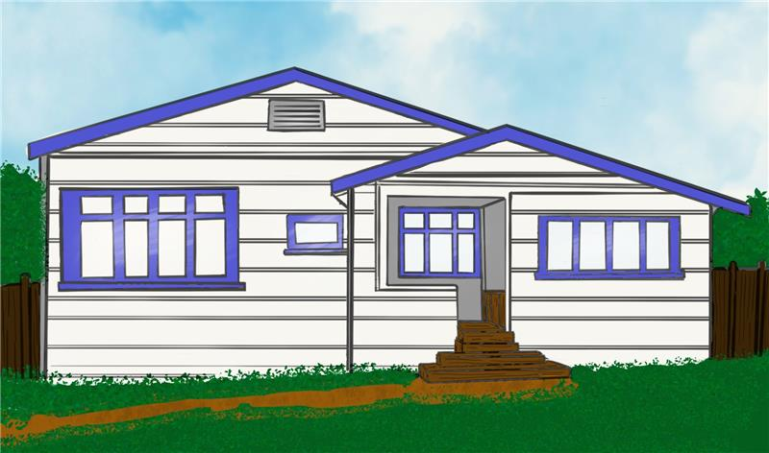

Tenancy Services is the part of the government that tells people what they have to do when they are renting a house:
from someone
to someone.
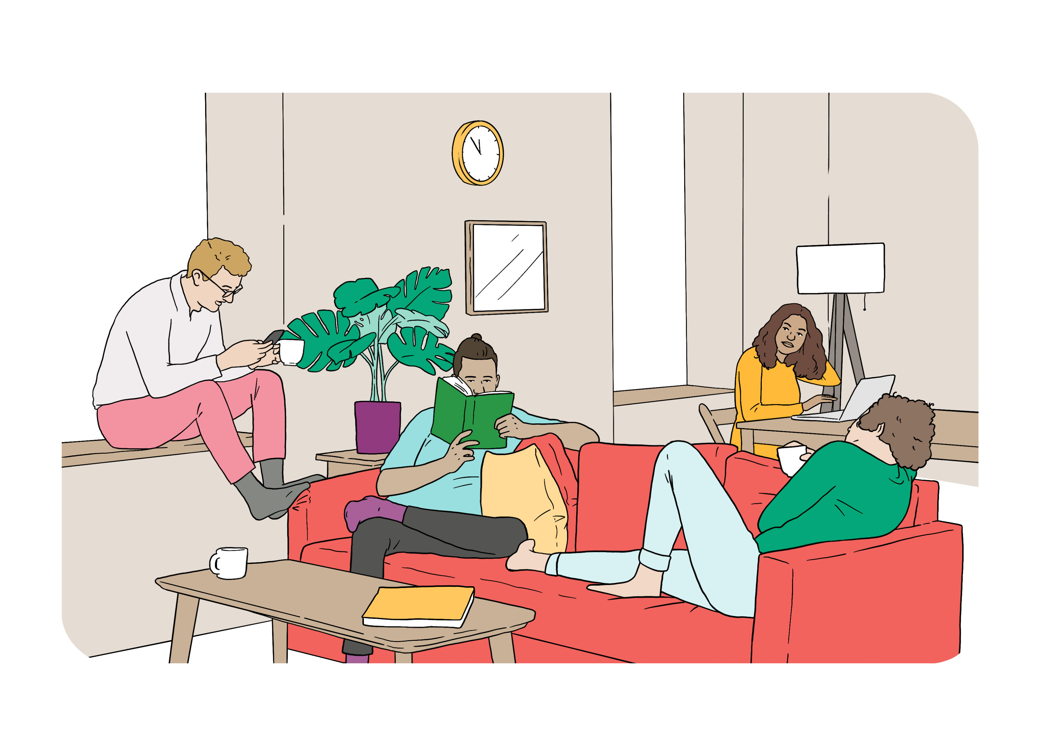

A tenant is a person who rents a house from someone else.

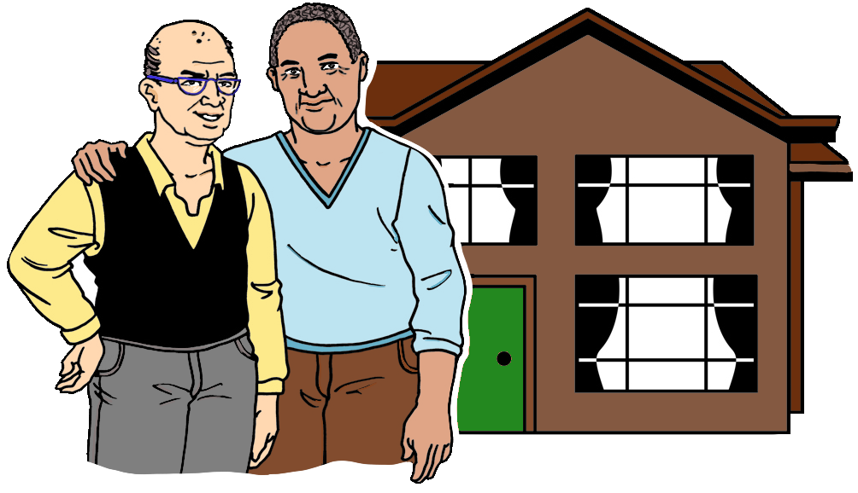
A landlord is a person who rents a house to someone else.

You can phone Tenancy Services on:

0800 836 262

You can visit their website at:

www.tenancy.govt.nz/

This website is not in Easy Read.

Schools / Early Childhood Centres

After an emergency:
schools might be closed
early childhood centres might be closed.


Early childhood centres are
places where children go to learn before they start school like:
kindy
daycare.

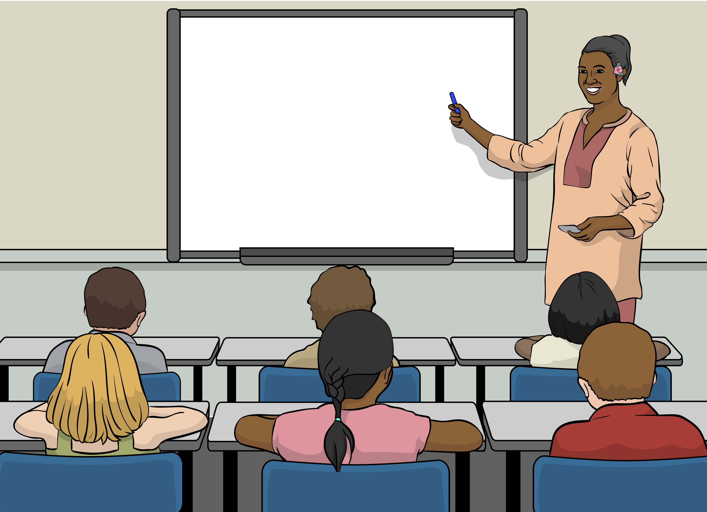
Check with the school / early childhood centre your children go to to find out:
if they are closed
when they will open again.

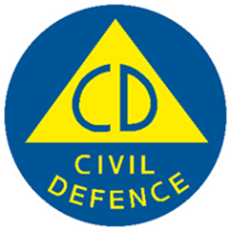
This information has been written by the National Emergency Management Agency and contributed to by participating agencies.


It has been translated into Easy Read by the Make it Easy Kia Māmā Mai service of People First New Zealand Ngā Tāngata Tuatahi.

The ideas in this document are not the ideas of People First New Zealand Ngā Tāngata Tuatahi.

All images used in this Easy Read document are subject to copyright rules and cannot be used without permission.


Make it Easy uses images from:


- Photosymbols

- Change Images


- Huriana Kopeke-Te Aho

- SGC Image Works

- T Wood


- Studio Rebeko

- Inga Kramer.

