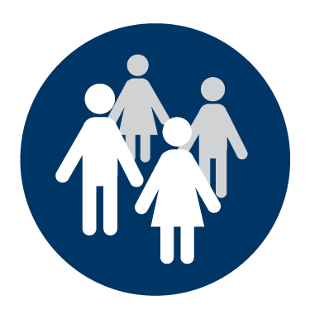
Communities and hapū
Ngā hapori me ngā hapū

Understand your risk
Seek to build a collective understanding of your risks: the hazards or disruptions you could face, your collective exposure in terms of people, animals, property, and assets, and your vulnerabilities – how these could be adversely affected.
Reduce your risk factors
Consider whether there are ways to reduce your community’s exposure or vulnerabilities – it needn’t cost money, but there may be options if it does.
Keep the long-term in mind
Consider the longer term changes in your environment, for example, the impact of climate change, and what you can do about them.
Benefit today, benefit tomorrow
Try to find risk reduction, readiness, and resilience solutions that have an everyday benefit to your community. As well as being prepared for tomorrow, you will have a richer community today.
Learn about response and recovery
Understand how response to and recovery from emergencies will work in your city or district.
Understand your collective resources
Think about what resources you have, now or in an emergency, and how you could put them to work.
Make a plan and practise it
Community response and recovery planning helps communities understand how they can help each other after a disaster. Ask your local emergency management office for help if you need it, and practise any plans, as practicable.
Organise community events
Communities who know each other are stronger communities – in good times and in bad.

