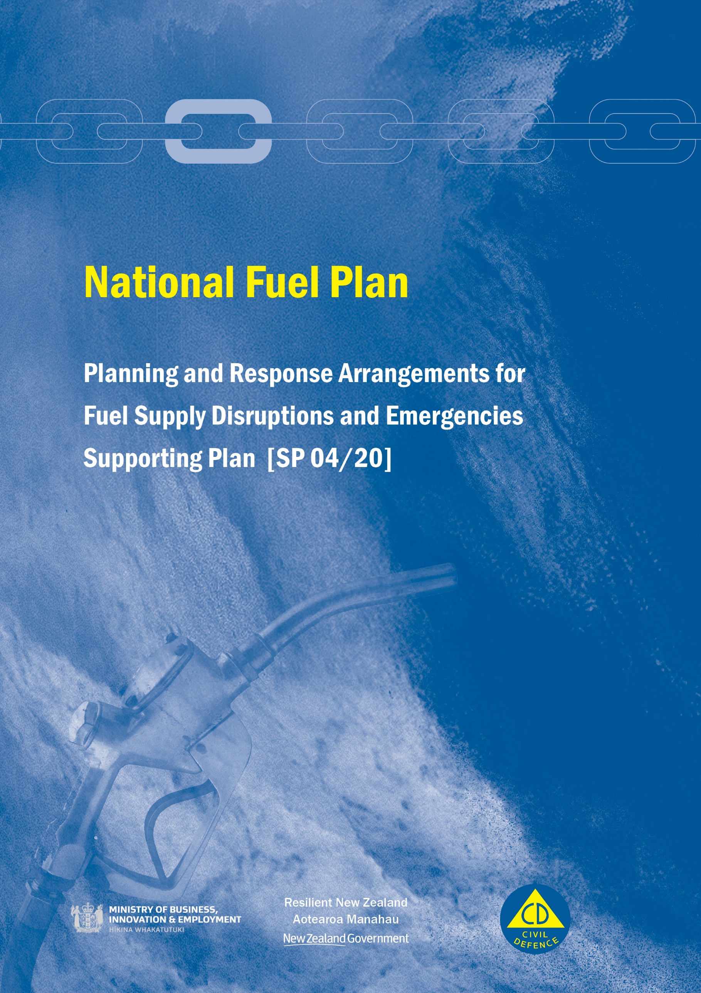

National Fuel Plan

Supporting Plan [SP 04/20]

March 2020

ISBN 978-0-478-43528-3

Published by the National Emergency Management Agency

CDEM Act 2002 Authority

This Plan has been issued by the Director of Civil Defence Emergency Management pursuant to s9(3) of the Civil Defence Emergency Management (CDEM) Act 2002.

This document is not copyright and may be reproduced with acknowledgement. It is available, along with further information about the National Emergency Management Agency, on the National Emergency Management Agency website [www.civildefence.govt.nz](http://www.civildefence.govt.nz).

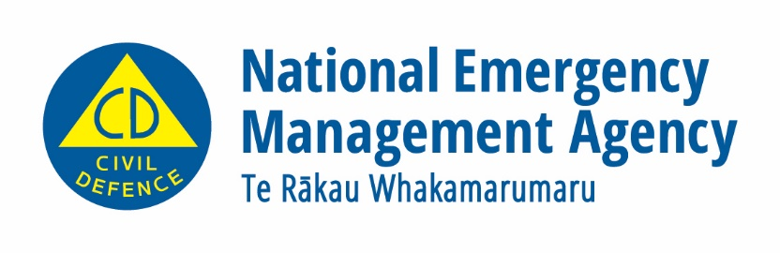

National Emergency Management Agency

PO Box 5010

Wellington 6145

New Zealand

Tel: +64 4 817 8555

Fax: +64 4 817 8554

Email: [emergency.management@nema.govt.nz](mailto:emergency.management@nema.govt.nz)

Website: [www.civildefence.govt.nz](http://www.civildefence.govt.nz)

Foreword

Petrol, diesel, aviation and marine fuels are essential for everyday life and the economy of New Zealand. They are also critical resources in the event of an emergency, with response agencies, businesses and communities all reliant to some extent.

New Zealand’s fuel supply chain is exposed to a whole suite of hazards in various locations across the country. Disruptions to fuel distribution networks are a real possibility and planning and coordination between the fuel sector and government agencies is vital in order to ensure the impacts of any disruptions are minimised and well managed.

Fuel companies have efficient and flexible logistics operations and are well versed at making adjustments to allow for disruptions and to ensure continuity of supply. Public sector involvement will never replace these systems during an emergency, but it will support coordination of a major fuel disruption to ensure effective communications between and within government and the fuel sector. The Ministry of Business, Innovation, and Employment (MBIE) and the National Emergency Management Agency work with the fuel sector nationally and through Civil Defence Emergency Management (CDEM) Groups to ensure that oil companies understand local hazards and collaborate to ensure that options and support mechanisms are identified before emergencies occur.

This Plan has been created to provide a readiness planning framework for the fuel sector, MBIE and the National Emergency Management Agency. It includes agreed roles and responsibilities for agencies and documents agreed operational communications and coordination for use by the lead government agency in the National Crisis Management Centre, the Fuel Sector Coordinating Entity (chaired by MBIE with representation from the National Emergency Management Agency and the fuel companies) and CDEM Group Emergency Coordination Centres.

This Plan has been developed in conjunction with fuel companies, government departments and agencies, local government and CDEM Groups. It provides a framework for implementing government powers under the Petroleum Demand Restraint Act 1981. The Plan is issued under the authority of the Director of Civil Defence Emergency Management and the provisions of Section 9(3) of the Civil Defence Emergency Management Act 2002.

This Plan replaces the National CDEM Fuel Plan 2012 and expands on operational aspects of MBIE’s Oil Emergency Response Strategy 2008. It will be jointly reviewed by National Emergency Management Agency and MBIE every three years.

We would like to acknowledge and thank representatives from fuel companies, government agencies, local government and CDEM Groups who have provided input and feedback in developing this plan.

|  |  |
| --- | --- |
|  | cid:image001.png@01D5EB25.6FA9E460 |
| **Sarah Stuart-Black**  Director, Civil Defence Emergency Management | **Chris Bunny**  Deputy Chief Executive, Building, Resources and Markets  Ministry of Business, Innovation, and Employment |

Contents

Part A Arrangements and Planning for a Fuel Supply Disruption or Emergency

Section 1 Introduction 2

1.1 Plan purpose 2

1.2 Plan scope and exclusions 2

1.3 Key terminology 3

1.4 Plan authorities and regulation 3

1.5 Plan activation 6

1.6 Plan monitoring, review and testing 6

Section 2 Fuel sector overview 8

2.1 Fuel sector companies 8

2.1.1 Main fuel companies (producers, processors and importers) 8

2.1.2 Associated fuel companies (refiners and bulk storage) 9

2.1.3 Haulers and distributors 10

2.1.4 Other major retailers 10

2.2 The Fuel Supply Chain 11

2.3 Fuel products 16

2.4 Fuel disruption scenarios 18

2.4.1 Fuel supply chain vulnerabilities2F 18

2.4.2 Summary of fuel disruption scenarios 19

2.4.3 Risk mitigation considerations 20

Section 3 Planning requirements (readiness) 21

3.1 Roles and responsibilities 21

3.2 Fuel Sector Coordination 24

3.2.1 Fuel Sector Coordinating Entity 24

3.3 Regional and local CDEM fuel plans 25

3.4 Planning arrangements for fuel management measures 26

3.4.1 Fuel management options 26

3.4.2 Planning arrangements for critical customer prioritisation 26

3.4.3 Planning arrangements for priority fuel retail outlets 27

3.4.4 Future planning activities 29

Part B: Response to a Fuel Supply Disruption or Emergency

Section 4 Response framework 31

4.1 Roles and responsibilities 31

4.1.1 National Security System 31

4.1.2 Lead agency 32

4.1.3 Other key roles 32

4.2 Escalation and activation of arrangements 34

4.2.1 Escalation of event 34

4.2.2 Activation of arrangements in this Plan 36

4.3 Fuel Sector Coordination Arrangements 37

4.3.1 Fuel Sector Coordinating Entity 37

4.3.2 Other working groups 37

4.4 Communications 38

4.4.1 Communication lines in an emergency under the CDEM Act 38

4.4.2 Communication lines when it is not an emergency under the CDEM Act 40

4.4.3 Fuel sector reporting requirements 40

4.4.4 Communication with CDEM Groups 40

4.4.5 Public communications 41

4.4.6 Communications with the International Energy Agency 41

Section 5 Implementing fuel management measures 42

5.1 Fuel sector mechanisms to manage disruptions to fuel supply 42

5.2 Relaxing fuel specifications 43

5.3 Relaxing transport regulations 44

5.4 Government logistical support 45

5.5 Voluntary fuel demand constraints 45

5.6 Mandatory fuel demand constraints 46

5.7 Prioritising fuel to critical customers 47

5.7.1 Ground fuels 47

5.7.2 Aviation fuels 49

5.7.3 Marine fuels 49

5.8 Managing safety and quality 49

Appendix A Glossary 51

Appendix B Acronyms and abbreviations 55

Appendix C Regional Fuel Plan template 56

Appendix D Public information 60

Appendix E References 62

**Part A  
Arrangements and Planning for a Fuel Supply Disruption or Emergency**

*In a response situation, refer to Part B.*

# Introduction

|  |  |
| --- | --- |
|  | This section sets out the Plan purpose, scope, authorities and related legislation. |

## Plan purpose

|  |  |
| --- | --- |
| Background  Objective  Purpose of this plan | There are many events that could cause fuel supply disruptions in New Zealand: hazards damaging significant facilities such as regional fuel terminals, pipelines or the refinery, offshore disruptions to international fuel markets, trucking distribution disrupted by road failures and many others.  The overall objective of the arrangements outlined in this Plan is to minimise the effects of a fuel supply disruption on New Zealand, whatever the cause, as far as reasonably practicable.  The purpose of this Plan is to:   * provide an agreed planning framework between government agencies, Civil Defence Emergency Management (CDEM) Groups and fuel sector organisations to respond to major disruptions to fuel supplies; * document agreed communication and coordination arrangements at the national level for response operations during major disruption of fuel supplies; and * support the implementation of regional fuel supply arrangements. |

## Plan scope and exclusions

|  |  |
| --- | --- |
| Plan scope  Plan exclusions | This Plan covers government and fuel sector coordination and responses in the event of a major disruption to fuel supply, including petroleum, diesel, aviation fuel and marine fuel.  The Plan is jointly developed by the National Emergency Management Agency (NEMA) and the Ministry of Business, Innovation, and Employment (MBIE). It supersedes the *National Civil Defence Emergency Fuel Plan 2012* (NEMA) and expands on operational aspects of the *Oil Emergency Response Strategy 2008*, which is expected to be reviewed in light of this Plan.  Natural Gas sector coordination arrangements are not covered in this Plan – they are described in the *First Gas* *Critical Contingency Management Plan* ([*http://www.cco.org.nz/Publications/*](http://www.cco.org.nz/Publications/))*.*  LPG is also not included in this Plan as the supply chain, agencies involved, and response mechanisms are quite different. Development of a national plan for LPG emergencies will be considered in future planning.  This Plan does not replace the need for:   * critical fuel customers to develop and test business continuity plans and arrangements in case of fuel supply disruption,      * detailed risk management and business continuity planning by individual fuel companies to mitigate risks where practicable, * regional and local CDEM fuel plans detailing local issues and priorities (refer to [*Section 3*](#_Planning_requirements_(readiness))), * monitoring of the security and resilience of the fuel sector, or * government strategy in relation to energy conservation and efficiency. |

## Key terminology

|  |  |
| --- | --- |
| Disruption | A fuel supply disruption is any event that either has caused, or has the potential to cause, fuel shortages at the supply point. A fuel supply disruption can be defined as minor, moderate, major or severe, as per the escalation process described in Section 4.2.  In this Plan, the over-arching term ‘major disruption’ is used to refer to an event that may require activation of arrangements in this Plan. |
| Emergency | A fuel disruption may cause, or be part of, an emergency under the CDEM Act 2002.  A fuel disruption may also trigger the declaration of a Petroleum Emergency under the International Energy Agreement (IEA) Act 1976. |

## Plan authorities and regulation

|  |  |
| --- | --- |
| Enabling powers | Table 1‑1summarises the legislation and legislated plans that provide enabling powers for the Government and set out expectations and requirements of fuel companies. The main Acts are:   1. The **International Energy Agreement Act (1976)**, which provides for emergency regulations to be made when required by New Zealand's obligations under the International Energy Agreement to deal with a reduction or threatened reduction of petroleum supplies. These powers could be invoked in response to a global oil supply disruption. 2. The **Petroleum Demand Restraint Act (1981)**, which provides for regulations to be made for the purpose of restraining the demand for, or reducing the consumption of, petroleum products in New Zealand or for the purpose of ensuring the equitable distribution in New Zealand of petroleum products that are, or are likely to be, in short supply in New Zealand. 3. The **Civil Defence Emergency Management Act 2002**, which requires lifeline utilities to ensure they are able to operate to the fullest possible extent, even though this may be at a reduced level, and provides Controllers with various powers under a declared state of emergency (such as directing people to take action to limit the extent of an emergency). |

Table 1‑1 Key legislation relating to fuel supply disruptions

| Legislation or Plan | Notes |
| --- | --- |
| **International Energy Agreement (IEA) Act 1976:** Under section 3 of the IEA Act 1976, the Governor-General may declare a “petroleum emergency” when required by New Zealand’s International Energy Agreement obligations. | Following such a declaration, section 4 of this Act provides similar regulation-making powers as those described below under the Petroleum Demand Restraint Act 1981, while such a petroleum emergency exists. |
| **Petroleum Demand Restraint Act 1981:** Under section 4, the Governor-General may make regulations to restrain the demand for, or ensure the equitable distribution of, petroleum products that are in short supply. | Regulations made under section 4 may control, regulate, prohibit or otherwise make provision as to the acquisition, distribution, supply, storage, sale or use of petroleum products in New Zealand.  Regulations under this Act may only be made when the Governor-General is satisfied that reasonably available supplies of petroleum products are, or are likely to be, insufficient to maintain stocks at normal levels in New Zealand or parts of New Zealand. |
| **Civil Defence Emergency Management Act 2002 s60(a):** Requires lifeline utilities to ensure that they are able to function to the fullest possible extent, even though this may be at a reduced level, during and after an emergency. (Refer to Glossary for definition of *emergency*). | Oil companies and associated distribution companies are defined as ‘lifeline utilities’ under the CDEM Act 2002, Schedule 1, Part B (7):  *“An entity that produces, processes, or distributes to retail outlets or bulk customers any petroleum products used as an energy source or an essential lubricant or additive for motors for machinery.”* |
| **Civil Defence Emergency Management Act 2002 s85(1)(e):** A CDEM Group may provide for the conservation and supply of food, fuel and other essential supplies. | A state of emergency is required to be in force in the area. |
| **Civil Defence Emergency Management Act 2002 s90:** Provides requisitioning powers of materials, equipment and supplies where considered necessary for the preservation of human life. | A state of emergency is required to be in force in the area. Requisitioning powers are seen as a tool of last resort when the fuel sector fails to implement lead agency instructions and/or the measures in this Plan are inadequate to secure supply to critical customers. |
| **Civil Defence Emergency Management Act 2002 s91:** Provides powers for a Controller or Police to direct a person to stop an activity that may substantially contribute to an emergency; and to request a person to take action to limit the extent of the emergency. | A state of emergency is required to be in force in the area. This provides a legal basis for fuel companies to interrupt their commercial contracts allowing for greater allocations to critical customers. |
| **National Civil Defence Emergency Management Plan Order (s59-61):** Requires lifeline utilities to plan for responsibilities across the ‘4Rs’ (reduction, readiness, response and recovery). | Under Plan Order Sections 60 and 61, Lifeline Utilities are required to:   * analyse hazards and risks to implement reductions strategies, * plan collaboratively with CDEM Groups and lifeline utilities, * provide information on network status, * plan response arrangements, and * establish communications procedures. |

|  |  |
| --- | --- |
| CDEM Plan framework | This Plan is a supporting plan to the National CDEM Plan and is designed to operate within the legislative framework. Figure 1‑1 illustrates how this Plan fits in the national CDEM planning framework.    *Developed from Figure 1.1 in the Guide to the National CDEM Plan 2015.*  Figure 1‑1 Relationship between CDEM Plans |
|  |  |
| IEA requirements | The International Energy Agreement (IEA) was set up by fuel importing countries in response to the 1973-74 fuel crisis. In the event of a major international oil supply disruption, IEA countries are required to release oil stocks, restrain demand, switch to other fuels, increase domestic production and share available oil, if necessary.  Commercial stocks of crude and product held within New Zealand (owned by the fuel companies) currently cover about 60 days of fuel demand net of oil exports. Membership of the IEA requires New Zealand to hold stocks equivalent to 90 days of net demand. To make up the shortfall (currently about 30 days), the government contracts with other parties for reserve fuel stocks. These reserves are currently held offshore, and the government has an option to purchase the stocks in the event of an IEA declared global emergency.  Fuel companies remain responsible for ensuring that adequate commercial stock levels throughout New Zealand are maintained. |

## Plan activation

|  |  |
| --- | --- |
| Plan activation | This Plan may be activated for the purposes of government communicating and coordinating with the fuel sector in a major fuel disruption.  Government action under statutory powers will generally only be taken where required to fulfil New Zealand’s obligations under the IEA, or to respond to major disruptions to fuel supply where a fuel industry response may not be enough to ensure continued supply to critical customers (critical customers are defined in Section 3.4.2).  It is intended that any fuel supply disruption will be managed within the fuel sector and existing supply / distribution processes as far as possible. |
| Government powers | Government powers can be enabled through any of the legislation listed in Table 1-1 (IEA Act 1976, Petroleum Demand Restraint Act (PDR) Act 1981, CDEM Act 2002), following a declaration of a petroleum emergency (Governor-General) or a state of emergency (CDEM). Use of these powers are discussed in Section 4.1.2. |

## Plan monitoring, review and testing

|  |  |
| --- | --- |
| Plan reviews | This Plan will be reviewed at three yearly intervals from the time of publication. NEMA and MBIE will jointly undertake this review and will consult with all agencies with responsibilities under this Plan.  This Plan must be tested every year, either as a separate fuel sector exercise, or whenever possible, as part of the National Exercise Programme, particularly Tier 3 and 4 exercises. |
| Fuel company reports | A brief annual report is required by the end of April each year by all fuel importing, processing or producing companies plus any company owning or managing more than 80 fuel retail outlets0F[1] (ground, marine or aviation) in New Zealand. This report shall cover:   * + confirmation of compliance with the responsibilities under the CDEM Act 2002 and in this Plan;   + specific participation in CDEM and lifeline utilities group activities, exercises and projects during the year; and   + lists of priority fuel retail outlets, aligned to lists in Regional Fuel Emergency Plans (where they exist), including status of power backup arrangements and arrangements with fuel retail outlet managers around implementing critical fuel customer measures   The report shall be provided to MBIE and NEMA and made available to regional CDEM Groups, along with updated information on main terminal storage and offtakes (Figure 2‑3 and Figure 2‑4 of this Plan). |
| Fuel incident/ emergency plans | Every three years, with the first delivery being before the end of April 2020, the fuel companies noted above shall provide their emergency management plans to the Fuel Sector Coordinating Entity (SCE) Chair, along with confirmation of alignment of arrangements with this National fuel plan.  *These plans may be referred to as emergency, crisis, business continuity, incident management plans. Where companies have contracted out key parts of the supply chain (eg: haulage) the plans should summarise arrangements of key contractors or append their plans.* |
| CDEM Group reports | Every three years, with the first delivery before the end of April 2021, CDEM Groups shall provide the latest version of the regional fuel plan to NEMA.  Each year, before the end of September, CDEM Groups shall provide any updated information in relation to:   * + the list of critical regional customers,   + the summary of fuel requirements of critical customers, and   + priority fuel retail outlets. |

# Fuel sector overview

|  |  |
| --- | --- |
|  | This section provides an overview of the fuel sector in New Zealand, including fuel companies, fuel products, and how they are stored and distributed. |

## Fuel sector companies

### Main fuel companies (producers, processors and importers)

Table 2‑1 Main fuel companies operating in New Zealand

| Company | Description |
| --- | --- |
| **BP** | * Bulk terminals at Mount Maunganui, Napier, New Plymouth, Seaview, Hutt City, Nelson, Lyttelton and Dunedin * Joint aviation facilities at Christchurch Airport, Wellington Airport, and Auckland Airport, and joint aviation fuel storage with Wiri Oil Services Limited * Around 104 owned and operated retail sites, with approximately 105 independent dealers * 60 truck stops |
| **Mobil** | * Bulk terminals at Mount Maunganui, Seaview, Kaiwharawhara, Woolston, Lyttelton and Bluff * Pipeline from Lyttelton Port terminal to inland terminal at Woolston * Pipelines from all terminals to the local wharf (except Woolston) and marine bunker pipelines at Mt. Maunganui, Kaiwharawhara and Lyttelton * Airport terminal at Miramar, supplied by pipeline from Burnham Wharf * Aviation facilities at Auckland and Wellington Airports, and aviation fuel storage with Wiri Oil Services Limited and Auckland JUHI * Around 170 branded retail sites (some company-owned and agent-operated, some dealer-owned) * Two unused large aviation fuel storage tanks within the Christchurch Fuel Farm |
| **Z Energy** | * Bulk terminals at Mount Maunganui, Napier, Nelson, Lyttelton, Timaru and Dunedin * Aviation facilities at Auckland Airport and Christchurch Airport * Around 75 truck stops and 220 fuel retail outlets under Z Energy brand * Around 150 sites under Caltex brand |
| **Gull** | * Bulk terminal at Mount Maunganui * Around 80-90 branded fuel retail outlets |
| **TOSL** | * Timaru Oil Services Limited (TOSL), a subsidiary of Pacific Energy, is expected to start importing fuel to a terminal in Timaru from 2020 |

### Associated fuel companies (refiners and bulk storage)

Table 2‑2 Associated fuel companies

|  |  |
| --- | --- |
| Company | Description |
| **Refining NZ** | * Operates New Zealand’s only oil refinery at Marsden Point, processing a variety of crude oil types to produce fuels including petrol, diesel, Jet A-1 and heavy fuel oil. It also produces bitumen. * Publicly listed company (NZX) * BP, Z Energy and Mobil are the main customers of Refining NZ |
| **Wiri Oil Services Ltd (WOSL)** | * Independent company, owned by BP, Mobil and Z Energy (2015) Ltd * Manages the following facilities:   + Wiri terminal, the main petroleum depot and distribution centre   + Truck loading facility at Marsden Point Terminal, supplies Northland and northern Auckland   + Wiri-Airport Pipeline (WAP), supplies Jet-A1 fuel to the JUHI terminal |
| **Joint User Hydrant Interplane (JUHI) terminal** | * Based at Auckland airport, supplied by the Wiri-Airport Pipeline (WAP) * The JUHI has storage tanks (12Ml) and an underground hydrant system around the tarmac for supplying jet fuel to international aircraft * Tank trucks are used to supply Jet A-1 to domestic aircraft |
| **Joint Operating Storage Facility (JOSF)** | * Based at Christchurch airport and operated by Z Energy, BP and Mobil. * JOSF has an underground pipe system operated by Z Energy, which supplies fuel to domestic and international jet operations * Fuel supplied either by BP or to the Regional and Antarctic aprons by fuel truck |
| **Coastal Oil Logistics Ltd (COLL)** | * Manage and schedule shipping from the refinery to ports around the country via ships chartered from Silver Fern Shipping * Owned by BP, Mobil and Z Energy |
| **Silver Fern Shipping Ltd (SLSL)** | * Owned by ASP Ship Management, has two ships and is New Zealand’s only coastal shipping fuel tanker operator* |

* Import vessels are used sometimes for coastal shipping.

### Haulers and distributors

|  |  |
| --- | --- |
| Major haulers and distributors in New Zealand | Haulage operators are contracted by the fuel companies to supply fuel product to fuel retail outlets. Distributors purchase fuel from the fuel companies and sell to fuel retail outlets and other customers (such as farms). At the time of writing this Plan, the following major haulers and distributors are:   * Allied Petroleum Limited (distributor/retailer, Mobil’s contracted hauler) * Pacific Fuel Haul (Z Energy’s contracted hauler) * TOLL logistics (BP hauler) * McFalls (distributor/retailer plus BP contracted hauler the in North Island) * RD Petroleum – and Aratuna (BP contracted hauler in the South Island) * Linfox (BP hauler in the North Island) * Tranzliquid Logistics (provides services to all fuel companies) * Waitomo Petroleum Limited (retailer/hauler/distributor) * McKeown Petroleum (hauler/distributor) * Nelson Petroleum Distributors Limited (retailer/hauler/distributor). |

### Other major retailers

|  |  |
| --- | --- |
| Other major fuel retailors | As well as the main fuel companies and distributors, there are around 12 other fuel retail outlet providers supplied by the three major fuel companies, including a growing network associated with supermarket retailers.  The largest networks (as at October 2018) are maintained by:   * Gasoline Alley (supply contract with BP) * Waitomo Petroleum Limited (supply contract with Mobil) * Nelson Petroleum Distributors Limited / NPD (supply contract with Mobil) * Challenge – co-owned by Farmlands (supply contract with Z Energy 2015 – formerly Caltex). |

## The Fuel Supply Chain

|  |  |
| --- | --- |
| Importing and refining | New Zealand’s three major fuel companies (Z Energy, BP and Mobil) currently both import crude oil and refined petroleum products. The broad supply chain is illustrated in Figure 2‑1.  In summary:   * Crude oil is sourced from multiple international regions. * Crude oil is shipped into Marsden Point Refinery (in Northland) on vessels carrying around 100-150 million litres (Ml) of fuel with a ship arriving on average once a week. Crude oil is refined into petroleum products that meet around two-thirds of domestic fuel demand (around 85% of jet fuel, 67% of diesel, 58% of petrol, and all fuel oil for ships). * The remaining domestic demand is met by the fuel companies importing refined petroleum products directly to selected regional terminals1F[2]. Most of these imports come from Asia and take at least 16 days’ shipping time. |

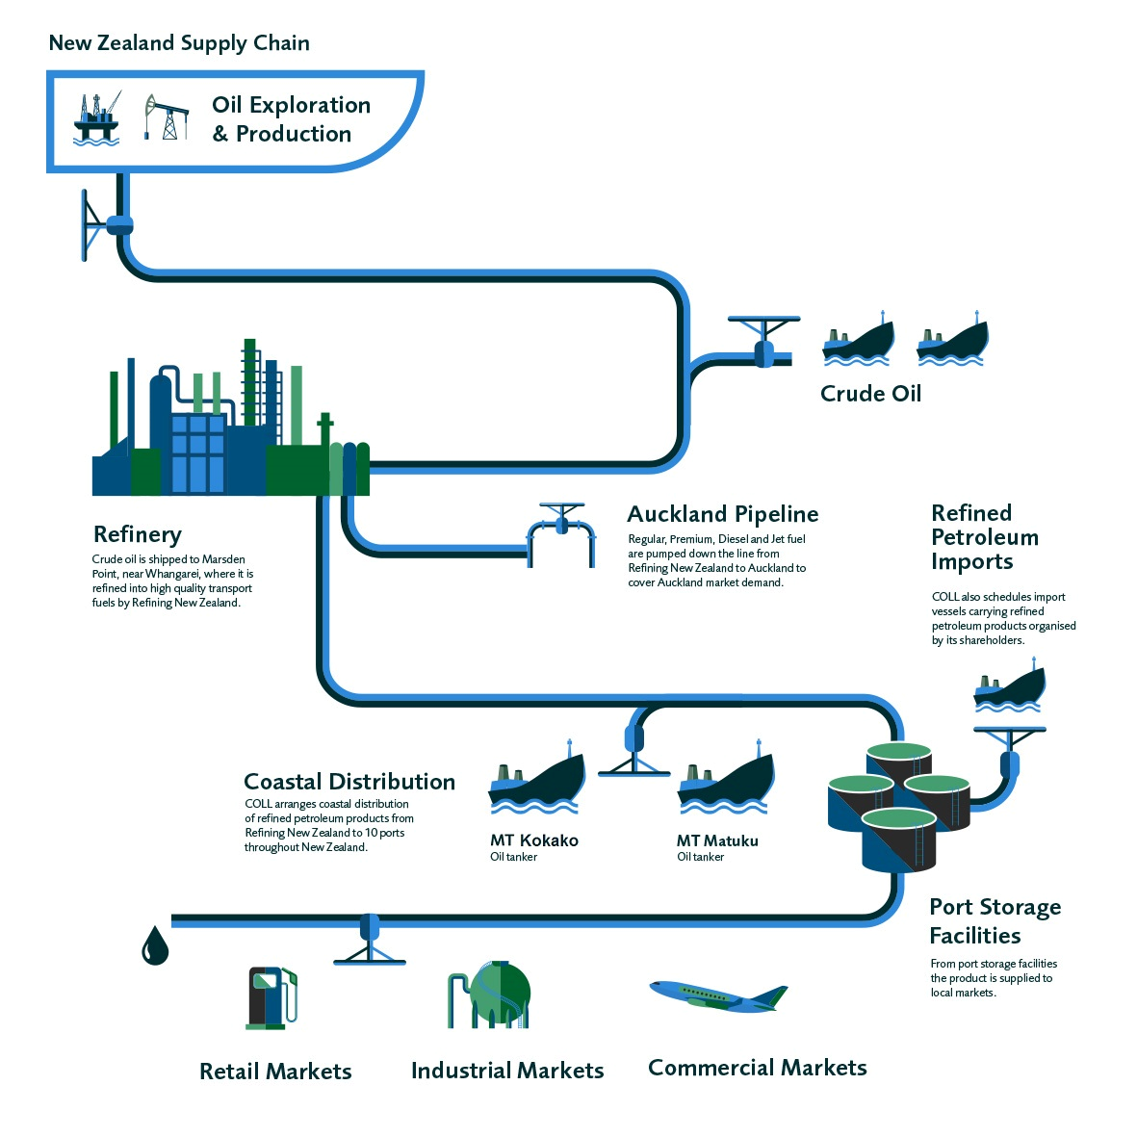

New Zealand Supply Chain

Figure 2‑1 Fuel Supply Chain (pictures are not to scale)

|  |  |
| --- | --- |
|  | Gull, a fourth, smaller supplier, has facilities to import refined petroleum products through its port terminal in Mount Maunganui and does this either directly or by purchasing off one of the three major fuel companies.  A new fuel supplier is expected to enter the market in 2020 (new tanks are being constructed in Timaru for Timaru Oil Services Limited, a subsidiary of Pacific Energy). |
| Distribution  Pipelines and wharflines  Ship  Road | Refined petroleum products are distributed from Marsden Point and other ports via pipeline, coastal shipping, and road transport. Figure 2‑2 shows the distribution of petroleum throughout New Zealand, discussed further below.  All port terminals are connected by pipe from the wharves (wharflines) and failures of these would prevent terminals from filling.  There are also several pipelines taking fuel from port/wharf terminals to other terminals and transferring fuel between terminals, including:  Figure ‑ National Fuel Supply Chain   * the Refinery-Auckland pipeline, which transports approximately half of the refinery’s product to the Wiri terminal, providing around 95% of Auckland’s petroleum supply (the pipeline is used for Regular, Premium, Diesel and Jet-A1 including all jet fuel for Auckland and regional airports in the upper North Island); * the Wiri-Airport Pipeline (WAP), which supplies Jet-A1 to Auckland International Airport from the Wiri terminal; and * the pipeline from fuel terminals at Lyttelton to the inland Woolston Terminal in Christchurch, which is a critical piece of infrastructure for the South Island (note Jet A-1 is not distributed through this pipeline – it is trucked from Lyttelton).   Products are shipped from the Marsden Point Refinery to ten ports around the country. Some products are also imported directly at some ports. There are currently two coastal vessels operating in New Zealand carrying all fuel types, each carrying a maximum capacity of around 40-45 million litres.  Fuel is delivered from bulk fuel terminals to fuel retail outlets and bulk customers via trucking networks. The trucks used by some fuel companies are a dedicated fleet and others contract out their transport to third-party haulage companies. |
| Storage/fuel terminals | Commercial stocks of crude oil and refined products in New Zealand typically provide between 53 and 64 days of normal demand (based on average daily consumption of all products). In principle (if not in practice), normal demand for fuels could be supplied for at least 53 days, if all tanks were drained empty. Also, at any given time, approximately 15-20 days of demand is in transit to New Zealand by ship.  Marsden Point Refinery holds the largest stocks of fuel in the country, including (average stockholdings) around 245 million litres of crude oil and 175ML of refined product (Petroleum 75ML, Diesel 60ML, Jet 35ML. The volume of storage and throughput of refined fuel at other terminals is illustrated in Figure 2‑3 and Figure 2‑4.  Stocks and supply are managed to minimise stock outs (tanks running empty). If stored product in a terminal reaches a critical threshold (e.g. three days of cover for normal demand) due to a minor supply chain event, the relevant companies use mechanisms such as those described in Section 5.1.  There are also large fuel stocks in New Zealand held by companies other than the main fuel companies, including:   * the New Zealand Defence Force (NZDF), which has its own stocks to be self-sufficient for several weeks; * roading contractors that store diesel for vehicles, plant and equipment – for example New Zealand Transport Agency (NZTA) network contractors in 13 out of 26 of their regions hold around 250,000 litres at depots; and * many agencies with backup generators that hold 1-2 days worth of fuel in the generators and sometimes extra tank storage to enable longer operation before fuel can be supplied to the site. |
| Retail operations | Service (petrol) stations and truck stops are the main point-of-sale for the public, including commercial vehicles. Fuels are also delivered directly to some customers, including the farming, forestry, health and disability, and construction sectors.  Fuel retail outlets have a variety of ownership and operating models, though all fuel is currently sourced from the four producing/importing fuel companies (Z Energy, Mobil, BP and Gull). These operating models include:   * fuel company owned and operated, * fuel company owned and independently operated, * independently owned and operated, and * independently owned and operated (branded by fuel company supplying product under contract). |

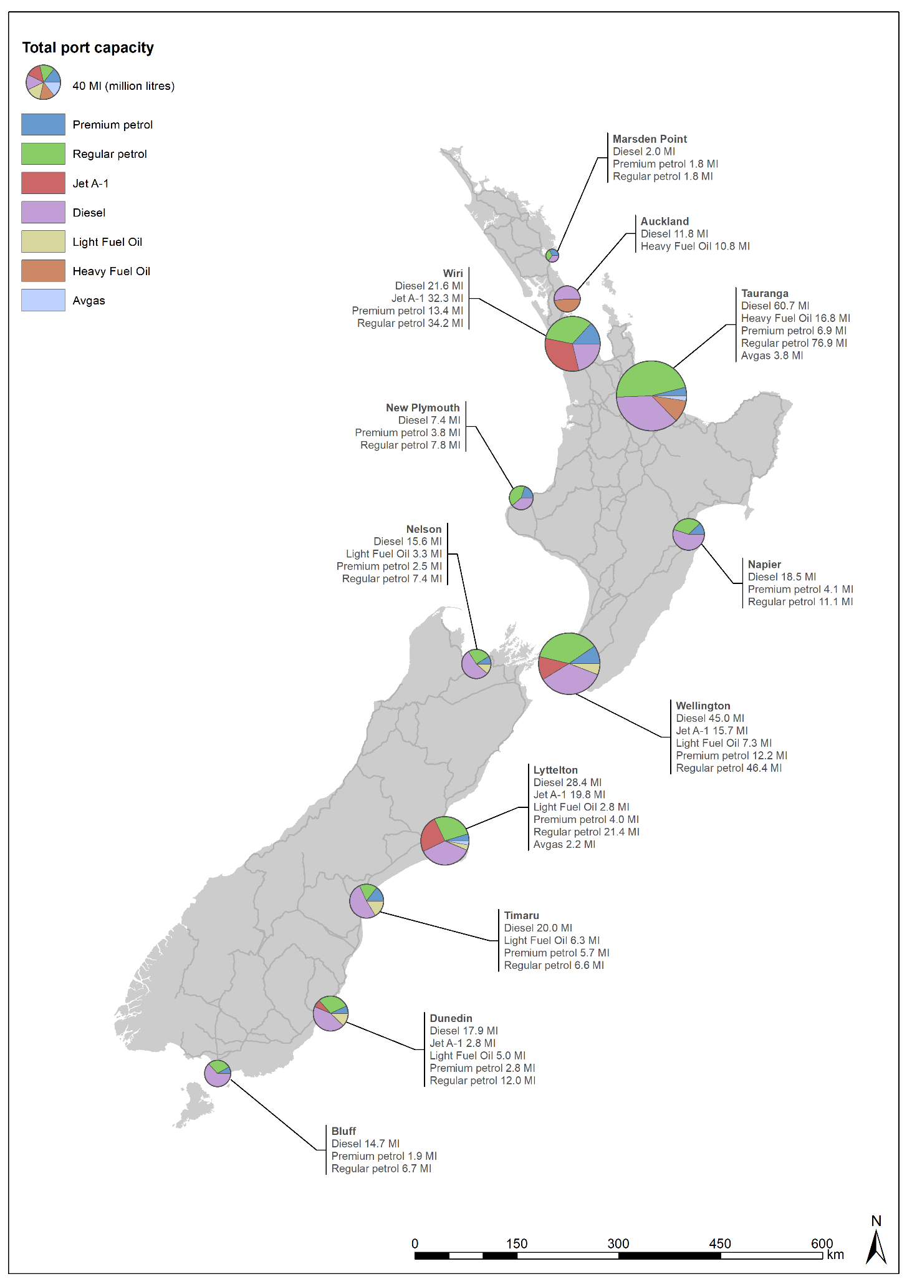

Figure 2‑3 Terminal storage capacities (as at June 2019, excludes non-operational storage tanks and crude oil).

*Notes: JUHI has 9.5 million litres useable capacity not shown in map. Annual offtake is included in the Wiri figures.*

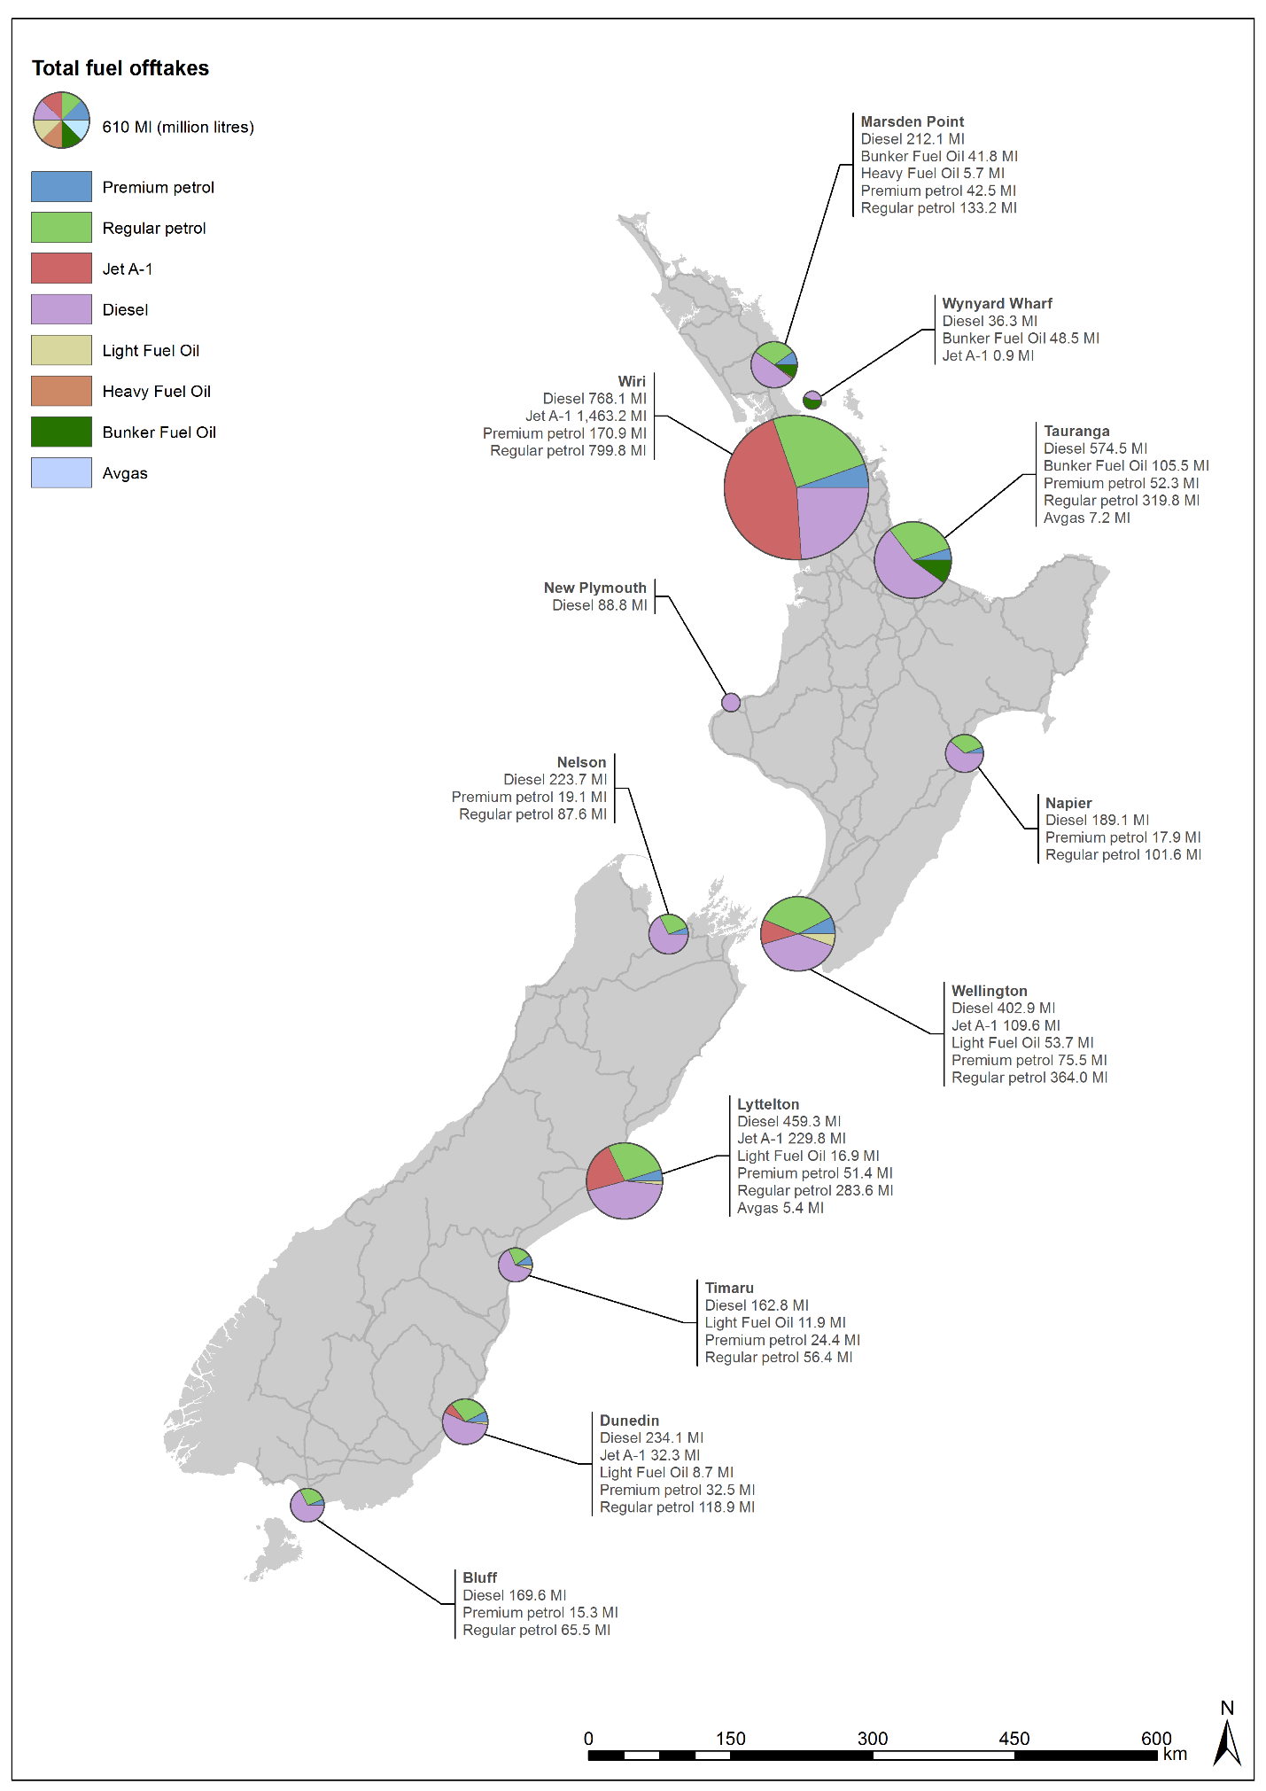

Figure 2‑4 Fuel taken from main fuel terminals (2017 calendar year)

*Notes: Data for Marsden Point is for the truck loading facility, not the Refinery.*

|  |  |
| --- | --- |
| Retail operations cont’d | Truck stops are usually unattended and unattended fuel retail outlets for all vehicles are also increasingly common. These dispense fuel to commercial customers with fuel cards and most fuel retail outlets accept credit cards and EFTPOS as well.  Petrol and diesel are also available at marinas for use in recreational vessels. Marine fuel oil, diesel and other fuels are available to commercial vessels at some ports. |

## Fuel products

|  |  |
| --- | --- |
| Petrol / motor gasoline | Petroleum products are distributed by ship and road as described in the previous section. The petroleum categories are by minimum Research Octane Number (RON) – RON91, RON95 and RON98. Many fuel companies provide proprietary additives. |
| Diesel | Diesel (which refers to all liquid fuel used in diesel engines) is also known as automotive gas oil and marine gas oil. It is distributed by ship and road to all terminals in New Zealand.  Note: 94% of petrol use is for light passenger vehicles while 80% of diesel use is for trucks, utilities and vans, and 7% for buses and trains (source: MBIE). However, in an emergency with power outages there will likely be a significant increase in fuel types required for generators.    Figure 2‑5 Demand for petrol and diesel 1998-2018 (MBIE) |

|  |  |
| --- | --- |
| Aviation fuels | Jet A-1 (used in jet propelled aircraft) is piped from Marsden Point Refinery to the Wiri terminal and then Auckland Airport. It is also shipped from the Refinery or imported from overseas sources to Dunedin, Lyttelton (Christchurch) and Wellington where it is then distributed by truck (and pipeline in the case of Wellington Airport) to airport fuel storage tanks.  Fuel hydrant operations at Auckland and Christchurch airports are summarised in Table 2-2.  At peak demand times, Auckland Airport’s demand may take all Marsden Point Refinery jet fuel products with the others supplied by ship from imported sources.  Avgas (aviation gasoline) is used in helicopters and small fixed wing aircraft with spark-ignited internal combustion engines. All avgas is imported to terminals at Mount Maunganui and Lyttelton and distributed to airfields by road tanker. BP is currently the only importer of avgas and wholesale supplies to Z Energy.    Figure 2‑6 Demand for Jet A-1, avgas and fuel oil 1998-2016 (MBIE) |
| Marine fuels | All marine fuel for NZ (including marine diesel, light fuel oil, heavy fuel oil and bunker fuel oil) is shipped from the Marsden Point Refinery to tank storage at most ports. Various grades of marine fuels are also stored at Mount Maunganui, Kaiwharawhara, Lyttelton, Timaru and Dunedin bulk storage terminals.  A large proportion of sales are by pipeline in the port where the tanker has delivered. Large vessels have bunkers which can be supplied by pipeline or truck. Most recreational vessels are supplied from marine/boat stops (which are supplied by truck from the main port location) – these are typically unmanned card-activated facilities. |

## Fuel disruption scenarios

### Fuel supply chain vulnerabilities2F[3]

|  |  |
| --- | --- |
| Marsden Point Refinery | The Marsden Point Refinery and jetty are critical points in the national fuel supply chain. Without Marsden Point Refinery, or its jetty operating, there would be fuel shortages in many parts of the country unless demand was constrained. Refinery production can be replaced by imported fuel, though this would take some time to get here (days-weeks).  If the jetty was damaged, this would affect the ability to import refined fuels to the Port and the Refinery-Auckland Pipeline as well as the ability to ship refined fuel to other ports. |
| Fuel storage and pipeline facilities | In most cases of an isolated failure of a single port (or associated fuel storage facility), normal demand could be met by surging capacity at surrounding ports and trucking in fuel supplies. This is dependent on roads being open and the capacity in the trucking fleet, both of which could constrain the ability to meet normal demand.  The Wiri Oil Terminal and the Refinery-Auckland pipeline are critical facilities in New Zealand in terms of numbers of customers potentially affected by outages. The availability of suitable trucks, drivers and a functional road network to distribute fuel is the key constraint in the ability to supply Auckland from other ports. |
|  | In recent years, jet fuel demand and Auckland regional fuel demand has increased significantly. While the Wiri Oil Terminal used to hold up to one week’s demand, fuel supply is increasingly ‘just in time’, increasing the fuel shortage risks associated with a pipeline or refinery failure (there is typically 6 days supply at Wiri terminal and 2 days of Jet A-1 at Auckland Airport). Pipeline capacity has been increased to mitigate this risk to some extent.  The other critical fuel supply facilities are in Mount Maunganui, Lyttelton and Wellington. Lyttelton is important for the whole South Island.  Further south, both Dunedin and Bluff terminals are critical supply points, particularly following a major earthquake as road and rail links will likely be compromised.  Refinery-Auckland, Wiri-Auckland Airport and Lyttelton-Woolston Pipelines are designed to withstand seismic events but are at risk from major land movement. Regular inspections, testing, spares and contingency planning are all undertaken to mitigate the risk of failure and facilitate restoration as soon as practicable if failure does occur. The consequences of outages lasting longer than a few days were discussed earlier in this section. |
| Risks of facility outages | The operators of fuel storage facilities take risk management very seriously. However, there are many potential hazards that are challenging to mitigate, for example:   * Marsden Point Refinery and many fuel terminals are in a tsunami zone * The Marsden Point Refinery is dependent on the electricity supply, (which is in itself vulnerable to hazards) * Other terminals are also dependent on electricity supply though some have generator backups * Fire is a risk for all fuel terminals. * Fuel pipelines are at risk from major landslides, third party damage / explosion and loss of electricity supply to pump stations feeding the pipeline. |
| Constraints in the road distribution network | Secondary fuel distribution3F[4] in New Zealand is highly road dependent. Many areas and in fact some entire regions (the West Coast of the South Island and Manawatū-Wanganui) are dependent on trucked fuel. Many other regions, such as Wellington, are likely to see damage to coastal terminals in many hazard scenarios and may be reliant on trucked road fuel for weeks or months. The fuel industry is working on methods to supply fuel from ship-to-shore for these scenarios.  For these areas, isolation by road essentially means loss of fuel supply into that area until the logistics to enable air or sea transport can be put in place. |

### Summary of fuel disruption scenarios

Table 2‑3 Summary of fuel supply disruption scenarios

|  |  |
| --- | --- |
| External Outage Scenario | |
| **International disruption** | Natural or man-made disasters, war or other geo-political disruption in significant oil-producing regions, likely to result in an international shortage / price spike. Most recent example: Hurricane Katrina (2005). |
| Internal Supply Breakdown Scenarios | |
| **Long-term refinery outage** | A natural disaster or other event makes the refinery inoperable for several weeks to months. Fuel companies would need to import refined fuel and it is expected to take around six weeks for new “emergency response” imports to arrive. The jetty at the refinery is needed to supply the Refinery-Auckland pipeline. |
| **Short-term refinery outage** | A shorter period of refinery inoperability, less than 1-2 weeks, such that emergency response imports are not required. |
| **Long-term Refinery-Auckland Pipeline / Wiri disruption** | Long-term disruption at Wiri, making the terminal inoperable. Supply to Auckland and airports in the upper North Island would be impacted. Restoration of petrol and diesel would involve trucking from other terminals. |
| **Short-term Refinery-Auckland Pipeline / Wiri disruption** | Disruption to the Refinery-Auckland Pipeline. Supply to Auckland region would be impacted. Such disruptions are likely to be resolved within days, except in the case of a major natural disaster (for example, the pipeline outage in September 2017 was resolved within 14 days). |
| **Long-term Wellington disruption** | Damage to the Seaview terminal. Supply to Wellington and the lower North Island would be impacted. Restoration of supply to Wellington could involve trucking from other terminals, provided roads into Wellington (SH1 and SH2) remain open. |
| **Long-term Christchurch disruption** | Damage to the Lyttelton terminal. Supply to Christchurch and the wider region would be impacted. Restoration would involve trucking from other terminals, assuming roads are open. |
| **Isolation of geographical area or region by road** | This is a particular vulnerability for regions potentially without the facilities to import fuel by ship. For example, in a major Alpine Fault disruption, it may be weeks before road access to bring fuel into the West Coast can be restored. |
| **Multiple facility and transport disruptions** | A significant natural hazard event (tsunami, earthquake) has the potential to cause damage to multiple terminals as well as isolating regions by roads, cutting off the alternative supply route. This is a particular vulnerability highlighted in Wellington Resilience Planning. |
| **Widespread power outage** | There is very little backup generation on site in the retail sector, although capability to ‘plug in’ generators is increasing. The refinery cannot operate without power from the national grid, but some other key facilities (e.g. Wiri Oil Terminal, Refinery-Auckland Pipeline pump stations) have full backup generation on site. |

### Risk mitigation considerations

|  |  |
| --- | --- |
| Increased fuel storage | To mitigate some of the supply chain risks, several areas have been recommended for consideration following reviews by industry and government (e.g. New Zealand Petroleum Supply Security 2017 Update, September 2017; Hale and Twomey, for MBIE; and the Government Inquiry into the Auckland Fuel Supply Disruption, August 2019).  Recommended mitigations include:   * increase the storage at Wiri (provides more redundancy in a Refinery or Refinery-Auckland Pipeline disruption), and * increase jet storage at Auckland Airport (to address significant demand increases/projections).   Fuel companies plan and fund new facilities with consideration for commercial arrangements (e.g. major customer requirements) and investment processes. |

# Planning requirements (readiness)

|  |  |
| --- | --- |
|  | This section details the parties involved in planning in the event of a disruption to the fuel supply chain, and the roles and responsibilities of those parties. |

## Roles and responsibilities

|  |  |
| --- | --- |
| Roles of parties  Fuel sector responsibilities | Table 3‑1 outlines the roles and responsibilities of key parties in planning for major disruptions to fuel supply in New Zealand.  The primary responsibility for planning resides within the fuel sector, with their legislated responsibility under the CDEM Act 2002, as well as specific requirements for lifeline utilities in the *National CDEM Plan 2015*, to:   * identify and understand all hazards and risks to implement risk reduction strategies, * collaborate with CDEM Groups and other lifeline utilities for planning, and * plan response arrangements including appropriate contracting arrangements with key suppliers.   *Note: While the CDEM Act 2002 requires lifeline utilities to provide technical advice to CDEM Groups, fuel companies are not required to release customer information to any party during pre-response planning. Fuel company customer details may be required by the lead agency during a response / recovery where there is a supply conflict that needs to be resolved (in which case this should be done in a timely manner).* |

Table 3‑1 Roles and responsibilities for fuel sector planning

| Agencies | Roles and responsibilities |
| --- | --- |
| **MBIE** | * Maintain this Plan, in partnership with NEMA. * Convene and chair the Fuel Sector Coordinating Entity (Section 3.2) to coordinate fuel sector planning for major fuel disruptions. * Maintain supporting operational procedures for the Fuel Sector Coordinating Entity (Fuel SCE). * Conduct national exercises that test the arrangements in this Plan. * Monitor and advise the government on New Zealand’s fuel supply security. * Ensure New Zealand meets the requirements of the IEA. * Participate in National CDEM exercises. |
| **NEMA** | * Maintain this Plan, in partnership with MBIE. * Maintain supporting operational procedures for the NEMA NCMC/NCC. * Participate in the Fuel SCE and contribute to coordinated fuel sector planning for major fuel disruptions. * Maintain a central register of regional fuel plans including collated lists of critical customers and priority retail outlets received from regional CDEM Groups and issue updates to fuel companies annually. * Identify the sectors deemed ‘critical customers’. * Support CDEM Groups with regional fuel emergency planning. * Represent the Fuel SCE in regional fuel emergency planning. * Plan to coordinate support to the fuel sector as identified in Part B of this document. |
| **CDEM Groups / Local CDEM** | Develop regional/local CDEM fuel plans (Section 3.3).  Maintain regional/local arrangements to implement the plans, including:   * identifying and maintaining a database of regional / local critical customers (Section 3.4.2) and priority fuel retail outlets (Section 3.4.3), * engaging with regional critical customers around their requirements in this Plan, * engaging with priority retail outlet owners and planning to support the allocation of prioritised fuel to critical customer (Section 3.4.3), * liaising with neighbouring regions to ensure alignment of plans and assumptions, * conduct exercises that test the arrangements in regional / local fuel plans, and * additional planning as detailed in [*Section 3*](#_Planning_requirements_(readiness)) and Appendix C. |
| **Fuel companies (producers/importers, processors, distributors)** | * Comply with statutory requirements as outlined in section 60 of the CDEM Act 2002. * Develop and maintain business continuity plans to identify risks and steps to eliminate or reduce their likelihood, and to maintain services during an emergency. * Incorporate the planning and response arrangements in this Plan into their own planning (priority fuel retail outlets, critical customer lists, etc.). * Participate in the Fuel SCE and contribute to coordinated fuel sector planning for major fuel disruptions. * Participate in regional lifeline utilities and CDEM sector planning and exercises (while ensuring compliance with the Commerce Act 1986 and acknowledgement and management of commercial sensitivities). * Oversee the requirements below of company-owned fuel retail outlets. |
| **Fuel retail outlets, including unmanned** | Owners of retail outlets identified as a priority site by CDEM Groups shall:   * maintain business continuity plans, including testing and procedures for use of backup arrangements (e.g. for power / internet / water supply failure / staffing and any other critical resource), * plan for the security of staff in an emergency event, * participate in local and regional CDEM planning and exercises, and * liaise with CDEM for support required to implement prioritised supply to critical fuel customers. |
| **Critical customers, including lifeline utilities** | * Business continuity planning to maintain essential functions during fuel shortages, including fuel stored for generators, fuel-efficient vehicles, remote working, etc. * Provide information to support regional fuel planning. * Discuss priority access arrangement contracts with fuel supplier. * Establish processes for communicating with essential staff / contractors around priority fuel supply arrangements and ensuring they have ID. |

## Fuel Sector Coordination

### Fuel Sector Coordinating Entity

|  |  |
| --- | --- |
| Role | The Fuel SCE is the national organisation for planning for, and coordinating a response to, a major fuel disruption. It is established as per the role of SCEs defined in the *National CDEM Plan 2015*.  The role of the Fuel SCE also encompasses the role of the National Emergency Sharing Organisation (NESO) under the IEA. During the planning phase, its role is as per Table 3‑1.  The Fuel SCE provides a coordinated approach to planning for a major disruption to fuel supplies, including progressing initiatives such as those identified in Section 3.4.4. During response, the Fuel SCE provides a single point of contact to the lead agency and coordinates the sector’s response in a fuel emergency (Table 4‑1). |
| Membership | The Fuel SCE is chaired by MBIE and its core members include:   * MBIE (Energy and Resource Markets Branch) * NEMA (National Lifeline Utilities Coordinator (National LUC)) * Mobil Oil New Zealand Ltd * Z Energy Ltd * BP Oil New Zealand * Gull Petroleum New Zealand * Timaru Oil Services Limited (when operating). * Ministry of Transport, during a response (in a response, the Ministry of Transport Chairs the national Transport Response Team which provides national coordination for the transport sector) |
| Meeting requirements | As per Table 3-1, the Fuel SCE Chair will convene a Fuel SCE meeting at least annually to review the plan, and to progress matters identified in *Section 3.6*. |
| Inclusion of other parties | Other key parties will be invited to Fuel SCE planning meetings, relevant to the matters being discussed, for example:   * other fuel sector companies (Refining NZ, COLL, terminal operators, distributors/haulers, major retailers); * CDEM Groups (where significant regional issues are being discussed), otherwise the sector will be represented by the National LUC; * Ministry of Transport (which has a role coordinating the national transport SCE – the Transport ResponseTeam); and * transport industry representatives – airlines, airports (where jet fuel issues are a focus). |
| Commerce Act 1986 considerations | Many participants in the fuel industry are also competitors, so any joint response to a fuel supply disruption must be done so in compliance with the Commerce Act 1986 and ensure any commercial sensitivities are acknowledged and managed appropriately. |

## Regional and local CDEM fuel plans

|  |  |
| --- | --- |
| CDEM Plan Framework | There are three levels of CDEM planning in New Zealand – national, Group (regional) and local. This Plan provides the national planning and response framework and is one of three supporting plans to the National CDEM Plan under section 9(3) of the CDEM Act. |
| Requirement for regional fuel emergency plans. | CDEM Groups are required to develop regional CDEM fuel plans to give effect to this National fuel plan, as shown in Table 3‑2 below.  The Regional CDEM Fuel Plan should be developed in collaboration with critical fuel customers, including lifeline utilities. Regional Lifeline Utilities Groups often lead or jointly develop these plans with CDEM Groups, due to their interest in ensuring prioritised supply to essential lifeline utilities.  A Regional CDEM Fuel Plan template example is provided in Appendix C. |
| Option for local CDEM fuel plans | Local authorities and CDEM Groups may have a single Regional CDEM Fuel Plan covering regional and local issues or separate regional and local fuel plans. |

Table 3‑2 National, Regional and Local CDEM Fuel Plans

|  |  |
| --- | --- |
| National fuel plan | Regional and Local Fuel Plans (detail in Appendix C) |
| * National fuel supply overview and key risks (Section 2) * Government and fuel sector responsibilities (Planning: Table 3.1 and Response: Table 4.1) * National fuel planning framework (Section 3) * National fuel emergency response framework (Section 4) * Critical customer sectors (Section 3.4.2) * Fuel management measures (Section 5) * Plan review and testing arrangements | * Scope of the Regional fuel plan, giving effect to the National Fuel Plan. * Overview of fuel supply chain within the region. * Major stocks of fuel within the region. * Regional/local hazard/impact assessments on fuel sector. * Regional critical fuel customer list and emergency fuel demand requirements. * Regional/local priority fuel retail outlets and continuity arrangements at those sites (e.g. power backup). * Support to be provided to priority retail outlets, such as critical customer identification, queue management, crowd control. * CDEM Group support to regional fuel distribution networks (e.g. transport regulation relaxations, per *Section 6*). |

## Planning arrangements for fuel management measures

### Fuel management options

|  |  |
| --- | --- |
| Fuel sector role | The primary responsibility lies with the fuel sector for managing fuel shortages and a range of mechanisms are / can be used, as summarised in Section 5.1. |
| Government support | Government can implement other measures to either improve supply or constrain demand where there is a risk that supply to critical customers may be threatened.  The main government agencies responsible for planning for these arrangements are MBIE, Ministry of Transport (MoT) and NEMA.  The Fuel SCE provides oversight of preparation for the following arrangements, and that options to improve resilience (Section 3.4.4) are investigated and implemented where practicable. |
| Options to improve supply | Options to improve supply include:   * Relaxation of fuel specifications (Section 5.2) * Relaxation of transport regulations (Section 5.3) * Government logistical support (Section 5.4) * Release overseas-held oil stocks (MBIE procedures). |
| Options to restrain demand | Options to restrain demand include:   * Voluntary demand constraints (Section 5.5) * Mandatory savings mechanisms (Section 5.6).   *Implementing measures to prioritise supply to ‘critical customers’ is the most likely response to a short to medium term disruption. Planning to establish these arrangements is covered in* Section 3.4.2. *Implementing these arrangements in a response is dealt with in* Section 5.7*.* |

### Planning arrangements for critical customer prioritisation

|  |  |
| --- | --- |
| Critical customer definition  Critical customer sectors  Critical customer identification in regional fuel plans  Critical customer identification at fuel outlets | Critical customers are those agencies responsible for the health, safety and welfare of the community and, in an emergency, CDEM response and recovery activities.  The following sectors (in no particular order) are defined as critical customers, with the right to access priority supply at nominated sites ***for the purpose of continuing essential functions***:   * Health and disability sector (hospitals, public health services, health emergency coordination centres, primary care, ambulance services, aged care facilities) * NZDF (noting that they hold limited stocks for normal NZDF operations) * New Zealand Police and Fire and Emergency New Zealand (response to public and property health and safety) * New Zealand Search and Rescue * Civil defence emergency management (national/regional/local CDEM Group) * Local authorities, for lifeline utility services, solid waste and other essential functions * Lifeline utilities (major supplies of energy, transportation, telecommunications, water, wastewater services) * Corrections * Transport and storage of food * Welfare services – e.g. household goods and services, Civil Defence Centres * Public transport – rail, bus and ferry * Airlines (where operating to support emergency response operations).   Regional Fuel Emergency Plans shall define specific critical customer organisations for fuel supply within the region based on the above categories. These will include key contractors to the main agencies that are required to provide essential services.  Critical fuel customers are required to ensure essential staff / contractors have a means of identification if they are not in a branded vehicle – either a company ID card or a letter from the company identifying them as essential staff or a contractor.  There is no national identification system with pre-approved lists of approved vehicles or people. However, CDEM Groups may make their own arrangements if they believe the effort to maintain the system warrants this.  The lead agency, in consultation with the Fuel SCE Chair, shall determine any other critical customer organisations to be included in the prioritisation process, specific to the event response (refer to [*Section 3*](#_Planning_requirements_(readiness))). |

### Planning arrangements for priority fuel retail outlets

|  |  |  |
| --- | --- | --- |
| Identifying priority fuel retail outlets  Considerations in selecting priority fuel retail outlets  Engagement between CDEM Groups and priority fuel retail outlets | | Regional Fuel Emergency Plans shall identify the ‘priority fuel retail outlets’ that, in a fuel emergency are the priority for re-opening and supplying fuel to critical customers.  *It is recognised that event-specific issues (such as damage to priority fuel retail outlets) may require flexibility in deciding which fuel retail outlets are used for critical customer use during response. The identification of these sites is not intended as a commitment by fuel companies to open all of these stations immediately following a disaster.*  In determining the list of regional priority fuel retail outlets, CDEM Groups shall engage with major retail fuel organisations in the region (Section 2.1) and consider:   * priority local routes/roads (those that have been identified in lifelines group planning as a priority to re-open for evacuation routes or access to critical sites) * availability of on-site generators or generator plugs (to be able to operate in an emergency) * retail sites that are owned and managed by fuel companies (easier to direct and coordinate through fuel companies rather than dealing with individual dealers) * sites that fuel companies have designated as a priority – because of larger storage capacity / throughput and/or proximity to critical customer depots * access to all parts of the region * newer retail sites (which may be more robust if designed to modern standards). * hazards and risks associated with each fuel retail outlet.   The engagement between CDEM Groups and priority retail outlets will be determined by the CDEM Group, but should include maintaining relationships, emergency contact lists and possible inclusion in CDEM exercises. Memorandum of Understanding are an option that can be considered but can be difficult to establish and maintain.  Major fuel companies shall confirm the inclusion of priority fuel retail outlets in their business continuity planning arrangements in their annual update to MBIE and NEMA. |
| Business continuity planning for priority fuel retail outlets | Business continuity issues for owners and managers of fuel retail outlets to consider include:   * plans for opening and staffing during an emergency, with consideration of likely staffing impacts in a major emergency situation where many staff may not be able to come to work – for example, ability to bring in additional staff, support that may be required in relation to managing critical customer prioritisation * on-site power back-ups and/or connectivity for portable mobile electricity generators * alternative non-powered delivery methods: non-powered fuel delivery means such as compressed air methods. These methods may be locally available via Fire and Emergency New Zealand or petroleum industry suppliers. Joint arrangements between local or regional CDEM Groups and fuel retail outlet operators may be appropriate. ***Note:*** *Methods that require repeated removal of fuel storage covers are not preferred due to the need to manage fuel contamination and/or safety risks.* * security of fuel retail outlets, which is primarily the responsibility of the fuel retail outlet owner/operator. However, in order to ensure safe and effective management fuel supply to critical customers at priority fuel retail outlets, CDEM Groups will most likely need to provide support, as detailed in Section 3.1, and should have plans in place to provide this.   *This recognises that fuel station staff are not resourced or trained to manage these processes and that fuel companies will close fuel retail outlets if there are health and safety concerns.* | |
| Other fuel supply options | Another option where fuel companies and CDEM Groups are unable to make appropriate management and security arrangements at retail outlets is to establish temporary supply points for critical customers at other locations.  However, there are a limited number of mobile units that can be currently deployed, and further work is needed to plan for this option. | |

### Future planning activities

|  |  |
| --- | --- |
| Considerations for Fuel SCE future planning | More detailed planning and development of procedures will be led by the Fuel SCE Chair and supported by fuel companies, as follows:   * plans for fuel specification relaxation (‘ready to go’ applications) * emergency transport of fuel by sea, air, off-road (‘ship to shore’), including Refining NZ proposed containerised temporary tanker * use of other ships for transport, including planning within the maritime sector (NZDF, COLL) * pre-approved routes for transport of Jet A-1 * feasibility of setting up identification systems for critical customers * feasibility of setting up temporary compounds / supply points for critical fuel customers (if the concept is generally agreed, the detailed planning would be led by CDEM Groups, supported by NEMA) * arrangements for payment that could be made where EFTPOS terminals are down * develop information sharing protocols with fuel sector for efficient information sharing during events. |

**Part B:  
Response to a Fuel Supply Disruption or Emergency**

# Response framework

|  |  |
| --- | --- |
|  | This section describes the national response framework for responding to a major disruption to fuel supplies. |

## Roles and responsibilities

### National Security System

|  |  |
| --- | --- |
| National Security System three levels of operation | Any significant government response to a national fuel supply emergency will take place within the National Security System (NSS). The NSS operates at three levels during a crisis response:   * Ministers (Cabinet External Relations and Security Committee), led by the Prime Minister; * Chief Executives (Officials’ Committee for Domestic and External Security Coordination / ODESC), led by the Chief Executive of the Department of the Prime Minister and Cabinet (DPMC); and * Officials (Watch Group and Working/Specialist Groups), led by the Deputy Chief Executive – National Security Group, DPMC. |

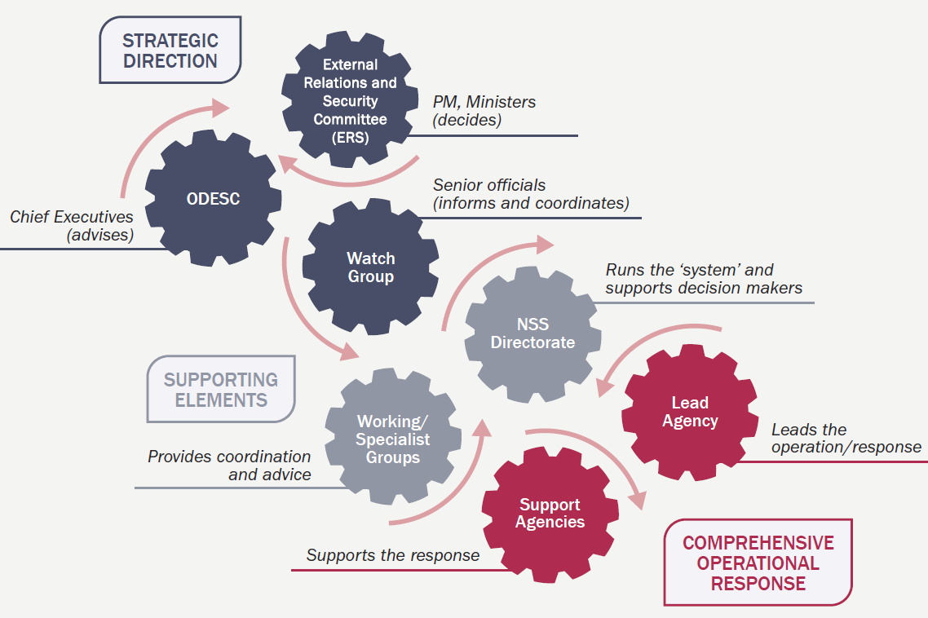

Figure 4‑1 National Security System in a Crisis (National Security System Handbook, August 2016)

### Lead agency

|  |  |
| --- | --- |
| Lead agency | MBIE, as the Government’s lead advisor on the fuel industry and as the chair of the Fuel SCE, will always manage and coordinate the Government’s response to a major fuel disruption. This role continues even if the event becomes an emergency under the CDEM Act 2002.  Depending on the cause of the disruption, the lead agency for coordinating the overall management of the emergency will initially be as per Appendix 1 of the National CDEM Plan 2015 e.g. CDEM for Geological/Meteorological hazards, Police for Terrorism, Fire and Emergency New Zealand (FENZ) for Fire. MBIE is the lead agency for Fuel infrastructure failure*.  If the event escalates and a state of emergency is declared (local or national), CDEM is always the overall lead agency (CDEM Group or NEMA). In this case MBIE is a support agency and MBIE will still chair the Fuel SCE and manage and coordinate the response to any fuel disruption that is part of the overall emergency.  *\*Currently, under Appendix 1 of National CDEM Plan 2015, NEMA is the lead agency for Infrastructure Failure. However, under the National Fuel Plan, MBIE is the lead agency for Fuel infrastructure failure. The National CDEM Plan will be updated in the upcoming review to reflect this change.* |

### Other key roles

|  |  |
| --- | --- |
|  | Table 4-1 describes the roles and responsibilities of the relevant agencies during a major disruption to fuel supplies. The roles of other key parts of the National Security System and other lead agencies are described in the NSS Handbook (<https://dpmc.govt.nz/publications/national-security-system-handbook-html>). |

Table 4‑1 Roles and responsibilities during response

| Agencies | Roles and responsibilities |
| --- | --- |
| **Minister of Civil Defence** | * The Minister may declare a state of national or local emergency under which the National Fuel Plan is activated. |
| **Minister of Energy and Resources** | * Activate the authorities under the IEA and/or Petroleum Demand Restraint Act 1981 to implement fuel demand measures or measures to meet IEA obligations. |
| **MBIE** | * Chair the Fuel SCE to manage and coordinate the government response to a national fuel supply disruption (regardless of the lead agency). * Provide advice to the Minister of Energy and Resources on measures to be implemented. * Collect information from the fuel industry and, where necessary, coordinate the implementation of response measures. |
| **NEMA (through National LUC)** 4F**[5]** | * Coordinate information from other lifeline utilities to support response (e.g. road status, electricity status). * Communicate situational information to CDEM Groups and other response agencies, as per the National CDEM Plan 2015. * Participate in, and contribute to the role of, the Fuel SCE. * Support CDEM Groups as required. * Provide logistical support to the fuel sector as per Section 5. |
| **CDEM Groups / ECC5** | * Maintain critical customer lists and make available to the National LUC. * Provide support to the management of allocation of fuel to critical customers (e.g.: confirming critical customer identification, queue management / crowd control). * Provide situational information (e.g. road access) to support the fuel response. * Cover costs associated with the provision of security at fuel retail outlets that the CDEM Group has procured. * Provide other logistical support to the fuel sector as per Section 5. |
| **Fuel companies** | * Coordinate their own organisation’s response. * Undertake operational tasks to manage fuel demand or increase fuel supply as part of their normal response and as directed by the lead agency. * Provide information to the lead agency, as per Section 4.4.3. * Provide a communication point for organisations supplied by the fuel company (e.g. dealers, distributors)5F[6]. * Support/advise the government response through the Fuel SCE and jointly undertake Fuel SCE roles with other fuel organisations. |
| **Fuel SCE** | * Facilitate sector solutions. * Request/coordinate support from the government. * Coordinate and provide fuel sector situational information to the lead agency. * Distribute situational information from the lead agency (through members to their sector / organisation / supply chain). * Coordinate with other affected sectors, particularly where dependencies exist (e.g. the electricity sector). |
| **Fuel retail outlets** | * Implement demand restraint measures as requested by the lead agency (communicated through fuel companies) or as directed via regulations. (Planning for priority fuel retail outlets is covered in Section 3.5.3). |
| **Critical customers** | * Ensure staff and contractors responsibly access prioritised fuel supply arrangements (essential staff and contractors only). * Reduce fuel demand as far as practicable without compromising services. * Have a process of identifying staff and/or vehicles to access fuel. * Have a means of payment if normal means (e.g. cards) cannot be used. |

## Escalation and activation of arrangements

### Escalation of event

|  |  |
| --- | --- |
| Escalation of emergencies | A major disruption to fuel supplies may be categorised in severity as well as scope – this concept is illustrated in the CIMS 3rd Edition Response Levels shown in Figure 4‑2. The fuel escalation process for this Plan is summarised in Figure 4‑3 and detailed in Table 4‑2  The ‘response’ level will determine whether the response is being led at the local, regional or national level (an incident is unlikely to trigger arrangements in this Plan). The decision to activate the Fuel SCE will depend on the severity of the impact on the fuel sector and may use activation arrangements described in Section 4.2.2.  An emergency may progress from one level to another (for example, a damaged pipeline that takes longer than expected to repair) or move straight to a high level (for example, a sudden, major refinery disruption expected to last longer than a few days).  The lead agency shall determine when to escalate or de-escalate to lower levels or business-as-usual, in consultation with the Fuel SCE.    Figure 4‑2: Response Levels, CIMS 3rd Edition    Figure 4‑3: Fuel escalation level based on severity of impact |

Table 4‑2: Description of Escalation Levels for Fuel Response

| Escalation Level | Description |
| --- | --- |
| Level 1: Minor Impact on Fuel Sector | * Potential for escalating fuel supply disruption to Levels 2-3 but minimal current impact on fuel distribution. * Fuel companies notify Fuel SCE Chair and start planning for potential disruption. * Fuel SCE convened to monitor situation and start planning for potential escalation. * NEMA notifies CDEM Groups (noting CDEM ECCs may already be activated if this is part of wider emergency). |
| Level 2: Moderate Impact on Fuel Sector | * Moderate fuel distribution impacts, most customers still serviced but causing risk of shortages to critical fuel customers. * Fuel SCE activated (*Section 4.2.2*) to monitor demand levels and re-supply options and coordinate Government support as required for the fuel sector (*Section 5.4*). * Critical Fuel Customer prioritisation is invoked (*Section 5.7*). Fuel companies to take steps to ensure critical customers are supplied. Government powers may be used to enforce this. * CDEM ECCs maintain list of critical customers and communicate changes to national LUC and local service stations. * State of emergency may be in place (see note). |
| Level 3: Major Impact on Fuel Sector | * Serious impact on fuel distribution with severe resource and capacity constraints and multi region and/or major impacts to critical customers. * Actions as above, plus additional demand management measures implemented (*Section 5.6* and *Section 5.7*) and coordinated through the Fuel SCE. * State of emergency likely to be in place (see note). |
| Level 4: Severe Impact on Fuel Sector | * Severe impact on national fuel supplies and resource and capacity limits well exceeded. * Actions as above, plus fuel companies to supply only critical fuel customers and these customers to be serviced by any supplier. * State of emergency likely to be in place (see note). |

*Note: The level of activation of CDEM and declaration of emergencies will not necessarily follow the level of fuel disruption if a wider emergency is in place.*

### Activation of arrangements in this Plan

|  |  |
| --- | --- |
| Activation of Arrangements | Arrangements in this Plan may be activated through any of the following (referenced legislation is detailed further in Section 1.2).   1. By a National or Group Controller in a declared state of emergency. 2. Upon the declaration of an IEA oil emergency under the IEA Act 1976 (the IEA is required to consult with member countries before declaring, which is likely to allow some time for consideration of response measures). 3. Upon the declaration of a petroleum emergency under the PDR Act 1981 by the Minister of Energy and Resources, on the advisement of MBIE, subject to cabinet decisions and the drafting of regulations and associated ministerial directions. 4. Upon the activation of the National Security System, on the advisement of MBIE, NEMA and/or other lead agency.   *Notes: A declaration under the IEA Act would only be in response to a global oil disruption. Regulations under the PDR Act 1981 can be made whenever supply is short. If a CDEM state of emergency is in place, IEA Act and PDR Act 1981 authorities are unlikely to be triggered; however, it is possible.* |
| IEA Declarations | Prior to any formal declaration of an IEA emergency under the International Energy Programme Agreement, the IEA is obliged to consult with member countries. This means there will be a warning of up to several days before an emergency is declared, affording New Zealand the opportunity to hold preliminary discussions (between government and industry) about response options. Approval from the Minister of Energy and Resources is required before New Zealand can agree to any IEA-mandated action.  Once it has consulted with and received agreement from member countries, the IEA can officially declare an emergency and call for a specific response under the International Energy Programme. The IEA will notify each country of what is required from them (e.g. how much stock they are expected to release or conserve). |

## Fuel Sector Coordination Arrangements

### Fuel Sector Coordinating Entity

|  |  |
| --- | --- |
| Objectives | The objectives of the Fuel SCE arrangements are to:   * assist the effective management of potential or actual fuel supply emergencies; and * ensure government, key stakeholders and the public are kept informed with consistent information. |
| SCE Activation  Initial teleconference  Other SCE participants | MBIE shall convene an initial teleconference of Fuel SCE members (*Section 3.2.1*) when:   * oil company representatives believe it to be necessary; * the emergency or event has / is likely to have a major effect on national or regional fuel infrastructure and/or distribution; or * the NEMA Duty Manager, National LUC or National Controller believe it to be necessary.   MBIE will convene this by individually contacting Fuel SCE members and notifying them of the time, number and location for the meeting, which may be by teleconference (MBIE and NEMA jointly hold an emergency contact list for all members).  Other participants may be invited to participate if their organisation is considered to have a material contribution to the event, such as:   * Coastal Oil Logistics Ltd (COLL) * Refining NZ * CDEM Group LUC (where one or two regions are the main affected regions) * Major retailers/distributors * Group Controllers of affected region(s).   The Fuel SCE Chair shall determine, in consultation with the SCE members, whether ongoing communications shall be by teleconference or in person and the timing/location of those meetings. |

### Other working groups

Other specific working groups may be convened during response to support local prioritisation arrangements or specific sector issues. The Chair of these Groups would liaise with the Fuel SCE to coordinate actions.

|  |  |
| --- | --- |
| Local fuel working group | Where a disruption to fuel supply is primarily affecting a single region, the CDEM Controller in the jurisdiction may convene a local working group (by conference call or in person) to coordinate local prioritisation arrangements.  For localised disruptions to fuel supplies, a local fuel working group under the direction of the Group or Local Controller may be convened without the national Fuel SCE being convened. Communication should be maintained with the Fuel SCE Chair and NEMA National LUC to ensure arrangements are put in place to support if the situation escalates. |
| Jet fuel working group | Where there is a significant disruption to the jet fuel supply, a working group may be convened by the Fuel SCE with representatives from the most affected organisations, for example:   * Airports * Air NZ and other airlines * Senior fuel company representatives * BARNZ * Fuel terminal operators * Regional CDEM Groups. |

## Communications

### Communication lines in an emergency under the CDEM Act

|  |  |
| --- | --- |
| Communication arrangements in a CDEM emergency | Once the Fuel SCE is convened, key communication lines are shown in Figure 4‑5 and discussed below.   * The National LUC shall provide links between the Fuel SCE, NEMA NCMC/NCC and affected Group LUCs to share situational awareness information (e.g. road/power outages, etc.) and communicate information on the fuel sector situation with the CDEM Groups. * CDEM ECCs and fuel retail outlets within the local area will communicate directly as needed and as per any local arrangements, such as providing CDEM support to manage priority fuel retail outlets for critical customers. * An MBIE or fuel company communications person may be appointed to the Fuel SCE to support public communications (under the overall direction of the lead agency’s Public Information Manager). * The fuel companies shall provide a communications link between the Fuel SCE and retailers that they own, manage and/or supply. It is noted that they may not be able to control the retail operations (other than how they supply the site) but can coordinate information and direction. * A reporting timeline will be determined by the lead agency for status reports, action plans and further conference calls. * Major disruptions to fuel supplies will also affect the transport industry. The Ministry of Transport may convene the national Transport Response Team (TRT) to coordinate the transport sector response to the emergency (the TRT is not shown in Figure 4-2 for simplicity). |

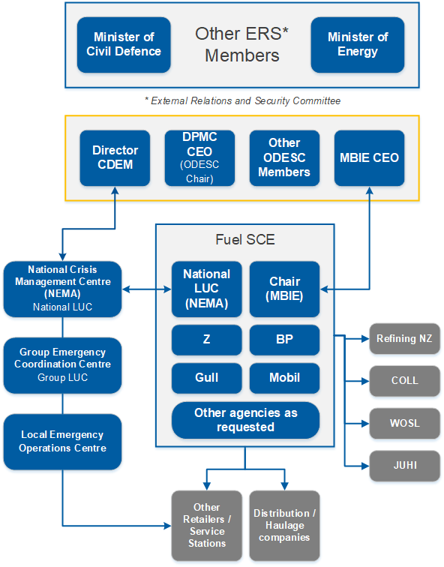

Figure 4‑4 Communication lines in a CDEM emergency

### Communication lines when it is not an emergency under the CDEM Act

|  |  |
| --- | --- |
| Communications with other lead agencies | If the Fuel SCE has been convened for a major fuel disruption that does not result in an emergency requiring coordination by CDEM under the CDEM Act, the arrangements will be similar but without the activated CDEM structure shown in Figure 4‑5.  However, the National LUC will still be on the Fuel SCE to monitor the situation, facilitate support by CDEM if required and provide information to NEMA NCMC/NCC to determine whether CDEM activation may be required (such as where there is potential for welfare issues to be managed). |

### Fuel sector reporting requirements

|  |  |
| --- | --- |
| General information to be provided  Reporting measures  Frequency of reporting | During emergency response and recovery activities there will be a need for ongoing communications between the lead agency and fuel sectors. Information will be provided by fuel companies to the Fuel SCE Chair on:   * status of fuel distribution and storage infrastructure (operational / not operational), * risk of imminent fuel shortages at fuel terminals or at multiple retail outlets (potential impact on fuel customers), * requirements for CDEM support to maintain/re-establish service, and * methods of allocating fuel to critical fuel customers (where critical customer prioritisation measures are being invoked).   Reporting should be structured to enable information to be provided specific to CDEM regions, where possible.  Specific metrics to be reported will be agreed at the first Fuel SCE meeting with consideration of the objectives of those receiving information, and may include:   * status of fuel sector facilities, stocks and networks; * current fuel stocks by type and location; * estimation of scheduled replenishment times and other future changes to fuel stock; and * estimated likelihood of fuel stock-outs at terminals or retail outlets.   Frequency of reporting will be determined by the lead agency, but will consider resourcing required to provide information and, where possible, be limited to no more than once per day (preferably later in the day). |

### Communication with CDEM Groups

|  |  |
| --- | --- |
| Communication lines  Information to be communicated | The relationship between the Fuel SCE and CDEM Groups is via the National and Group LUCs (unless only one or two regions are primarily affected, in which case the Group LUC will be directly represented on the Fuel SCE).  Key information to be exchanged between the National LUC and Group LUCs include:   * fuel sector status information (to be provided promptly from the National LUC when received); and * regional situation status, particularly relating to fuel dependencies such as road and other lifeline utilities’ status.   In the early stages of an emergency and/or where the Group LUC role is not activated, the CDEM Duty Officers and Controllers are likely to be the key points of contact. |

### Public communications

|  |  |
| --- | --- |
| Coordination of public communications | Where significant public communication is required, the lead agency will establish a Public Information Management Team (or similar). This team will:   * coordinate with the Fuel SCE over key messaging required; * implement a communications strategy to support the agreed plan of action, particularly for measures where public understanding and voluntary action is required; and * coordinate with other agencies/groups that may be releasing public information about the event to coordinate public messaging.   *Appendix D* provides suggestions and templates for Public Information as guidance. |
| Industry spokesperson | The Fuel SCE will seek to identify an industry spokesperson by consensus to provide consistent media messaging, with an agreed scope of content that can be discussed.  ***Note:*** *Fuel companies retain the right to release their own information to the public, and publicly listed companies have obligations to release information under the NZX. However, they must coordinate with the lead agency Public Information Management function to ensure consistency of information provided to the public.* |

### Communications with the International Energy Agency

|  |  |
| --- | --- |
| MBIE communications with IEA | The IEA and its member countries have an ongoing responsibility to exchange information in the event of an emergency. The IEA provides information on the nature of the disruption to member countries and involves them in the decision-making on the declaration. Member countries have a reporting obligation.  MBIE is responsible for leading communications with the IEA. |

# Implementing fuel management measures

|  |  |
| --- | --- |
|  | This section describes the specific measures that the fuel sector can (and does) use in order to manage the quality and quantity of fuel during disruptions to the normal supply chain.  It also identifies measures that the Fuel SCE, in consultation with the lead agency, may consider using to assist fuel companies to mitigate the impact of a disruption.  Fuel companies and critical fuel users should not plan on the assumption such measures will always be available. |

## Fuel sector mechanisms to manage disruptions to fuel supply

|  |  |
| --- | --- |
|  | The fuel sector has a wide range of mechanisms that they use to manage fuel supply distribution in both minor and severe disruptions to the fuel supply chain. |
| Accessing fuel from other terminals | Fuel tanker operators can access fuel from most (not all) terminals. If there are disruptions to any terminal, the operator will access the nearest available. For example, during the Refinery-Auckland Pipeline disruption in September 2017, fuel was trucked from Mount Maunganui and Marsden Point to supply Auckland and the surrounding area.  There are some constraints around the ability to truck fuel as an alternative when pipelines or terminals are disrupted. For example:   * There is only sufficient capacity to truck less than 25% of normal jet demand from Wiri to Auckland Airport if the Wiri-Auckland Pipeline (WAP) is closed. * There is only sufficient capacity to truck less than 15% of normal jet demand from Marsden Point if the Refinery-Auckland Pipeline is closed.   *Refining NZ has been investigating options to enable emergency road tanker loading of jet fuel at the refinery, at WOSL’s Marsden Point road tanker loading facility, and/or at a suitable wharf; for example, in Auckland on the Waitemata Harbour or the Port of Lyttelton. One potential option under development is an off-the-shelf skid or container road tanker loading facility. This is a standalone, modular facility that can be transported to the designated area, connected up to all relevant sources (process piping, electricity, appropriate earthing, etc.) ready for loading jet fuel into road tankers. There are still a number of matters to be resolved around ship redirection, sufficient jet fuel road tankers and drivers, receiving facilities, etc.* |
| Diverting nearby ships | In a disruption to the refinery or one of the coastal fuel ships, to deploy an additional ship from normal ports of origin such as Singapore could take several weeks. The fuel sector would seek to divert a closer ship to bring in additional refined fuel (for example a ship diverted from Australia could take only a few days). However, this is not always possible due to dependencies, which include the urgency with which the vessel's cargo is required at the original port and the fuel meeting New Zealand specifications.  ***Note:*** *New Zealand fuel specifications may differ from Australian specifications and may not be substituted with fuel that meets Australian specifications, unless regulations are relaxed (see* Section 5.2*).* |
| Mobile fuel storage units | Some companies have mobile fuel storage units that can be deployed to supply fuel to areas where normal supply points are unavailable, though there are very limited numbers of these in the country. |
| Other transport mechanisms | Other mechanisms for enabling transport of fuel where normal supply routes are disrupted include:   * Barges – where populations are isolated by road, fuel companies have at times transported fuel on barges where available. This occurred in 2018 to transport fuel to Takaka6F[7]; however, there are limited barges available in New Zealand and this option will not be viable in areas inaccessible by barge. Fuel products can only be transported on barges that are not carrying any other products at the time of transportation. * Air transport – noting that volumes that can be transported by NZDF and other local aircraft are small and only likely to be sufficient to fuel a small number of critical facilities. * Ship to shore mechanisms – such as pumping directly from ships to truck, pumping from ship to a barge to shore. These require onshore offloading facility and storage and there are many safety considerations. It is noted that this technology has not been tested or proven yet but is an item to be progressed by the fuel industry and the Fuel SCE. * Tanker trucks brought in on roll-on, roll-off ships or barges, where there is facility for these vessels to dock. * Carrying diesel in the running tanks for ships |

## Relaxing fuel specifications

|  |  |
| --- | --- |
| Reasons for relaxing fuel specifications | Relaxed fuel specifications can facilitate supply and:   * enable imports of refined fuel from a wider range of overseas sources, * improve viability of processing alternative crude oils (possibly domestically sourced) by Refining NZ, * enable Refining NZ to increase output by relaxing specifications, and * permit fuel meeting specifications of another country or specific regions (e.g. winter specifications) to be supplied. |
|  | *Note: The requirements of the Consumer Guarantees Act 1993 still apply, although may require waiver of rights for critical fuel customers during a state of emergency (to enable fuel of changed specifications to be supplied).* |
| Process to be followed to relax fuel specifications | The process to be followed for relaxing fuel specifications is as follows.   * The lead agency, in consultation with MBIE and the Fuel SCE, considers the type of specifications that are constraining the supply of products to New Zealand. * MBIE liaises with other government agencies – including the Ministry for the Environment, Ministry of Transport and Ministry of Health – to assess the potential impacts. * MBIE advises the Minister of Energy and Resources whether to approve the relaxation of the specifications. |

## Relaxing transport regulations

|  |  |
| --- | --- |
| Processes for relaxing transport regulations | The process to be followed for relaxing transport regulations is as follows.   1. The Fuel SCE, in consultation with the lead agency, considers whether any of the following is necessary to ensure continued supply to critical customers.    1. Increasing the capacity that can be carried by road tankers (mass and dimension limits apply and can be varied by permit application to NZTA for designated routes).    2. Relaxing enforcement of resource consents or bylaws restricting the operation of fuel tankers (e.g. noise restrictions on night deliveries in residential areas).    3. Varying traffic management rules or arrangements to facilitate more frequent truck movements (e.g. allowing use of bus lanes).    4. Relaxing restrictions on use of road tunnels (e.g. specifying dedicated time period when petrol tankers may use a tunnel).    5. Relaxing cabotage rules (relating to the shipping of fuel).    6. Relaxing restrictions on driving hours. |
|  | 1. The Fuel SCE, in consultation with the lead agency, makes recommendations for NZTA, local authorities and any other agencies that have jurisdiction to consider and implement the measures above. |

## Government logistical support

|  |  |
| --- | --- |
| Lead agency / NEMA support with logistics, regulation  Local/Regional CDEM support | The fuel companies are responsible for ensuring continuity of fuel supplies, as per the CDEM Act 2002. However, in events such as when road closures have isolated an area or region, the lead agency or NEMA NCMC/NCC will facilitate logistics support in collaboration with fuel companies to assist fuel supplies to reach affected areas.  This may include:   * air or overland vehicle transport;   *Note that volumes that can be transported by this method are small and only likely to be sufficient to keep the most essential facilities operating (e.g. hospitals).*   * a range of support by NZDF, where resources are available, such as NZDF ships, drivers, engineering resourcesor specialist aviation resources;   *There are some planning issues to be resolved as discussed in* Section 3.4.4 *such as compatibility of COLL and NZDF shipping specifications;*   * assistance with sourcing key international resources including barges and fuel air transport capacity; and * relaxation of regulations, such as those identified in Section 5.2 and Section 5.3 and others.   *For example, allowing night-time fuelling to increase distribution capacity.*  Through local and regional CDEM Groups, government can also facilitate:   * giving priority to re-establishing road routes to fuel terminals and priority fuel retail outlets; * giving priority to road use for essential supplies (such as fuel), for example if there is a single road into the West Coast; and * assistance with prioritisation of lifeline restoration, particularly including water and electricity. |

## Voluntary fuel demand constraints

|  |  |
| --- | --- |
| Implementing voluntary demand constraints | The public can be encouraged by Government and the fuel sector to voluntarily reduce fuel consumption by implementing fuel conservation measures. This can be achieved through reducing speed on open roads, carpooling, working from home, checking tyre pressure and reducing unnecessary trips or using other transport modes.  This is only considered a practicable option when managing a long-term supply disruption where immediate stocks are not at threat (panic buying will be a likely result otherwise).  Following a decision to seek voluntary fuel conservation measures, the Fuel SCE Chair shall:   1. Confer with the Energy Efficiency and Conservation Authority, National LUC, lead agency Public Information Manager (PIM) and Group LUC. 2. Agree roles for developing and disseminating key public information messages (key spokespeople). 3. Liaise with relevant government agencies to seek approval for media releases. 4. Monitor the effectiveness of the response and consider a move to mandatory measures if required.   *The Energy Efficiency and Conservation Authority has done planning on fuel conservation campaigns and can assist.* |

## Mandatory fuel demand constraints

|  |  |
| --- | --- |
| Deciding mandatory fuel conservation measures  Process for implementing fuel conservation measures | Some mandatory savings mechanisms (e.g. temporary closures of fuel retail outlets) are likely to be an industry response to a major fuel supply disruption, as tanks run dry and take time to be re-filled. However, government has powers to require action under both the Petroleum Demand Act (1981) (in a Petroleum Emergency as per IEA 1976) and the CDEM Act 2002 (in a declared state of emergency).  Following a decision to seek mandatory fuel conservation measures, the Fuel SCE Chair shall, in consultation with the Fuel SCE; Minister of Energy and Resources; and National, Group or Local Controller (if part of a declared state of emergency) determine which of the following measures shall be implemented.   * Opening hour restrictions (reduced hours, only open on alternate days). * Setting maximum purchases at point of sale – either price or volume. * Restricting sales into containers (to discourage hoarding). * Critical customer prioritisation measures (discussed in more detail in the following section).   *Price limits can be set at unmanned fuel retail outlets (e.g. truck stops). However, maximum purchase limits do not prevent customers from re-filling several times.*  MBIE, as the Fuel SCE Chair, shall:   * prepare draft regulations for agreement by the Minister of Energy and Resources and Cabinet; * draft directions to fuel companies and retailers to be issued, if necessary, by the Minister of Energy and Resources, if provided for in any Petroleum Demand Restraint Regulations that are made, or by the CDEM Controller, if a state of emergency has been declared under the CDEM Act 2002; * monitor fuel companies’ compliance with any directions issued by the Minister of Energy and Resources or CDEM Controller, as relevant; and * confer with relevant agencies around developing and disseminating key public messages (as per Section 4.4). |
| Messaging related to mandatory conservation measures | The key messages will include matters such as:   * the reason for the measures and what it requires from them, and * continuing communications on ways to save fuel and reduce car use. |

## Prioritising fuel to critical customers

### Ground fuels

|  |  |
| --- | --- |
| Decision to invoke fuel prioritisation measures | Fuel prioritisation measures can be invoked by a Controller (where a state of emergency under the CDEM Act is in force) or through regulations and associated instructions issued by the Minister of Energy and Resources (where a petroleum emergency is in place), as per Section 4.2.2.  The decision by the Controller or Minister of Energy and Resources to invoke fuel prioritisation should be made in consultation with the Fuel SCE and lead agency with consideration to the nature and magnitude of the emergency, current fuel availability and re-supply capability and observed/anticipated consumer usage and behaviours.  Priority fuel users will continue to source fuel from, and be supplied by, their regular fuel suppliers until it is no longer possible or practicable to do so.  These are subject to operational change and prioritisation at the discretion of a Controller (when a state of emergency has been declared under the CDEM Act).  *During a fuel disruption that has not led to an emergency under the CDEM Act, the list of priority fuel users is subject to Cabinet’s decision and will be contained in regulations made under the Petroleum Demand Restraint Act 1981.* |
| Fuel prioritisation measures at different levels of emergency | Fuel supply and distribution should function under normal commercial arrangements for as long as the situation allows. Within business-as-usual arrangements, fuel companies will take certain measures to allocate supplies to their contracted customers in order to continue a level of service.  Critical fuel customers will continue to source fuel from, and be supplied by, their regular fuel suppliers until it is no longer possible or practicable to do so.  As per the escalation process in Section 4.2.1:   1. Initial consideration of the need for government-mandated fuel supply prioritisation shall start at Level 1 (noting that some emergencies may immediately escalate to Level 3 or 4). 2. At Level 2, fuel prioritisation measures will be in place (designated fuel retail outlets, lanes, etc.) Other customers will continue to be supplied but fuel companies will prioritise re-supply to sites dedicated to critical customers and manage stocks to ensure ongoing supply to those customers. 3. As an emergency worsens and more fuel needs to be reserved for priority fuel users, fuel companies will decrease the percentage of stock allocated to their commercial customers and the difference will be allocated to critical customers. |
|  | 1. At Level 4, only critical customers will be supplied at designated fuel retail outlets or at other designated distribution points (e.g. to refuel generators at critical sites). |
| Implementing fuel prioritisation measures  Security and management at priority fuel outlets | Following the decision to invoke fuel prioritisation measures:   1. The National Controller or Minister of Energy and Resources (under regulations) shall direct fuel companies to restrict supplies to customers as per normal business arrangements and instead prioritise supply to ‘critical fuel customers’ as per Section 5.7 and detailed in regional fuel plans7F[8]. 2. The National LUC shall confirm the list of critical fuel customers and priority fuel retail outlets, in consultation with CDEM Groups (a database of critical fuel customers and priority fuel retail outlets identified in regional fuel plans is held by the National LUC). 3. The Fuel SCE may, with consideration of the above, confirm a list of fuel retail outlets to be dedicated to critical customers. 4. Fuel companies shall communicate the requirements to retailers in their supply contracts. Fuel companies may designate lanes in fuel retail outlets or entire fuel retail outlets for critical customer use. 5. The Fuel SCE shall coordinate with CDEM agencies providing support in managing priority fuel retail outlets. 6. Fuel companies will provide ongoing information on stocks and demand for the bulk supply chain, plus storage and demand specifically at designated fuel retail outlets.   As noted in Section 5.7.1, CDEM Groups are likely to need to facilitate security arrangements and assist with identification of critical customers at fuel retail outlets and maintain a safe working environment for site personnel. CDEM Groups may also liaise with New Zealand Police to assist with providing community support and reassurance, maintaining law and order and providing crime prevention advice at fuel retail outlets if required.  *Note: Any costs associated with the provision of security at fuel retail outlets provided by CDEM Groups is the responsibility of that Group – refer to section 33, The Guide to the National CDEM Plan 2015.* |

### Aviation fuels

|  |  |
| --- | --- |
| Fuel sector allocation mechanisms  Fuel SCE intervention | The major fuel companies have agreed allocation mechanisms with airlines when jet fuel supply is disrupted at major airports. Typically, this involves determining the proportion of normal demand able to be supplied and then allocating it to airline customers based on, for example, the previous three months’ demand. In response, airlines may carry additional fuel and refuel at destination airports, where practicable.  MBIE as the Fuel SCE Chair may decide that intervention is required to adjust this normal emergency allocation process. For example, where an airline is supporting response operations. This would be directed by a CDEM Controller (where a state of emergency is in force) or the Minister of Energy and Resources (under regulations where a petroleum emergency is in place), as per Section 4.2.2.  For smaller airports and airlines, jet fuel allocation will be managed under the ‘critical fuel customer’ prioritisation methods. The supply of aviation fuel to critical customers (e.g. such as helicopter operators) as key contractors in support of emergency response activity, noting a significant increase in demand for these services, is likely in a number of response scenarios. |

### Marine fuels

|  |  |
| --- | --- |
| Marine fuel allocation | Under normal arrangements, the fuel allocation is based on industry ownership and each fuel company would determine priorities to its customers within that allocation.  The Fuel SCE may direct fuel companies to prioritise supply to critical customers, as per ground fuels. |

## Managing safety and quality

|  |  |
| --- | --- |
|  | Some of the key safety and fuel quality requirements in storing and handling different fuel that need to be considered in implementation of the fuel restraint/supply mechanisms include:   * **Dangerous goods endorsements required by tanker drivers.** A dangerous goods-certified vehicle and local terminal approval are needed to enter terminals, particularly gantries, to load fuel. (Approved handlers are approved under the Hazard Substances and New Organisms Act (HSNO) 1996. * **Following a damaging event, operations at many facilities are likely to cease** while safety inspections are completed. This includes checking adequate drafts for ships in case of sea bed changes. This process may take several days – more if remediation works are required. * **Any additional restrictions/requirements imposed by terminal operators before allowing access to their sites.** Terminals also have verification processes around contractors allowed on site, e.g. health and safety policies, drug and alcohol testing procedures for drivers, police background checks, etc. * **Dangerous goods are not permitted in State Highway tunnels.** Special rules may need to be put in place during an emergency response to enable transport. * **Generators on forecourts** can be hazardous – consider connecting to the electricity network away from the station, e.g. to the local transformer and removing low tension fuses not feeding the service station. |
|  | * **Fuel companies may choose not to accept fuel deliveries to a retail outlet from a competitor.** This is mainly a legal issue concerning risk of liability from the sale of fuel that is not fit for purpose under the Consumer Guarantees Act 1993, or does not meet regulated specifications. A fuel company may consider this risk to be unacceptable if the fuel is acquired from outside its own ‘chain of custody’. A fuel company may also perceive legal risk under the Fair Trading Act 1986 if it sells fuel that does not contain the proprietary additives specified in its advertising and other marketing claims. * **Jet fuel**, whichrequires a period of settling before it can be safely released for use.   **Notes:**   * Dangerous Goods licensing is managed by NZ Transport Agency. * Approved handler regime is managed by Worksafe New Zealand. |

###### Glossary

|  |  |
| --- | --- |
| Agencies | **Agencies** are government agencies (including public service departments, non-public service departments, Crown entities and Offices of Parliament), non-governmental organisations, local government bodies, emergency services andlifeline utilities. |
| Critical fuel customers | **Critical fuel customers** are named organisations that are generally critical to response activities and have a reliance on fuel re-supply to carry out response activities. These are subject to operational change and prioritisation at the discretion of a Controller based on the nature and magnitude of the emergency. |
| CDEM Group | In this plan, **CDEM Group** refers to the collective of local authorities, emergency services, and other agencies that work together to implement CDEM in their area. **CDEM Group** may also refer to the committee of elected officials that are accountable for CDEM in their area.  CDEM Groups are required under the CDEM Act 2002; every local authority is required to be a member of a CDEM Group.  There are 16 CDEM Groups in New Zealand. Each is responsible for CDEM in its area, including:   * identifying and managing hazards and risks; * providing the organisational structure and resources necessary (including suitably trained personnel) for the effective delivery of CDEM; * undertaking CDEM readiness activities, including raising public awareness about CDEM and preparing a CDEM Group Plan; * coordinating or undertaking CDEM response and recovery activities; and * providing support and assistance to other CDEM Groups, if required. |
| Civil defence emergency management | In this document, **Civil Defence Emergency Management (CDEM)** has the same meaning as in the CDEM Act 2002:  **civil defence emergency management**—   * 1. means the application of knowledge, measures, and practices that—      1. are necessary or desirable for the safety of the public or property; and      2. are designed to guard against, prevent, reduce, or overcome any hazard or harm or loss that may be associated with any emergency; and      3. includes, without limitation, the planning, organisation, co-ordination, and implementation of those measures, knowledge, and practices. |
| Critical customers | **Critical customers** are agencies responsible for the health, safety and welfare of the community and, in an emergency, CDEM response and recovery activities. |
| National Security System | The **National Security System (NSS)** is the system of domestic and external security co-ordination used by the Government to manage all national crises.  The NSS operates at three levels during a crisis response:   * Ministers (Cabinet External Relations and Security Committee), led by the Prime Minister; * Chief Executives (ODESC), led by the Chief Executive of DPMC; * Officials (Watch and Specialist Groups), led by the Deputy Chief Executive; Security and Intelligence, DPMC.   *[National Security System Handbook 2016]* |
| Duty Officer, NEMA | **Duty Officer** is an immediate 24/7 response position, as part of the NEMA Duty Team.  *[Guide to the National CDEM Plan 2015]* |
| Emergency | In this document, **emergency** has the same meaning as in the CDEM Act 2002:  **emergency** means a situation that—   * 1. is the result of any happening, whether natural or otherwise, including, without limitation, any explosion, earthquake, eruption, tsunami, land movement, flood, storm, tornado, cyclone, serious fire, leakage or spillage of any dangerous gas or substance, technological failure, infestation, plague, epidemic, failure of or disruption to an emergency service or a lifeline utility, or actual or imminent attack or warlike act; and   2. causes or may cause loss of life or injury or illness or distress or in any way endangers the safety of the public or property in New Zealand or any part of New Zealand; and   3. cannot be dealt with by emergency services, or otherwise requires a significant and co-ordinated response under this Act. |
| Emergency services | **Emergency services** has the same meaning as in section 4 of the CDEM Act 2002, which means the New Zealand Police, Fire and Emergency New Zealand, and hospital and health services. |
| Hazard | **Hazard** has the same meaning as in section 4 of the CDEM Act 2002, which means something that may cause, or contribute substantially to the cause of, an emergency. |
| Lifeline utility | **Lifeline utility** has the same meaning as in section 4 of the CDEM Act 2002, which means an entity named or described in Part A of Schedule 1, or that carries on a business described in Part B of Schedule 1.  *[CDEM Act 2002]* |
| Local authority | A **local authority** can refer to a regional council or territorial authority.  *[Local Government Act 2002]* |
| Lead agency | The **lead agency** is the agency with the primary mandate for managing a particular hazard or risk across the “4Rs” of risk reduction, readiness, response and recovery. Whilst some risks are managed by the lead agency alone, many require the support of other government departments and agencies.  *[National Security System Handbook 2016]* |
| National Controller | **National Controller** is the Director of Civil Defence Emergency Management or person delegated by the Director to deal with any state of national emergency*.*  *[CDEM Act 2002]* |
| National Emergency Sharing Organisation (NESO) | The **National Emergency Sharing Organisation (NESO)** is a committee of fuel industry representatives chaired by the Ministry of Business, Innovation, and Employment. NESO is activated primarily when there is a threat or actual disruption to international fuel supplies.  Under the International Energy Agreement (IEA), every IEA member is required to have a NESO. It exists to make arrangements for sharing oil supplies between member countries in the event of a severe emergency. New Zealand also uses the NESO committee to assist with responding to lower level or non-IEA emergency measures. Under this Plan, the Fuel Sector Coordinating Entity takes on the role of NESO. |
| National significance | **National significance** includes, without limitation, any case where the Minister of Civil Defence or the Director CDEM considers that—   * there is widespread public concern or interest; or * there is likely to be significant use of resources; or * it is likely that the area of more than one Civil Defence Emergency Management Group will be affected; or * it affects or is likely to affect or is relevant to New Zealand’s international obligations; or * it involves or is likely to involve technology, processes, or methods that are new to New Zealand; or * it results or is likely to result in or contribute to significant or irreversible changes to the environment (including the global environment).   *[CDEM Act, Section 4]* |
| Priority allocation | **Priority allocation** refers to the prioritisation of fuel to agencies listed as critical fuel customers over corporate commercial customers and the public. |
| Rationing | **Rationing** refers to government-imposed restrictions on all individual sales of oil by quantity (volume or price). The purpose of rationing is to reduce the demand for oil and discourage hoarding behaviour. In the event of physical shortages, it reduces the likelihood of oil products running out. The Minister of Energy and Resources must approve any formal rationing measure. |
| Risk | **Risk** has the same meaning as in section 4 of the CDEM Act 2002, which means the likelihood and consequences of a hazard*.* |
| Sector Coordinating Entities (SCEs) | The **Sector Coordinating Entity (SCE)** is the organisation, group of sector representatives, or individuals agreed by a lifeline utility sector to provide an effective single point of contact to the NEMA NCMC/NCC and which will undertake a range of sector coordinating functions during an emergency.  *[Guide to the National CDEM Plan 2015]* |
| State of emergency | **State of emergency** has the same meaning as in section 4 of the CDEM Act 2002, which means a state of national emergency or a state of local emergency. |
| State of local emergency | **State of local emergency** has the same meaning as in section 4 of the CDEM Act 2002, which means a state of emergency that has occurred or may occur in the area or district of any CDEM Group. |
| State of national emergency | **State of national emergency** has the same meaning as in section 4 of the CDEM Act 2002, which means a state of emergency that exists over the whole of New Zealand or any areas or districts where the emergency is, or likely to be, beyond the resources of the CDEM Groups whose areas may be affected by the emergency. |

###### Acronyms and abbreviations

|  |  |
| --- | --- |
| CDEM | Civil Defence Emergency Management |
| COLL | Coastal Oil Logistics Limited |
| DPMC | Department of the Prime Minister and Cabinet |
| ECC | Emergency Coordination Centre |
| EOC | Emergency Operations Centre |
| ERS | External Relations and Security Committee (of Cabinet) |
| IEA | International Energy Agreement |
| JUHI | Joint User Hydrant Interplane Terminal |
| JOSF | Joint Operating Storage Facility |
| LUC | Lifeline Utilities Coordinator |
| MBIE | Ministry of Business, Innovation, and Employment |
| NEMA | National Emergency Management Agency |
| NCMC | National Crisis Management Centre |
| NCC | National Coordination Centre |
| NESO | National Emergency Sharing Organisation |
| NSS | National Security System |
| ODESC | Officials’ Committee for Domestic and External Security Coordination |
| OERS | Oil Emergency Response Strategy |
| PIM | Public Information Management |
| PDR | Public Demand Restraint (PDR Act 1981) |
| RAP | Refinery-Auckland Pipeline |
| SCE | Sector Coordinating Entity |
| TOSL | Timaru Oil Services Limited |
| WOSL | Wiri Oil Services Limited |

###### Regional Fuel Plan template

| Section | Comments |
| --- | --- |
| **Introduction** | |
| **1.1 Scope** | * Explains that the Plan gives effect to the National Fuel Plan at a regional level. * Includes a brief summary of Plan content, noting that a main purpose is to set out arrangements to promote continued fuel supply to critical customers who may be involved in a response to an emergency under the CDEM Act 2002. * Note that this Plan supports the CDEM Group Plan. |
| **1.2 Planning Framework** | * Brief industry overview and description of relevant legislation. Reference details in the National Fuel Plan, Section 1.2. |
| **1.3 Roles and Responsibilities** | * Brief list of petroleum sector and CDEM entities noting their roles and responsibilities.  Reference details in the National Fuel Plan Section 3.1 (planning) and Section 4.1 (response). |
| **1.4 Fuel Supply to the Region** | * A high-level summary of the national fuel supply chain with a focus on how fuel is supplied to the region.  Reference details in the National Fuel Plan Section 2. * Include brief descriptions of fuel shortage scenarios that may be managed through the Plan. * A wider or more detailed regional analysis / risk assessment of the regional fuel supply chain may also be undertaken. It could identify supply chain vulnerabilities and backup options (e.g. if key port, pipeline or terminal shut). * If work along these lines is undertaken, a summary could be included as an attachment. |
| **Activation and Communication** | |
| **2.1 Activation of Arrangements** | * A summary of the escalation table from the National Fuel Plan *Section 4.2*, noting actions of the relevant response agencies as fuel shortages escalate from Level 1 (minor) to Level 4 (severe). |
| **2.2 Communication Arrangements** | Summarise from National Fuel Emergency Management Plan, for example:   * The Taranaki CDEM Group will in most cases coordinate with the Fuel SCE via the national LUC. However, in an event mainly impacting the Taranaki Region, the Taranaki LUC (or other CDEM representative) will participate directly in the Fuel SCE. * Fuel companies will engage nationally through the Fuel SCE and are required to provide a communications link to retail outlets that they supply, such as to advise of fuel management requirements. * Direct communication between local/Group CDEM and fuel retail outlets may be required where fuel prioritisation arrangements are activated, and retail outlets require support to manage arrangements. * Fuel sector reports on supply and distribution impacts will be distributed to affected CDEM Groups.   Include Figure 4.2 from the National Fuel Plan. |
| **Fuel Management Measures** | |
| **3.1 Fuel Management Mechanisms** | Summarise from National Fuel Emergency Management Plan. |
| **3.2 Government/ CDEM Support** | Note Group support such as:   * assist with fuel prioritisation arrangements for critical fuel customers; * give priority to re-establishing road routes to fuel terminals and priority fuel retail outlets; * give priority to road use for essential supplies (such as fuel), for example if there is only a single road open to the region; and * assist with prioritisation of lifeline restoration, particularly including water and electricity. |
| **3.3 Prioritising Supply to Critical Customers** | Summarise options for prioritisation arrangements to critical sites and at fuel retail outlets, for example:   * designated retail outlets only supplying critical fuel customers; * designated lanes or mini-tankers within retail outlets only supplying critical fuel customers; and * monitoring stocks at fuel retail outlets and closing the station to all except critical fuel customers until the station is re-supplied. |
| **3.4 Priority Fuel Retail Outlets** | * Map/table showing fuel retail outlets – geographical spread, which ones have backup power arrangements. * Identify priority sites, which may be used to supply critical customers, using criteria in the National Fuel Plan. Note that event-specific consideration will need to be given to which of these stations is used in an emergency (and others may need to be considered ‘on the day’). * Agreements with these fuel retail outlets describing emergency responsibilities can be formalised (noting a preference by fuel companies for this to be managed via headquarters rather than directly with fuel retail outlets for stations owned by the fuel company). * Summarise arrangements for providing management and security support for priority fuel retail outlets (including contract arrangements with security companies). |
| **Critical Fuel Customers** | |
| **4.1 Critical Customers** | * Critical customers are agencies responsible for the health, safety and welfare of the community and, in an emergency, CDEM response and recovery activities. * CDEM Groups are expected to specify critical customers for the region. While the list may require tailoring to recognise specific needs in an actual event, it is necessary to have a list to start from. The list typically includes customers from health, emergency services, lifeline utilities, CDEM, welfare, defence, fast moving consumer goods and broadcasting. Contractors required for the main critical customers to function should be included. * The categories to be used to specify critical customers are set out in the National Fuel Plan. That list should inform development of regional lists of specific organisations. |
| **4.2 Critical Customer Fuel Requirements** | * This section should summarise critical customers’ fuel usage to assist fuel company and CDEM sector understandings of the quantity of fuel that may be required. * Requirements should be estimated for both business-as-usual and emergency conditions. Petrol, diesel, avgas and Jet A-1 should be distinguished. * Differing impacts as fuel shortage duration varies (e.g. some customers self-sufficient for two days but not one week) should be noted. Customers’ own arrangements to manage shortages should also be taken into account. * It may also be useful to describe increased fuel dependencies if the shortage is associated with a major electricity outage (increased amounts of diesel may be needed). |
| **4.3 Critical Customer Responsibilities** | Critical customers are responsible for:   * ensuring that the staff and contractors required for critical response functions:   + are aware of their CDEM-critical customer status,   + have suitable identification (branded cars, company ID cards and/or a signed letter on letterhead), and   + have alternative means of payment if they are unable to use their contracted fuel company (some fuel companies allow fuel cards to be used at their retail sites if EFTPOS is down); * reasonably conserving fuel (to the extent possible, without impacting their ability to maintain core services); * if requested by the Controller, giving priority restoration to support bulk fuel supply (notably water supplies to depots and facilities where mains water is a requirement for them to function and roads); * ensuring that non-critical staff and contractors do not unnecessarily take advantage of priority status; and * having their own business continuity arrangements relating to fuel supply (priority supply arrangements, own stocks, etc.) |
| **4.4 Critical Sites with Generators** | * In a longer term, widespread fuel shortage, re-fuelling of generators is likely to be a key issue. To support local and regional coordination of re-fuelling critical lifeline utilities and community sites, a map and list of major sites potentially requiring generator fuel is recommended. * Plans may also consider the potential demand for hireage of generators and availability within the region (although this is sometimes covered in a separate Generator Plan). |
| **Other Considerations** | |
| **5.1 Management of Critical Resources** | Addresses issues relating to relevant critical resources (e.g. generators, pumps, road access, security). May reference more detailed work (e.g. regional generator resources).  Includes a summary of arrangements for inspection of fuel retail outlet tanks (e.g. following serious earthquakes) and lists companies that undertake this service. |
| **5.2 NEMA NCMC/NCC Support** | Outline expectations of NEMA NCMC / NCC / government support (Section 4 of the National Fuel Plan). |
| **Other** | Bring through any key information relevant for context from the National Fuel Plan. |
| **Attachments** | * Lists of critical customers * Fuel station lists and maps * Critical sites with generators |

###### Public information

*This guidance is intended for public information management (PIM) or communications personnel preparing public messaging about voluntary or mandatory fuel conservation measures.*

Public information approach

Public information about voluntary or mandatory fuel conservation measures needs to be consistent with and incorporated into public information for the wider emergency response.

Work closely with key stakeholders, including local authorities, fuel companies and fuel retail outlets, to ensure accurate and coordinated information flows to the public.

Public information objectives:

* Provide reassurance to the public that there is a plan to manage the situation in place, and to minimise public concerns
* Provide accurate, up-to-date information on the situation, and as early a warning as possible of any need to move to mandatory measures.
* Explain the reasons for the move to fuel conservation measures and ensure that the public are fully informed on what it involves and what it requires from them.
* Provide continuing communications on ways to save fuel and reduce car use.

Key messages

Key messages should explain why the measures are necessary and appeal to the public desire to help. If relevant, provide messages explaining how fuel conservation and/or fuel prioritisation will enable response activities and allow essential services to operate.

Suggested voluntary fuel demand constraints messages

People are asked to reduce their use of petrol following the *[name of event or brief description of the situation]*.

*[briefly explain why, e.g. fuel tankers are not able to deliver fuel to petrol stations due to landslides on SH1]*

To help ensure that fuel is available for the essential services that need it, such as *[ambulances and contractors clearing slips [edit as appropriate]]*, and avoid further fuel restrictions, we need the public's help.

What you can do to reduce fuel use:

* Avoid unnecessary car trips.
* Walk, cycle, use public transport or carpool if you can.
* Work from home if possible.
* Check your tyre pressure – low tyre pressure can make your vehicle work harder to overcome road resistance, increasing fuel consumption.
* Reduce your load – take unnecessary items out of the car, remove roof racks/boxes and cycle racks if you’re not using them.
* Reduce speed on the open road and practise good driving habits.

You can find more tips about driving efficiently at <https://www.energywise.govt.nz/on-the-road/driving-efficiently/>

Suggested mandatory fuel conservation measures messages

Fuel conservation measures are being introduced following *the [name of event or brief description of the situation]*.

*[briefly explain why, e.g. there is a fuel shortage because tankers are not able to deliver fuel to petrol stations due to landslides on SH1]*

To help ensure that fuel is available for the essential services that need it, such as *[ambulances and contractors clearing slips [edit as appropriate]]*, the following measures are now in place:

*[insert description of measures in place]*

What you can do to reduce fuel use:

* Avoid unnecessary car trips.
* Walk, cycle, use public transport or carpool if you can.
* Work from home if possible.
* Check your tyre pressure – low tyre pressure can make your vehicle work harder to overcome road resistance, increasing fuel consumption.
* Reduce your load – take unnecessary items out of the car, remove roof racks/boxes and cycle racks if you’re not using them.
* Reduce speed on the open road and practise good driving habits.

You can find more tips about driving efficiently at <https://www.energywise.govt.nz/on-the-road/driving-efficiently/>

###### References

Department of the Prime Minister and Cabinet. *National Security System Handbook.* Wellington, New Zealand: Department of the Prime Minister and Cabinet, 2018.

Ministry of Business, Innovation, and Employment. *Monitoring Fuel Supply in an Emergency: Proposed Protocol for Information Provision and Use.* Wellington, New Zealand: Ministry of Business, Innovation, and Employment, 2018.

Ministry of Business, Innovation, and Employment. *New Zealand Petroleum Supply Security 2017 Update.* Hale & Twomey Limited. Wellington, New Zealand: Ministry of Business, Innovation, and Employment, 2017.

Ministry of Economic Development. *Oil Emergency Response Strategy: Government Response to an Oil Supply Disruption.* Wellington, New Zealand: Ministry of Economic Development, 2008.

*National Civil Defence Emergency Management Plan Order 2015*

National Emergency Management Agency. *National Civil Defence Emergency Management Fuel Plan.* Supporting Plan [SP 03/12]. Wellington, New Zealand: National Emergency Management Agency, 2012.

National Emergency Management Agency. *The Guide to the National Civil Defence Emergency Management Plan 2015.* Wellington, New Zealand: National Emergency Management Agency, 2015.

New Zealand Lifelines Council. *New Zealand Lifelines Infrastructure Vulnerability Assessment: Stage 1.* Wellington, New Zealand: New Zealand Lifelines Council, 2017.

1. Note this is not intended to limit engagement by CDEM Groups with any fuel retail outlets in their region.
2. Not all regional terminals have the capacity to receive imported refined product.
3. National Infrastructure Vulnerability Assessment, NZLC, September 2017
4. Primary distribution methods are shipping and pipeline.
5. This description of roles is not intended to limit the powers of Controllers under the CDEM Act, including Section 85(1)(e) provide for the conservation and supply of food, fuel, and other essential supplies, Section 90 Requisitioning Powers and Section 91 Power to give directions.
6. The major fuel companies can control the business actions of their company owned and operated fuel retail outlets but have little direct influence over those independents that carry their branding. However, they are required under this Plan to provide a communication link between the lead agency in an emergency and the retail outlets that they supply.
7. Barges were used to transport and supply Takaka and Golden Bay following closure of the Takaka Hill road due to slips in 2018.
8. The use of s91 of the CDEM Act 2002 allows oil companies to implement force majeur (unforeseeable circumstances) on their commercial contracts, allowing for greater allocations to critical fuel customers.