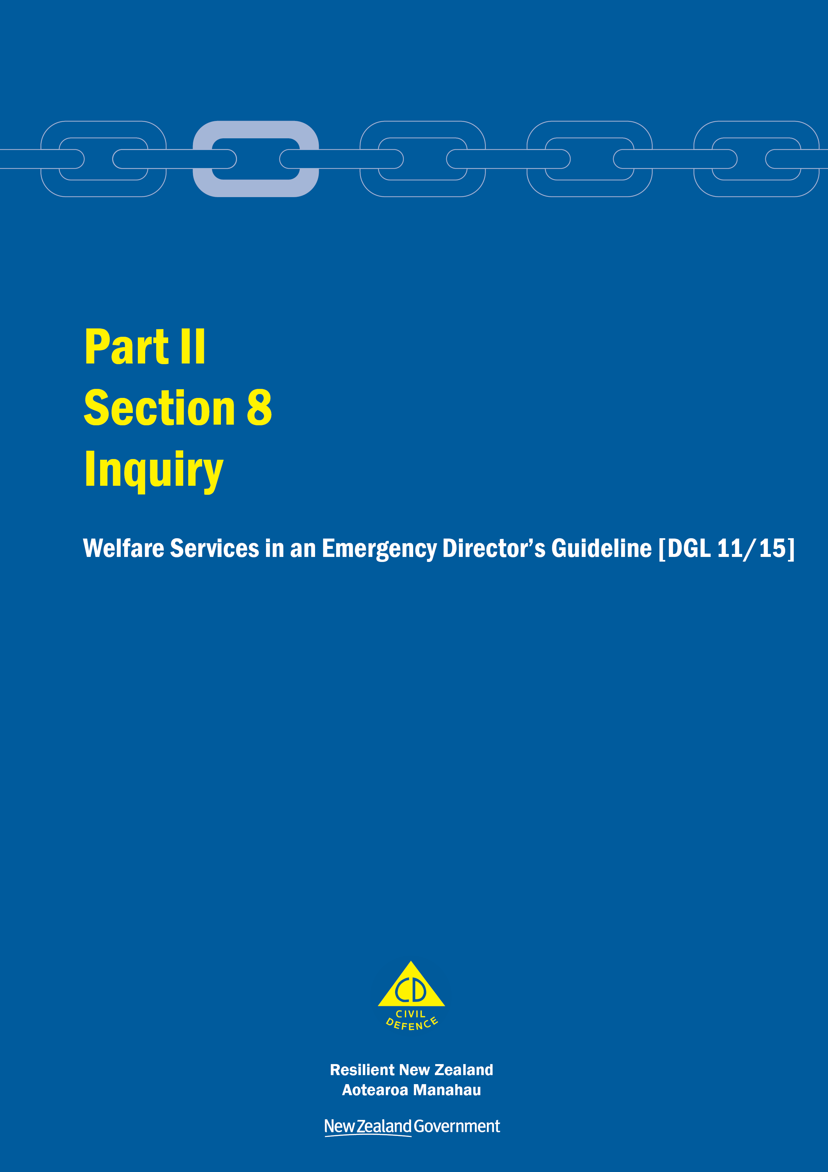
Welfare Services in an Emergency
Director’s Guideline for CDEM Groups and agencies with responsibilities for welfare services in an emergency [DGL 11/15]

October 2015
ISBN 978-0-478-43513-9
Published by the Ministry of Civil Defence & Emergency Management

Authority
This guideline has been issued by the Director of the Ministry of Civil Defence & Emergency Management pursuant to s9(3) of the Civil Defence Emergency Management (CDEM) Act 2002. It provides assistance to CDEM Groups and agencies with responsibilities for welfare services in an emergency to understand and work towards the welfare roles, structures, and responsibilities described in the National Civil Defence Emergency Management Plan 2015.

This document is not copyright and may be reproduced with acknowledgement. It is available, along with further information about the Ministry, on the MCDEM website www.civildefence.govt.nz.

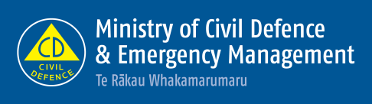

Ministry of Civil Defence & Emergency Management
PO Box 5010
Wellington 6145
New Zealand
Tel: +64 4 817 8555
Fax: +64 4 817 8554
Email: emergency.management@dpmc.govt.nz
Website: www.civildefence.govt.nz

Contents
Section 8 Inquiry 1
8.1 Introduction 1
8.2 Principles 2
8.3 Readiness 3
8.4 Response 4
8.5 Recovery 5
Appendix A Information applicable to all welfare services 6

Inquiry
This section should be read in conjunction with the other parts and sections in the Welfare Services in an Emergency Director’s Guideline [DGL 11/15].

Introduction
Inquiry involves identifying people who have been affected by an emergency and assisting family, whānau, and significant others to make contact.
During an emergency, friends, family, whānau and significant others want to make contact with one another to confirm their whereabouts and safety. As a result, large volumes of phone calls are made by the public (via many available phone numbers) to various responding agencies, regarding people who they are concerned about.

Agency responsible | The New Zealand Police (Police) is the agency responsible for a process to coordinate inquiries.
Usual or pre-planned means of contact | During the first 72 hours of an emergency, all resources (including telecommunications networks and responding agencies) are stretched.  The public are encouraged to utilise their usual and pre-planned means of contacting their family, whānau and significant others. Examples of contact methods include usual contact phone numbers, place of residence, social media, planned meeting places, or use of websites (including those that may be established during large-scale emergencies).  When a member of the public has exhausted these means of contact, and there are genuine fears for the person’s safety, an inquiry can be made with Police.
Support agencies | Table 1 shows the agencies that are required to plan for and support Police to facilitate the inquiry process.

Table 1 Support agencies for the inquiry sub-function
Agency | Support
MCDEM  CDEM Group  Local authority | MCDEM: as the agency responsible for the provision of the CDEM welfare registration system.  CDEM Groups and local authorities: using the CDEM welfare registration system.
Ministry of Education | To provide enrolment and other information (when legally able to do so) to Police about the current location (and identity) of children and their families who have been affected by an emergency.
Ministry of Foreign Affairs and Trade | Coordination with Foreign Diplomatic and Consular Missions for information about foreign nationals.

Agency | Support
Ministry of Health  District Health Boards (DHBs)  Primary care  Ambulance services | Ministry of Health: agency responsible for patient registration; via contracts with DHBs, primary care, and ambulance services.  DHBs/primary care/ambulance services: to ensure that patient management systems are maintained and available for inquiry purposes using the National Health Index (NHI) system (which allows interrogation and enables restricted information to be shared with agencies, such as Police, when requested).
New Zealand Red Cross | To provide an international tracing facility through International Federation of Red Cross and Red Crescent Societies partners, e.g. via Restoring Family Links (RFL); an international service operating during business as usual using social media, telephone directories, club directories, door-to-door visits, talking to neighbours etc.

Further support | Support may be provided by any other government agency or non-government organisation (in addition to those listed above) that can provide relevant advice or information.

Principles
The following principles apply to the inquiry process:
- The inquiry process is able to scale from small-scale local emergencies to large-scale national emergencies in a timely manner.
- When the scale of the emergency is such that Police cannot manage the volume of calls through their business as usual processes, an 0800 phone number may be established by Police.
- Inquiries made to other agencies about persons for whom there are safety concerns should be able to be transferred to Police.
- Where an inquiry is about matters other than a person’s safety, Police will transfer the call to the agency best suited to meet the inquirer’s needs.
- Agencies will make every effort to resolve inquiries made to them.
- Information is collected electronically by Police and then collated for further inquiry by an inquiry team using an established and consistent set of data requirements.
- Police will establish an inquiry team and work to resolve inquiries using established investigation and file management processes.
- Support agencies that register the details of people who require welfare services (using their own systems) will record information in a format and to a standard that can be used by Police.
- In resolving inquiries, all agencies will apply the Privacy Act 1993 and any other legislative constraints, including family violence and child protection legislation.
- Consistent public messaging as part of both readiness planning and response is vital to the inquiry process. This will be coordinated between Police and MCDEM and will be undertaken concurrently by both Police and CDEM Public Information Management (PIM). Public messaging will include informing people:
  - to use their usual and pre-planned means of contact to check on the whereabouts or safety of a person (i.e. usual contact phone numbers, place of residence, social media, planned meeting places or websites that may be established during large-scale emergencies)
  - how to inquire with Police
  - when a Police Inquiry 0800 number is activated and operational, and the purpose of this number
  - when to inquire with Police (i.e. when there are genuine concerns for a person’s safety)
  - when not to make inquiries with Police (i.e. about casual acquaintances), and
  - alternatives to inquiring with Police in these cases (including word of mouth, SMS messaging, going to agreed meeting places, and social media options).

Readiness
Readiness includes the Police having in place:
- A range of mechanisms for making inquiry with Police, including phoning the local station, public inquiry counter (which may be at a station, or nearer the incident) and an 0800 number (which may be activated in the event of an emergency)
- consistent public messaging prepared by Police and CDEM Public Information Management, and
- support from other Government agencies, including those described in Table 1 on page 1.

Readiness in communities | It is expected that community members will take responsibility for contacting their family, whānau, or significant others using a range of methods before contacting Police.  Methods include:  - using a pre-planned meeting place  - phone and/or SMS messaging  - social media (Facebook, Twitter)  - websites established by other organisations for the purpose of connecting people during an emergency, and  - other online options for individuals to notify others of their status.

Response
As an incident occurs, Police have capability and capacity to meet the demand of surges in inquiries by phone.
Inquiries are to be recorded in a standard format, enabling Police to activate and manage the inquiry process. This may include activating Police and other agencies’ emergency plans to meet staffing demands.
Police Family Liaison services will be part of the Police response to missing or deceased persons inquiries.

Support agencies | Supporting agencies are to provide information from their own registration systems on a regular basis and in a format as agreed with Police. Police will use this information to resolve inquiries.
Inquiry process | Figure 1 shows an overview of the Inquiry process, which involves Police working with support agencies to coordinate that process.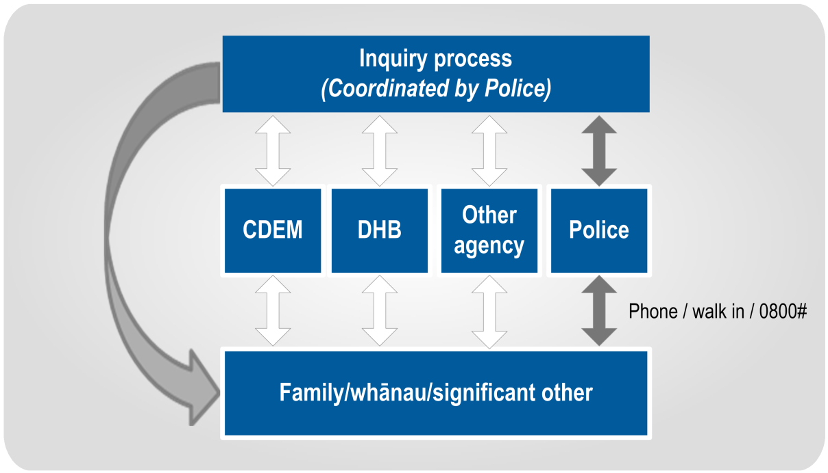  Figure 1 Overview of the Inquiry process

Recovery
Recovery involves a planned return to business as usual, including a phased stand down of any enhanced call-taking capability.
Police will continue to manage the resolution of inquiries that have not been resolved during the response phase. These inquiries, including ongoing Family Liaison service provision, may continue into business as usual.

Information applicable to all welfare services
This section provides overarching information applicable to all welfare services.

Welfare services agency representation
Some government agencies responsible for the coordination of the welfare services sub-functions do not have a presence in all communities.
Where agencies are not represented at the regional or local level, those agencies need to identify how they will fulfil their responsibilities. This may include:
- identifying alternative agencies or organisations to coordinate or support the delivery of the welfare services sub-function, or
- deploying personnel into the region or local area.
Agencies should work with the CDEM Group/local authority to identify alternative agencies/organisations present in the local community. These organisations may be non-government, community-based, or voluntary.
See the National CDEM Plan 2015, the Guide to the National CDEM Plan 2015, and the sections in Part II Welfare services of this guideline for details of the agencies responsible for, and who support the welfare services sub-functions.

Human rights
New Zealand’s human rights commitments | The provision of welfare services to people affected by an emergency, either via a Civil Defence Centre (CDC) or in a community setting, must contribute to ensuring that New Zealand meets its national and international human rights commitments.  See the Human Rights Commission website www.hrc.co.nz under the ‘Your rights’ tab for more information.
Age, people with disabilities, and people from CALD communities | Consideration must be given to providing access to welfare services to people of any age, people with disabilities, and people from culturally and linguistically diverse (CALD) communities. For example, people with disabilities require welfare services to be delivered in a disability-inclusive way, and will work with CDEM to achieve this. CALD community members often have specific requirements around social interaction, food, prayer, or gender which must be considered when planning for the delivery of welfare services.
More information | For more information and a list of relevant statutory documents, refer to the MCDEM publications:  - Including people with disabilities: Information for the CDEM Sector [IS 13/13]  - Including culturally and linguistically diverse (CALD) communities: Information for the CDEM Sector [IS12/13].  Along with the resources listed above, see Part I of the Welfare Services in an Emergency Director’s Guideline [DGL 1/15] (Appendix H Accessibility).  These are available at www.civildefence.govt.nz (search for the document name).

Working with communities
An inclusive approach | An emergency can be a stressful and emotional experience, which may impact or compound any existing difficulties or issues that people are facing. At the local and regional levels, consideration must be given to vulnerable and hard to reach communities, acknowledging that they may have:  - specific challenges to address  - skills and strengths that may contribute to welfare services delivery.
Considerations | Consider when planning:  - age  - gender  - children and young people  - people living alone  - elderly  - health and disability issues  - mental health and general health issues  - drug or alcohol dependency  - cultural requirements  - ethnicity and language  - socio-economic status  - people with companion animals  - isolation, and  - people with unreliable or no internet access or mobile phone coverage.
Utilising community networks | Opportunities should be taken wherever possible to build links with existing community networks. These networks should be utilised to reach people requiring support in an emergency, with resulting arrangements formalised in local plans.
Culturally and linguistically diverse (CALD) communities | CALD communities have many strengths, including skills, experience, and language capabilities.  CALD community networks are often well developed, with strong connections both within their own community and between communities. Partnering with CALD community leaders can enable appropriate and effective engagement and communication with community members.
People with disabilities | Working with people with disabilities and their wider networks of family/whānau, friends, and supporters provides an opportunity to gain an understanding of both the requirements and strengths of these members of the community.  People with disabilities and disabled people’s organisations provide expertise on the impact of disability. Disability service providers have technical and professional expertise, and may also have resources that can be drawn upon in an emergency.

Minimum standards in the Sphere Handbook
CDEM Groups/local authorities should take The Sphere Handbook: Humanitarian Charter and Minimum Standards in Humanitarian Response into account when planning for, setting up, and delivering welfare services.
The Sphere Handbook is one of the most internationally recognised sets of common principles and universal minimum standards in life-saving areas of humanitarian response.
The Minimum Standards include recommendations in water supply, sanitation, hygiene promotion, food security and nutrition, shelter, settlement, and non-food Items.
The Sphere Handbook is available at www.spherehandbook.org.

Key considerations | Some of the key requirements (taken from the Sphere Handbook) to be considered when planning for people affected by an emergency are shown in Table 2.  Table 2 Key considerations for planning for people affected by an emergency  Rights Key requirements  Protection from Poor health, disease and wellbeing  Environment, weather, heat or cold  Violence, crime or abuse  Dangerous structures  Nutrition Clean drinking water  Food, baby food and pet food  Cooking facilities, utensils and fuel  Water and Sanitation, Hygiene (W.A.S.H) Clean water for washing  Waste water, solid waste  Hygiene, nappies, soap and disinfectant

Privacy, information sharing, and vetting
Information about welfare registrants, including personal information, will be shared with agencies contributing to the coordination and delivery of welfare services.
A privacy statement features as the first step in the registration process, and this must be understood and agreed to by all potential registrants. The privacy statement can be displayed by way of posters, hand-outs or on-screen if people are waiting to be registered (e.g. in a CDC).
Welfare registrars need to be trained in and must understand and abide by the provisions of the Privacy Act 1993. This Act controls how agencies collect, use, disclose and give access to personal information. Note that people have the right to request any information gathered about them under this Act.
See section 6 in Part 2 of the Privacy Act 1993 which features 12 Information privacy principles.
The Privacy Act 1993 is available at the New Zealand Legislation website: www.legislation.govt.nz or for more information refer to the Privacy Commissioner’s website: www.privacy.org.nz .

Civil Defence National Emergencies (Information Sharing) Code 2013 | The Civil Defence National Emergencies (Information Sharing) Code 2013 (the Information Sharing Code) is a regulation issued by the Privacy Commissioner, and applies to a state of national emergency only.  The Information Sharing Code provides agencies with the authority to collect, use, and disclose personal information relating to an individual, in relation to an emergency.  The Information Sharing Code applies as follows:  - To assist with the effective management of the response to a national emergency, this code applies in relation to any emergency in respect of which a state of national emergency is in force.  - To assist with the recovery from a national emergency, this code continues to apply in relation to such an emergency for a further 20 working days after the date on which a state of national emergency expires or is terminated.  Specific criteria apply to the Information Sharing Code. For full details, refer to the Civil Defence National Emergencies (Information Sharing) Code 2013 on the Privacy Commissioner’s website: www.privacy.org.nz.  As stated above, the Information Sharing Code applies only to a state of national emergency. The Privacy Act 1993 applies at all times including during and following any emergency.
Police Vetting Service | The New Zealand Police Vetting Service offers an online process for approved organisations to check the criminal records of potential or existing personnel, including volunteers.  Vetting requests cannot be made by individuals, and organisations must register in order to ask for Police vetting. To become an approved organisation, agencies must show that their personnel provide services or care for children, older people, people with special needs or other vulnerable members of society.  Vetting can only be carried out with the signed consent of the person being vetted. Organisations are expected to ensure the person being vetted is aware of the vetting process.  The standard turnaround time for completing a Police vetting process is 20 working days.  Police recommend that vetting of existing personnel including volunteers, is carried out on a regular basis, i.e. every two to three years.  An organisation must have information security procedures in place to protect the confidential information and any Police material they hold as a result of the vetting process.  More information about Police vetting is available at www.police.govt.nz.
Safety checking for the children’s workforce | The Vulnerable Children Act 2014 introduces new requirements for organisations funded by the government that employ people to work with children. Safety checking requirements are being phased in over several years.  Any agency working with children and young people must meet the approval obligations outlined in the Vulnerable Children Act 2014.  The Vulnerable Children Act 2014 is available at the New Zealand Legislation website: www.legislation.govt.nz or for more information refer to the Children’s Action Plan website: www.childrensactionplan.govt.nz.
Screening CDEM-trained volunteers | For information about screening processes for CDEM-trained volunteers, refer to the Volunteer Coordination in CDEM Director’s Guideline for CDEM Groups [DGL 15/13] available at www.civildefence.govt.nz (search for ‘volunteer coordination DGL’).

