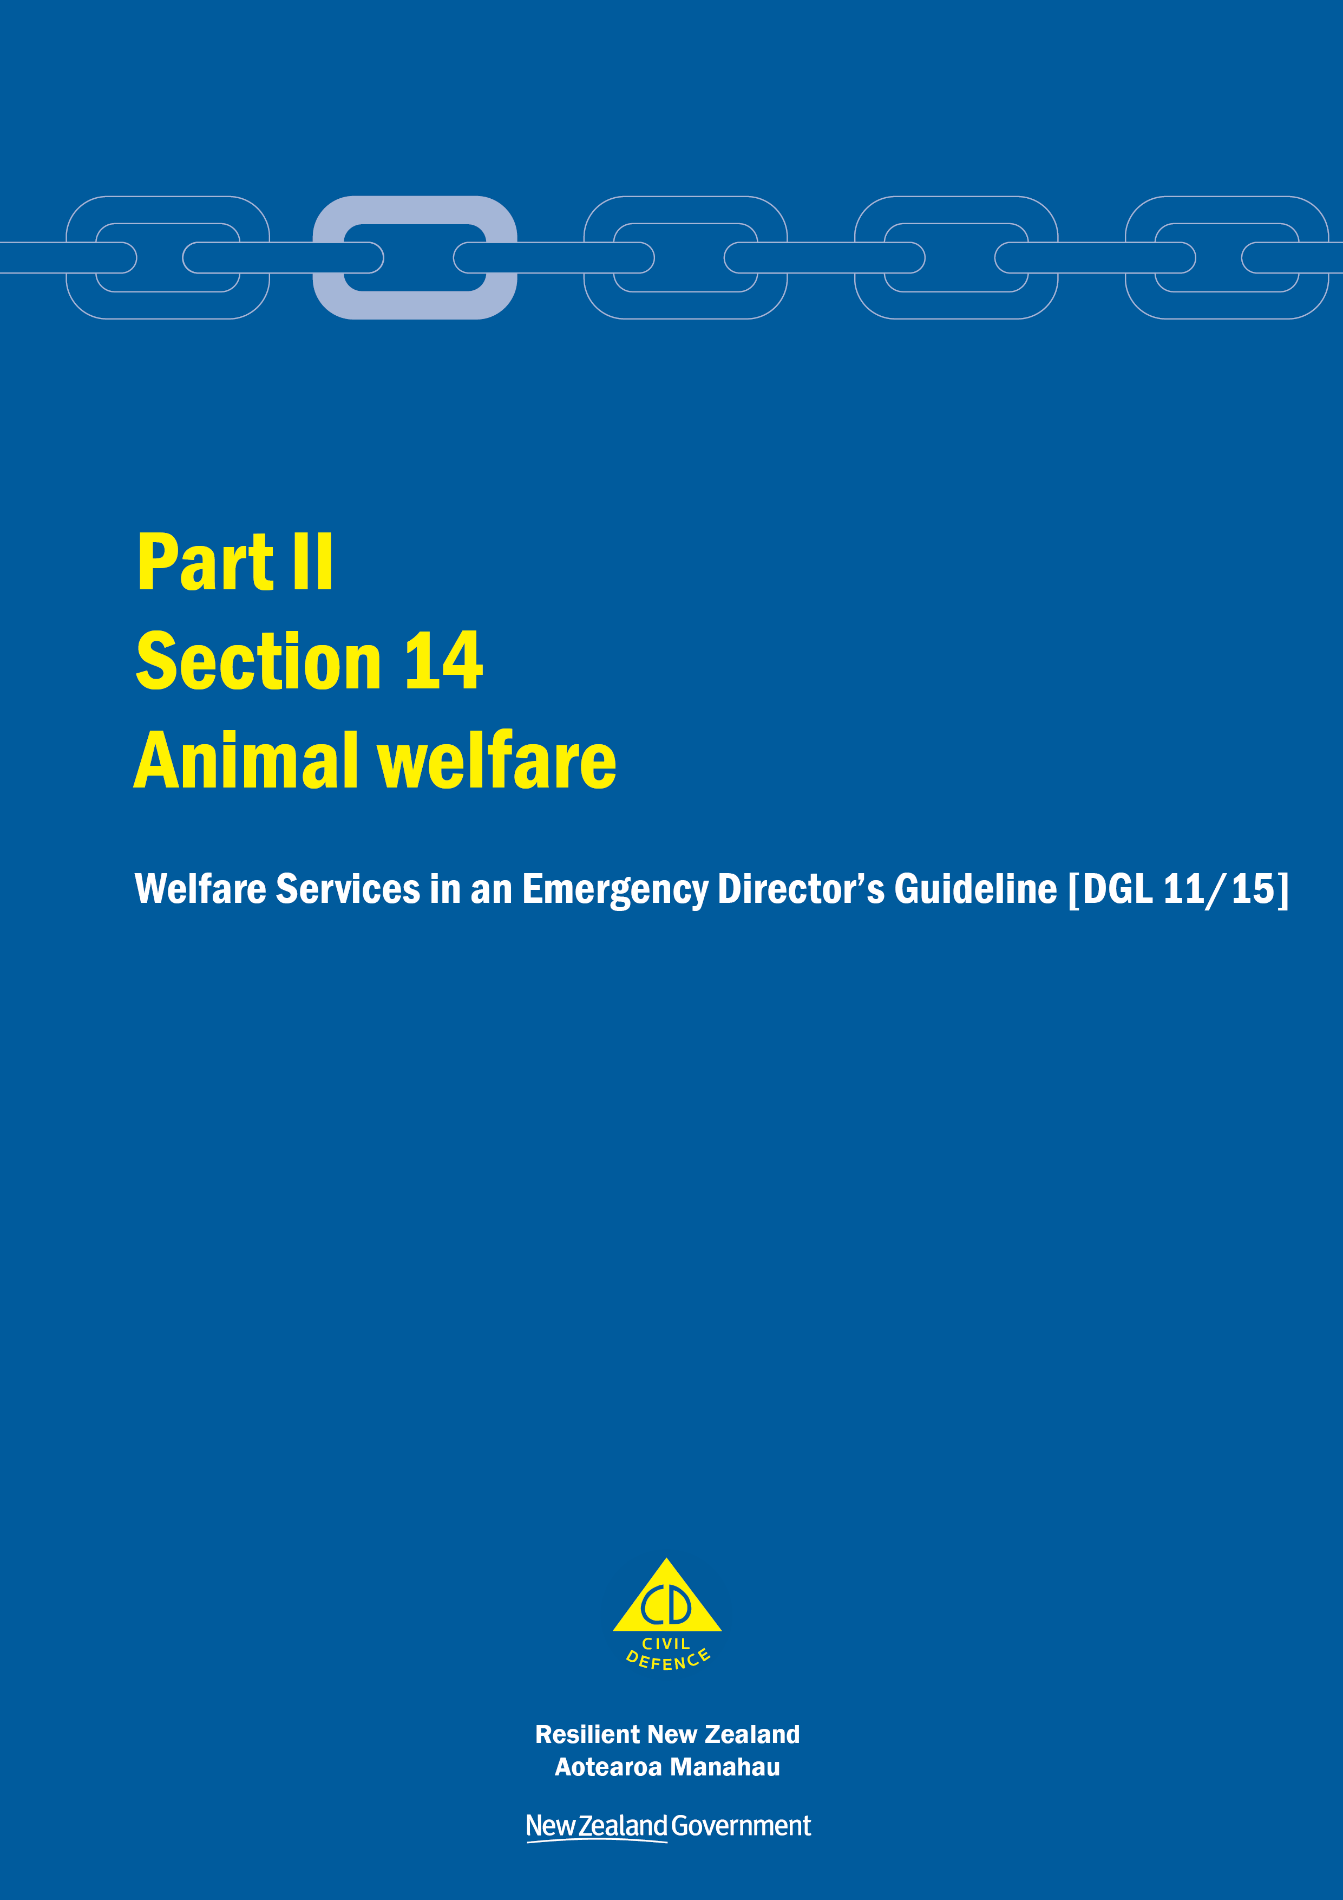
Welfare Services in an Emergency
Director’s Guideline for CDEM Groups and agencies with responsibilities for welfare services in an emergency [DGL 11/15]

October 2015
ISBN 978-0-478-43513-9
Published by the Ministry of Civil Defence & Emergency Management

Authority
This guideline has been issued by the Director of the Ministry of Civil Defence & Emergency Management pursuant to s9(3) of the Civil Defence Emergency Management (CDEM) Act 2002. It provides assistance to CDEM Groups and agencies with responsibilities for welfare services in an emergency to understand and work towards the welfare roles, structures, and responsibilities described in the National Civil Defence Emergency Management Plan 2015.

This document is not copyright and may be reproduced with acknowledgement. It is available, along with further information about the Ministry, on the MCDEM website www.civildefence.govt.nz.

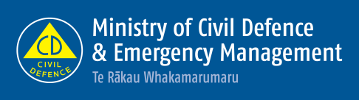

Ministry of Civil Defence & Emergency Management
PO Box 5010
Wellington 6145
New Zealand
Tel: +64 4 817 8555
Fax: +64 4 817 8554
Email: emergency.management@dpmc.govt.nz
Website: www.civildefence.govt.nz

Contents
Section 14 Animal welfare 1
14.1 Introduction 1
14.2 Principles for animal welfare emergency management 2
14.3 Animal welfare emergency management framework 3
14.4 National Animal Welfare Coordinator 4
14.5 Regional Animal Welfare Coordinator 6
14.6 Local Animal Welfare Coordinator 7
14.7 Animal welfare emergency management across the 4Rs 8
14.8 Companion animals 10
14.9 Other animal types 12
Appendices 13
Appendix A Information applicable to all welfare services 14
Appendix B Animal registration form 20
Appendix C Animal owner agreement form 23
Appendix D Declaration of disability and reliance on an assistance animal form 25

Animal welfare
This section should be read in conjunction with the other parts and sections in the Welfare Services in an Emergency Director’s Guideline [DGL 11/15].

Introduction
All animal owners, or persons in charge of animals, should develop their own plans to care for their animals during emergencies.
The role of the animal welfare sub-function is to help provide for the needs of animals when their owners (or persons in charge) are not able to do so themselves, because of the consequences of the emergency.
The animal welfare sub-function includes the provision of animal rescue, animal shelter, food, water, husbandry, and veterinary care and other essentials for all animals.

Agency responsible | At the national and CDEM Group levels, the Ministry for Primary Industries (MPI) is the agency responsible for:  - coordinating the provision of the animal welfare services sub-function for all animals, including companion animals, production animals, animals in research, testing and teaching facilities, zoo and circus animals, and wildlife  - coordinating the planning for animal welfare in emergencies, and  - maintaining the Government’s reporting and advisory capability on animal welfare in an emergency.
Support agencies | Support from the following agencies, at both the national and CDEM Group levels may be required to provide these services:
Table 1 Support agencies for the animal welfare sub-function
Agency | Support
Federated Farmers of New Zealand | To provide direct support and coordination services to commercial livestock owners to assist in mitigating animal suffering as a result of an emergency.
New Zealand Companion Animal Council | To provide support services to companion animal owners to assist in mitigating animal suffering as a result of an emergency and returning animals to their owners.

Agency | Support
New Zealand Veterinary Association | To provide advice on where veterinary treatment can be obtained.  To provide assistance in alleviating animal suffering through the coordination of the provision of advice, feeding, relocation, or sheltering of animals during and after an emergency.  To coordinate the provision of trained veterinary personnel to assist in affected areas.  To ensure rapid communication of relevant information to veterinary members and branches, especially to and from affected areas.
The Royal New Zealand Society for the Prevention of Cruelty to Animals | To provide direct support and coordination services to companion animal owners to assist in mitigating animal suffering as a result of an emergency.
Territorial authorities, through animal control or animal services | To provide direct support and coordination services to companion animal owners to assist with the care, relocation, and housing of companion animals and other animals, in response to an emergency.
World Animal Protection | May provide support in the event of a national emergency, if formally requested, in the form of animal emergency management response (which could take the form of veterinary support, help with setting up and running temporary animal shelters, and provision of animal food).  Their expertise can provide technical consultancy, support in coordination, or the deployment of field staff and resources as the situation allows.
Ministry for Primary Industries | Will advise local authorities on the disposal of dead animals.
Medical officers of health and health protection officers | Will advise local authorities on the public health issues that may result from the death and disposal of animals.

Further support | Additional agencies listed in the Guide to the National CDEM Plan 2015 may be required at the national and CDEM Group level to provide animal welfare services.  Support may also be provided by any other agencies or individuals that can provide relevant advice or information at national, regional, or local levels.

Principles for animal welfare emergency management
The following principles underpin the coordination and delivery of animal welfare services:
- The Animal Welfare Act 1999 states that all people who own, or are in charge of, animals have a legal obligation to meet the physical, health, and behavioural needs of those animals. These needs are fulfilled through the provision of food, water, shelter, appropriate handling, protection from injury and disease, and the opportunity to display normal patterns of behaviour. This “duty of care” applies under all circumstances including during and following an emergency.
- Public education – in terms of ways that animal owners/persons in charge can prepare for an emergency, and the animal welfare actions that should be taken during response/recovery – is essential to successful animal welfare emergency management.
- Animal welfare emergency management plans should take account of all animal types, and the particular needs of each animal type.
- Whenever possible utilise people in animal welfare emergency management whose daily job involves working with animals.

Animal welfare emergency management framework
MPI, as the responsible agency for the animal welfare sub-function, fulfils its role via animal welfare coordinators.
The animal welfare coordination structure in readiness is provided in Figure 1 (below) and in response and recovery is provided in Figure 2 (on the next page).
The readiness and response/recovery structures may vary depending on the arrangements within CDEM Groups. CDEM Groups may need to adapt the structure to suit arrangements in their area and to take account of responsibilities at both the regional and local levels.
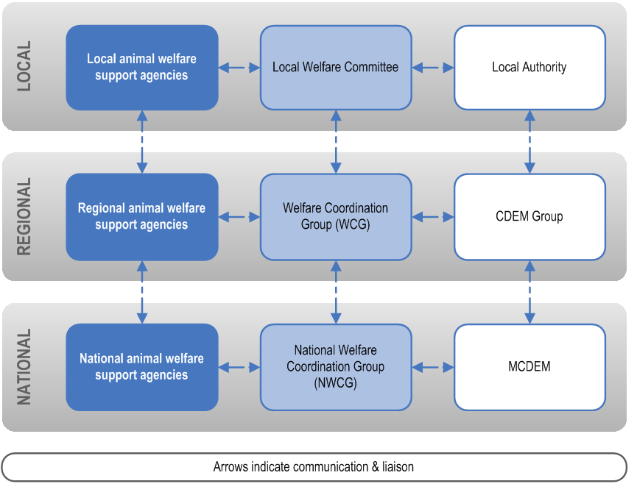
Figure 1 Animal welfare coordination during readiness
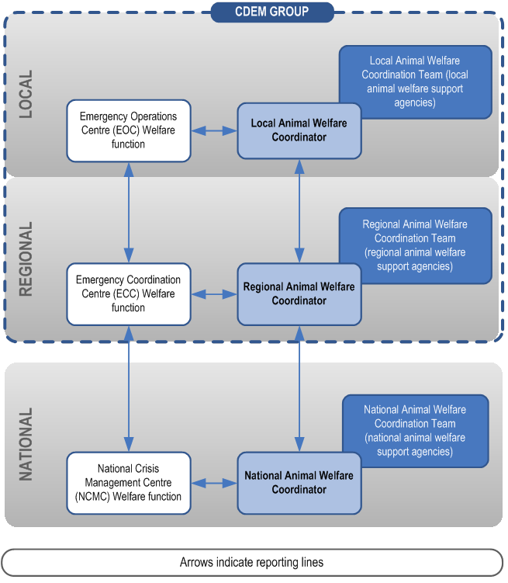
Figure 2 Animal welfare coordination during response and recovery

National Animal Welfare Coordinator
 | The National Animal Welfare Coordinator is an MPI employee responsible for leading MPI’s programme for meeting its animal welfare responsibilities under the National CDEM Plan 2015. The role of the National Animal Welfare Coordinator is set out below.
During readiness | During readiness, the National Animal Welfare Coordinator:  - leads the animal welfare subgroup at the national level (which includes representatives from national animal welfare support agencies listed in Table 1)  - works with support agencies (listed in Table 22) and other organisations listed in the Guide to the National CDEM Plan 2015 for example, Dairy NZ, Beef and Lamb NZ, etc. to promulgate public education and advice on readiness activities to animal owners and persons in charge  - leads the development of animal welfare planning arrangements at the national level involving all animal welfare sub-function support agencies (listed in Table 22), and other organisations listed in the Guide to the National CDEM Plan 2015  - participates in national level CDEM training and exercises  - liaises regularly with each of the Regional Animal Welfare Coordinators, and assists with the development of animal welfare emergency management plans, and  - represents the animal welfare sub-function at the national level on the National Welfare Coordination Group (NWCG), and other committees, and provides regular updates to the NWCG, MCDEM, and CDEM Groups concerning the above matters.
During response | During response, the National Animal Welfare Coordinator:  - coordinates the provision of national animal welfare services with the National Animal Welfare Coordination Team (comprised of representatives from support agencies involved in animal welfare listed in Table 1)  - provides animal welfare technical advice to the National Welfare Manager and Regional Animal Welfare Coordinators  - coordinates the provision of national animal welfare status updates as required by the National Crisis Management Centre (NCMC), and  - works with MCDEM to promulgate public information messaging to animal owners (and persons in charge) on the animal welfare actions they should take.
During recovery | During recovery, the National Animal Welfare Coordinator coordinates at a national level the provision of animal welfare recovery measures and contributes to public information.

Regional Animal Welfare Coordinator
Regional Animal Welfare Coordinators are appointed by the Ministry for Primary Industries in consultation with CDEM Groups.
The roles and responsibilities of Regional Animal Welfare Coordinators are set out below.

During readiness | During readiness, the Regional Animal Welfare Coordinator:  - leads the animal welfare subgroup at the regional level (which may include representatives from regional animal welfare support agencies listed in Table 1)  - works with support agencies (listed in Table 1) and other organisations listed in the Guide to the National CDEM Plan 2015 for example, Dairy NZ, Beef and Lamb NZ, etc. to promulgate public education and advice on readiness activities to animal owners and persons in charge  - works with animal welfare support agencies (listed in Table 1), and other organisations listed in the Guide to the National CDEM Plan 2015, to develop an animal welfare emergency management plan for the CDEM Group  - works with support agencies and local authorities to establish Local Animal Welfare Coordinators, and assists with the development of animal welfare emergency management plans at the local level  - represents the animal welfare sub-function at all relevant regional level meetings with animal welfare emergency management stakeholders, including meetings of the Welfare Coordination Group (WCG) and CDEM Group  - participates in national, regional, and local level (as relevant) CDEM training and exercises, and  - provides regular updates to the CDEM Group Welfare Manager, WCG, CDEM Group, and the National Animal Welfare Coordinator concerning the above matters.
During response | During response, the Regional Animal Welfare Coordinator:  - coordinates the provision of regional animal welfare services (including animal welfare technical advice) with the Regional Animal Welfare Coordination Team (which may include representatives from the support agencies listed in Table 1), and  - coordinates the provision of animal welfare status updates, as required, by the WCG, CDEM Group, and the National Animal Welfare Coordinator, and  - works with the CDEM Group to promulgate public information messaging to animal owners (and persons in charge) on the animal welfare actions they should take.
During recovery | Where required during recovery, the Regional Animal Welfare Coordinator coordinates the provision of animal welfare recovery measures and contributes to public information in the region.

Local Animal Welfare Coordinator
Regional Animal Welfare Coordinators will work with support agencies and local authorities to identify and appoint Local Animal Welfare Coordinators.
In some cases local animal welfare arrangements have been established by members of the community. It is important that both the Regional Animal Welfare Coordinator and any appointed Local Animal Welfare Coordinators take stock of existing animal welfare arrangements and engage those members of the community that have proactively fostered and established animal welfare arrangements. In principle these arrangements should be built upon.
The roles and responsibilities of Local Animal Welfare Coordinators, where appointed, are set out below.

During readiness | During readiness, the Local Animal Welfare Coordinator:  - leads the animal welfare subgroup at the local level (which may include representatives from local animal welfare support agencies listed in Table 1)  - works with support agencies (listed in Table 1), and other organisations listed in the Guide to the National CDEM Plan 2015 (for example, Dairy NZ, Beef and Lamb NZ) and members of the community to promulgate public education and advice on readiness activities to animal owners and persons in charge  - works with animal welfare support agencies (listed in Table 1), and other organisations listed in the Guide to the National CDEM Plan 2015, and members of the community, to develop an animal welfare emergency management plan for the local level  - represents the animal welfare sub-function at all relevant local level meetings with animal welfare emergency management stakeholders, including meetings of the local welfare committee (where these exist) and territorial authority  - participates in national, regional, and local level (as relevant) CDEM training and exercises  - provides regular updates to the Local Welfare Manager and local welfare committee (where they exist), territorial authority, and the Regional Animal Welfare Coordinator concerning the above matters, and  - works with the local authorities to promulgate public information messaging to animal owners and persons in charge on the animal welfare actions they should take.
During response | During response, the Local Animal Welfare Coordinator:  - coordinates the provision of local animal welfare services (including animal welfare technical advice) with the Local Animal Welfare Coordination Team (which may include representatives from the support agencies listed in Table 1)  - coordinates the provision of animal welfare status updates, as required, by the local welfare committee (where this exists), territorial authority and the Regional Animal Welfare Coordinator, and  - works with the territorial authority to promulgate public information messaging to animal owners and persons in charge on the animal welfare actions they should take.
During recovery | Where required during recovery, the Local Animal Welfare Coordinator coordinates the provision of animal welfare recovery measures and contributes to public information in the local area.

Animal welfare emergency management across the 4Rs
The MPI Animal Welfare Emergency Management technical reference document [to be published] (available at www.mpi.govt.nz) contains detailed information on animal welfare emergency management across the 4Rs. In addition to the general provisions, there are specific animal welfare risk reduction, response, and recovery measures for floods, volcanic eruptions, snowstorms, earthquakes, and droughts.
The primary animal welfare emergency management considerations at local and regional levels identified within each phase are set out below.

Reduction activities | Reduction activities include:  - identification of hazards and risks to animals and risks that would prevent owners/persons in charge of animals discharging their duty of care, and  - development and implementation of risk reduction measures.
Readiness activities | Readiness activities include:  - gathering of information about the location, number, and types of animals present within the area  - development of an animal welfare emergency management plan, covering:  - key animal welfare stakeholders  - key factors that should be considered for animal welfare planning  - information for CDEM Public Information Managers  - identification of regional/local resources, including facilities, businesses/organisations and people  - planning for temporary animal shelter/facility requirements and processes, and  - plan monitoring and review  - training and development for animal welfare emergency management.
Response activities | Response activities include:  - animal welfare emergency management in relation to the Coordinated Incident Management System (CIMS)  - the role of the National, Regional, and Local Animal Welfare Coordinators and response teams during response  - rapid animal welfare needs assessment  - temporary animal shelters/facilities requirements, processes and personnel, including:  - arrivals processes  - assessment (for contamination and/or veterinary care)  - registration of animals, owner consent and agreement  - identification  - accommodation  - record keeping  - departure processes  - reunification with the owner  - disposal  - foster care, re-homing  - provision of information to the public, and  - animal rescue teams.
Recovery activities | For the rural farming community, the role of Rural Support Trusts and the provision of assistance for localised, medium, and large scale adverse events (as classified under MPI’s Primary Sector Recovery Policy) will be a key aspect of rural recovery.  Recovery in urban communities will involve the continued provision of animal welfare services to companion animals and their owners; key support agencies are outlined in the following section.
Refer to the MPI Animal Welfare Emergency Management technical reference document [to be published] for more information, at www.mpi.govt.nz.
For further recovery related resources, visit www.mpi.govt.nz and search for ‘resources for adverse events’.

Companion animals
 | Companion animals are defined as small animals that are kept for companionship and enjoyment, such as cats, dogs (including disability assist dogs), caged birds, ornamental fish, reptiles, amphibians, rabbits, guinea pigs, rats, and mice.
Responsibility and support agencies | The responsibility for companion animal welfare lies foremost with the owner or person in charge of the animal(s).  Key support agencies for companion animal welfare are:  - the Royal New Zealand Society for the Prevention of Cruelty to Animals  - the New Zealand Companion Animal Council  - the New Zealand Veterinary Association, and  - territorial authorities (Animal Control/Services).
Planning for companion animal welfare | Planning for companion animals in an urban area should consider what types and number of companion animals are in these locations:  - private homes  - dog or cat breeders  - dog day care centres  - dog boarding kennels  - catteries  - SPCA shelters  - pet stores, and  - schools.  There are two databases in New Zealand which contain information about companion animals – the National Dog Database and the New Zealand Companion Animal Register (NZCAR).  See the MPI Animal Welfare Emergency Management technical reference document [to be published] for more information, at www.mpi.govt.nz.
Animal registration and owner agreement | During response and recovery, animals may require temporary accommodation, and may need to be registered. It is important that registration details are accurately recorded and maintained, and that owners agree to animal welfare provisions.  The following appendices provide templates:  - Appendix B Animal registration form on page 20  - Appendix C Animal owner agreement form on page 23.

Disability Assist Dogs
Under the Dog Control Act 1996, a ‘disability assist dog’ means:
- Interpretation
disability assist dog means a dog certified by one of the following organisations as being a dog trained to assist (or as being a dog in training to assist) a person with a disability:
  - Hearing Dogs for Deaf People New Zealand
  - Mobility Assistance Dogs Trust
  - New Zealand Epilepsy Assist Dogs Trust
  - Royal New Zealand Foundation of the Blind
  - Top Dog Companion Trust
  - An organisation specified in an Order in Council made under section 78D.

The Dog Control Act 1996 is administered by the Department of Internal Affairs.
Disability assist dogs in CDCs | Certified Disability Assist Dogs are required to remain with their owners at all times. Along with their owners, Disability Assist Dogs are a priority during evacuation, rescue, and emergency shelter/accommodation at Civil Defence Centres (CDCs). This means that CDC personnel are required to accommodate, and know how to meet the needs of, Disability Assist Dogs and their owners.
Identifying Disability Assist Dogs | The Disability Assist Dog identification tag is a unique tag worn by a certified dog to provide easy identification of Disability Assist Dog status. The brass identification tag depicts the Civil Defence logo on the front and information specific to the Disability Assist Dog and the certifying organisation on the back.  For more information, refer to the Department of Internal Affairs website at www.dia.govt.nz and search for ‘dog control’, ‘Disability Assist Dogs’.
Declaration of a disability and reliance on an assistance animal | When disability assistance animals (including dogs) are present in CDCs, a Declaration of disability and reliance on an assistance animal form should be completed, as per Appendix D on page 25.

Other animal types
Further information on all aspects of animal welfare during emergencies, including production animals such as cattle, sheep, deer, goats, alpacas, and llamas, is available in the Animal Welfare Emergency Management technical reference document [to be published], available at www.mpi.govt.nz. The technical reference document also includes specific information on:
- horses
- poultry
- pigs
- animals used in research, testing, and teaching
- animals in containment (zoos and wildlife parks), and
- wildlife.

Appendices
Appendix A Information applicable to all welfare services 14
A.1 Welfare services agency representation 14
A.2 Human rights 14
A.3 Working with communities 15
A.4 Minimum standards in the Sphere Handbook 16
A.5 Privacy, information sharing, and vetting 17
Appendix B Animal registration form 20
Appendix C Animal owner agreement form 23
Appendix D Declaration of disability and reliance on an assistance animal form 25

Information applicable to all welfare services
This section provides overarching information applicable to all welfare services.

Welfare services agency representation
Some government agencies responsible for the coordination of the welfare services sub-functions do not have a presence in all communities.
Where agencies are not represented at the regional or local level, those agencies need to identify how they will fulfil their responsibilities. This may include:
- identifying alternative agencies or organisations to coordinate or support the delivery of the welfare services sub-function, or
- deploying personnel into the region or local area.
Agencies should work with the CDEM Group/local authority to identify alternative agencies/organisations present in the local community. These organisations may be non-government, community-based, or voluntary.
See the National CDEM Plan 2015, the Guide to the National CDEM Plan 2015, and the sections in Part II Welfare services of this guideline for details of the agencies responsible for, and who support the welfare services sub-functions.

Human rights
New Zealand’s human rights commitments | The provision of welfare services to people affected by an emergency, either via a CDC or in a community setting, must contribute to ensuring that New Zealand meets its national and international human rights commitments.  See the Human Rights Commission website www.hrc.co.nz under the ‘Your rights’ tab for more information.
Age, people with disabilities, and people from CALD communities | Consideration must be given to providing access to welfare services to people of any age, people with disabilities, and people from culturally and linguistically diverse (CALD) communities. For example, people with disabilities require welfare services to be delivered in a disability-inclusive way, and will work with CDEM to achieve this. CALD community members often have specific requirements around social interaction, food, prayer, or gender which must be considered when planning for the delivery of welfare services.
More information | For more information and a list of relevant statutory documents, refer to the MCDEM publications:  - Including people with disabilities: Information for the CDEM Sector [IS 13/13]  - Including culturally and linguistically diverse (CALD) communities: Information for the CDEM Sector [IS12/13].  Along with the resources listed above, see Part I of the Welfare Services in an Emergency Director’s Guideline [DGL 1/15] (Appendix H Accessibility).  These are available at www.civildefence.govt.nz (search for the document name).

Working with communities
An inclusive approach | An emergency can be a stressful and emotional experience, which may impact or compound any existing difficulties or issues that people are facing. At the local and regional levels, consideration must be given to vulnerable and hard to reach communities, acknowledging that they may have:  - specific challenges to address  - skills and strengths that may contribute to welfare services delivery.
Considerations | Consider when planning:  - age  - gender  - children and young people  - people living alone  - elderly  - health and disability issues  - mental health and general health issues  - drug or alcohol dependency  - cultural requirements  - ethnicity and language  - socio-economic status  - people with companion animals  - isolation, and  - people with unreliable or no internet access or mobile phone coverage.
Utilising community networks | Opportunities should be taken wherever possible to build links with existing community networks. These networks should be utilised to reach people requiring support in an emergency, with resulting arrangements formalised in local plans.
Culturally and linguistically diverse (CALD) communities | CALD communities have many strengths, including skills, experience, and language capabilities.  CALD community networks are often well developed, with strong connections both within their own community and between communities. Partnering with CALD community leaders can enable appropriate and effective engagement and communication with community members.
People with disabilities | Working with people with disabilities and their wider networks of family/whānau, friends, and supporters provides an opportunity to gain an understanding of both the requirements and strengths of these members of the community.  People with disabilities and disabled people’s organisations provide expertise on the impact of disability. Disability service providers have technical and professional expertise, and may also have resources that can be drawn upon in an emergency.

Minimum standards in the Sphere Handbook
CDEM Groups/local authorities should take The Sphere Handbook: Humanitarian Charter and Minimum Standards in Humanitarian Response into account when planning for, setting up, and delivering welfare services.
The Sphere Handbook is one of the most internationally recognised sets of common principles and universal minimum standards in life-saving areas of humanitarian response.
The Minimum Standards include recommendations in water supply, sanitation, hygiene promotion, food security and nutrition, shelter, settlement, and non-food Items.
The Sphere Handbook is available at www.spherehandbook.org.

Key considerations | Some of the key requirements (taken from the Sphere Handbook) to be considered when planning for people affected by an emergency are shown in Table 2.  Table 2 Key considerations for planning for people affected by an emergency  Rights Key requirements  Protection from Poor health, disease and wellbeing  Environment, weather, heat or cold  Violence, crime or abuse  Dangerous structures  Nutrition Clean drinking water  Food, baby food and pet food  Cooking facilities, utensils and fuel  Water and Sanitation, Hygiene (W.A.S.H) Clean water for washing  Waste water, solid waste  Hygiene, nappies, soap and disinfectant

Privacy, information sharing, and vetting
Information about welfare registrants, including personal information, will be shared with agencies contributing to the coordination and delivery of welfare services.
A privacy statement features as the first step in the registration process, and this must be understood and agreed to by all potential registrants. The privacy statement can be displayed by way of posters, hand-outs or on-screen if people are waiting to be registered (e.g. in a CDC).
Welfare registrars need to be trained in and must understand and abide by the provisions of the Privacy Act 1993. This Act controls how agencies collect, use, disclose and give access to personal information. Note that people have the right to request any information gathered about them under this Act.
See section 6 in Part 2 of the Privacy Act 1993 which features 12 Information privacy principles.
The Privacy Act 1993 is available at the New Zealand Legislation website: www.legislation.govt.nz or for more information refer to the Privacy Commissioner’s website: www.privacy.org.nz .

Civil Defence National Emergencies (Information Sharing) Code 2013 | The Civil Defence National Emergencies (Information Sharing) Code 2013 (the Information Sharing Code) is a regulation issued by the Privacy Commissioner, and applies to a state of national emergency only.  The Information Sharing Code provides agencies with the authority to collect, use, and disclose personal information relating to an individual, in relation to an emergency.  The Information Sharing Code applies as follows:  - To assist with the effective management of the response to a national emergency, this code applies in relation to any emergency in respect of which a state of national emergency is in force.  - To assist with the recovery from a national emergency, this code continues to apply in relation to such an emergency for a further 20 working days after the date on which a state of national emergency expires or is terminated.  Specific criteria apply to the Information Sharing Code. For full details, refer to the Civil Defence National Emergencies (Information Sharing) Code 2013 on the Privacy Commissioner’s website: www.privacy.org.nz.  As stated above, the Information Sharing Code applies only to a state of national emergency. The Privacy Act 1993 applies at all times including during and following any emergency.
Police Vetting Service | The New Zealand Police Vetting Service offers an online process for approved organisations to check the criminal records of potential or existing personnel, including volunteers.  Vetting requests cannot be made by individuals, and organisations must register in order to ask for Police vetting. To become an approved organisation, agencies must show that their personnel provide services or care for children, older people, people with special needs or other vulnerable members of society.  Vetting can only be carried out with the signed consent of the person being vetted. Organisations are expected to ensure the person being vetted is aware of the vetting process.  The standard turnaround time for completing a Police vetting process is 20 working days.  Police recommend that vetting of existing personnel including volunteers, is carried out on a regular basis, i.e. every two to three years.  An organisation must have information security procedures in place to protect the confidential information and any Police material they hold as a result of the vetting process.  More information about Police vetting is available at www.police.govt.nz.
Safety checking for the children’s workforce | The Vulnerable Children Act 2014 introduces new requirements for organisations funded by the government that employ people to work with children. Safety checking requirements are being phased in over several years.  Any agency working with children and young people must meet the approval obligations outlined in the Vulnerable Children Act 2014.  The Vulnerable Children Act 2014 is available at the New Zealand Legislation website: www.legislation.govt.nz or for more information refer to the Children’s Action Plan website: www.childrensactionplan.govt.nz.
Screening CDEM-trained volunteers | For information about screening processes for CDEM-trained volunteers, refer to the Volunteer Coordination in CDEM Director’s Guideline for CDEM Groups [DGL 15/13] available at www.civildefence.govt.nz (search for ‘volunteer coordination DGL’).

Animal registration form
This template is available to download at www.civildefence.govt.nz
Although this form has been designed with the individual animal in mind, it can be modified, as appropriate, to document the identity of a group (e.g. herd or flock) of animals.

Animal presented by owner/person in charge
Date
Name of owner / person in charge
Usual residential address
Current residential address
(if different from above)
Contact phone number
Alternative phone number
Email
OWNER’S REGISTRATION NUMBER, or other suitable ID

Name of animal |  | Species |  | Breed
ANIMAL’S REGISTRATION NUMBER assigned at the shelter

Age |  |  |  |  |  | Sex |  |  | Neutered | Yes | No
Colour
Distinctive markings
Microchip |  | Yes |  | No | Microchip number

Usual Veterinarian |  | Phone
Practice name & address
NB: In the event that access to your animal’s previous medical records is required, the temporary animal facility’s supervisor, or veterinarian, may contact your own veterinarian to provide those records.

Has your animal sustained any injuries? If so describe the location of the injury. If you believe your animal requires urgent medical attention, alert staff immediately.
Does your animal have any pre-existing medical conditions or needs? If so, please list:

Name/s of people the animal may be released to:

Animal presented without owner
Found/accompanied by:
Name
Address
Contact phone number
Alternative phone number
Email

Location animal found
Date found
Time found

Microchip | Yes | No | Microchip number

Other relevant information (including conditions the animal was living or found in)

STAFF USE ONLY
Shelter location
Address
Phone

Date animal released |  | Time

Animal released / transferred to | Name
Address
 |  | Phone

Photograph of animal

Veterinary procedures carried out
Date
Date

Veterinarian in Attendance
Practice Name & Address
Signature & Date

Animal owner agreement form
This template is available to download at www.civildefence.govt.nz

- Signatory’s Name

I ________________________(owner/person in charge of the animal(s) named on this animal registration and agreement form), understand that an emergency exists and that special arrangements have been made to allow my animal(s) to be temporarily sheltered in this facility. I understand and agree to abide by the animal care rules contained in this agreement and that they have been fully explained to me, and I agree to explain these rules to any family member/ person caring for my animal(s). I understand that there may be the need for the provision of veterinary care for my animal and that I may be responsible for the payment of these costs when my animal is returned to me. I understand that if serious illness or injury results in undue suffering that my animal(s) may need to be euthanased in accordance with section 138 of the Animal Welfare Act by a veterinarian, inspector or auxiliary officer.

- Rules for the owner/person in charge to agree to follow

I will:
- Keep my animal(s) in their approved temporary accommodation
- Feed, water, and care for my animal(s)
- Follow the instructions of the temporary animal shelter personnel, including any hygiene procedures and proper waste disposal
- Document any medication that is given, including dosage and time
- Ensure my animal(s) have the proper identification at all times
- Not allow people other than the temporary animal shelter personnel to handle my animal(s)

- Statements for the owner/person in charge

I agree that the veterinarian(s) working at the temporary shelter can:
- carry out any additional vaccinations he/she decides are necessary
- carry out any veterinary procedures that he/she decides are necessary, including
- microchipping my animal(s)

I agree that temporary animal facility personnel may:
- Examine my animal(s) to determine if medical or stress conditions requiring attention are present
- Administer medication to alleviate any symptoms

I agree to cover reasonable costs for any necessary vaccinations and identification (such as microchipping), veterinarian procedures, other medical care, or medications; and any limits the owner places on the amount. The owner should be aware that if these costs are likely to be exceeded there is no obligation to continue further treatment (other than to alleviate immediate unreasonable pain and distress) and that euthanasia may be advocated.

I recognise that if I have not collected my animal(s), or made further arrangements for its care within 7 days after the emergency is terminated, or when the danger is declared over, my rights to ownership/custodianship of the animal(s) may be forfeited

I accept any consequences of not following the rules, such as my animal(s) being moved to another location

I accept any consequences, such as my animal(s) being moved to a more appropriate location, if my animal(s) become unruly or aggressive, show signs of contagious disease, or begin to show signs of stress-related conditions

I accept any decisions concerning the care and welfare of my animal(s), and other animals in the temporary animal shelter, being at the sole discretion of the Temporary Animal Shelter Supervisor, whose decisions are final

I accept the risks for my animal(s) of exposure to diseases, and other risks while being housed at the facilities, and that I will not hold the authorised agents responsible for the health of my animal(s)

I declare that the registration information I provided is true and accurate.

Signed: ___________________________

Date (dd/mm/yyyy):__________________

Declaration of disability and reliance on an assistance animal form
This template is available to download at www.civildefence.govt.nz

Owner declaration
- I have a disability.
- I require and rely on this animal to function and cannot be separated from it.
- I am responsible for this animal, I will control it, and will remain responsible for it at all times in this public place and during the use of this facility.
- If my animal, in the opinion of the supervisor, puts at risk the health or safety of other occupants of this public place/facility, I will comply with a request from that supervisor to remove my animal from this public place/facility.
- I understand that if other occupants of this public place, or people who use this facility, have a fear of or allergy to my animal, then my animal and I may need to be separated from those people.
- I understand the content of this form/have had it explained to me.

Signed
Name
Date
On behalf of (name)
As | Parent / Guardian/ Caregiver (delete as appropriate)

Details of assistance animal

Name of animal |  |  | Species |  |  | Breed
Age |  |  | Sex |  |  | Neutered | Yes | No
Colour |  |  | Council registration tag number (if applicable)
Distinctive markings
Microchip | Yes | No | Microchip number

STAFF USE ONLY
Copy this form: one copy to owner, retain one copy.
Ensure an Animal Registration and Agreement Form, is also completed and attach this form to it.

