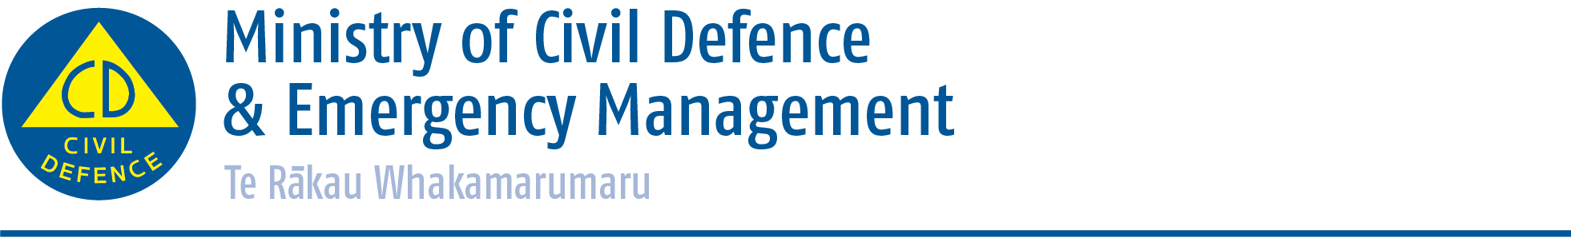

Media release 16 June 2015
Sign language interpreter Jeremy Borland
backing New Zealand ShakeOut

Sign language interpreter Jeremy Borland is the latest prominent New Zealander to get behind New Zealand ShakeOut, our national earthquake drill.

Best known for being a vital link to the deaf community following the Canterbury earthquakes, Jeremy worked with the Ministry of Civil Defence and Emergency Management to produce an advertisement in sign language for social media.

The video, hosted on You Tube,, encourages all New Zealanders to take part in New Zealand ShakeOut and sign up for the drill taking place at 9:15am, 15 October 2015.

Almost 300,000 people have signed up so far at www.shakeout.govt.nz, with four months to go until the drill.

“It’s great to have so many people on board already,” says Director of Civil Defence Emergency Management Sarah Stuart-Black. “Our aim is to have 1.5million people take part in the drill and Drop, Cover, Hold at 9:15am.”

She says everyone, everywhere should know the right action to take before, during and after an earthquake.

“New Zealand ShakeOut is more than just a drill, it’s a chance for all of us to learn more about the earthquake hazards in our area, check our plans at home and at work, and make sure we have emergency survival items.”

More information on New Zealand ShakeOut can be found at www.shakeout.govt.nz, facebook.com/nzgetthru and twitter/nzgetthru.

Media contact
Public Information Manager
Ministry of Civil Defence & Emergency Management
24/7 media phone: 04 494 6951
E-mail: pim@ncmc.govt.nz

Twitter https://twitter.com/nzcivildefence; https://twitter.com/nzgetthru
Facebook https://www.facebook.com/NzGetThru?fref=ts
If a disaster happened now, would you be ready? www.getthru.govt.nz

