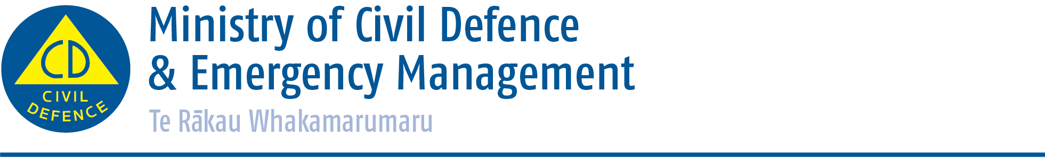

Media release Tuesday 3 February 2015

Back to school messages help families ‘get ready to get thru’

The Ministry of Civil Defence & Emergency Management is celebrating the start of the school year with a social media campaign to help kids understand and plan for disasters.
Aimed at parents, the week-long campaign started on Sunday February 1 and includes daily tips which will be shared on the Ministry’s Facebook and Twitter pages.
The Director of Civil Defence Emergency Management, Sarah Stuart-Black, says the start of the school year is a great time to start talking to kids about being prepared at school and at home.
“Involving the kids in learning about the hazards in your area, figuring out where you’ll meet up if you can’t get home, deciding who your emergency contacts will be and checking what supplies you will need makes them feel more prepared too.”
The Back to School Get Ready tips are:
- Back to school get ready tip #1: Use the walk or drive to school to talk about the hazards in your area and how you would ‘get thru’. http://www.getthru.govt.nz/disasters

- Back to school get ready tip #2: Get kids involved in household emergency planning so they know things like who will pick them up if you can’t make it. Make sure the school has the names of three other contacts. Keep ICE numbers in their mobiles and on their bag tags. http://www.getthru.govt.nz/household-emergency-plan

- Back to school get ready tip #3: While you’re getting supplies for school, grab a few emergency survival items for the home as well. Get the kids to help check the supplies regularly, e.g. check the torch and radio work. http://www.getthru.govt.nz/emergency-survival-items

- Back to school get ready tip #4: Make sure you have getaway kits for everyone in the family in case you have to evacuate in a hurry. Check what provisions your school has for the kids too. http://www.getthru.govt.nz/emergency-survival-items#kit

- Back to school get ready tip #5: Get to know the families of your kids’ friends and your neighbours. Host a barbeque or picnic at the local park or beach, and talk about how you’ll get thru together. http://www.getthru.govt.nz/how-to-get-ready/household-emergency-plan/

- Back to school get ready tip #6: Visit Whatstheplanstan.govt.nz, a tool for teachers and parents to help kids understand and plan for disasters. Find out whether What’s the Plan Stan is being used in your school. http://www.whatstheplanstan.govt.nz/

Media contact
Bridget Cheesman
Public Education Advisor
Ministry of Civil Defence & Emergency Management
24/7 media phone: 04 494 6951
E-mail: pim@ncmc.govt.nz

Twitter https://twitter.com/nzcivildefence; https://twitter.com/nzgetthru
Facebook https://www.facebook.com/NzGetThru?fref=ts
If a disaster happened now, would you be ready? www.getthru.govt.nz

